Kubernetes -02.
- Create a Simple Pod Using YAML Task: Write a YAML file to create a Pod named firstpod with an nginx container. Verify the Pod creation using kubectl get pods and check the logs of the container using kubectl logs firstpod.

Step 1: Create a YAML file
Create a file named first.yaml
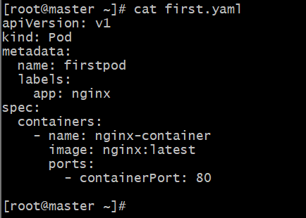

Explanation:
- apiVersion: v1 → default for Pods
- kind: Pod → specifies we’re creating a Pod
- metadata: includes the name and optional labels
- spec: defines the pod’s configuration
  - containers: list of containers inside the pod
  - image: Docker image to use (nginx:latest)
  - ports: exposes port 80 inside the container

Step 2: Apply the YAML file
Run this command to create the Pod:
kubectl apply -f firstpod.yaml

Step 3: Verify the Pod creation
Check if the pod is running:
kubectl get pods

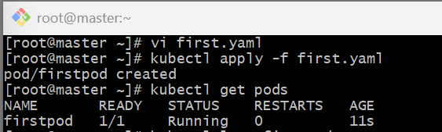

Step 4: Check the Pod logs
View container logs for your nginx container:
kubectl logs firstpod

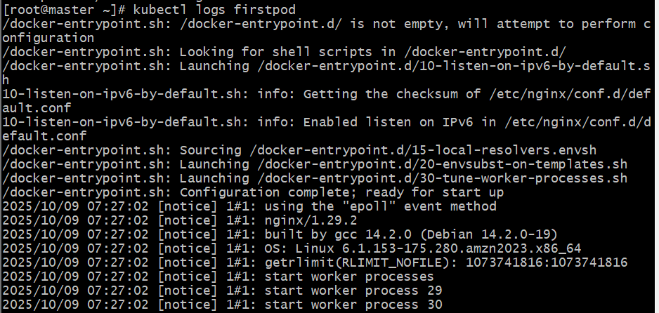

Step 5: Test Pod connectivity (optional)
You can temporarily access the Pod shell:
kubectl exec -it firstpod -- /bin/bash
Then run:
curl localhost
You should see the default NGINX welcome page HTML.

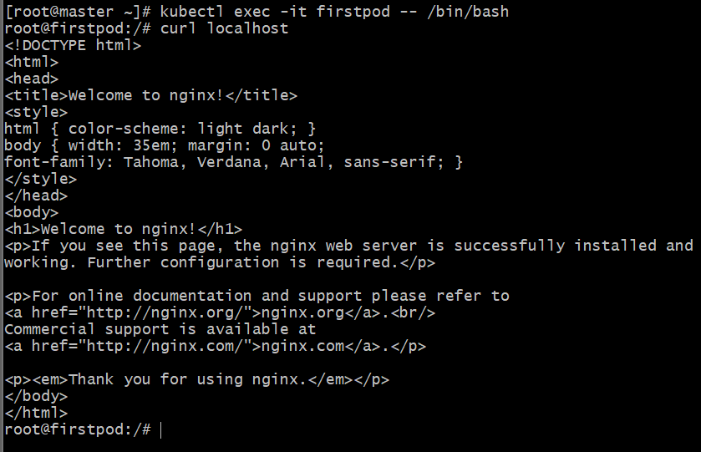

- Set Environment Variables in a Pod Task: Modify the YAML file to include environment variables myname: sabair and City: Hyderabad. Deploy the Pod and use kubectl exec <pod_name> -- env to check if the environment variables are set properly.

Step 1: Create or modify the YAML file
Create or edit the file first.yaml
env:
- name: myname
value: "sabair"
- name: City
value: "Hyderabad"

Step 2: Apply the YAML file
kubectl apply -f first.yaml

If a Pod named firstpod already exists, delete it first:
kubectl delete pod firstpod

Step 3: Verify the Pod is running
kubectl get pods

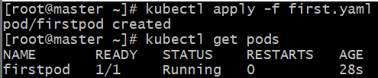

Step 4: Check the environment variables
Run this command to list all environment variables inside the container:
kubectl exec -it firstpod -- env

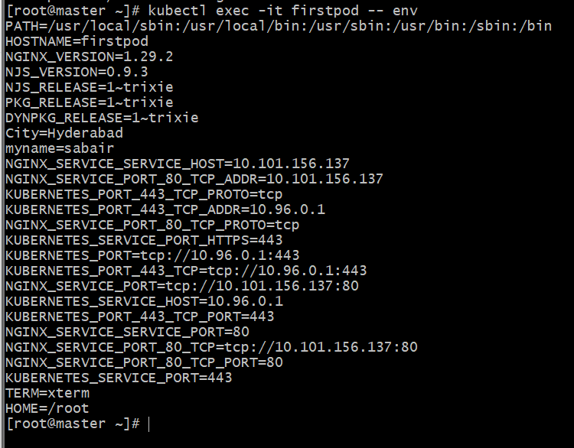
- Deploy a Pod with Commands (Args) in YAML Task: Modify the YAML file to add args that instruct the container to sleep for 50 seconds. Deploy the Pod and use kubectl describe pod to verify the args are correctly passed to the container.

Step 1: Create
Create a new file named secondpod-args.yaml:
apiVersion: v1
kind: Pod
metadata:
name: secondpod
labels:
app: nginx
spec:
containers:
- name: nginx-container
image: nginx:latest
command: ["/bin/sh"]
args: ["-c", "sleep 50"]

Explanation:
- command: replaces the container’s default entrypoint (here /bin/sh).
- args: provides arguments to the command (here -c "sleep 50").
- Together, this makes the container execute:
- /bin/sh -c "sleep 50"
This means the container will start, sleep for 50 seconds, then exit.

Step 2: Apply the YAML file
kubectl apply -f secondpod-args.yaml

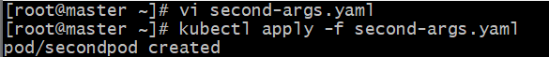

Step 3: Verify Pod status
Run:
kubectl get pods

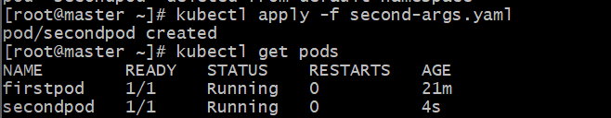
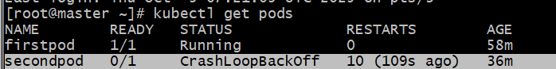

Step 4: Verify args are passed correctly
Run:
kubectl describe pod firstpod
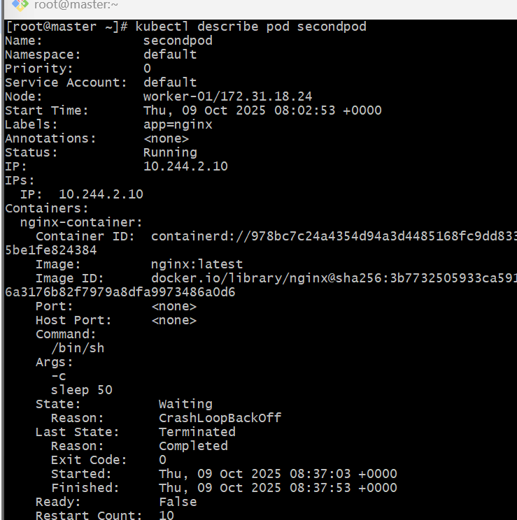
- Create a Pod with Two Containers Task: Create a YAML file to define a Pod with two nginx containers inside. Use kubectl exec to access both containers and verify that both containers can communicate through the same network (e.g., using telnet between them).

Step 1: Create a YAML file
Create a new file named twocontainers-pod.yaml:
apiVersion: v1
kind: Pod
metadata:
name: twocontainers-pod
labels:
app: nginx
spec:
containers:
- name: nginx-container-1
image: nginx:latest
ports:
- containerPort: 80
- name: nginx-container-2
image: nginx:latest
command: ["/bin/sh", "-c"]
args: ["sed -i 's/80/8080/g' /etc/nginx/conf.d/default.conf && nginx -g 'daemon off;'"]
ports:
- containerPort: 8080

Explanation
- Pod: A single Pod can have multiple containers.
- Both containers share:
  - Network namespace → same IP, can communicate via localhost.
  - Storage volumes (if defined).
- Here, we have:
  - nginx-container-1 (listening on port 80)
  - nginx-container-2 (listening on port 8080)
- Added a custom command + args for nginx-container-2 to:
  - Modify /etc/nginx/conf.d/default.conf to use port 8080 instead of 80.
  - Start Nginx manually with nginx -g 'daemon off;'.
- Ensures both Nginx servers run without port conflict.

Step 2: Deploy the Pod
kubectl apply -f twocontainers-pod.yaml

Step 3: Verify Pod status
kubectl get pods

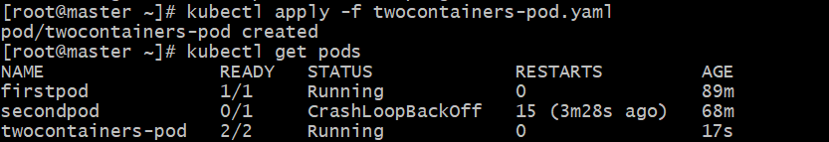

Step 4: Get Pod IP (optional)
kubectl get pod twocontainers-pod -o wide

Step 5: Access each container
To open a shell inside the first container:
kubectl exec -it twocontainers-pod -c nginx-container-1 -- /bin/bash
To open a shell inside the second container:
kubectl exec -it twocontainers-pod -c nginx-container-2 -- /bin/bash

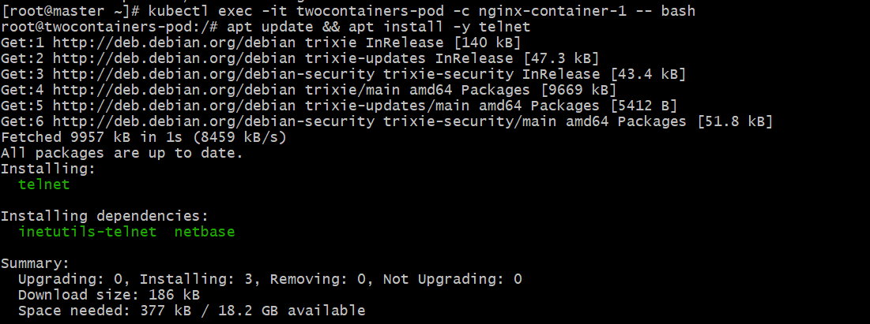

Step 6: Verify container-to-container communication
- From inside nginx-container-1, install telnet (if not already present):
apt update && apt install -y telnet
- Try connecting to the other container’s port (since both share localhost):
telnet localhost 8080
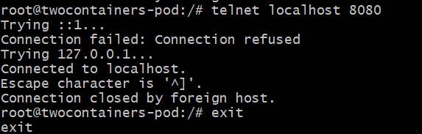
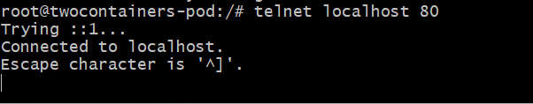
- Set Up an Init Container in a Pod Task: Modify the YAML to include an init container that sleeps for 30 seconds before the main containers start. Verify the init container's execution using kubectl describe pod and check the logs to confirm its completion.

Set Up an Init Container in a Pod

Step 1: Create the YAML file
Create a file named pod-with-init.yaml
apiVersion: v1
kind: Pod
metadata:
name: pod-with-init
labels:
app: nginx
spec:
initContainers:
- name: init-sleeper
image: busybox:latest
command: ["sh", "-c", "echo 'Init container started'; sleep 30; echo 'Init container completed'"]
containers:
- name: main-nginx
image: nginx:latest
ports:
- containerPort: 80

Explanation
- initContainers: Run before normal containers.
- They must complete successfully before main containers start.
- Here, the init-sleeper container:
  - Runs the busybox image.
  - Executes a simple shell command that sleeps for 30 seconds.
- Only after it completes will the nginx container start.

Step 2: Apply the YAML
kubectl apply -f pod-with-init.yaml

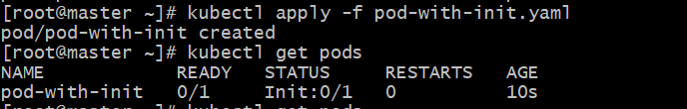

Step 3: Watch Pod startup progress
kubectl get pods -w

Step 4: Verify init container execution
kubectl describe pod pod-with-init
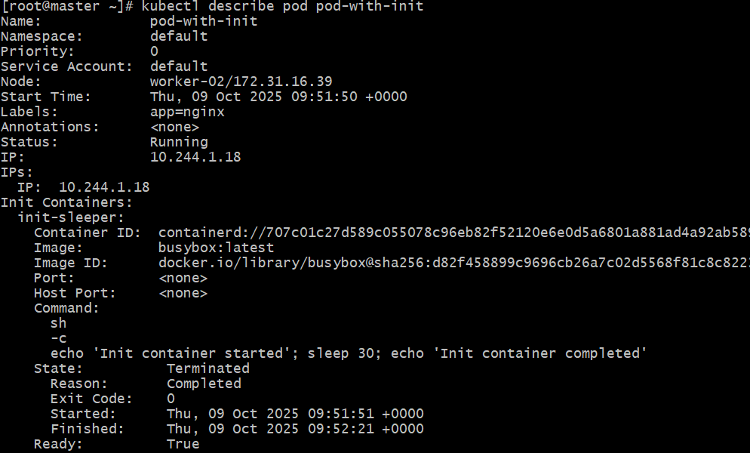

Step 5: Check init container logs
kubectl logs pod-with-init -c init-sleeper

Step 6: Verify main container logs (optional)
kubectl logs pod-with-init -c main-nginx
You should see Nginx startup logs.
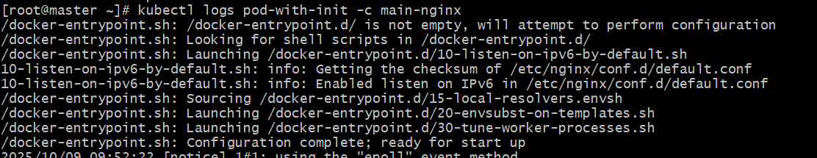
- Run a Dry Run Command to Generate YAML Task: Use the kubectl run nginx --image=nginx --dry-run=client -o yaml command to generate a Pod YAML definition. Modify the generated YAML to suit specific requirements (e.g., labels or environment variables) and deploy it.

Run a Dry Run Command to Generate YAML

Step 1: Use kubectl run with dry-run
Run the following command:
kubectl run nginx --image=nginx --dry-run=client -o yaml > sunil.yaml
✅ Explanation:
- --dry-run=client → creates the YAML manifest without deploying it.
- -o yaml → outputs in YAML format.
- > nginx-pod.yaml → saves the output to a file.

Step 2: View the generated YAML
cat sunil.yaml
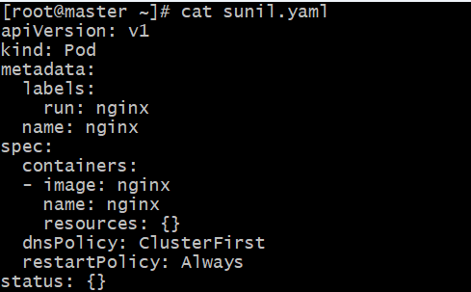

Step 3: Modify the YAML
Now edit the file
vi sunil.yaml
Add your own labels and environment variables —
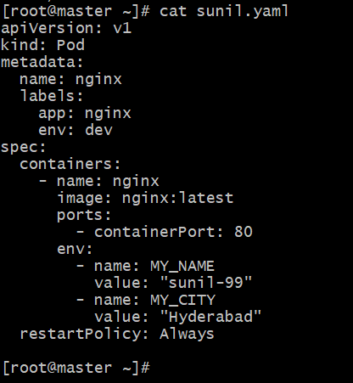

Step 4: Deploy the Pod
kubectl apply -f nginx-pod.yaml

Step 5: Verify the Pod is running
kubectl get pods

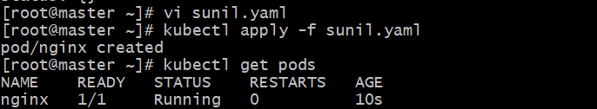

Step 6: Confirm environment variables
kubectl exec -it nginx – env

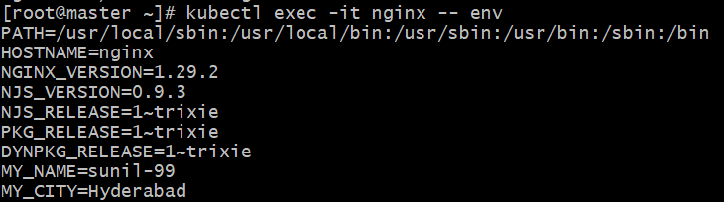
- Use kubectl apply vs kubectl create Task: Create a YAML file to define a Pod. First, deploy it using kubectl create -f <file_name>.yml and then modify the YAML (e.g., change the image version). Use kubectl apply to redeploy and verify the difference between both commands.

kubectl create vs kubectl apply

Step 1: Create a Pod YAML file
Create a file named task.yaml
apiVersion: v1
kind: Pod
metadata:
name: nginx-demo
labels:
app: nginx
spec:
containers:
- name: nginx
image: nginx:1.21
ports:
- containerPort: 80

Step 2: Deploy using kubectl create
kubectl create -f task.yaml
Check if it’s running:
kubectl get pods

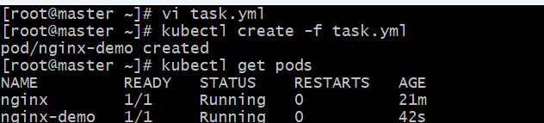

Step 3: Try changing something (e.g., the image version)
Edit the YAML file:
vi task.yaml
Change:
image: nginx:1.27

Step 4: Try to redeploy using kubectl create again
kubectl create -f task.yaml

❌ You’ll get an error

kubectl create only creates new resources.
If the object already exists, it fails — it cannot modify existing ones.

Step 5: Redeploy using kubectl apply
Now, use:
kubectl apply -f create-vs-apply.yaml

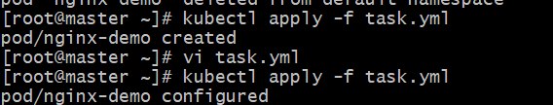

Step 6: Verify the change
kubectl describe pod nginx-demo | grep -i image

Step 7: Clean up
kubectl delete pod nginx-demo

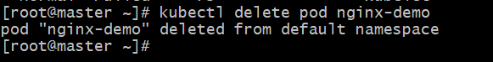

Quick Recap
- create → one-time creation
- apply → ongoing management / updates
- apply reads your YAML and makes only necessary changes in the cluster

- Edit an Existing Pod Configuration Task: Use kubectl edit pod <pod_name> to modify the running Pod's environment variables or image. After making the changes, verify if they took effect by checking the container logs or environment variables using kubectl exec.
Step-1
Check it’s running:
kubectl get pods
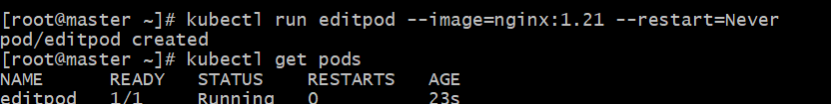

Step 2: Edit the Pod configuration
Now use the edit command:
kubectl edit pod editpod

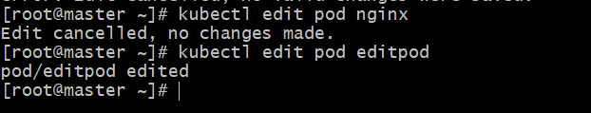
Check Pod status:
kubectl get pods

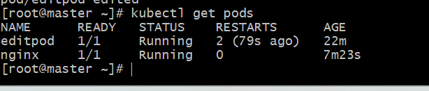
- Expose a Pod Using a Service Task: Create a YAML file to expose your firstpod using a Service (ClusterIP). Ensure that your service is exposing the Pod on port 80 and verify it using kubectl get svc.

Step 1: Verify that your Pod (firstpod) exists
Run:
kubectl get pods
If firstpod doesn’t exist, create it first:
kubectl run firstpod --image=nginx:latest --restart=Never

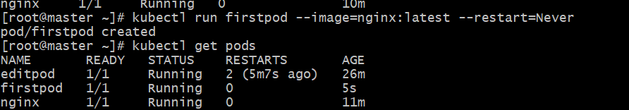

Step 2: Create the Service YAML file
Create a file named firstpod-service.yaml
apiVersion: v1
kind: Service
metadata:
name: firstpod-service
labels:
app: nginx
spec:
selector:
app: nginx # This must match the Pod's label
type: ClusterIP
ports:
- port: 80 # Service port
targetPort: 80 # Container port inside Pod
Make sure your firstpod has the label app: nginx.
Check it:
kubectl get pod firstpod --show-labels

Step 3: Apply the YAML
kubectl apply -f firstpod-service.yaml

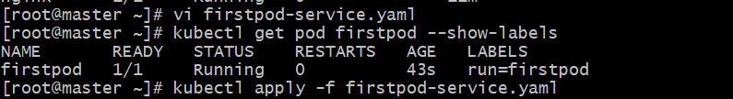

Step 4: Verify the Service
kubectl get svc

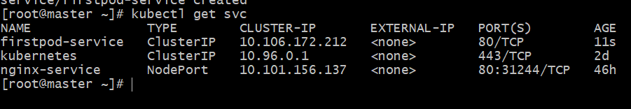
Verify in the web with ip and generated port no.

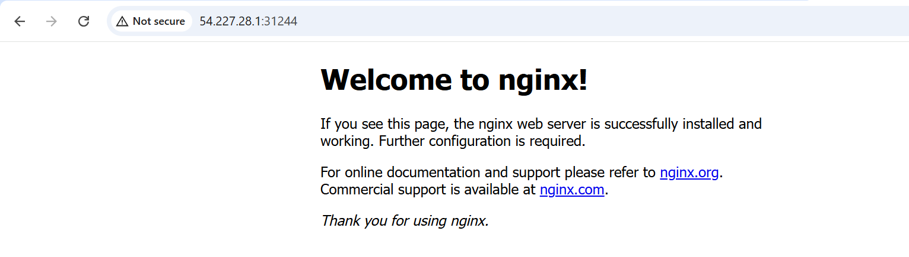
10. Pod with Resource Limits and Requests Task: Add resource requests and limits to the containers in your YAML file. Specify CPU and memory requests/limits for both containers and deploy the Pod. Use kubectl describe pod to verify if the resource configurations are correctly applied.

Step 1: Create or modify the Pod YAML
Create resource-pod.yaml for a Pod with two containers:
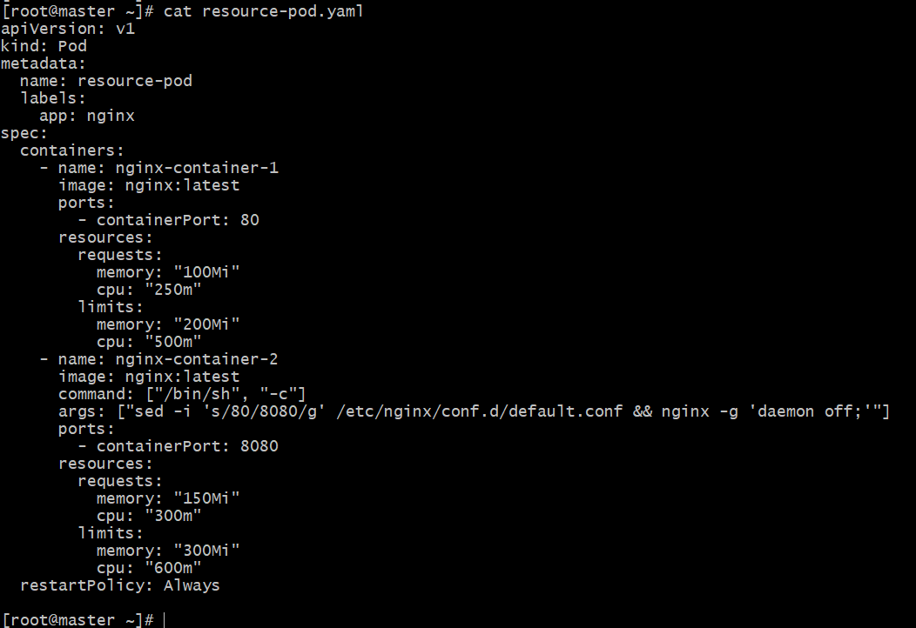

Step 2: Deploy the Pod
kubectl apply -f resource-pod.yaml

Step 3: Verify Pod status
kubectl get pods

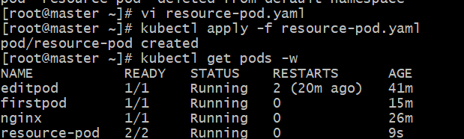

Step 4: Check resource configuration
Use kubectl describe pod:
kubectl describe pod resource-pod

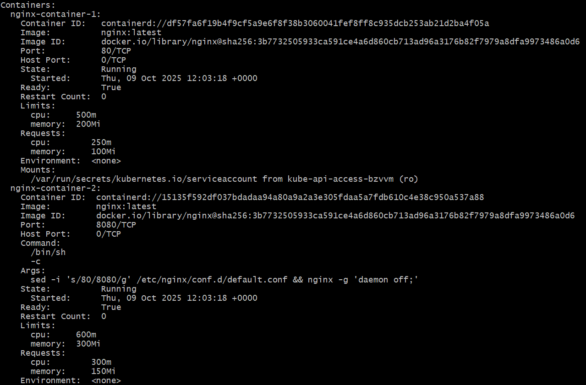

How Kubernetes Enforces These Restrictions
- CPU restriction:
  - Specified in millicores (1000m = 1 CPU core).
  - If the container tries to use more CPU than its limit, the kernel throttles its CPU usage.
  - For example:
    - limit: 500m → max half of one CPU core.
    - request: 250m → scheduler guarantees 0.25 of a core.
- Memory restriction:
  - Specified in bytes, typically Mi (mebibytes) or Gi (gibibytes).
  - If the container exceeds its memory limit, it is terminated (OOMKilled) and restarted.
  - Example:
    - request: 100Mi → scheduler ensures at least 100 MiB available before scheduling.
    - limit: 200Mi → process can’t use more than 200 MiB total.

In short, we restricted resources by:
- Adding a resources: block under each container.
- Setting specific CPU (m) and memory (Mi) values for both requests and limits.
- Allowing Kubernetes to:
  - Schedule Pod based on requests.
  - Enforce upper limits to prevent overconsumption.
- Achieving QoS class = Burstable, meaning it’s allowed to use more resources temporarily up to its limit.

