Kubernetes-03
1.Create a ClusterIP service for an Apache web server pod.

1 Create the Apache Pod
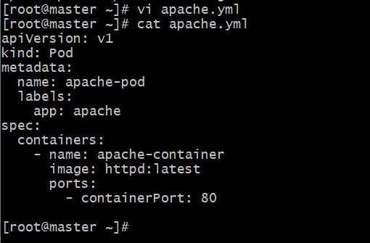
kubectl apply -f apache.yaml

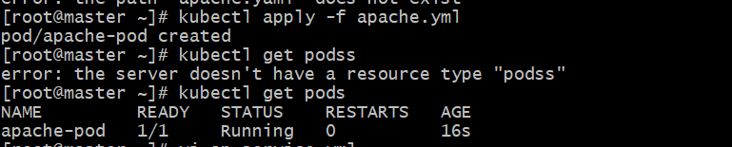
2.Create the ClusterIP Service
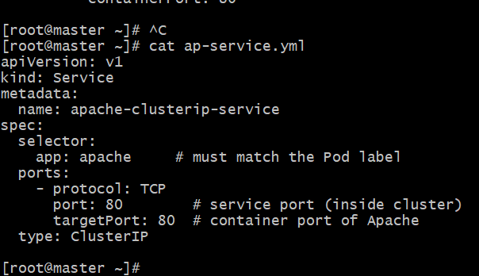
kubectl apply -f ap-service.yml
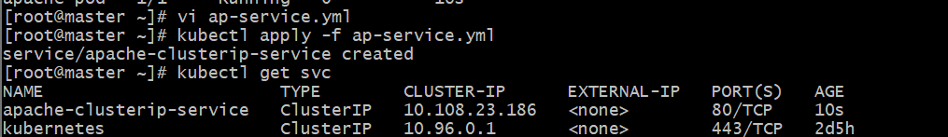
kubectl describe service apache-clusterip-service

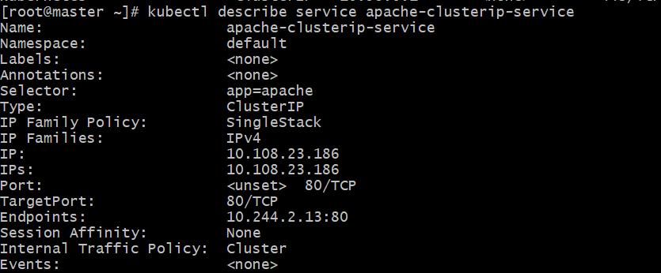
kubectl get pods -o wide

2.Expose an Nginx pod externally using a NodePort service.

Step 1: Create a Pod for Nginx
Create a YAML file — nginx-pod.yaml
apiVersion: v1
kind: Pod
metadata:
name: nginx-pod
labels:
app: nginx
spec:
containers:
- name: nginx
image: nginx:latest
ports:
- containerPort: 80
Apply it:
kubectl apply -f nginx-pod.yaml
Check pod status:
kubectl get pods

Step 2: Create a NodePort Service
Now create nginx-service.yaml
apiVersion: v1
kind: Service
metadata:
name: nginx-service
spec:
type: NodePort
selector:
app: nginx
ports:
- protocol: TCP
port: 80 # Service port (inside cluster)
targetPort: 80 # Container port
nodePort: 30080 # External port (range 30000–32767)
Apply it:
kubectl apply -f nginx-service.yaml
Verify:
kubectl get svc

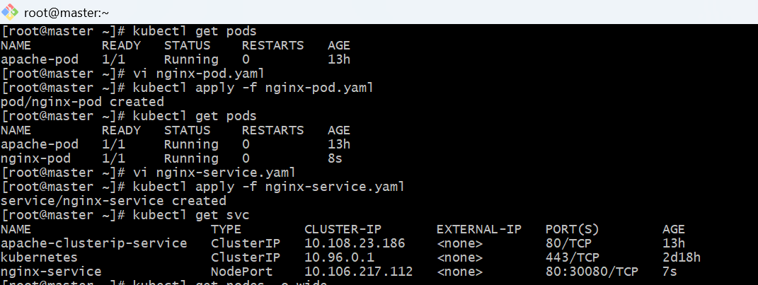
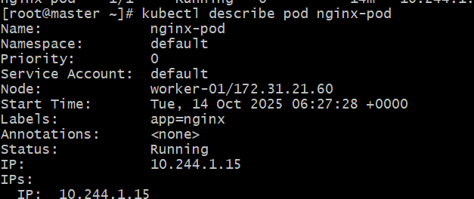
Then access in browser or curl:
http://<NodePublicIP>:30080



3.Deploy a ReplicationController to maintain 3 replicas of an Nginx pod.

Step 1: Create the ReplicationController YAML file
Create a file named nginx-rc.yaml
apiVersion: v1
kind: ReplicationController
metadata:
name: nginx-rc
spec:
replicas: 3
selector:
app: nginx
template:
metadata:
labels:
app: nginx
spec:
containers:
- name: nginx
image: nginx:latest
ports:
- containerPort: 80

⚙️Step 2: Apply the configuration
kubectl apply -f nginx-rc.yaml

🔍 Step 3: Verify ReplicationController and Pods
Check the ReplicationController:
kubectl get rc
Expected output:
NAME DESIRED CURRENT READY AGE
nginx-rc 3 3 3 20s
Check the pods created by it:
kubectl get pods -o wide
You should see 3 Nginx pods running with similar names like:
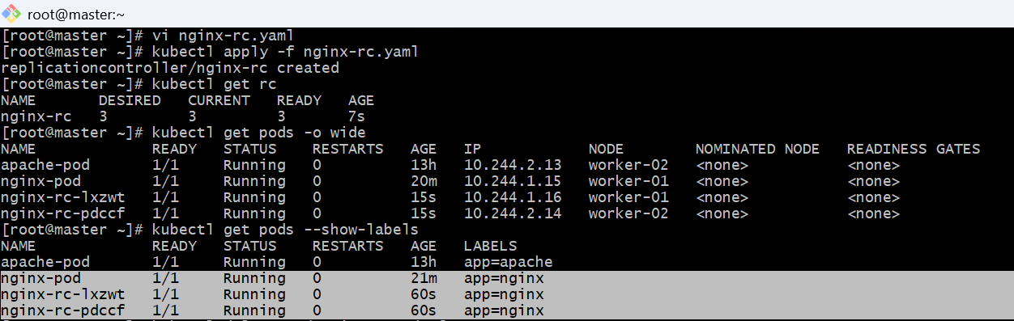

Step 4: Test Replication Behavior
If you delete one pod:
kubectl delete pod <pod-name>
The ReplicationController will automatically create a new pod to maintain 3 replicas.
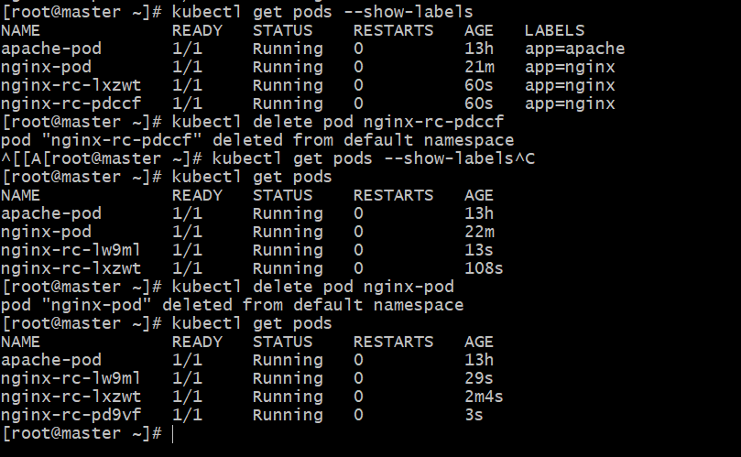

4.Scale the ReplicationController from 3 replicas to 5 replicas.

Edit the YAML file and re-apply
If you prefer to modify the configuration:
Open your nginx-rc.yaml file and change:
replicas: 3
to:
replicas: 5
Then re-apply:
kubectl apply -f nginx-rc.yaml
Verify:
kubectl get rc

kubectl get pods
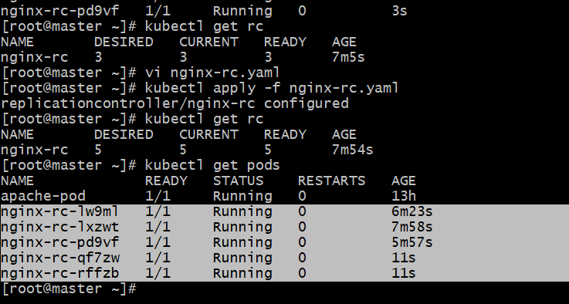

5.Create a ReplicaSet to manage pods based on multiple labels (prod and test).

Step 1: Create the ReplicaSet YAML file
Create a file named nginx-replicaset.yaml
apiVersion: apps/v1
kind: ReplicaSet
metadata:
name: nginx-rs
spec:
replicas: 3
selector:
matchLabels:
env: prod
tier: test
template:
metadata:
labels:
env: prod
tier: test
spec:
containers:
- name: nginx
image: nginx:latest
ports:
- containerPort: 80

Step 2: Apply the ReplicaSet
kubectl apply -f nginx-replicaset.yaml

Step 3: Verify ReplicaSet and Pods
Check the ReplicaSet:
kubectl get rs
Expected output:
NAME DESIRED CURRENT READY AGE
nginx-rs 3 3 3 15s
Check the pods:
kubectl get pods --show-labels

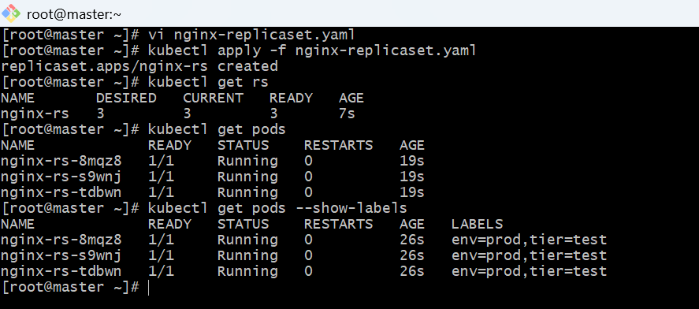
6.Deploy a ReplicaSet that excludes pods with the label backend.

Step 1: Create the ReplicaSet YAML file
Create a file named rs2.yml
apiVersion: apps/v1
kind: ReplicaSet
metadata:
name: nginx-rs-exclude-backend
spec:
replicas: 3
selector:
matchExpressions:
- key: backend
operator: NotIn
values: ["true"]
template:
metadata:
labels:
app: nginx
frontend: "true"
spec:
containers:
- name: nginx
image: nginx:latest
ports:
- containerPort: 80

kubectl apply -f rs2.yml

Step 3: Verify ReplicaSet and Pods
Check ReplicaSet:
kubectl get rs
Check pods and labels:
kubectl get pods --show-labels

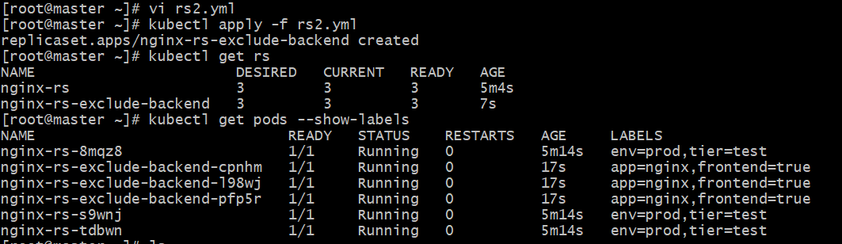
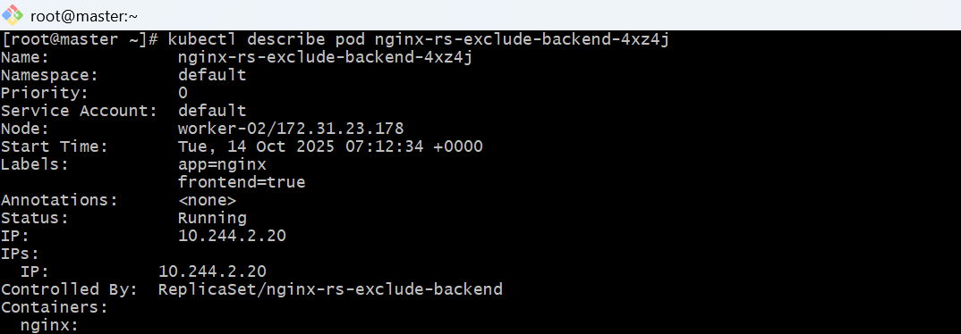

Step 4: Test the Exclusion
If you try to create a Pod manually with backend=true,
the ReplicaSet will not manage or affect it.
Example (not controlled by RS):
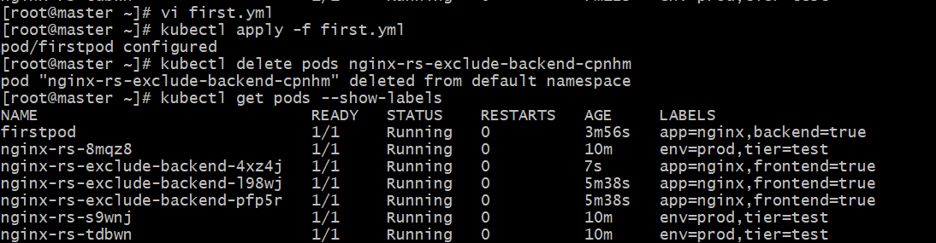
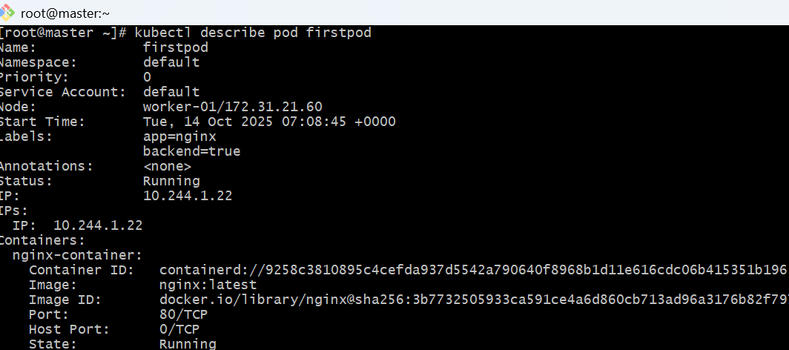
7.Test load balancing across multiple pods using a Node Port service.

Step 1: Create a ReplicaSet (or Deployment) with Multiple Pods
Let’s use a Deployment (simpler to scale/manage):
File: nginx-deploy.yaml
apiVersion: apps/v1
kind: Deployment
metadata:
name: nginx-deploy
spec:
replicas: 3
selector:
matchLabels:
app: nginx
template:
metadata:
labels:
app: nginx
spec:
containers:
- name: nginx
image: nginx:latest
ports:
- containerPort: 80
Apply it:
kubectl apply -f nginx-deploy.yaml
Check pods:
kubectl get pods -l app=nginx
You should see 3 pods running.

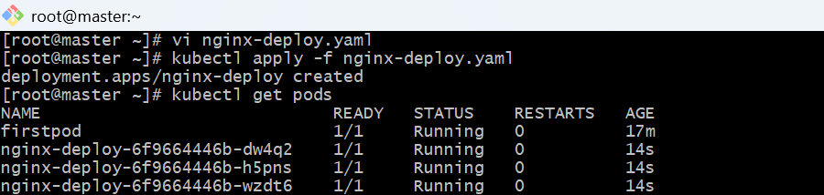

⚙️ Step 2: Expose Deployment using a NodePort Service
File: nginx-service.yaml
apiVersion: v1
kind: Service
metadata:
name: nginx-service
spec:
type: NodePort
selector:
app: nginx
ports:
- port: 80
targetPort: 80
nodePort: 30080
Apply it:
kubectl apply -f nginx-service.yaml
Check:
kubectl get svc
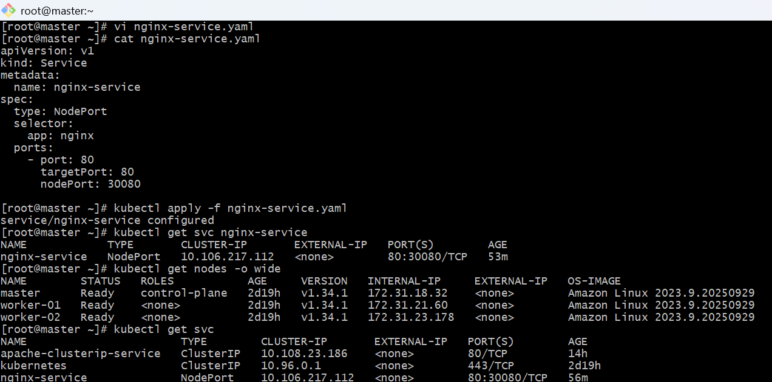
kubectl describe service nginx-service

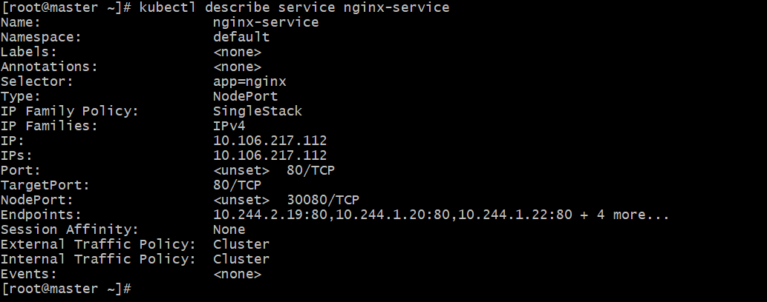
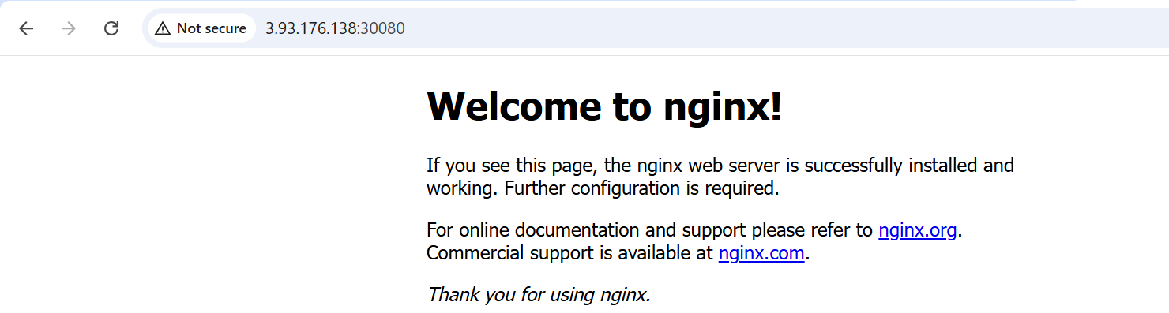

8.Delete a Replication Controller without affecting the running pods.

- Check existing RC: or rs
kubectl get rc
Delete it without deleting pods:
kubectl delete rc <rcname>

Verify pods still exist:
kubectl get pods
