Kubernetes-04
1.Deploy an application using a Deployment with 3 replicas and a rolling update strategy.

STEP-1

Create a Deployment YAML File
Create a file called deployment.yaml
apiVersion: apps/v1
kind: Deployment
metadata:
name: nginx-deployment
labels:
app: nginx
spec:
replicas: 3 # Number of replicas
selector:
matchLabels:
app: nginx
strategy:
type: RollingUpdate # Strategy type
rollingUpdate:
maxUnavailable: 1 # At most 1 pod unavailable during update
maxSurge: 1 # At most 1 extra pod created during update
template:
metadata:
labels:
app: nginx
spec:
containers:
- name: nginx
image: nginx:latest # Container image
ports:
- containerPort: 80

STEP-2Deploy the Application
Run the following command:
kubectl apply -f deployment.yaml

STEP-3 :Verify the Deployment
Check if all 3 replicas are running:
kubectl get deployments

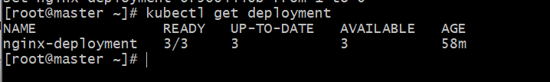
kubectl get pods

kubectl describe deployment nginx-deployment | grep Image

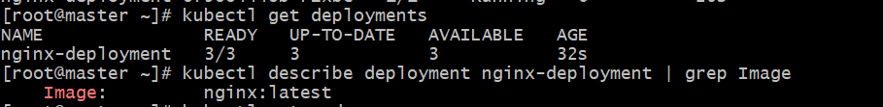

STEP :4-View the Rolling Update Behavior
If you update the image, Kubernetes will perform a rolling update automatically.
For example:
kubectl set image deployment/nginx-deployment nginx=nginx:1.25.0
Then monitor the rollout:
kubectl rollout status deployment/nginx-deployment

In another terminal, watch the pods:
kubectl get pods -w
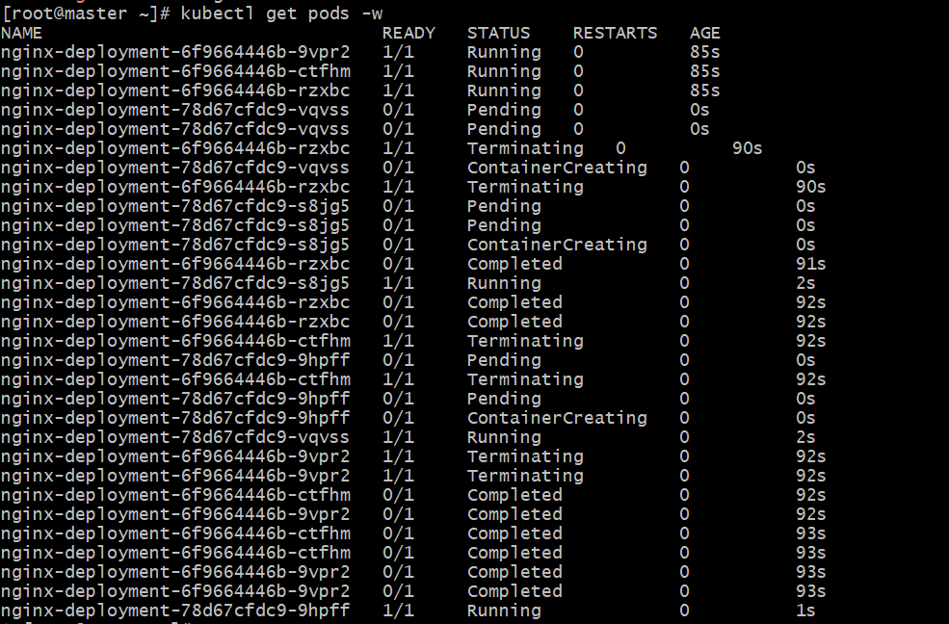
Kubernetes will:
- Create a new Pod (with the new image),
- Wait until it’s healthy,
- Then terminate an old Pod — maintaining availability (rolling update).

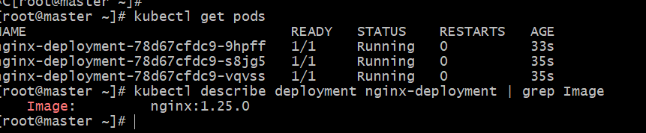

if You Want to See More Details About the Rolling Update
Run:
kubectl describe deployment nginx-deployment

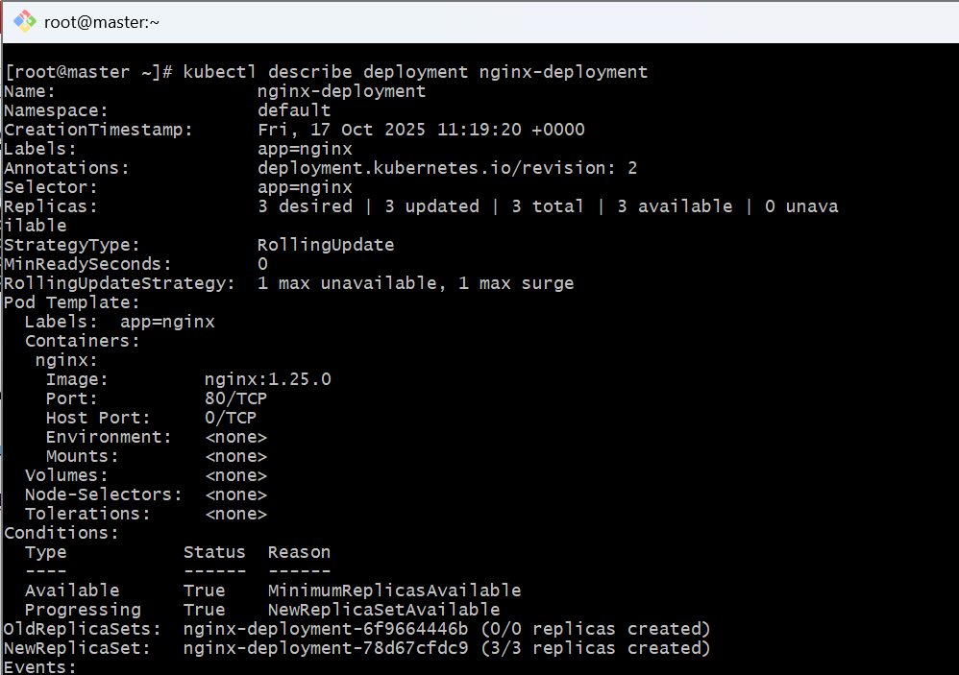
2.Configure a Deployment with a Recreate strategy and observe the downtime.

Step 1: Create a Deployment YAML (Recreate Strategy)
Create a file named recreate-deployment.yaml:
apiVersion: apps/v1
kind: Deployment
metadata:
name: recreate-deployment
labels:
app: recreate-demo
spec:
replicas: 3
selector:
matchLabels:
app: recreate-demo
strategy:
type: Recreate # 👈 Important: Recreate strategy
template:
metadata:
labels:
app: recreate-demo
spec:
containers:
- name: nginx
image: nginx:1.23.0 # Initial image version
ports:
- containerPort: 80

Step 2: Deploy It
kubectl apply -f recreate-deployment.yaml
Verify it’s running:
kubectl get deployments
kubectl get pods

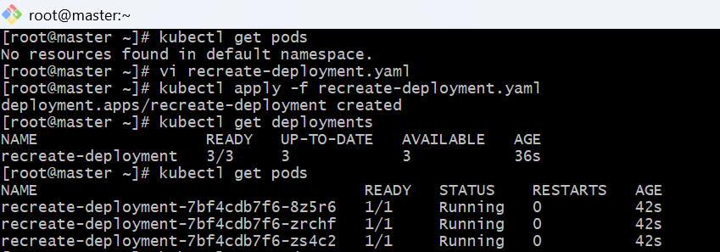

Step 3: Update the Image and Observe Downtime
Now, update the image version:
kubectl set image deployment/recreate-deployment nginx=nginx:1.25.0
Monitor the rollout:
kubectl rollout status deployment/recreate-deployment

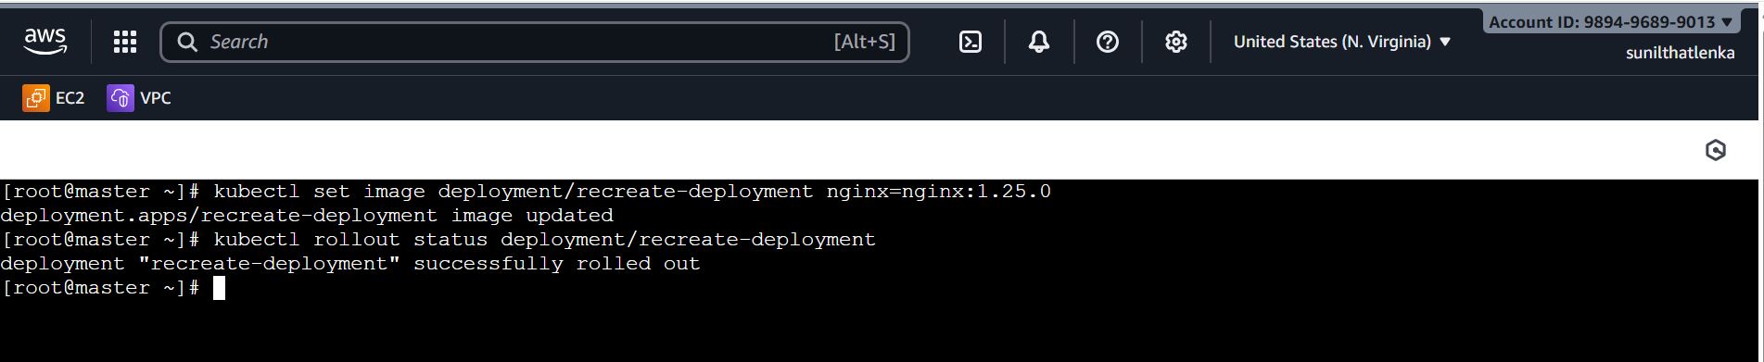
In another terminal, watch the pods:
kubectl get pods –w

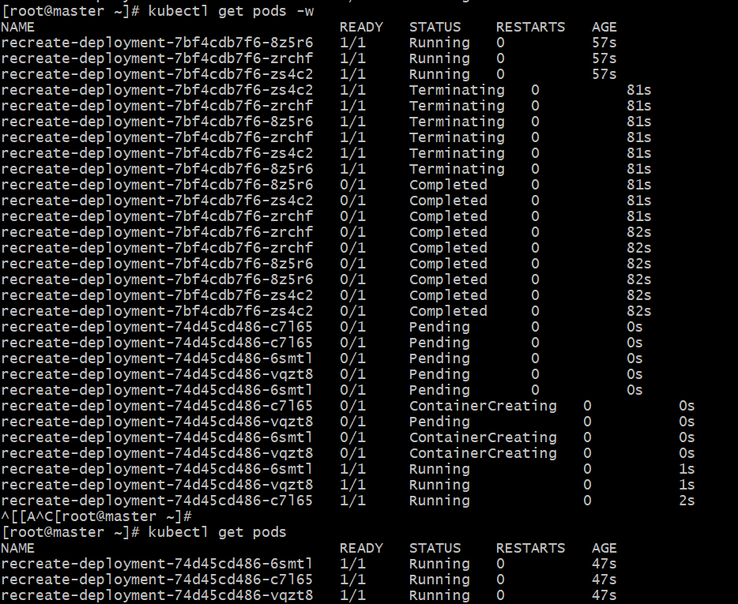

You’ll notice:
- All old pods are terminated first.
- Then new pods are created.
During this time, no pods are available, causing temporary downtime

Step 5: Confirm Strategy Type
To verify the strategy used:
kubectl describe deployment recreate-deployment | grep StrategyType
3.Update an existing Deployment and perform a rollback to the previous version.

Step 1: Check Current Deployment
First, confirm your current deployment details:
kubectl get deployments

Step 2: Check Current Image Version
To see which image version your deployment is using:
kubectl describe deployment nginx-deployment | grep Image

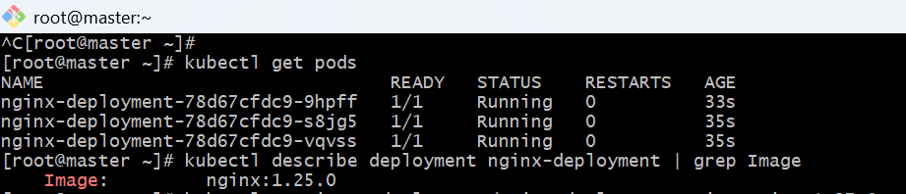

Step 3: Update the Deployment
Now, update it to a new image version (for example, nginx:1.27.0):
kubectl set image deployment/nginx-deployment nginx=nginx:1.27.0
Check rollout progress:
kubectl rollout status deployment/nginx-deployment

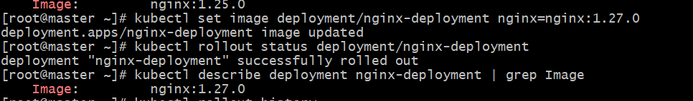

Step 4: Verify the Update

kubectl get pods -w
You should see old pods terminating and new ones being created (if RollingUpdate strategy is used).
Confirm the image change:
kubectl describe deployment nginx-deployment | grep Image

Step 6: Rollback to the Previous Version
If something goes wrong or you want to revert:
kubectl rollout undo deployment/nginx-deployment
Or rollback to a specific revision:
kubectl rollout undo deployment/nginx-deployment --to-revision=2
Check rollout progress:
kubectl rollout status deployment/nginx-deployment

Verify the Update

kubectl get pods -w

✅ Step 7: Verify the Rollback
Check again:
kubectl describe deployment nginx-deployment | grep Image
You should now see it reverted back to the previous image version (e.g., nginx:1.25.0).
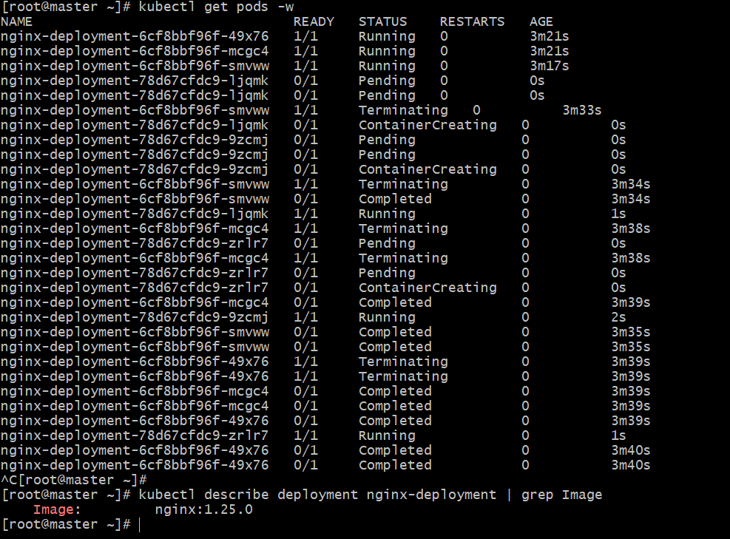

4.Modify a Deployment to add resource requests and limits for CPU and memory.

Step 1: Edit the Existing Deployment
Vi vi deployment.yml
kubectl apply -f deployment.yml

resources:
requests:
cpu: "100m" # Minimum 0.1 CPU core
memory: "128Mi" # Minimum 128MB memory
limits:
cpu: "250m" # Maximum 0.25 CPU core
memory: "256Mi" # Maximum 256MB memory

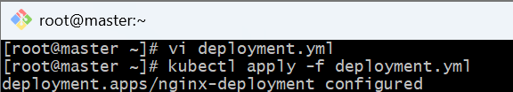

Step 2: Verify Pods Are Updated
Check rollout status:
kubectl rollout status deployment/nginx-deployment

Then view the pods:
kubectl get pods

Step 3: Inspect Resource Configuration on a Pod
Pick one pod name and run:
kubectl describe pod <pod-name> | grep -A5 "Limits:"
You’ll see your CPU and memory requests/limits applied.
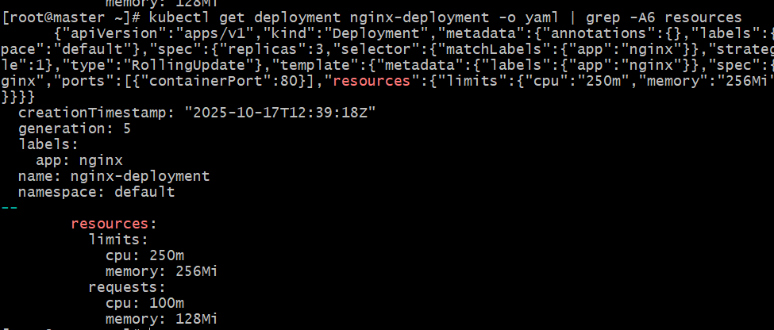

5.Create a Deployment with MaxSurge and MaxUnavailable configurations.

Objective
Create a Deployment that:
- Runs 3 replicas
- Uses a RollingUpdate strategy
- Has:
  - maxSurge: 2 → allows 2 extra pods above desired count during update
  - maxUnavailable: 1 → allows 1 pod to be unavailable during update

Step 1: Create the YAML File
Create a file named rollingupdate-deployment.yaml:
apiVersion: apps/v1
kind: Deployment
metadata:
name: rollingupdate-deployment
labels:
app: rolling-demo
spec:
replicas: 3
selector:
matchLabels:
app: rolling-demo
strategy:
type: RollingUpdate
rollingUpdate:
maxSurge: 2 # Allows up to 2 extra pods during update
maxUnavailable: 1 # Allows 1 pod to be unavailable during update
template:
metadata:
labels:
app: rolling-demo
spec:
containers:
- name: nginx
image: nginx:1.25.0
ports:
- containerPort: 80

Step 2: Apply the Deployment
kubectl apply -f rollingupdate-deployment.yaml
Verify it’s running:
kubectl get deployments
kubectl get pods

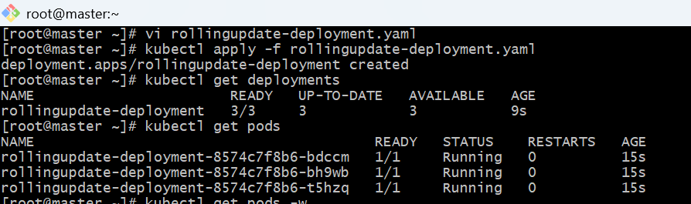

Step 3: Trigger a Rolling Update
Let’s update the image version to simulate an update:
kubectl set image deployment/rollingupdate-deployment nginx=nginx:1.27.0

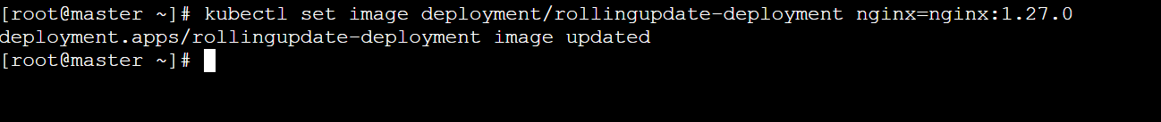
And in another terminal, watch the pods to see how the rollout happens:
kubectl get pods –w

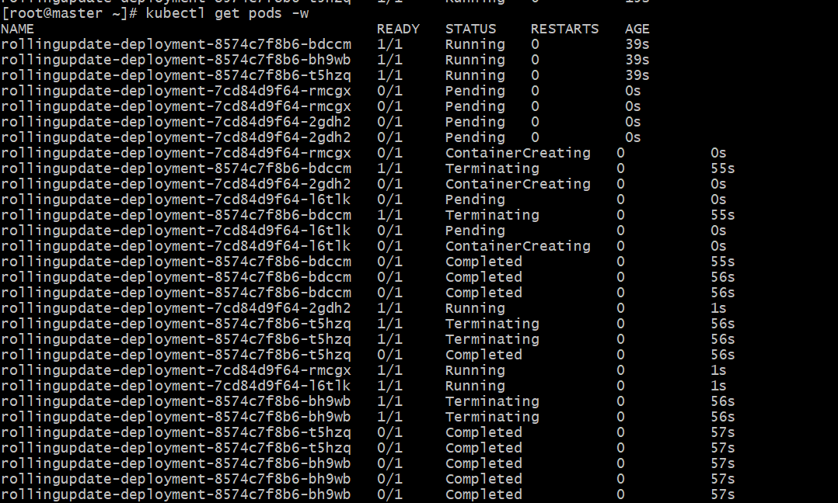

Step 4: Observe Behavior
You’ll see:
- Up to 5 pods running at once (3 desired + 2 surge)
- Up to 1 pod unavailable at a time
This ensures high availability while the update rolls out smoothly.
- After a while:
- All old pods terminated, new pods running → rollout complete.

Step 5: Verify Strategy Configuration
To confirm the strategy used:
kubectl describe deployment rollingupdate-deployment | grep -A3 StrategyType
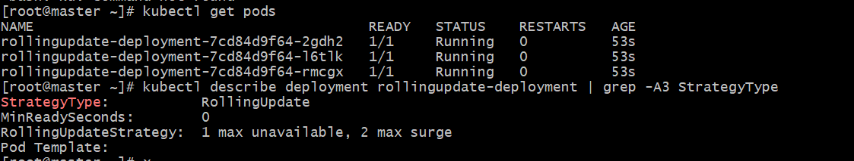

6.Set up a Deployment with a custom revision history limit.

Objective
Create a Deployment with:
- Custom revision history limit (e.g., keep only last 2 revisions)
- So that older ReplicaSets beyond this limit are automatically cleaned up

Step 1: Create the Deployment YAML
Create a file named revisionlimit-deployment.yaml with the following content:
apiVersion: apps/v1
kind: Deployment
metadata:
name: revisionlimit-deployment
labels:
app: revision-demo
spec:
replicas: 3
revisionHistoryLimit: 2 # 👈 Only keep the last 2 revisions
selector:
matchLabels:
app: revision-demo
strategy:
type: RollingUpdate
rollingUpdate:
maxSurge: 1
maxUnavailable: 1
template:
metadata:
labels:
app: revision-demo
spec:
containers:
- name: nginx
image: nginx:1.25.0
ports:
- containerPort: 80

🧩 Step 2: Deploy It
kubectl apply -f revisionlimit-deployment.yaml
Check status:
kubectl get deployments
kubectl get pods
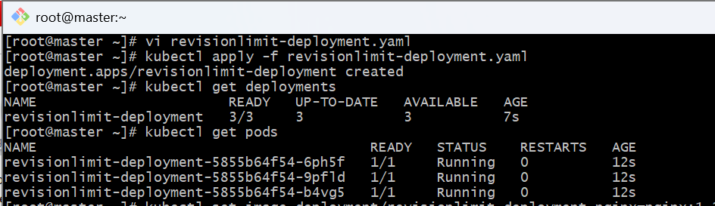

Step 3: Perform a Few Updates to Generate Revisions
Now, simulate multiple updates to create new revisions:
kubectl set image deployment/revisionlimit-deployment nginx=nginx:1.26.0
kubectl rollout status deployment/revisionlimit-deployment

kubectl set image deployment/revisionlimit-deployment nginx=nginx:1.27.0
kubectl rollout status deployment/revisionlimit-deployment

kubectl set image deployment/revisionlimit-deployment nginx=nginx:1.28.0
kubectl rollout status deployment/revisionlimit-deployment

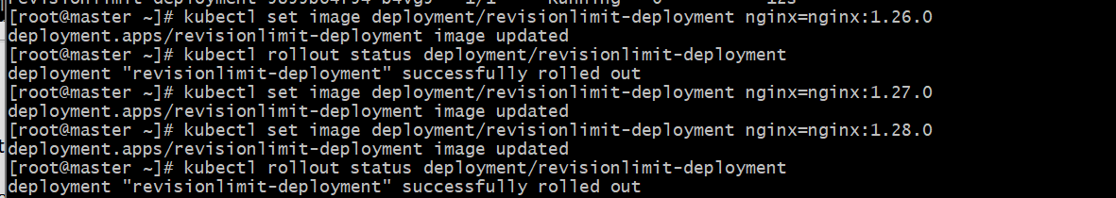

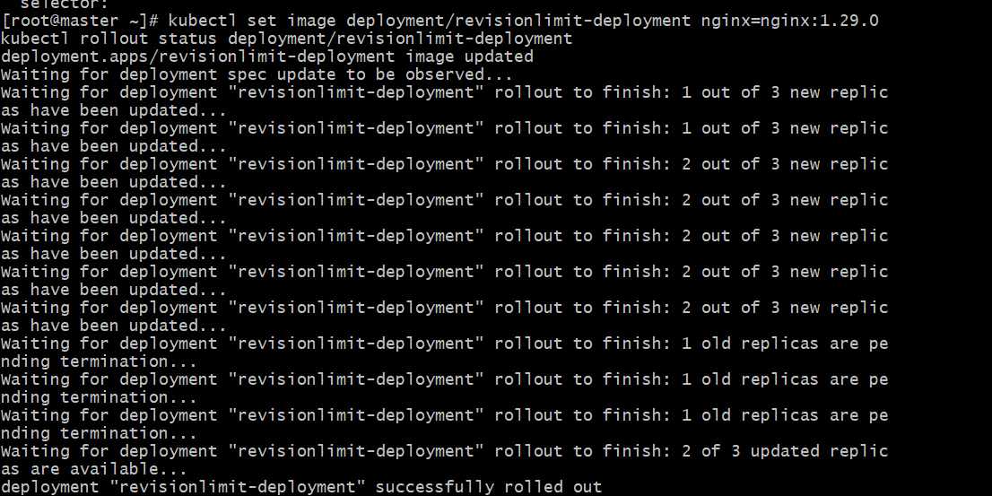

Step 4: Check Revision History
Now run:
kubectl rollout history deployment/revisionlimit-deployment

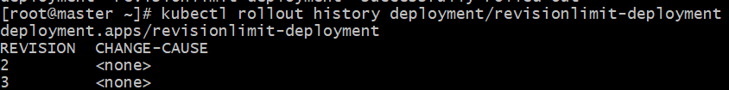
You can confirm it is set by running the YAML view instead of describe:
kubectl get deployment revisionlimit-deployment -o yaml | grep -A1 revisionHistoryLimit
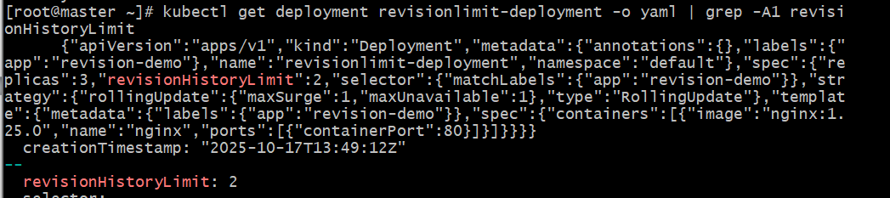

7.Pause a Deployment during an update, and then resume it.

Step 1: Create a Deployment
We’ll use a simple example (nginx app): vi pause-demo.yaml

apiVersion: apps/v1
kind: Deployment
metadata:
name: pause-demo
labels:
app: pause-app
spec:
replicas: 3
selector:
matchLabels:
app: pause-app
template:
metadata:
labels:
app: pause-app
spec:
containers:
- name: pause-container
image: nginx:1.25
ports:
- containerPort:80
Apply it:
kubectl apply -f pause-demo.yaml
Check pods:
kubectl get pods

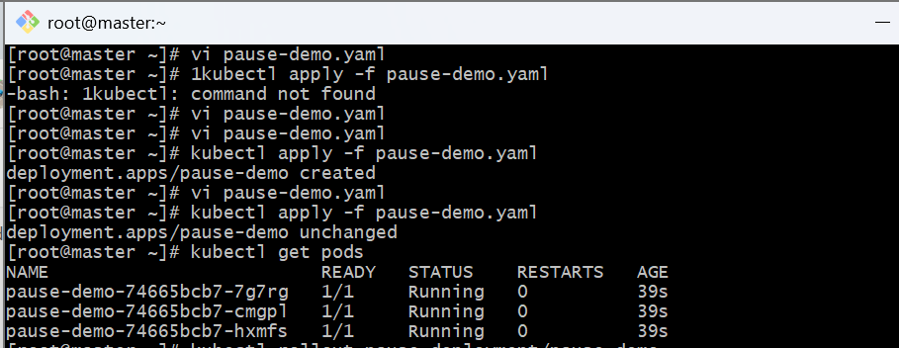

Step 2: Pause the Deployment
Now, pause the deployment so it won’t apply updates automatically:
kubectl rollout pause deployment/pause-demo
Confirm it’s paused:
kubectl rollout status deployment/pause-demo

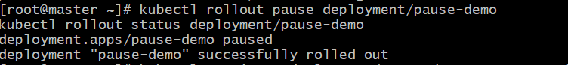

Step 3: Make an Update While Paused
Change the image version:
kubectl set image deployment/pause-demo pause-container=nginx:1.27
Check rollout status again:
kubectl rollout status deployment/pause-demo
You’ll notice — nothing happens.
No pods are updated yet because the rollout is paused.
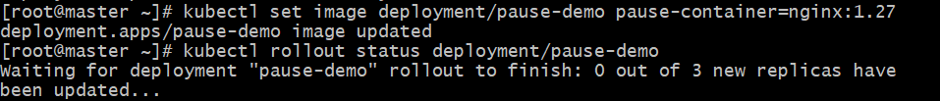

Step 4: Resume the Deployment
Now resume it to continue the rollout:
kubectl rollout resume deployment/pause-demo
Watch it complete:
kubectl rollout status deployment/pause-demo
Now the pods will gradually update to the new version (nginx:1.27).
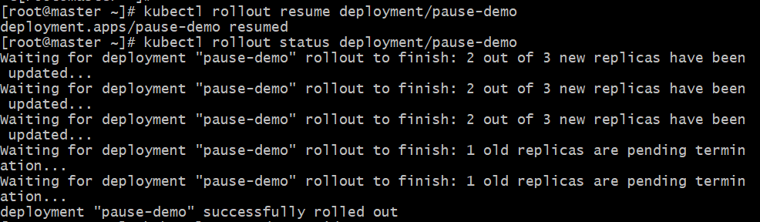

Step 5: Verify Changes
Check pods and ensure new image is deployed:
kubectl get pods -o wide
kubectl describe deployment pause-demo | grep Image
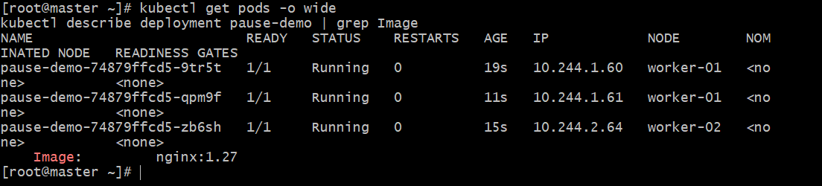

8.Create a pod using resource requests for memory and CPU, and observe how the scheduler assigns it to a node.

1 Create a YAML file
Create a file called resource-pod.yaml:
apiVersion: v1
kind: Pod
metadata:
name: resource-demo-pod
spec:
containers:
- name: nginx-container
image: nginx:latest
resources:
requests:
cpu: "200m" # Requests 0.2 CPU cores
memory: "256Mi" # Requests 256 MB memory
limits:
cpu: "500m" # Max 0.5 CPU cores
memory: "512Mi" # Max 512 MB memory

2 Apply the manifest
kubectl apply -f resource-pod.yaml
You should see:
pod/resource-demo-pod created

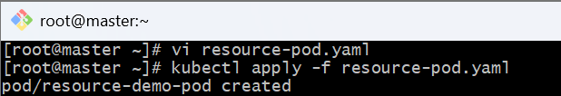

3 Check the Pod status
kubectl get pod resource-demo-pod -o wide
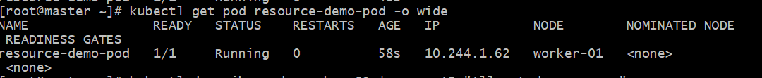

4 Verify resource requests
kubectl describe pod resource-demo-pod | grep -A5 "Limits"

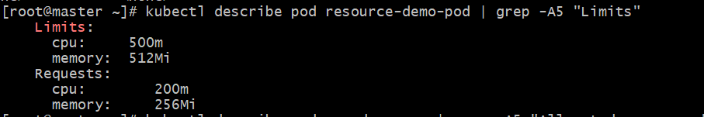

5 Check node resource availability
You can check node resources before and after scheduling:
kubectl describe node <node-name> | grep -A5 "Allocated resources"
It will show the CPU and memory used by Pods, including your resource-demo-pod.
