Kubernetes-05
1.Create a namespace dev-environment and apply a resource-based quota that restricts the number of pods to 3 and services to 2.

Goal
We want to:
- Create a namespace called dev-environment
- Apply a resource quota to restrict the number of Pods to 3 and Services to 2
This helps control how many resources a specific team, project, or environment can use inside the cluster.

Step 1: Create a Namespace
kubectl create namespace dev-environment
A namespace is like a separate workspace inside your Kubernetes cluster.
It allows you to organize and isolate resources (like Pods, Services, Deployments, etc.) so that different teams or environments (e.g., dev, test, prod) don’t interfere with each other.
So here, we’re creating a namespace named dev-environment to hold all our development-related resources.

Step 2: Create a ResourceQuota YAML File
We create a file named dev-quota.yaml:
apiVersion: v1
kind: ResourceQuota
metadata:
name: dev-quota
namespace: dev-environment
spec:
hard:
pods: "3"
services: "2"

Step 3: Apply the ResourceQuota
kubectl apply -f dev-quota.yaml

Step 4: Verify the ResourceQuota
kubectl get resourcequota -n dev-environment

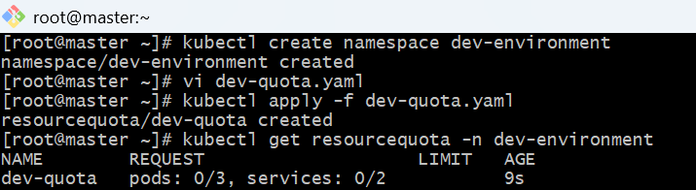

Step 5: Create a sample Pod YAML file
Create a file named test-pod.yaml:
apiVersion: v1
kind: Pod
metadata:
name: test-pod
namespace: dev-environment
spec:
containers:
- name: nginx-container
image: nginx:latest
ports:
- containerPort: 80
Run:
kubectl apply -f test-pod.yaml

Step -6Test the Quota Restriction
Since the quota allows only 3 pods, try creating more Pods with different names:
After the third one, when you try to create a fourth Pod, you’ll get an error like this:

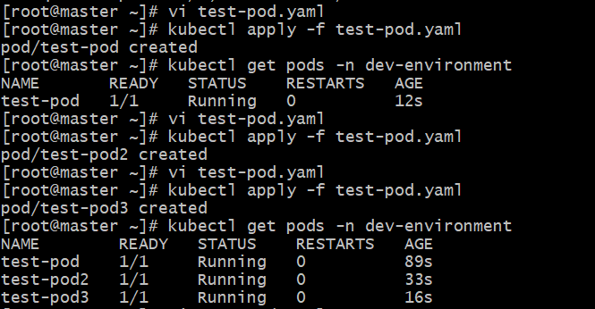

Step 7: Check the Quota Usage
Run:
kubectl describe resourcequota dev-quota -n dev-environment

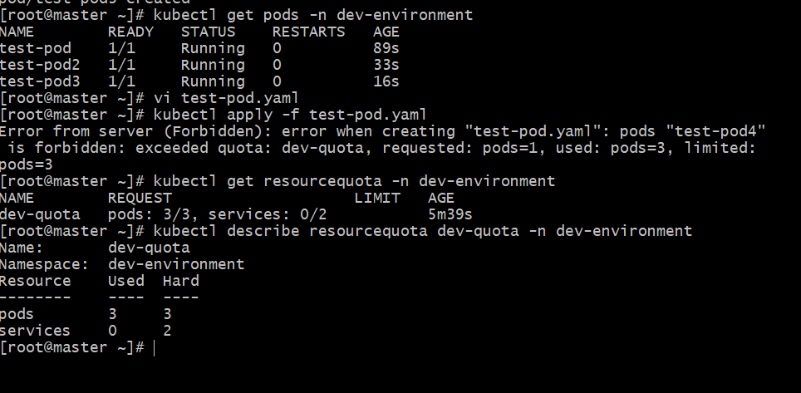

2.Create a pod in the prod-environment namespace with 0.2 CPU and 200Mi memory requests, and 0.5 CPU and 500Mi memory limits.

Goal
Create a namespace called prod-environment
Then create a Pod inside it that requests and limits CPU and memory resources.

Step 1: Create the namespace
kubectl create namespace prod-environment

Step 2: Create the Pod YAML file
Create a file named prod-pod.yaml:
apiVersion: v1
kind: Pod
metadata:
name: prod-pod
namespace: prod-environment
spec:
containers:
- name: nginx-container
image: nginx:latest
resources:
requests:
cpu: "0.2"
memory: "200Mi"
limits:
cpu: "0.5"
memory: "500Mi"

resources.requests | The minimum amount of resources the container is guaranteed to get.  Kubernetes uses these values when scheduling Pods to nodes.

resources.limits | The maximum amount of resources the container can use.  If it tries to use more than this, it will be throttled (for CPU) or killed (for memory).

Step 3: Apply the Pod configuration
kubectl apply -f prod-pod.yaml

Step 4: Verify the Pod
kubectl get pods -n prod-environment
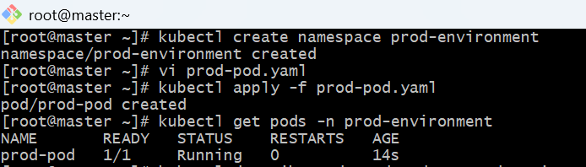

Step 5: Check resource requests and limits
Run:
kubectl describe pod prod-pod -n prod-environment
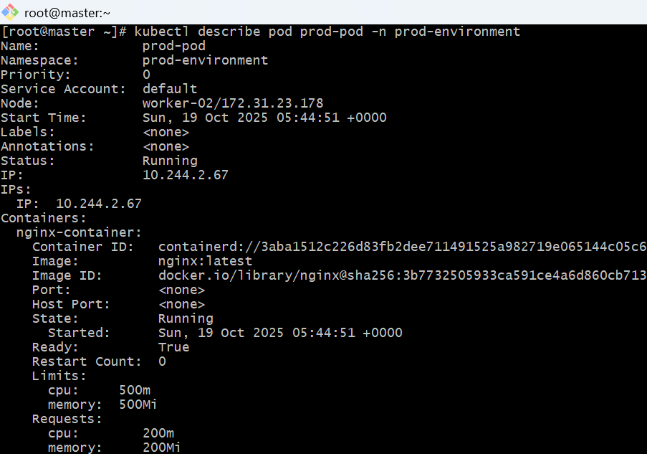

Why we use requests and limits
- Requests → helps Kubernetes schedule the Pod to a node that can provide those minimum resources.
- Limits → prevent the Pod from consuming too much CPU or memory, protecting other workloads.
3.In the staging-environment namespace, set a Limit Range that assigns default CPU and memory limits (300m CPU, 600Mi memory) and applies a minimum and maximum CPU.

Goal
✅ Create a namespace called staging-environment
✅ Apply a LimitRange that:
- Sets default CPU = 300m (0.3 CPU)
- Sets default memory = 600Mi
- Enforces minimum and maximum CPU limits for containers

Step 1: Create the namespace
kubectl create namespace staging-environment

Step 2: Create the LimitRange YAML
Create a file named staging-limitrange.yaml:
apiVersion: v1
kind: LimitRange
metadata:
name: staging-limitrange
namespace: staging-environment
spec:
limits:
- type: Container
default:
cpu: 300m
memory: 600Mi
defaultRequest:
cpu: 200m
memory: 300Mi
min:
cpu: 100m
memory: 200Mi
max:
cpu: 500m
memory: 800Mi

Step 3: Apply the LimitRange
kubectl apply -f staging-limitrange.yaml

Step 4: Verify the LimitRange
kubectl describe limitrange staging-limitrange -n staging-environment

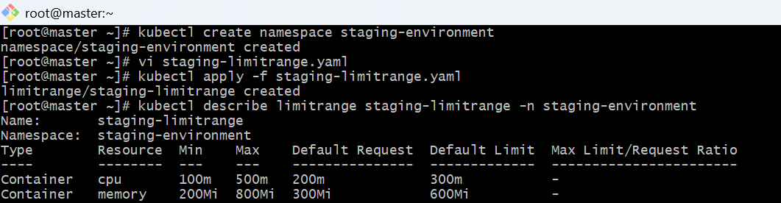

Step 5: Test the LimitRange
If you create a Pod without specifying resources, Kubernetes will automatically assign the defaults from the LimitRange.
Vi test-limit-pod.yaml:

apiVersion: v1
kind: Pod
metadata:
name: test-limit-pod
namespace: staging-environment
spec:
containers:
- name: nginx
image: nginx:latest
Apply it:
kubectl apply -f test-limit-pod.yaml
Then check the assigned limits:
kubectl describe pod test-limit-pod -n staging-environment

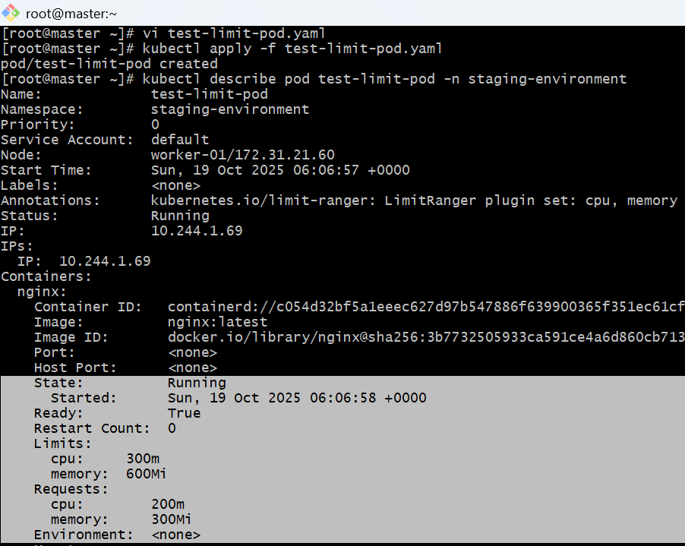

4.Create a pod and a Node Port service in the default namespace, then create another pod in the test namespace and communicate between them using Service DNS.

Step 1: Create a Pod in the default namespace
Create a file named default-pod.yaml:
apiVersion: v1
kind: Pod
metadata:
name: nginx-pod
namespace: default
labels:
app: nginx
spec:
containers:
- name: nginx-container
image: nginx:latest
ports:
- containerPort: 80
Apply it:
kubectl apply -f default-pod.yaml
Check:
kubectl get pods

Step 2: Expose the Pod using a NodePort Service
Create a file named nginx-service.yaml:
apiVersion: v1
kind: Service
metadata:
name: nginx-service
namespace: default
spec:
type: NodePort
selector:
app: nginx
ports:
- port: 80
targetPort: 80
nodePort: 30080
Apply it:
kubectl apply -f nginx-service.yaml
Check:
kubectl get svc -n default

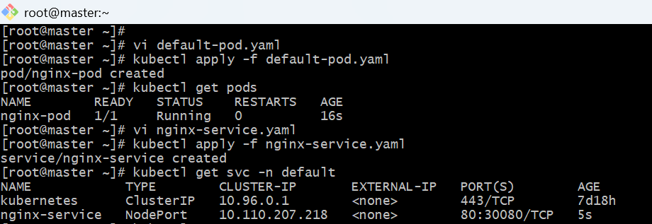

Step 3: Create a new namespace
kubectl create namespace test

Step 4: Create another Pod in the test namespace
Create a file named test-pod.yaml:
apiVersion: v1
kind: Pod
metadata:
name: test-pod
namespace: test
spec:
containers:
- name: curl-container
image: curlimages/curl:latest
command: ["sleep", "3600"]
Apply it:
kubectl apply -f test-pod.yaml
Check:
kubectl get pods -n test
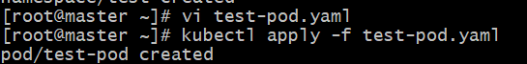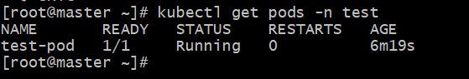

Step 5: Test communication using Service DNS
Now, exec into the test pod:
kubectl exec -it test-pod -n test -- sh
Inside the container, run:
curl nginx-service.default.svc.cluster.local
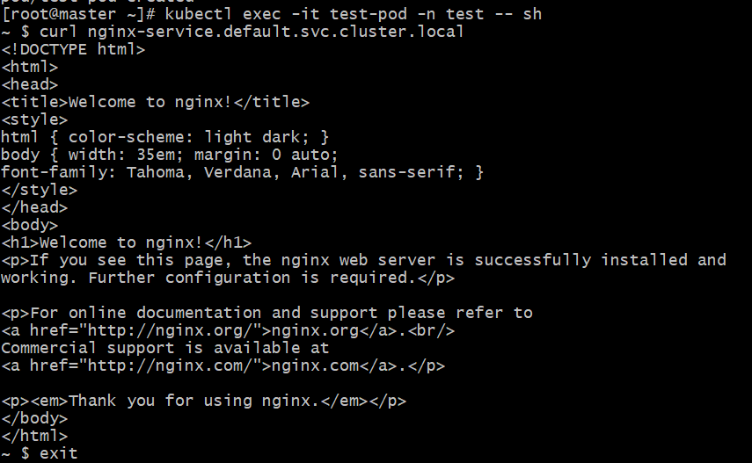

5.Apply a Limit Range with a max limit/request ratio of 2 for memory in the performance-environment namespace, and test by creating a pod with mismatched resource requests and limits.

Goal
Create a LimitRange in a new namespace called performance-environment that:
- Enforces a maximum limit/request ratio of 2 for memory
Then test it by creating a Pod that violates this rule.

Step 1: Create the namespace
kubectl create namespace performance-environment

Step 2: Create the LimitRange YAML
Create a file named performance-limitrange.yaml:
apiVersion: v1
kind: LimitRange
metadata:
name: performance-limitrange
namespace: performance-environment
spec:
limits:
- type: Container
maxLimitRequestRatio:
memory: 2

Step 3: Apply the LimitRange
kubectl apply -f performance-limitrange.yaml

Step 4: Verify
kubectl describe limitrange performance-limitrange -n performance-environment
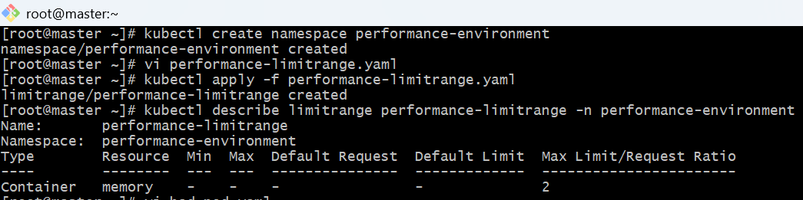

Step 5: Test by creating a Pod that violates the rule
Create a file named bad-pod.yaml:
apiVersion: v1
kind: Pod
metadata:
name: bad-pod
namespace: performance-environment
spec:
containers:
- name: test-container
image: nginx:latest
resources:
requests:
memory: "200Mi"
limits:
memory: "700Mi"
Apply it:
kubectl apply -f bad-pod.yaml
This means Kubernetes blocked the Pod because it exceeded the allowed ratio.

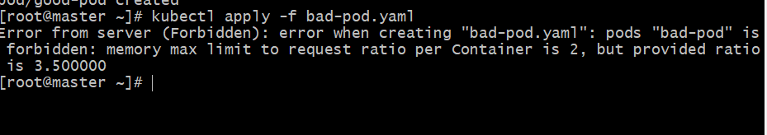

Step 6: Create a valid Pod (for comparison)
Create a file named good-pod.yaml:
apiVersion: v1
kind: Pod
metadata:
name: good-pod
namespace: performance-environment
spec:
containers:
- name: test-container
image: nginx:latest
resources:
requests:
memory: "200Mi"
limits:
memory: "400Mi"
Apply it:
kubectl apply -f good-pod.yaml
This one works because 400/200 = 2, which matches the rule.
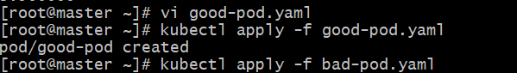

Why This Matters
The maxLimitRequestRatio in Kubernetes:
- Prevents containers from setting tiny requests and huge limits, which can cause scheduling inefficiency and resource hoarding.
- Helps maintain fairness and stability across workloads in a shared cluster.

Final Result:
- Kubernetes enforces the max limit/request ratio rule.
- Invalid Pods are rejected automatically by the API server, ensuring consistent resource allocation policies.
