Kubernetes-06
1.Create a ConfigMap from a directory containing multiple files and inject the variables into a pod as environment variables.

Goal
Create a ConfigMap from a directory that has multiple files, and then inject all of its key-value pairs into a Pod as environment variables.

Step 1: Prepare your directory
Suppose you have a directory called config-dir/ with multiple files:
config-dir/
├── app.properties
├── db.properties
Each file might contain something like:
app.properties
APP_NAME=MyApp
APP_ENV=Production
db.properties
DB_HOST=mysql-service
DB_USER=admin
DB_PASS=secret123

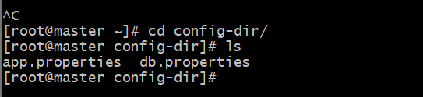

Step 2: Create a ConfigMap from the directory
Use the following command:
kubectl create configmap my-config --from-file=config-dir/
✅ This will:
- Create a ConfigMap named my-config
- Each file inside config-dir/ becomes a key
- The file content becomes the value

Step 3: Verify the ConfigMap
kubectl describe configmap my-config

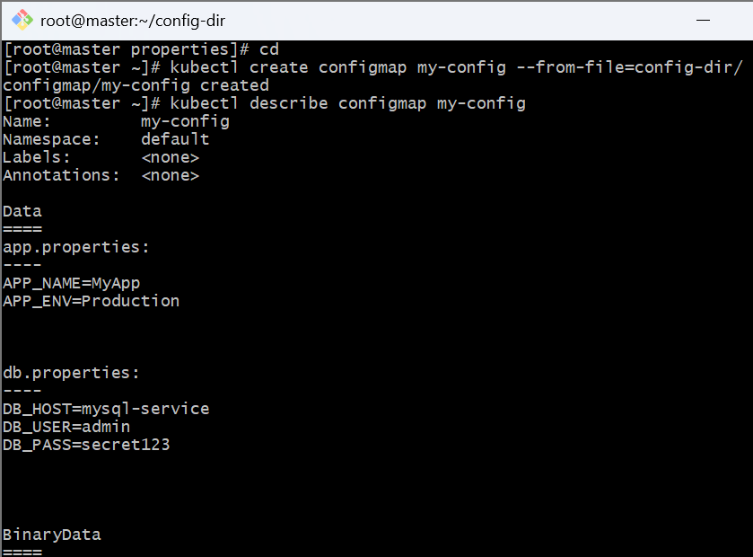

Step 4: Inject ConfigMap values as environment variables
Here’s a Pod YAML file (pod.yml):
apiVersion: v1
kind: Pod
metadata:
name: env-pod
spec:
containers:
- name: test-container
image: busybox
command: ["/bin/sh", "-c", "env"]
envFrom:
- configMapRef:
name: my-config
restartPolicy: Never

Step 5: Apply the Pod
kubectl apply -f pod.yml
Step 6: Check environment variables inside the Pod
kubectl logs env-pod

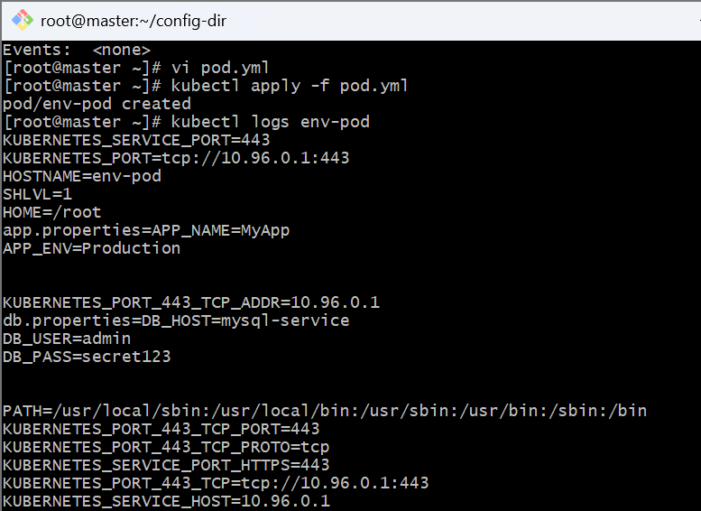
2.Create a ConfigMap from a file and mount it as a volume inside a pod, ensuring the configuration data is available as files.

Goal
Create a ConfigMap from a single file and mount it into a Pod as a volume.

Step 1: Create a configuration file
Let’s create a simple file called app-config.txt:
cat <<EOF > app-config.txt
APP_NAME=MyVolumeApp
APP_ENV=Development
DB_HOST=mysql
DB_USER=root
EOF

Step 2: Create a ConfigMap from this file
kubectl create configmap app-config --from-file=app-config.txt
✅ This will create a ConfigMap named app-config with one key:
- Key → app-config.txt
- Value → contents of the file

Step 3: Verify the ConfigMap
kubectl describe configmap app-config

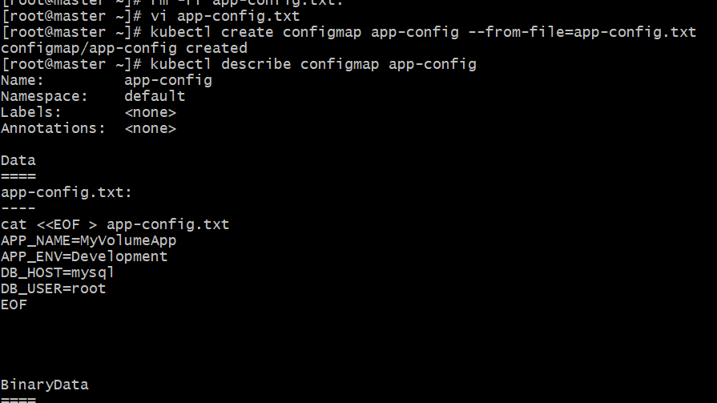

Step 4: Create a Pod that mounts this ConfigMap
Create a YAML file named pod-configmap-volume.yml:
apiVersion: v1
kind: Pod
metadata:
name: configmap-volume-pod
spec:
containers:
- name: test-container
image: busybox
command: ["/bin/sh", "-c", "cat /etc/config/app-config.txt; sleep 3600"]
volumeMounts:
- name: config-volume
mountPath: /etc/config
volumes:
- name: config-volume
configMap:
name: app-config
restartPolicy: Never

⚡ Step 5: Deploy the Pod
kubectl apply -f pod-configmap-volume.yml

🧾 Step 6: Verify the mounted file
Check that the ConfigMap file is visible inside the pod:
kubectl exec -it configmap-volume-pod -- cat /etc/config/app-config.txt

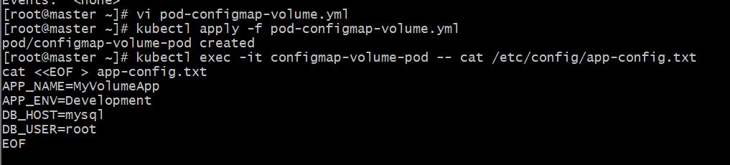

How it works
- The ConfigMap app-config contains one key: app-config.txt
- Kubernetes mounts that key as a file inside the container at /etc/config/app-config.txt
- Any change in the ConfigMap (if mounted) automatically updates the file in the pod (for most volumes).

Notes
- Each file in the ConfigMap becomes a file in the mount path.
- You can mount multiple ConfigMaps to different directories if needed.
- The container must have permission to read that directory.

3.Create a Secret with sensitive information (username and password) and inject it into a pod as environment variables.

Goal
Create a Kubernetes Secret (with username and password)
➡ Inject it into a Pod as environment variables.

🧩 Step 1: Create a Secret
You can create it directly from literal values using the command line:
kubectl create secret generic db-secret --from-literal=username=admral=password=MyP@ssw0rd

This creates a Secret named db-secret.

🔍 Step 2: Verify the Secret
Run:
kubectl describe secret db-secret

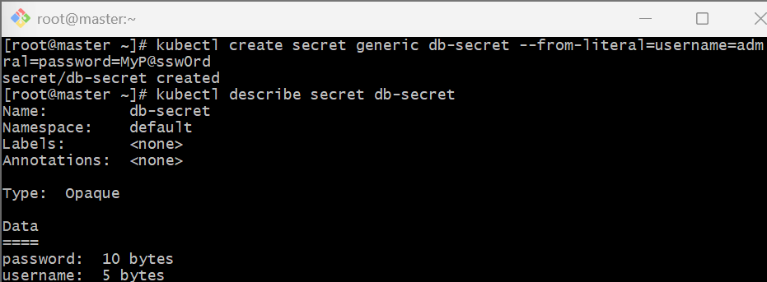
To view the decoded values (for checking only):
kubectl get secret db-secret -o yaml

You can decode them manually:
echo YWRtaW4= | base64 --decode
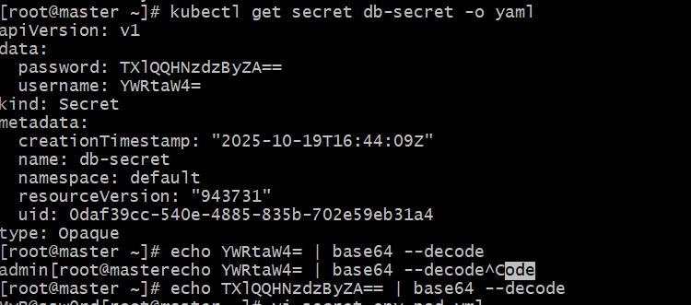

Step 3: Inject the Secret into a Pod as environment variables
Create a Pod definition file named secret-env-pod.yml:
apiVersion: v1
kind: Pod
metadata:
name: secret-env-pod
spec:
containers:
- name: test-container
image: busybox
command: ["/bin/sh", "-c", "echo Username=$USERNAME; echo Password=$PASSWORD; sleep 3600"]
env:
- name: USERNAME
valueFrom:
secretKeyRef:
name: db-secret
key: username
- name: PASSWORD
valueFrom:
secretKeyRef:
name: db-secret
key: password
restartPolicy: Never

Step 4: Apply the Pod
kubectl apply -f secret-env-pod.yml

Step 5: Verify that secrets are injected
Check the pod logs:
kubectl logs secret-env-pod

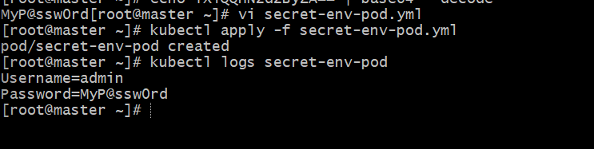

How it works
- The db-secret Secret stores your sensitive data.
- In the Pod’s container spec:
  - env[].valueFrom.secretKeyRef reads the value of each key in the Secret.
- Kubernetes injects those as environment variables at runtime.

Security Notes
- Avoid checking secrets into version control — always use kubectl create secret or CI/CD tools.
- Secrets are base64-encoded, not encrypted by default (enable encryption at rest for extra security).
4.Create a Secret using a YAML file, mount it as a volume in a pod, and verify the specific Secret values are available as files.

Goal
Create a Secret from YAML → Mount it → Verify files in the Pod.

Step 1: Create the Secret YAML file
Create a file named secret.yaml:
apiVersion: v1
kind: Secret
metadata:
name: db-secret
type: Opaque
data:
username: YWRtaW4= # base64 for "admin"
password: TXlQQHNzdzByZA== # base64 for "MyP@ssw0rd"

Step 2: Apply the Secret
kubectl apply -f secret.yaml
✅ Verify:
kubectl get secrets db-secret -o yaml

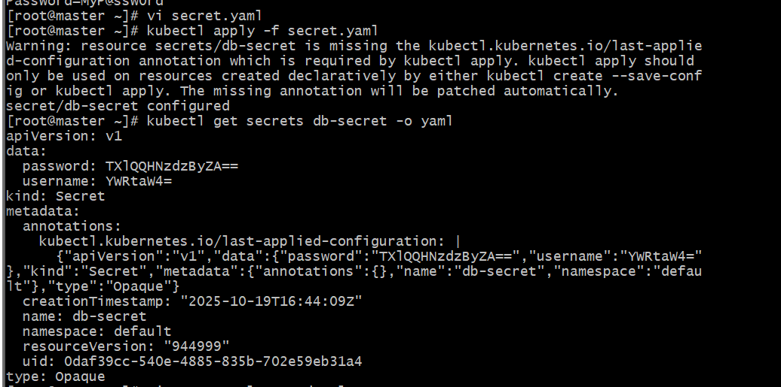

Step 3: Create a Pod that mounts the Secret as a volume
Create a YAML file named secret-volume-pod.yml:
apiVersion: v1
kind: Pod
metadata:
name: secret-volume-pod
spec:
containers:
- name: test-container
image: busybox
command: ["/bin/sh", "-c", "ls /etc/secret-data; echo '---'; cat /etc/secret-data/username; echo ''; cat /etc/secret-data/password; sleep 3600"]
volumeMounts:
- name: secret-volume
mountPath: "/etc/secret-data"
readOnly: true
volumes:
- name: secret-volume
secret:
secretName: db-secret
restartPolicy: Never

⚡ Step 4: Deploy the Pod
kubectl apply -f secret-volume-pod.yml

🔎 Step 5: Verify the mounted secret files
Check what files are created inside /etc/secret-data:
kubectl exec -it secret-volume-pod -- ls /etc/secret-data
Now view their contents:
kubectl exec -it secret-volume-pod -- cat /etc/secret-data/username
kubectl exec -it secret-volume-pod -- cat /etc/secret-data/pass

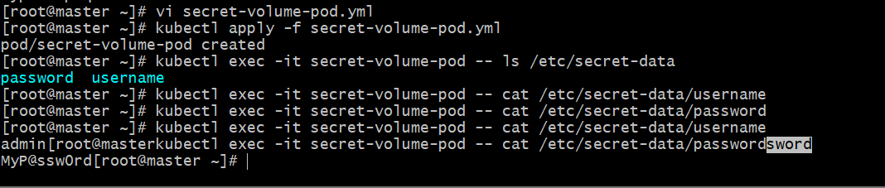

5.Inject a ConfigMap as environment variables and a Secret as files into the same pod, ensuring both are accessible within the pod.

Goal
Create:
- A ConfigMap → Inject as environment variables
- A Secret → Mount as files
- A Pod → Access both in one container

🧩 Step 1: Create a ConfigMap
Create a file named app-configmap.yaml:
apiVersion: v1
kind: ConfigMap
metadata:
name: app-config
data:
APP_NAME: "MyApp"
APP_ENV: "Production"
DB_HOST: "mysql-service"
Apply it:
kubectl apply -f app-configmap.yaml

Verify:
kubectl get configmap app-config -o yaml

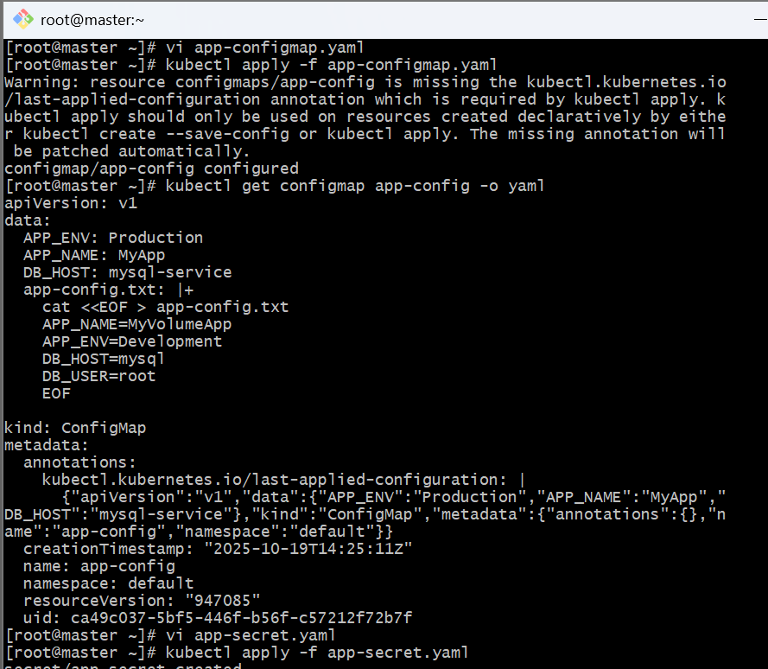

🧩 Step 2: Create a Secret
Create a file named app-secret.yaml:
apiVersion: v1
kind: Secret
metadata:
name: app-secret
type: Opaque
data:
username: YWRtaW4= # base64 for "admin"
password: TXlQQHNzdzByZA== # base64 for "MyP@ssw0rd"
Apply it:
kubectl apply -f app-secret.yaml
Verify:
kubectl get secret app-secret -o yaml

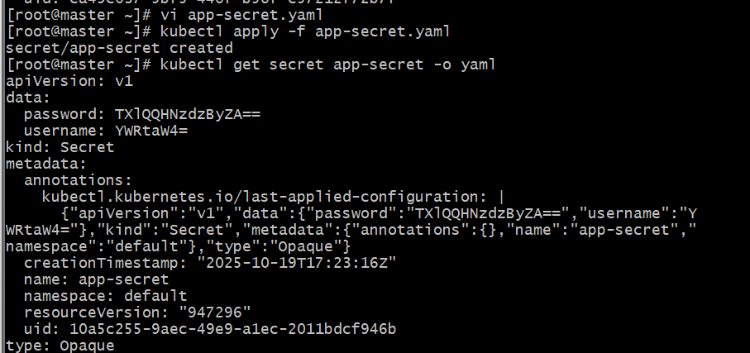

🧠 Step 3: Create a Pod using both
Now create a file named pod-config-secret.yml:
apiVersion: v1
kind: Pod
metadata:
name: config-secret-pod
spec:
containers:
- name: test-container
image: busybox
command: ["/bin/sh", "-c", "echo '--- ENV VARIABLES ---'; env | grep APP_; echo '--- SECRET FILES ---'; ls /etc/secret-data; echo '--- FILE CONTENTS ---'; cat /etc/secret-data/username; echo ''; cat /etc/secret-data/password; sleep 3600"]

# Inject ConfigMap as environment variables
envFrom:
- configMapRef:
name: app-config

# Mount Secret as files
volumeMounts:
- name: secret-volume
mountPath: "/etc/secret-data"
readOnly: true

volumes:
- name: secret-volume
secret:
secretName: app-secret

restartPolicy: Never

⚡ Step 4: Deploy the Pod
kubectl apply -f pod-config-secret.yml

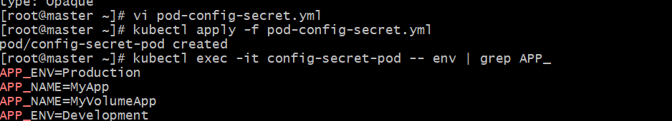

🔍 Step 5: Verify inside the Pod

Check environment variables:
kubectl exec -it config-secret-pod -- env | grep APP_

Check mounted secret files:
kubectl exec -it config-secret-pod -- ls /etc/secret-data

View file contents:
kubectl exec -it config-secret-pod -- cat /etc/secret-data/username
kubectl exec -it config-secret-pod -- cat /etc/secret-data/password

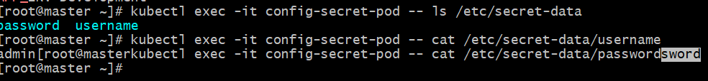

⚠️ Best Practices
- Store non-sensitive data in ConfigMaps and sensitive data in Secrets.
- Mark secret mounts as readOnly: true.
- Use RBAC and encryption at rest for Secrets.
- Don’t hardcode secrets or config data inside container images.

