Kubernetes-07
Task 1: Execute all yaml files shown in video.
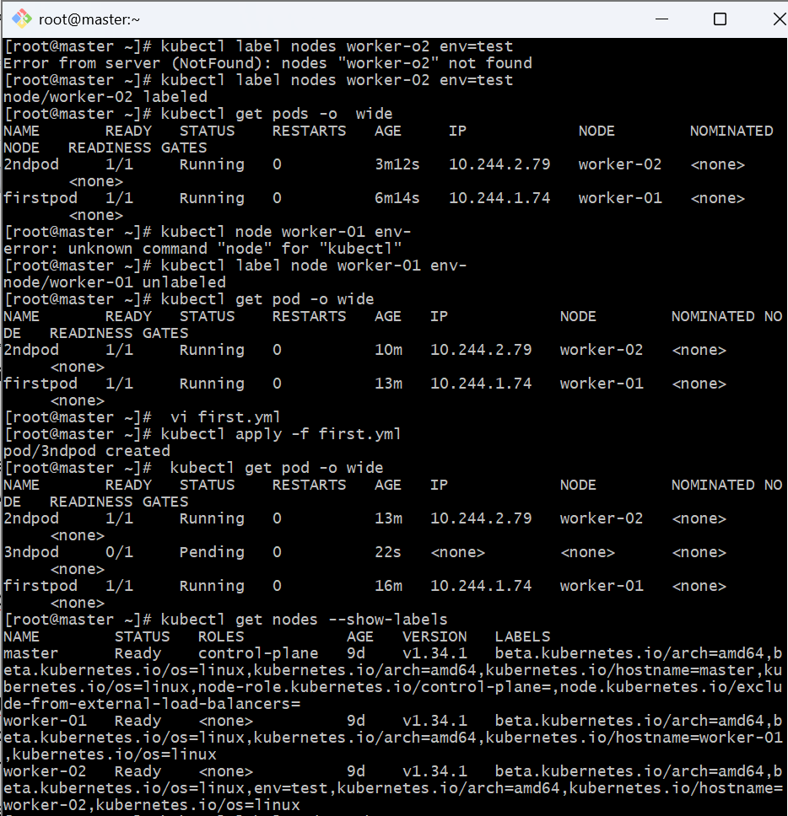
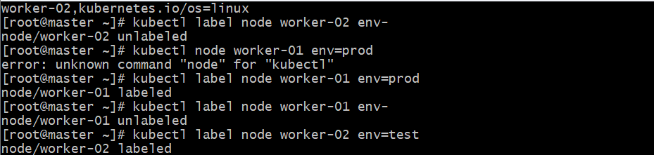

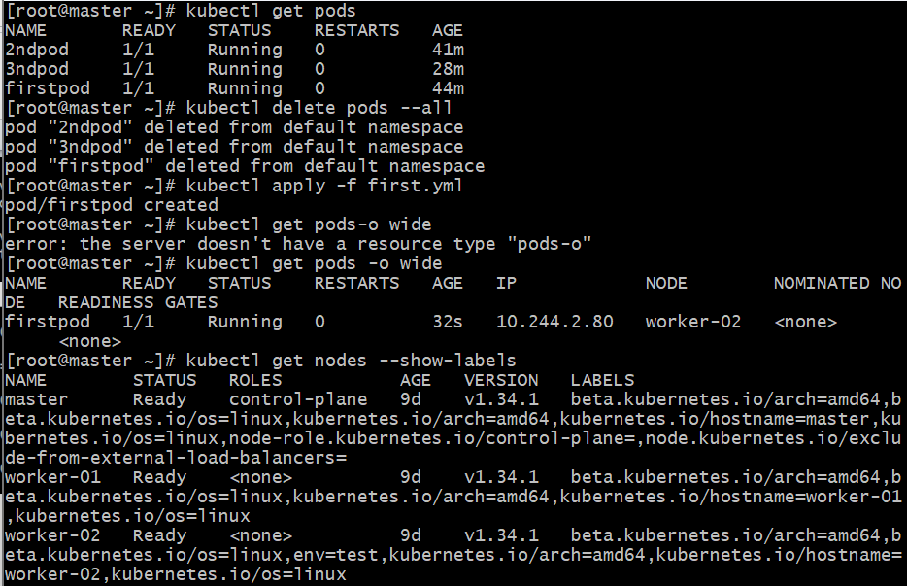
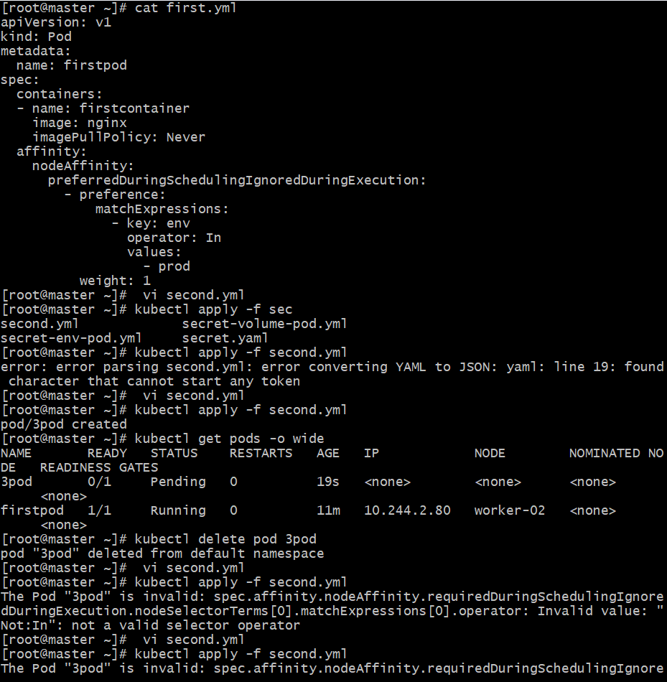
Task 2: Taint a Node and Schedule a Tolerant Pod Taint a node with special=true:NoSchedule. Create a pod with a toleration that matches the taint, allowing it to be scheduled on the tainted node.

Step 1: Taint the Node
First, list the available nodes:
kubectl get nodes
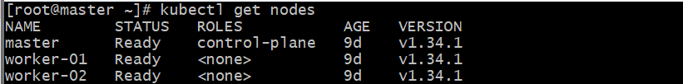
Now, taint one of the nodes (example: node2) with the taint special=true:NoSchedule.
kubectl taint nodes worker-02 special=true:NoSchedule
Explanation:
- special → Key
- true → Value
- NoSchedule → Effect (prevents pods without matching toleration from being scheduled)
You can verify the taint:
kubectl describe node worker-02 | grep Taints

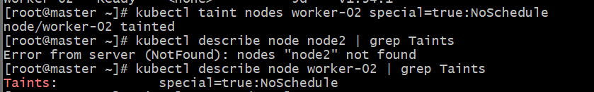

Step 2: Create a Pod with Toleration
Now, create a pod YAML file (e.g., tolerant-pod.yaml):
apiVersion: v1
kind: Pod
metadata:
name: tolerant-pod
spec:
containers:
- name: nginx
image: nginx
tolerations:
- key: "special"
operator: "Equal"
value: "true"
effect: "NoSchedule"

Step 3: Apply the Pod
kubectl apply -f tolerant-pod.yaml
Then check where the pod is scheduled:
kubectl get pod -o wide
✅ The pod should be scheduled on the tainted node (e.g., node2).
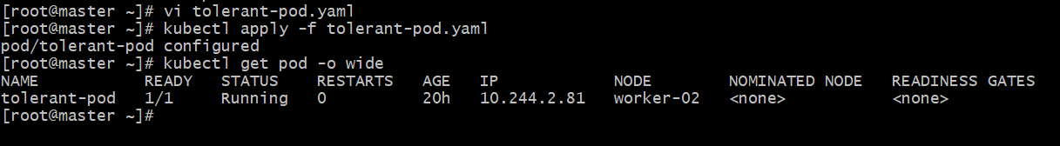

Step 5 (Optional): Remove the Taint
If you want to allow normal scheduling again:
kubectl taint nodes worker-02 special=true:NoSchedule-

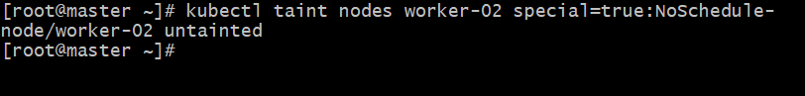
Task 3: Use NodeSelector to Schedule a Pod on a Specific Node Label a node with env=dev. Create a pod with a nodeSelector that schedules it only on the node labeled env=dev.

Goal
You will:
- Label a node with env=dev
- Create a pod with a nodeSelector that schedules it only on that labeled node.

Step 1: Check Available Nodes
kubectl get nodes

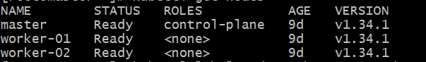

Step 2: Label a Node
Choose a node and label it as env=dev.
kubectl label node worker-01 env=dev
✅ Verify the label:
kubectl get nodes --show-labels

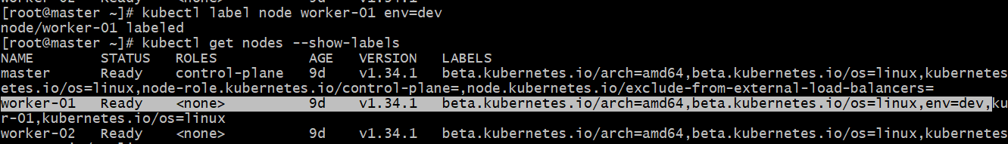

Step 3: Create a Pod with nodeSelector
Create a YAML file named node-selector-pod.yaml:
apiVersion: v1
kind: Pod
metadata:
name: dev-pod
spec:
containers:
- name: nginx
image: nginx
nodeSelector:
env: dev
✅ Explanation:
- The nodeSelector ensures this pod is scheduled only on nodes labeled env=dev.

Step 4: Apply the Pod
kubectl apply -f node-selector-pod.yaml
Check pod scheduling:
kubectl get pod -o wide

Step 5 (Optional): Remove the Label
If you want to remove the label later:
kubectl label node worker-01 env-

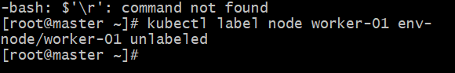
Task 4: Use Node Affinity with Soft Scheduling Label a node with env=test. Create a pod with PreferredDuringSchedulingIgnoredDuringExecution node affinity, preferring to schedule it on a node labeled env=test. Remove the label and verify the pod continues to run.

Goal
You will:
- Label a node with env=test
- Create a pod with soft node affinity (PreferredDuringSchedulingIgnoredDuringExecution)
- Remove the label and verify the pod still runs.

Step 1: Label the Node
Pick any worker node (say worker-02) and label it:
kubectl label node worker-02 env=test
✅ Verify:
kubectl get nodes --show-labels

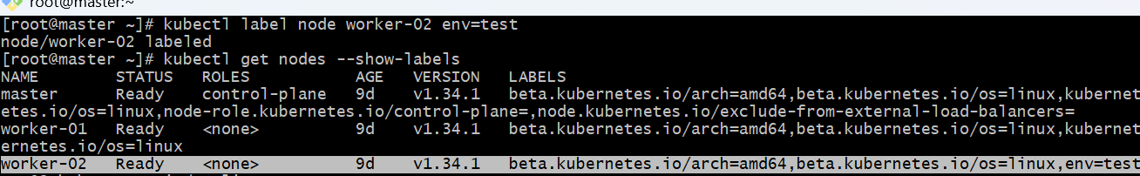

Step 2: Create a Pod with Soft Node Affinity
Create a file named affinity-pod.yaml:
apiVersion: v1
kind: Pod
metadata:
name: affinity-pod
spec:
affinity:
nodeAffinity:
preferredDuringSchedulingIgnoredDuringExecution:
- weight: 1
preference:
matchExpressions:
- key: env
operator: In
values:
- test
containers:
- name: nginx
image: nginx
✅ Explanation:
- preferredDuringSchedulingIgnoredDuringExecution → Soft rule (pod prefers a node but will still run elsewhere if not available).
- If no node with env=test is found, Kubernetes will place the pod on any other available node.

Step 3: Apply the Pod
kubectl apply -f affinity-pod.yaml
Check its node:
kubectl get pod -o wide

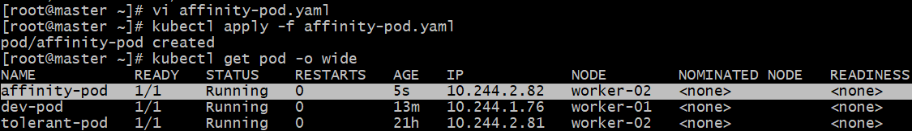
That means it honored the preferred node affinity.

Step 4: Remove the Label
Now, remove the label from the node:
kubectl label node worker-02 env-
Verify it’s gone:
kubectl get nodes --show-labels
✅ The label env=test should no longer appear.

Step 5: Verify the Pod Still Runs
Check the pod’s status again:
kubectl get pod -o wide
✅ You’ll see the pod still running on the same node.
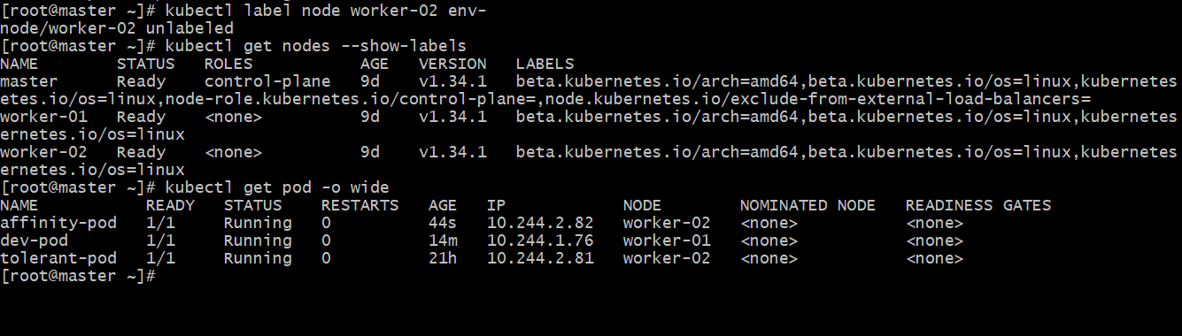
Reason:
The rule is IgnoredDuringExecution, meaning once scheduled, the pod stays there even if the label is removed late
Task 5: Implement Node Affinity with Hard Scheduling Create a pod with RequiredDuringSchedulingIgnoredDuringExecution node affinity, ensuring it will only be scheduled on a node labeled env=prod. Verify the pod cannot be scheduled if no node has the env=prod label.

Goal
You will:
- Create a pod that uses hard node affinity (requiredDuringSchedulingIgnoredDuringExecution).
- Ensure it schedules only on a node labeled env=prod.
- Verify it stays Pending when no such label exists.
- Add the label → confirm it schedules.

Step 1: Create the Pod YAML
Create a file named hard-affinity-pod.yaml:
apiVersion: v1
kind: Pod
metadata:
name: hard-affinity-pod
spec:
affinity:
nodeAffinity:
requiredDuringSchedulingIgnoredDuringExecution:
nodeSelectorTerms:
- matchExpressions:
- key: env
operator: In
values:
- prod
containers:
- name: nginx
image: nginx
Explanation:
- requiredDuringSchedulingIgnoredDuringExecution → Hard rule.
The pod will not be scheduled unless it finds a node labeled env=prod.

Step 2: Apply the Pod
kubectl apply -f hard-affinity-pod.yaml
Check pod status:
kubectl get pod -o wide
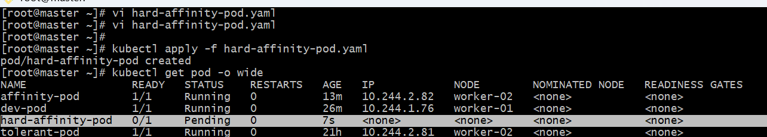

Step 3: Verify the Scheduling Failure
Describe the pod to see why it’s pending:
kubectl describe pod hard-affinity-pod

This confirms the pod cannot be scheduled because no node has the label env=prod.

Step 4: Add the Required Label
Label a node (for example worker-01) with the required key/value:
kubectl label node worker-01 env=prod
Verify:
kubectl get nodes --show-labels

Step 5: Check Pod Scheduling Again
Now that a matching node exists, the pod will automatically get scheduled:
kubectl get pod -o wide
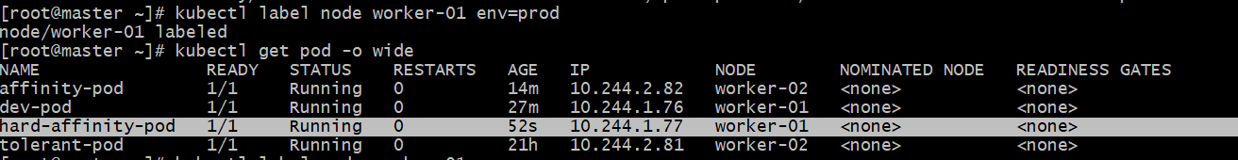

Step 6 : Test Behavior Again
If you remove the label:
kubectl label node worker-01 env-
The pod will remain running (because of IgnoredDuringExecution),
but new pods with the same spec will go Pending again.
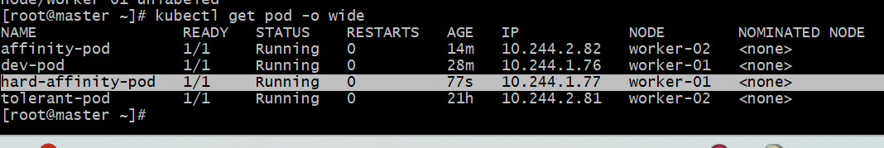
Task 6: Taint a Node and Use NoExecute with Toleration Seconds Taint a node with special=true:NoExecute. Create a pod with a tolerationSeconds field (e.g., 60 seconds) and observe it gets evicted after 60 seconds on the tainted node.

Goal
You will:
- Taint a node with special=true:NoExecute
- Create a pod that tolerates the taint only for 60 seconds
- Observe the pod gets evicted automatically after 60 seconds on that tainted node.
Step 1: Taint a Node
Choose a worker node (say worker-01) and taint it:
kubectl taint nodes worker-01 special=true:NoExecute
✅ Verify the taint:
kubectl describe node worker-01 | grep Taints

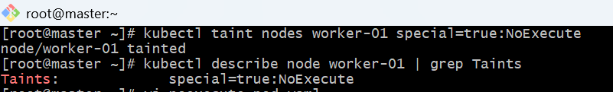

Step 2: Create a Pod with tolerationSeconds
Create a file named noexecute-pod.yaml:

apiVersion: v1
kind: Pod
metadata:
name: noexecute-pod
spec:
containers:
- name: nginx
image: nginx
tolerations:
- key: "special"
operator: "Equal"
value: "true"
effect: "NoExecute"
tolerationSeconds: 60
✅ Explanation:
- effect: NoExecute → Pods without matching toleration are immediately evicted.
- tolerationSeconds: 60 → Pod stays for 60 seconds even though the node is tainted, then gets evicted automatically.

Step 3: Apply the Pod
kubectl apply -f noexecute-pod.yaml
Then check where it is scheduled:
kubectl get pod -o wide

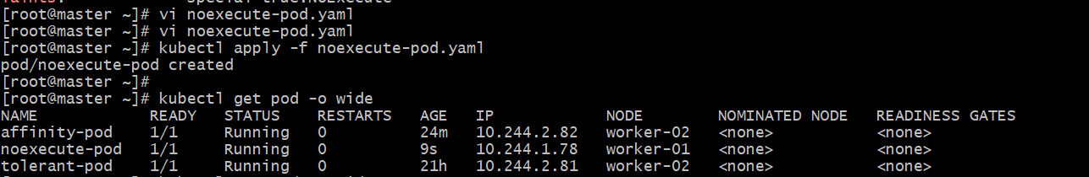

Step 4: Observe the Eviction
If you want to watch it live (to see when the pod gets evicted after 60 seconds), use:
kubectl get pods –w

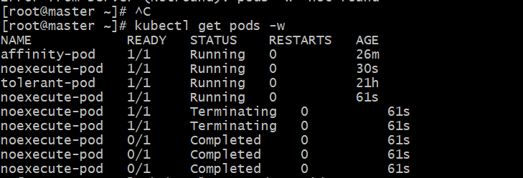
After about 60 seconds, the pod will be terminated automatically because of the NoExecute taint.
Check status again:
kubectl get pod -o wide

Step 5 : Remove the Taint
Once done, remove the taint to restore normal scheduling:
kubectl taint nodes worker-01 special=true:NoExecute-

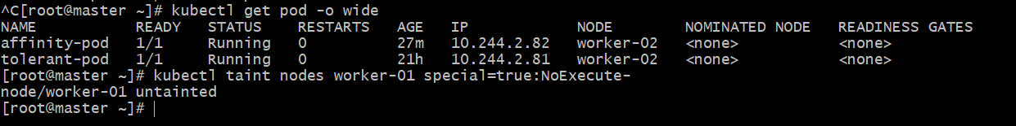
Behavior Summary
- Pods without toleration → immediately evicted
- Pods with tolerationSeconds → stay for given time, then evicted
- Pods with permanent toleration (no tolerationSeconds) → remain running indefinitely

