Kubernetes-08
1.Create and Test a Kubernetes Pod with an EmptyDir Volume

Task:
Create and Test a Kubernetes Pod with an emptyDir volume
An emptyDir volume is a temporary directory that is created when a pod is assigned to a node and exists as long as that pod is running.
When the pod is deleted, the emptyDir is also deleted — it’s often used for temporary storage, caching, or data sharing between containers in the same pod.
Step 1: Create the YAML file
Create a file named emptydir-pod.yaml
apiVersion: v1
kind: Pod
metadata:
name: emptydir-demo
spec:
containers:
- name: writer
image: busybox
command: ["/bin/sh", "-c"]
args: ["echo 'Hello from writer!' > /data/hello.txt && sleep 3600"]
volumeMounts:
- name: shared-data
mountPath: /data

- name: reader
image: busybox
command: ["/bin/sh", "-c"]
args: ["sleep 3600"]
volumeMounts:
- name: shared-data
mountPath: /data

volumes:
- name: shared-data
emptyDir: {}
Hello from writer!
2 Check the reader container

bash
Copy code
kubectl exec -it emptydir-demo -c reader -- sh
Then run:
cat /data/hello.txt
✅ You should see the same content, proving the data is shared via emptyDir.

Step 4: Cleanup
Once done, delete the pod:
kubectl delete pod emptydir-demo
Check:
kubectl get pods
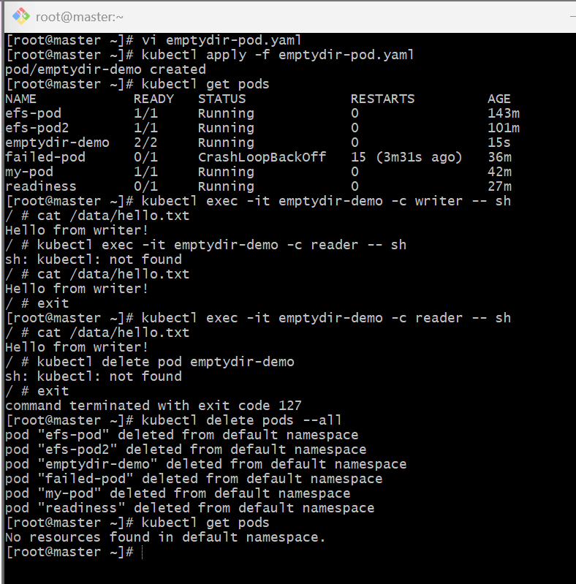
The pod and the emptyDir volume will be deleted.
✅ Summary
emptyDir is created when the pod starts and deleted when the pod stops.
Useful for temporary data or container-to-container communication within a pod.
All containers in a pod can share it through volumeMounts.

2.Configure a HostPath Volume in Kubernetes and Validate Data Persistence

Objective
You’ll create a Kubernetes Pod that uses a HostPath volume — which maps a directory from the node’s filesystem into the Pod.
This allows data to persist on the node even after the Pod is deleted.

📘 Step 1: Create the YAML file
Create a file named hostpath-pod.yaml and add the following content:
apiVersion: v1
kind: Pod
metadata:
name: hostpath-demo
spec:
containers:
- name: app
image: busybox
command: ["/bin/sh", "-c"]
args: ["while true; do sleep 3600; done"]
volumeMounts:
- name: hostpath-storage
mountPath: /data
volumes:
- name: hostpath-storage
hostPath:
path: /mnt/hostdata
type: DirectoryOrCreate

Step 2: Apply the Pod
Run:
kubectl apply -f hostpath-pod.yaml
Check status:
kubectl get pods
Wait until it’s in the Running state.
Step 3: Test Data Persistence
1 Write data inside the Pod
kubectl exec -it hostpath-demo -- sh
Inside the container:
echo "Hello from HostPath volume" > /data/testfile.txt
ls /data
cat /data/testfile.txt
✅ Output should be:
Hello from HostPath volume
Exit:
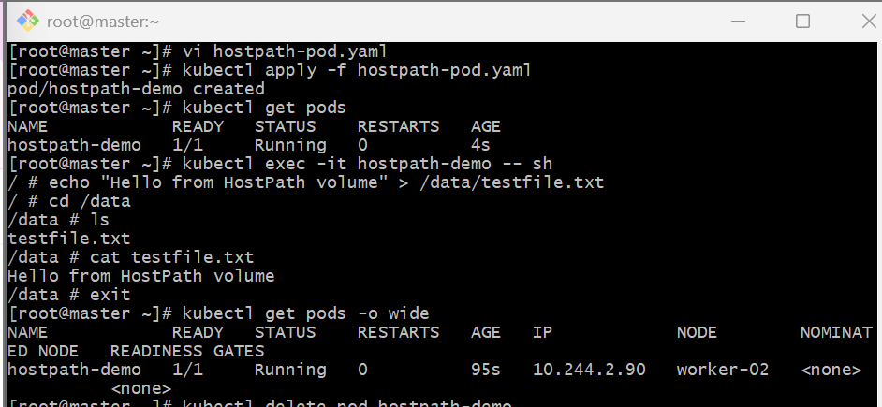
Check the data on the Node worker
SSH into your Kubernetes node (if using Minikube, run: minikube ssh):
sudo cat /mnt/hostdata/testfile.txt
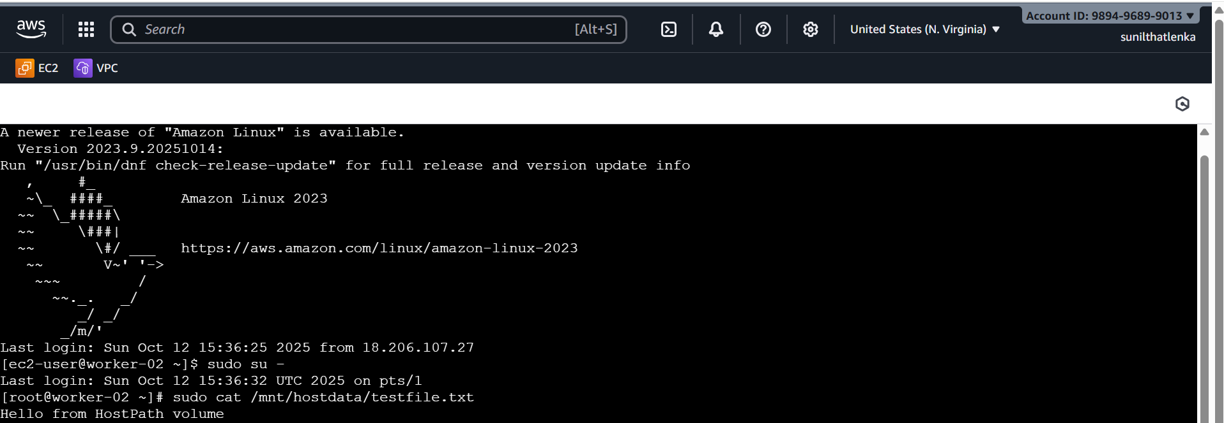

Step 4: Delete the Pod
Now delete the Pod:
kubectl delete pod hostpath-demo
Check:
kubectl get pods
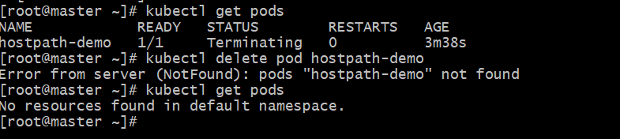

Step 5: Validate Data Persistence
Even though the Pod is deleted, the file still exists on the node’s host path.
SSH into your node again:
sudo cat /mnt/hostdata/testfile.txt
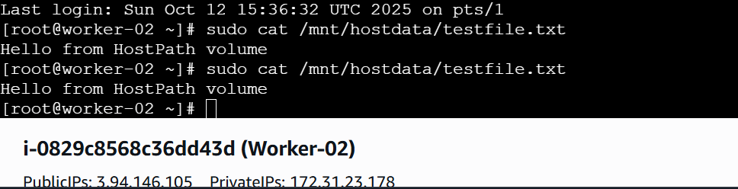
The file remains — proving data persistence because HostPath maps directly to the node’s storage.

3.Deploy an Amazon EBS Volume Using Persistent Volume and Persistent Volume Claim (PVC)

Objective
You’ll create and attach an EBS volume in AWS, expose it in Kubernetes as a Persistent Volume (PV), claim it using a PVC, and finally mount it in a Pod to validate that it works.

Step 1: Prerequisites
Before we start, make sure you have:
- A running Kubernetes cluster
- Worker nodes in the same Availability Zone (AZ) as the EBS volume

🪣 Step 2: Create an Amazon EBS Volume
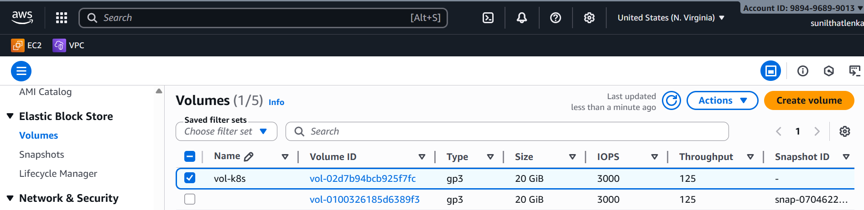

Step 3: Create the Persistent Volume (PV)
Create a file called ebs-pv.yaml:
apiVersion: v1
kind: PersistentVolume
metadata:
name: ebs-pv
spec:
capacity:
storage: 5Gi
volumeMode: Filesystem
accessModes:
- ReadWriteOnce
persistentVolumeReclaimPolicy: Retain
storageClassName: manual
awsElasticBlockStore:
volumeID: vol-0abcd1234efgh5678 # Replace with your actual EBS volume ID
fsType: ext4
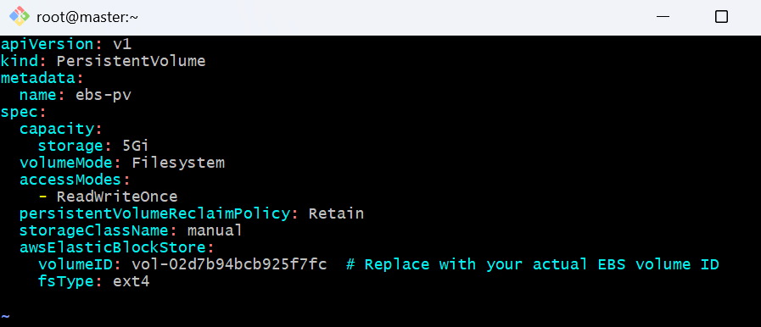

Step 4: Create the Persistent Volume Claim (PVC)
Create ebs-pvc.yaml:
apiVersion: v1
kind: PersistentVolumeClaim
metadata:
name: ebs-pvc
spec:
accessModes:
- ReadWriteOnce
storageClassName: manual
resources:
requests:
storage: 5Gi

Step 5: Apply PV and PVC
kubectl apply -f ebs-pv.yaml
kubectl apply -f ebs-pvc.yaml
Check their status:
kubectl get pv,pvc

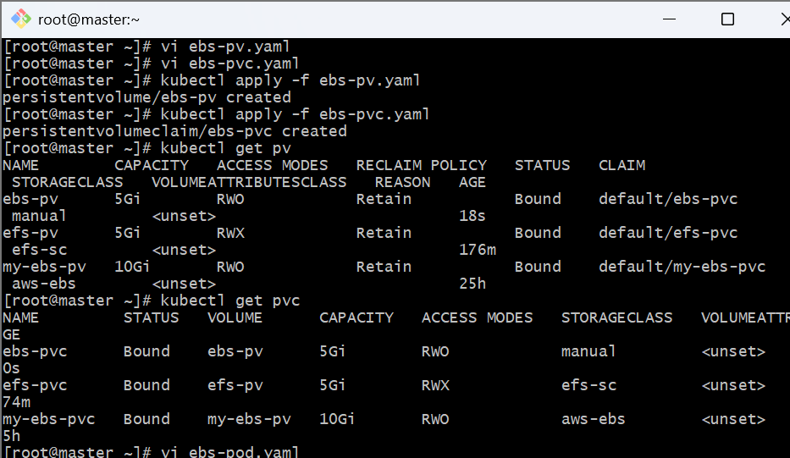

Step 6: Create a Pod Using the PVC
Create ebs-pod.yaml:
apiVersion: v1
kind: Pod
metadata:
name: ebs-app
spec:
containers:
- name: app
image: busybox
command: ["/bin/sh", "-c"]
args: ["echo 'Hello from EBS Volume' > /data/hello.txt && sleep 3600"]
volumeMounts:
- name: ebs-storage
mountPath: /data
volumes:
- name: ebs-storage
persistentVolumeClaim:
claimName: ebs-pvc

Step 7: Apply and Verify
Apply the Pod:
kubectl apply -f ebs-pod.yaml
Check if it’s running:
kubectl get pods
Access the container:
kubectl exec -it ebs-app -- sh
Check file content:
cat /data/hello.txt
✅ Output:
Hello from EBS Volume
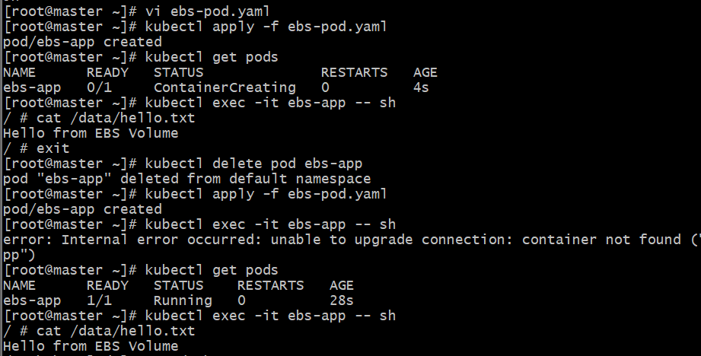

Step 8: Test Persistence
Now delete the pod:
kubectl delete pod ebs-app



Create another pod that uses the same PVC — you’ll still find the file /data/hello.txt.
That’s because the EBS volume persists beyond the pod lifecycle.

4.Set Up an Amazon EFS Volume and Attach it to Multiple Pods
If we have multinode k8s cluster,then in this case we need to keep our volume outside the cluster.
If our pod is created on other node then the volume should also be moved to that node.
We have already setup our 3 node k8s cluster.
1) Login to aws and create on efs volume.

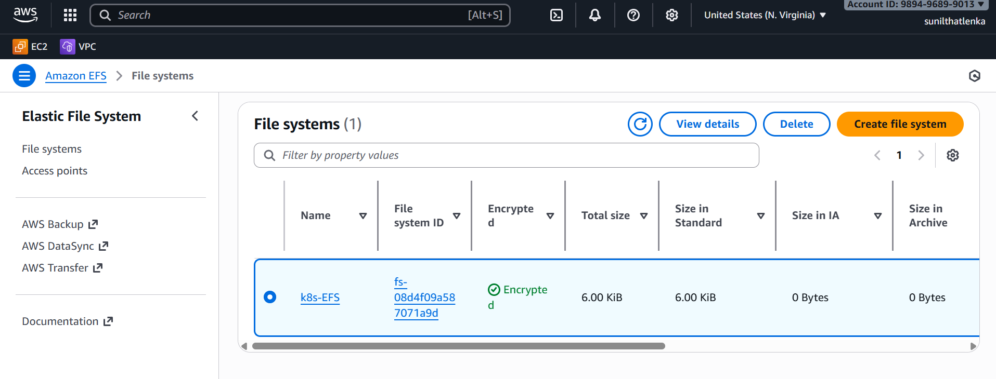
2) Create one access point to your efs volume.

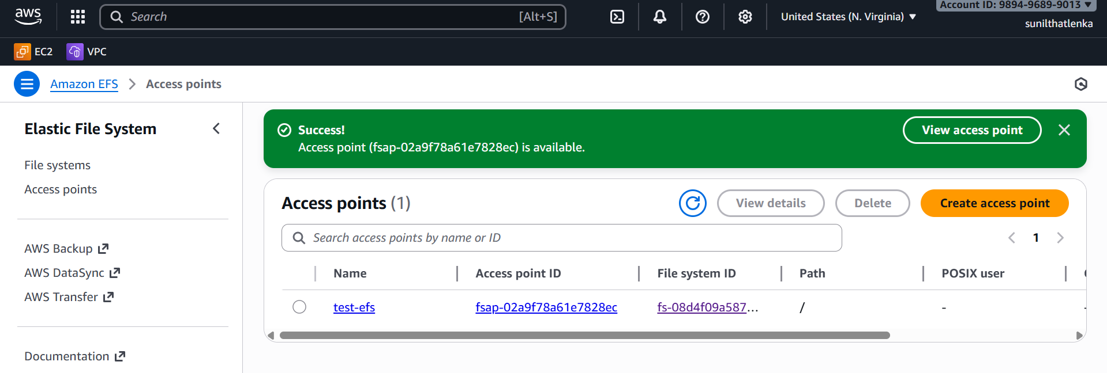
3)Install AWS EFS CSI driver on k8s master node.
#) git clone https://github.com/kubernetes-sigs/aws-efs-csi-driver.git
Apply the CSI Driver Manifests: Navigate to the cloned repository and apply the
Kubernetes manifests using the kubectl apply command:

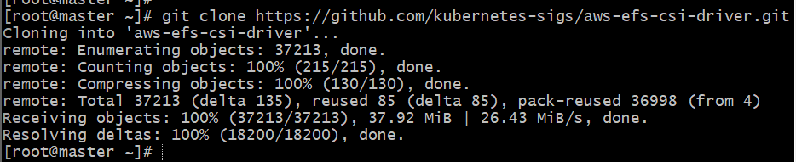
cd aws-efs-csi-driver/deploy/kubernetes/overlays/stable/
# kubectl apply -k .
verify the installation.
#kubectl get pods -n kube-system -l app=efs-csi-controller
#kubectl get pods -n kube-system -l app=efs-csi-node

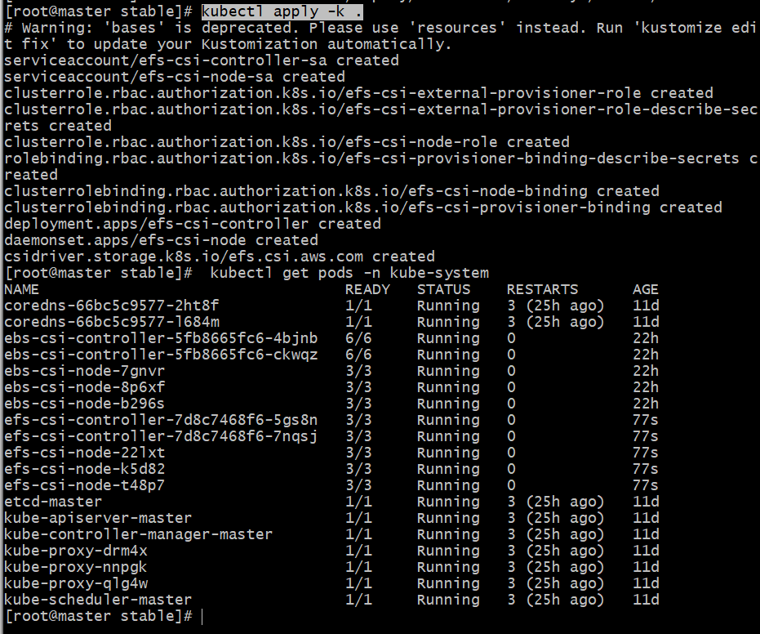

Create EFS Provisioner Storage Class: To dynamically provision EFS volumes,
you need to create a StorageClass that uses the EFS CSI driver.
storageclass.yaml
=================
apiVersion: storage.k8s.io/v1
kind: StorageClass
metadata:
name: efs-sc
provisioner: efs.csi.aws.com

kubectl apply -f storageclass.yaml #To create storage class

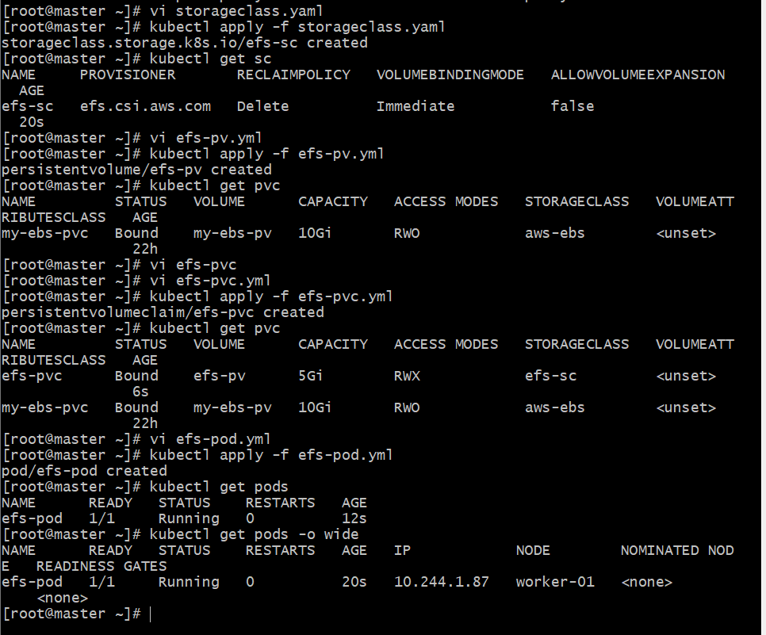
4) Now we need to create one Persistent volume for our EFS.

apiVersion: v1
kind: PersistentVolume
metadata:
name: efs-pv
spec:
capacity:
storage: 5Gi
accessModes:
- ReadWriteMany
persistentVolumeReclaimPolicy: Retain
storageClassName: efs-sc #storage class name
csi:
driver: efs.csi.aws.com #Efs csi driver name
volumeHandle: <efs-file-system-id>::<efs-access-point-id> #file system id and access point id

kubectl apply -f pv.yaml #to create PV

5) We need to create on claim for Persistent volume (PVC) for our EBS.

apiVersion: v1
kind: PersistentVolumeClaim
metadata:
name: efs-pvc
spec:
accessModes:
- ReadWriteMany
storageClassName: efs-sc
resources:
requests:
storage: 5Gi

kubectl apply -f pvc.yaml #to create PVC


6) Create pod with PVC.

apiVersion: v1
kind: Pod
metadata:
name: efs-pod
spec:
containers:
- name: my-app
image: nginx
volumeMounts:
- name: efs-volume
mountPath: /efs-mount #mount directory inside filesystem
volumes:
- name: efs-volume
persistentVolumeClaim:
claimName: efs-pvc #PVC name

kubectl apply -f pod.yaml #To create pod with pv

How to test:
1) Create one pod and login to pod and create some random files in efs-mount directory.
2) Create one more pod and check if the files are available or not
Note:
Here we can map multiple pods to same EFS volume.

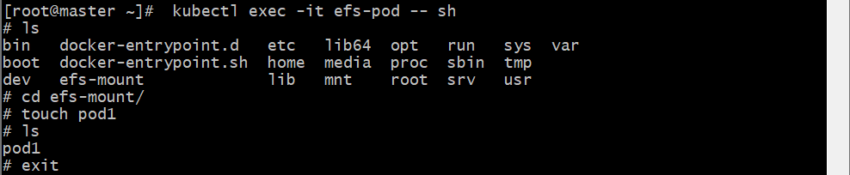
3) We can now connect multiple pods to same volume.

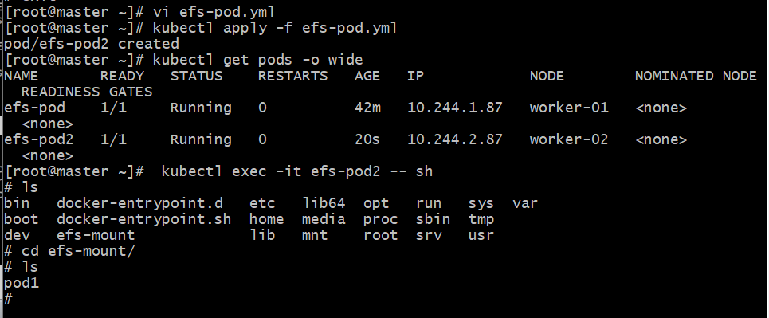
5.Implement and Test Liveness and Readiness Probes in a Kubernetes Pod
Liveness Probe:
==============
Liveness can use with pod configuration to check the health status of pod.
If pod in not healthy for any reason then Liveness will restart the pod.

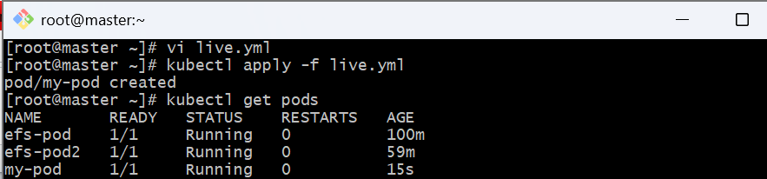

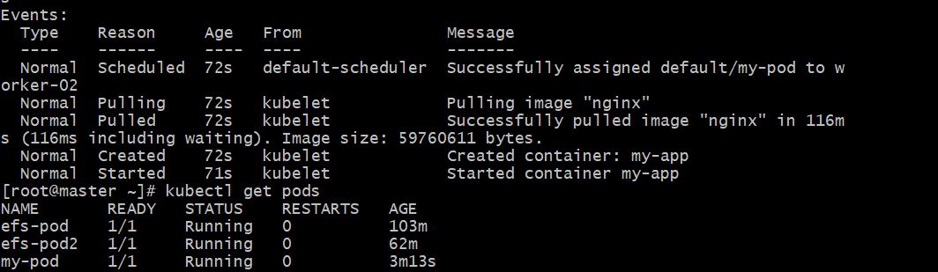

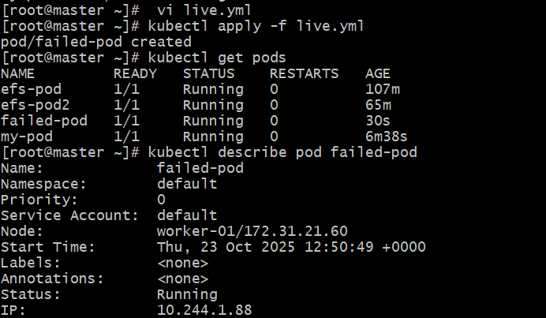
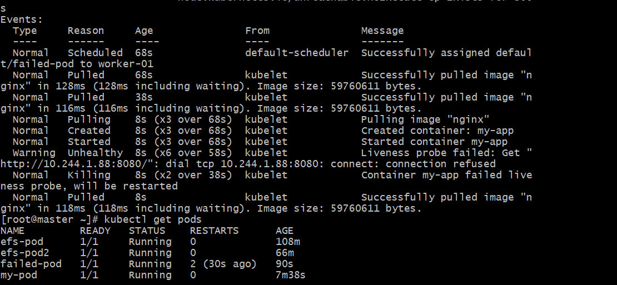
Readiness
