Kubernetes-10 [EKS]
1.Setup eks cluster using eksctl
a) Install Chocolatey (if not already installed): Open PowerShell as Administrator and run:
Set-ExecutionPolicy Bypass -Scope Process -Force; [System.Net.ServicePointManager]::SecurityProtocol = [System.Net.ServicePointManager]::SecurityProtocol -bor 3072; iex ((New-Object System.Net.WebClient).DownloadString('https://chocolatey.org/install.ps1'))

b) Install eksctl using Chocolatey:
choco install eksctl –y

Verify installation
After install completes, confirm:
eksctl version

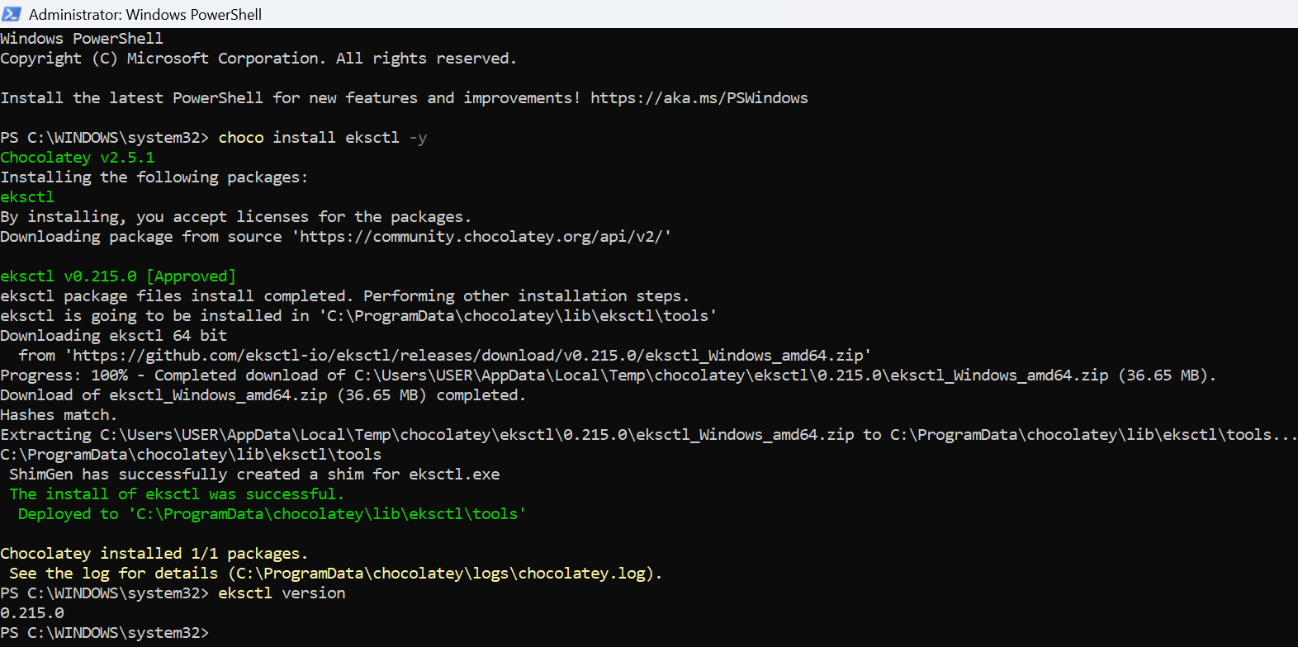

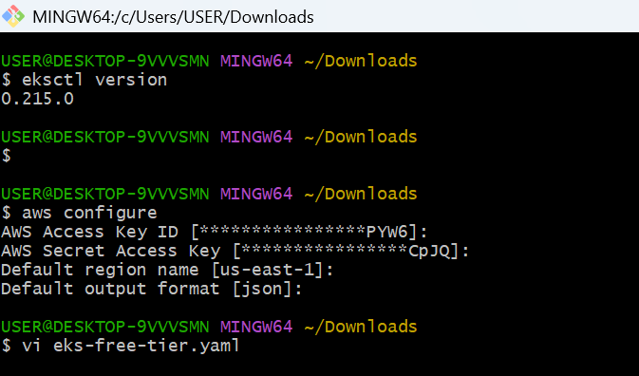
Setup EKS cluster using below yaml file:
########################################
filename: eks-free-tier.yaml
==============================
apiVersion: eksctl.io/v1alpha5
kind: ClusterConfig

metadata:
name: free-tier-eks
region: us-east-1
version: "1.28"

vpc:
clusterEndpoints:
publicAccess: true
privateAccess: false
publicAccessCidrs:
- 0.0.0.0/0 # Replace with your IP for security

nodeGroups:
- name: free-tier-nodes
instanceType: t3.small
desiredCapacity: 2
minSize: 2
maxSize: 3
volumeSize: 20
iam:
withAddonPolicies:
autoScaler: true
ebs: true
albIngress: true

Execute below command to create cluster:
########################################
eksctl create cluster -f eks-free-tier.yaml

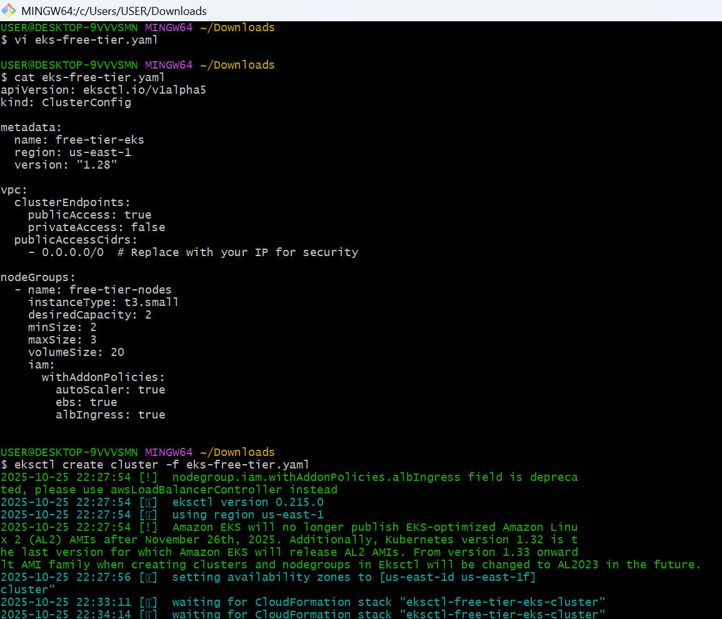
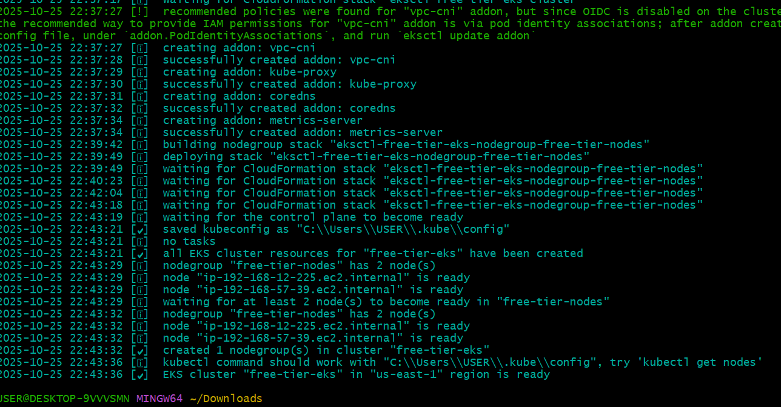

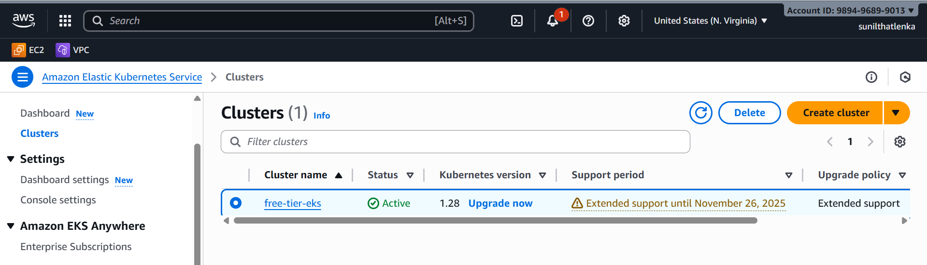

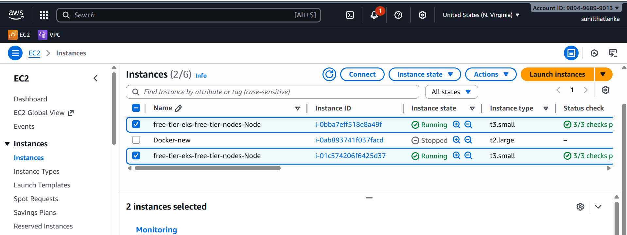

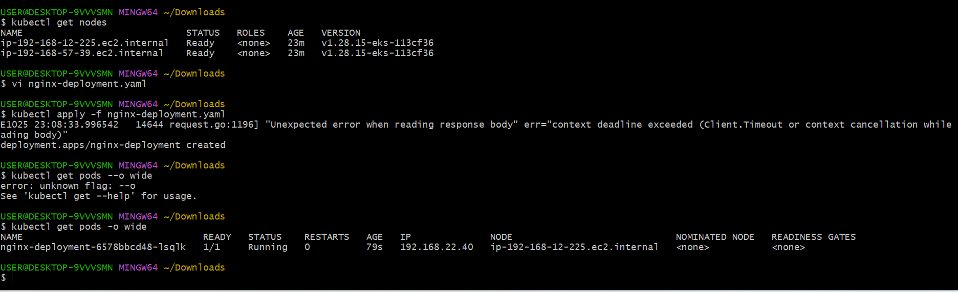

3.Setup HPA
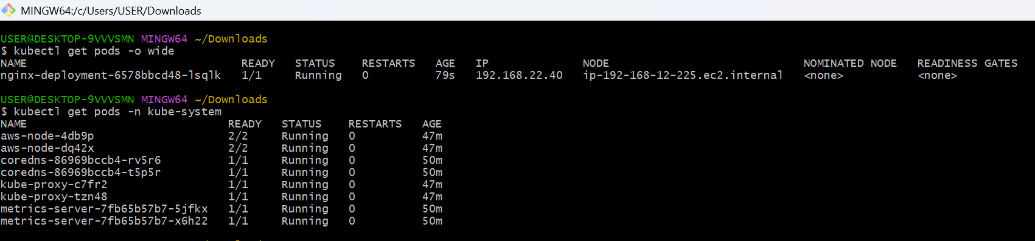

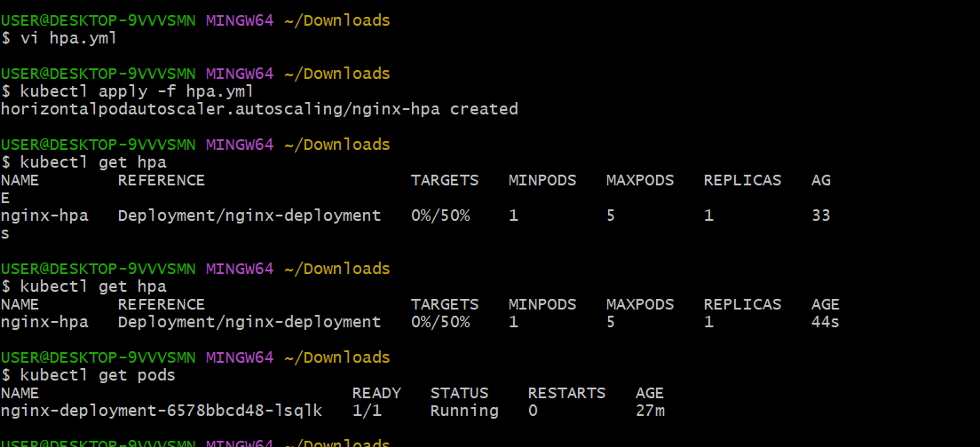

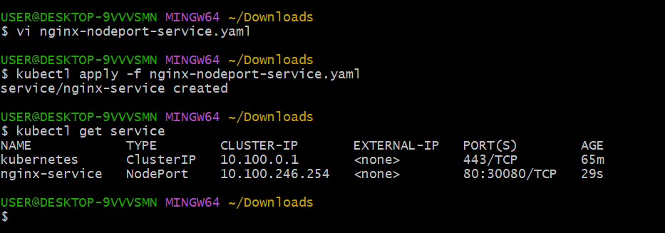
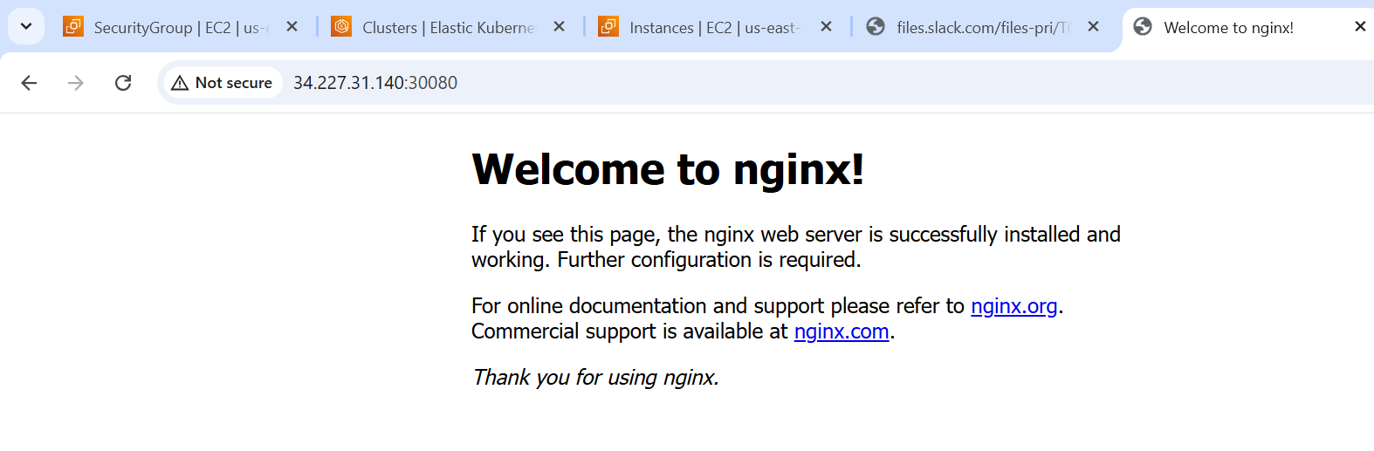
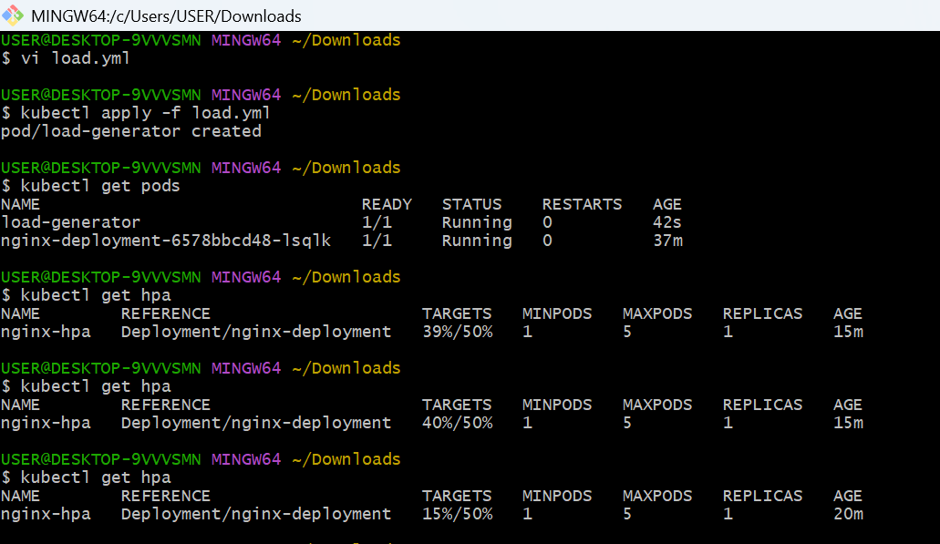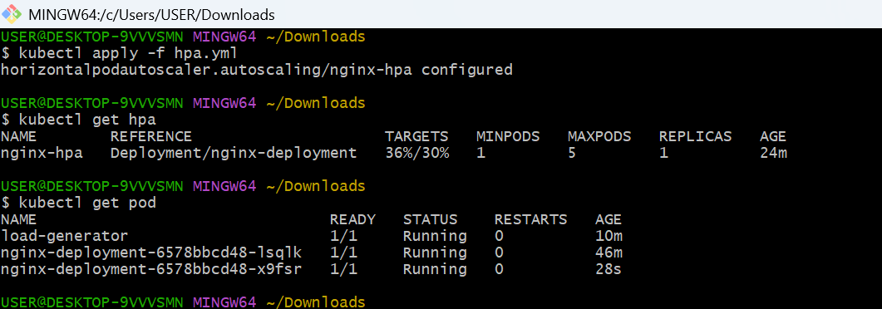

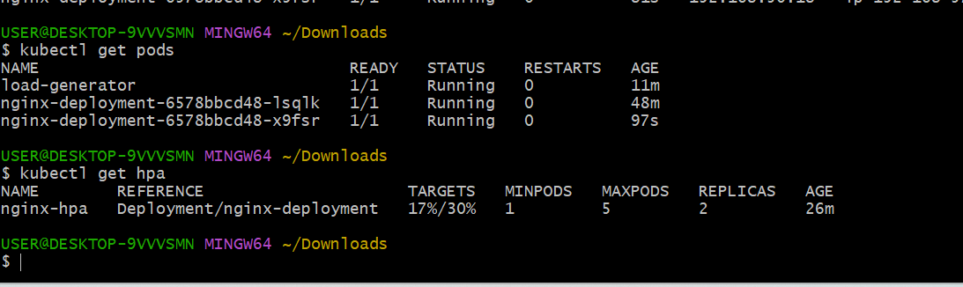

Load deleted then pods automatically reduce
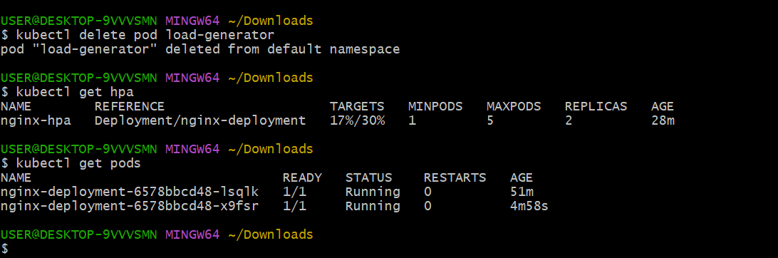

4.Setup cluster autoscale
CLuster Autoscaler:
###################
This will help you to scale number of worker nodes based on pending pods.

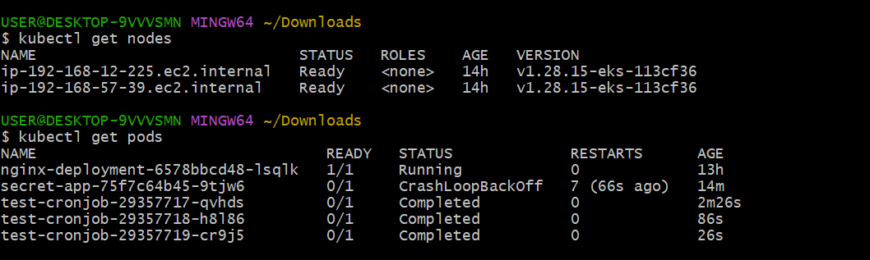
How to setup:
############
1) Get the name of autoscaling group.
# aws autoscaling describe-auto-scaling-groups --query "AutoScalingGroups[*].AutoScalingGroupName" --output table

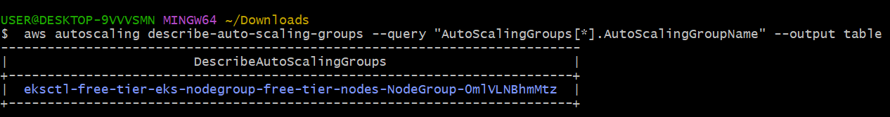

2) update the tags with name and execute below command.
# aws autoscaling create-or-update-tags --tags \
ResourceId=<ASG_NAME>,ResourceType=auto-scaling-group,Key=k8s.io/cluster-autoscaler/enabled,Value=true,PropagateAtLaunch=true \
ResourceId=<ASG_NAME>,ResourceType=auto-scaling-group,Key=k8s.io/cluster-autoscaler/medium-eks-cluster,Value=owned,PropagateAtLaunch=true

{k8s.io/cluster-autoscaler/enabled: Tells CA to manage this ASG.
k8s.io/cluster-autoscaler/<cluster-name>: Helps CA discover this node group.}

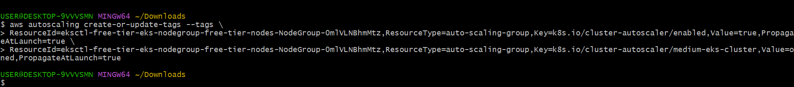

3) create iam policy for cluster autoscaling.
Policy name: AmazonEKSClusterAutoscalerPolicy
{
"Version": "2012-10-17",
"Statement": [
{
"Effect": "Allow",
"Action": [
"ec2:DescribeInstances",
"ec2:DescribeInstanceTypes",
"ec2:DescribeRegions",
"ec2:DescribeAvailabilityZones",
"ec2:DescribeSpotPriceHistory",
"ec2:DescribeSecurityGroups",
"ec2:DescribeKeyPairs",
"ec2:RunInstances",
"ec2:TerminateInstances",
"ec2:DescribeInstanceStatus",
"ec2:DescribeLaunchTemplateVersions",
"ec2:DescribeLaunchTemplates",
"ec2:DescribeImages",
"ec2:CreateTags",
"ec2:DescribeTags",
"autoscaling:DescribeAutoScalingGroups",
"autoscaling:DescribeLaunchConfigurations",
"autoscaling:UpdateAutoScalingGroup",
"autoscaling:DescribeScalingActivities",
"autoscaling:DescribeTags",
"autoscaling:SetDesiredCapacity",
"autoscaling:TerminateInstanceInAutoScalingGroup"
],
"Resource": "*"
}
]
}

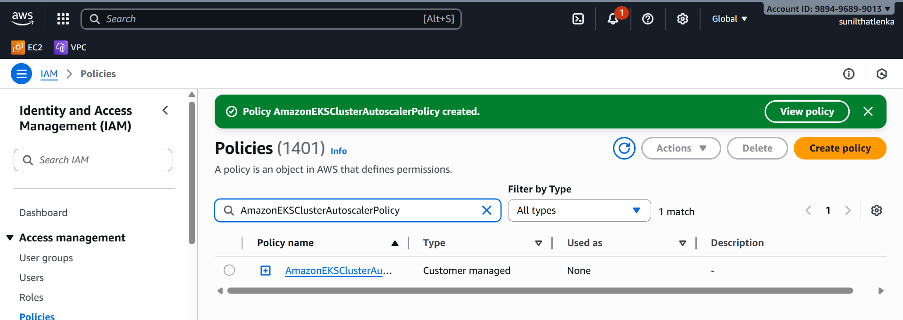
4) setup IAM Service Account for Cluster Autoscaler
eksctl create iamserviceaccount \
--cluster <your-cluster-name> \
--namespace kube-system \
--name cluster-autoscaler \
--attach-policy-arn arn:aws:iam::<AWS_ACCOUNT_ID>:policy/AmazonEKSClusterAutoscalerPolicy \
--approve
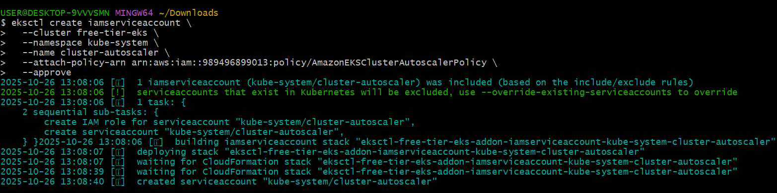
5) Install Cluster Autoscaler in the EKS Cluster
kubectl apply -f https://raw.githubusercontent.com/kubernetes/autoscaler/cluster-autoscaler-1.29.0/cluster-autoscaler/cloudprovider/aws/examples/cluster-autoscaler-autodiscover.yaml
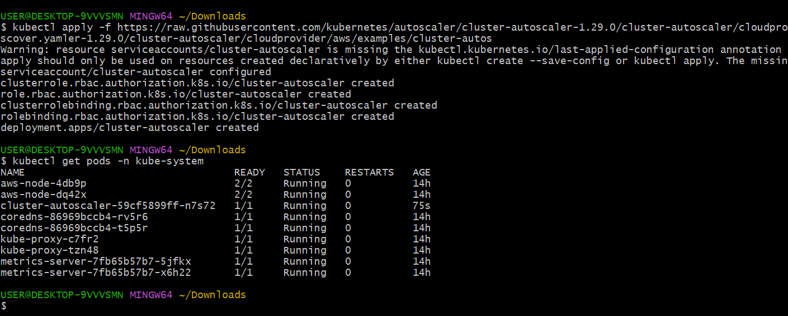

6)Once the Cluster Autoscaler is deployed, you'll need to patch the deployment to ensure it's properly configured with your cluster name and the right settings.
kubectl -n kube-system edit deployment.apps/cluster-autoscaler
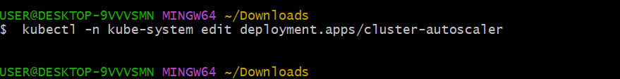
Replace with your cluster name either in args or command under container specifications.

7) Verify the Deployment by checking logs.
kubectl -n kube-system logs deployment/cluster-autoscaler

8) Test the Autoscaler by Creating a High Resource Demand
Create a test deployment with name test-deployment.yaml
apiVersion: apps/v1
kind: Deployment
metadata:
name: test-deployment
spec:
replicas: 5
selector:
matchLabels:
app: test
template:
metadata:
labels:
app: test
spec:
containers:
- name: test-container
image: nginx
resources:
requests:
cpu: "500m"
memory: "512Mi"
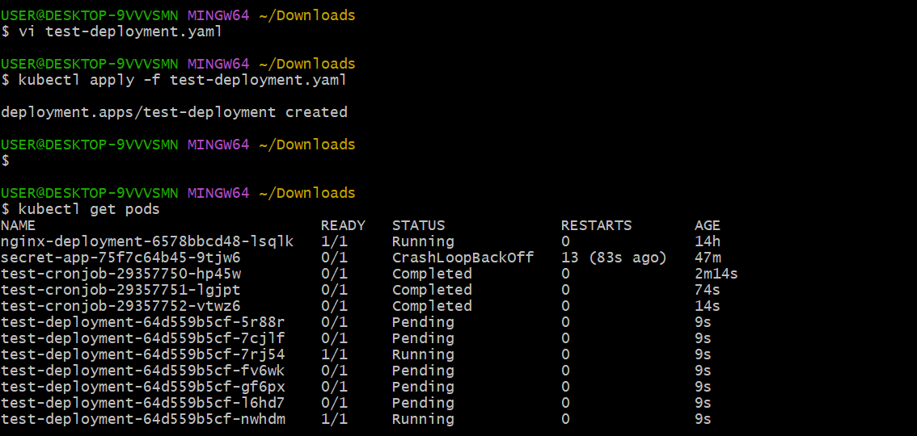

5.Setup cronjob and job
#########
THis wil help you to execute a job based on schedule.

How to setup:
############
Create one cronjob.yaml
#######################
apiVersion: batch/v1
kind: CronJob
metadata:
name: test-cronjob
namespace: default
spec:
# Cron schedule: “* * * * *” = every minute
schedule: "*/1 * * * *"
# Optional: limit number of successful/failed history
successfulJobsHistoryLimit: 3
failedJobsHistoryLimit: 1
jobTemplate:
spec:
template:
spec:
restartPolicy: OnFailure
containers:
- name: date-printer
# Lightweight image that has “date”
image: busybox:1.35
args:
- /bin/sh
- -c
- date; echo "Hello from EKS CronJob"

Run cronjob: kubectl apply -f cronjob.yaml
How to test: kubectl get cronjob
and check logs to see date: kubectl get pods and check logs

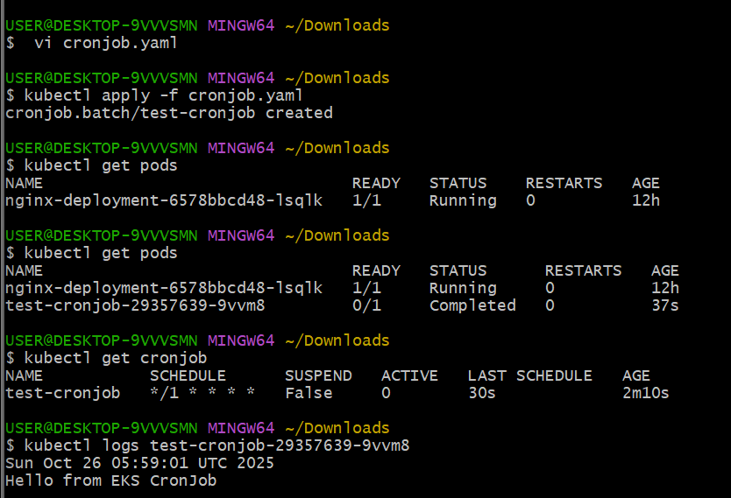

6.Create secret and inject inside pod
1) Create secret with name db-credentials in secret manager service.

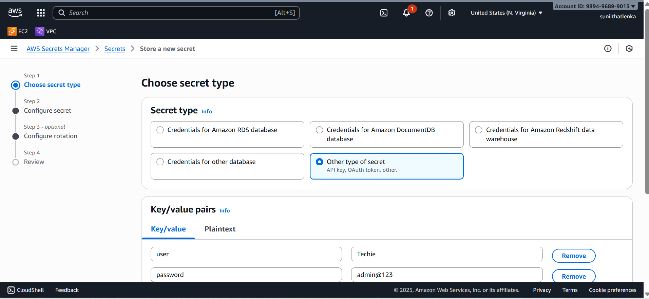

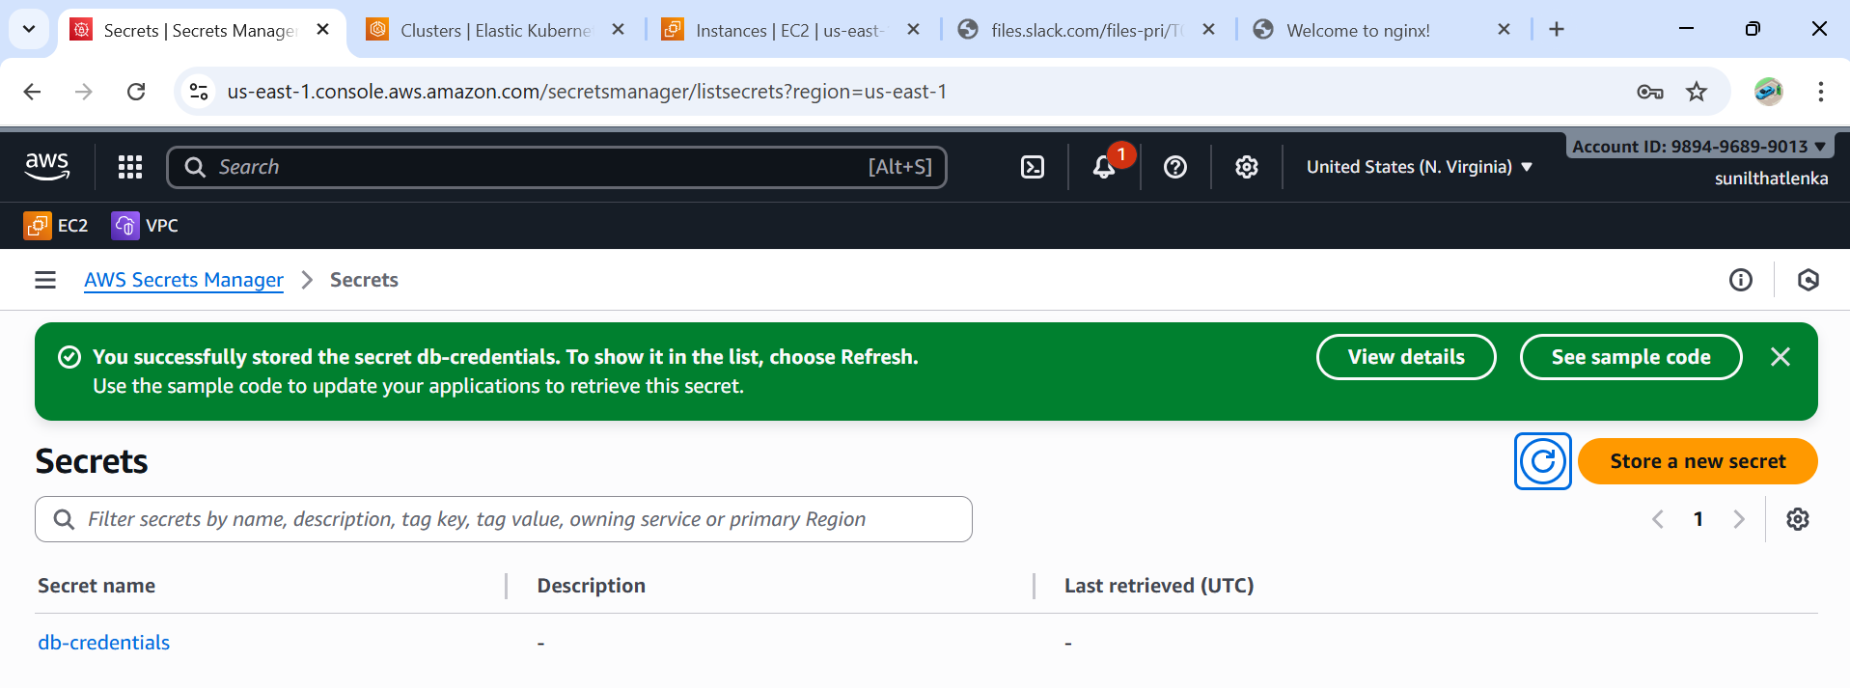

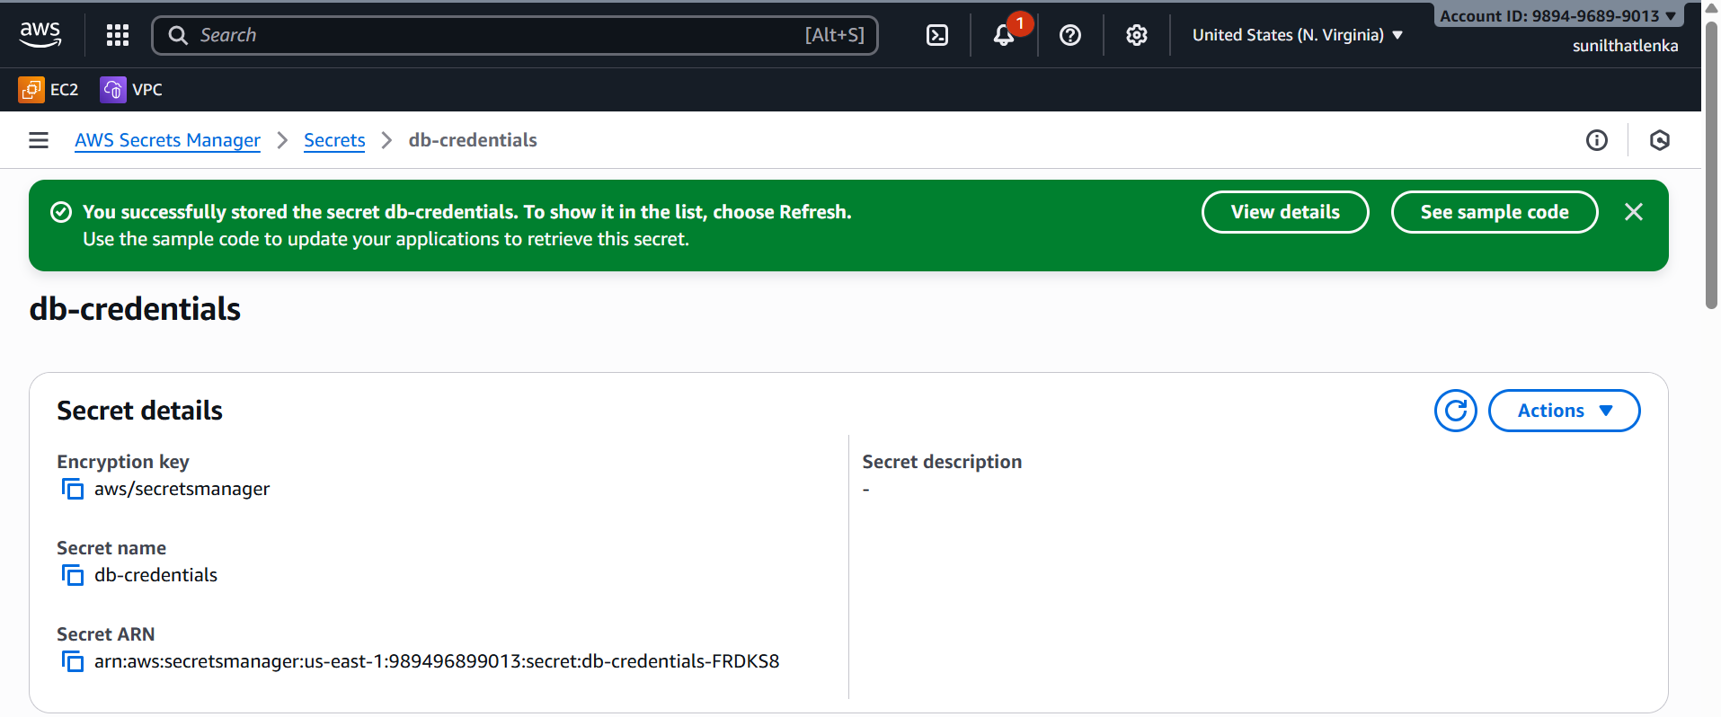

2) Enable OIDC (Open id connect) Provider for EKS.
OIDC will help us to check the token provided for eks to trust the identity of pod.
3) create OIDC connector for cluster using ekstl.
eksctl utils associate-iam-oidc-provider \
--region <your-region> \
--cluster <your-cluster-name> \
--approve

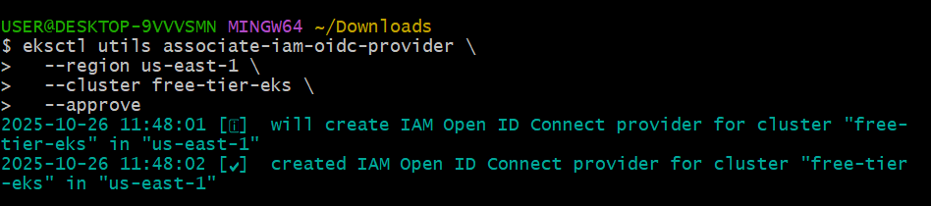
aws eks describe-cluster --name free-tier-eks --region us-east-1 --query "cluster.identity.oidc.issuer" --output text
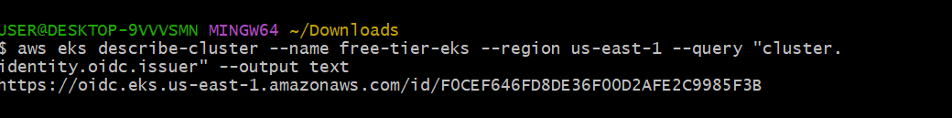
4) Create iam policy using below json template.
{
"Version": "2012-10-17",
"Statement": [{
"Effect": "Allow",
"Action": ["secretsmanager:GetSecretValue"],
"Resource": "arn:aws:secretsmanager:us-east-1:915992498174:secret:db-credentials*"
}]
}

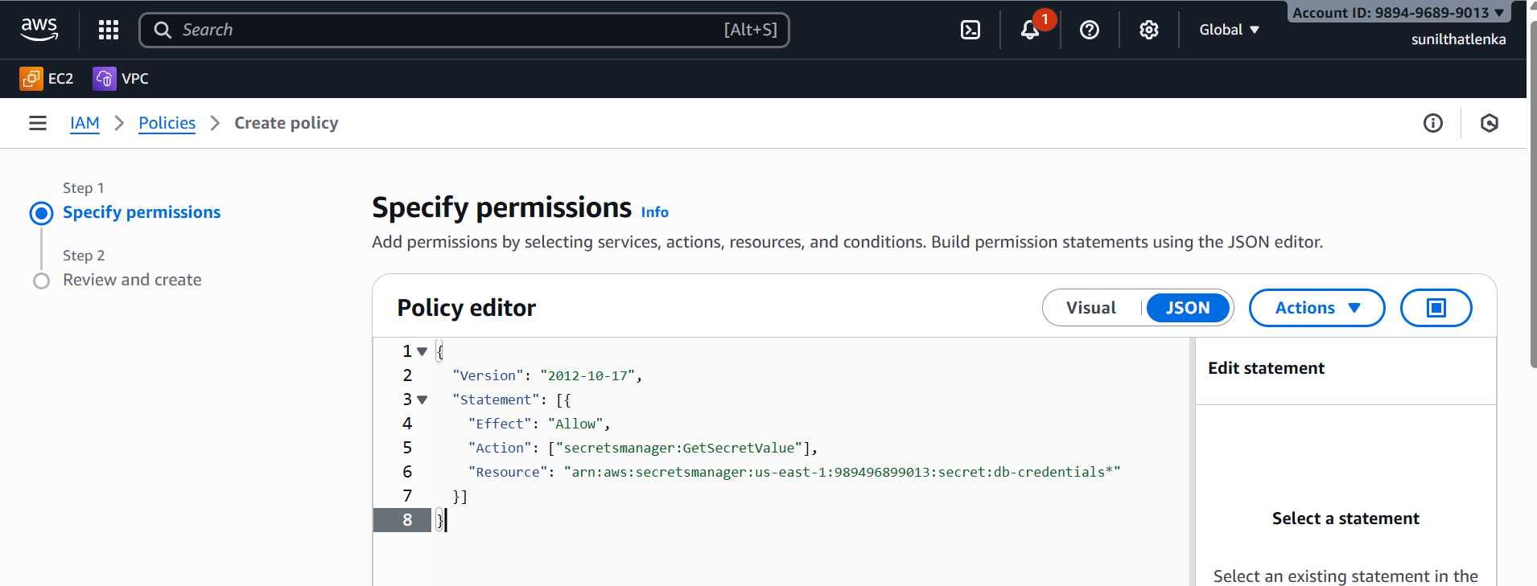
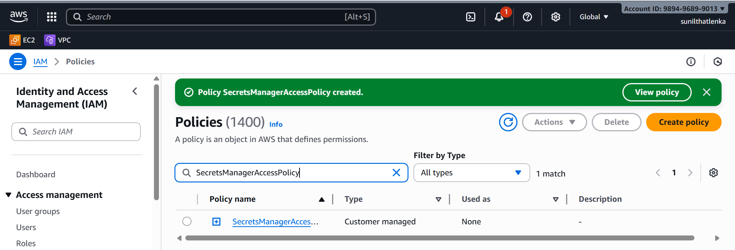

5) Create one role with custom trust policy using below json format and attach the policy created in step 4.

{
"Version": "2012-10-17" ,
"Statement": [{
"Effect": "Allow",
"Principal": {
"Federated": "arn:aws:iam::989496899013:oidc-provider/oidc.eks.us-east-1.amazonaws.com/id/F0CEF646FD8DE36F00D2AFE2C9985F3B"
},
"Action": "sts:AssumeRoleWithWebIdentity",
"Condition": {
"StringEquals": {
"oidc.eks.us-east-1.amazonaws.com/id/F0CEF646FD8DE36F00D2AFE2C9985F3B:sub": "system:serviceaccount:default:secrets-sa"
}
}
}]
}
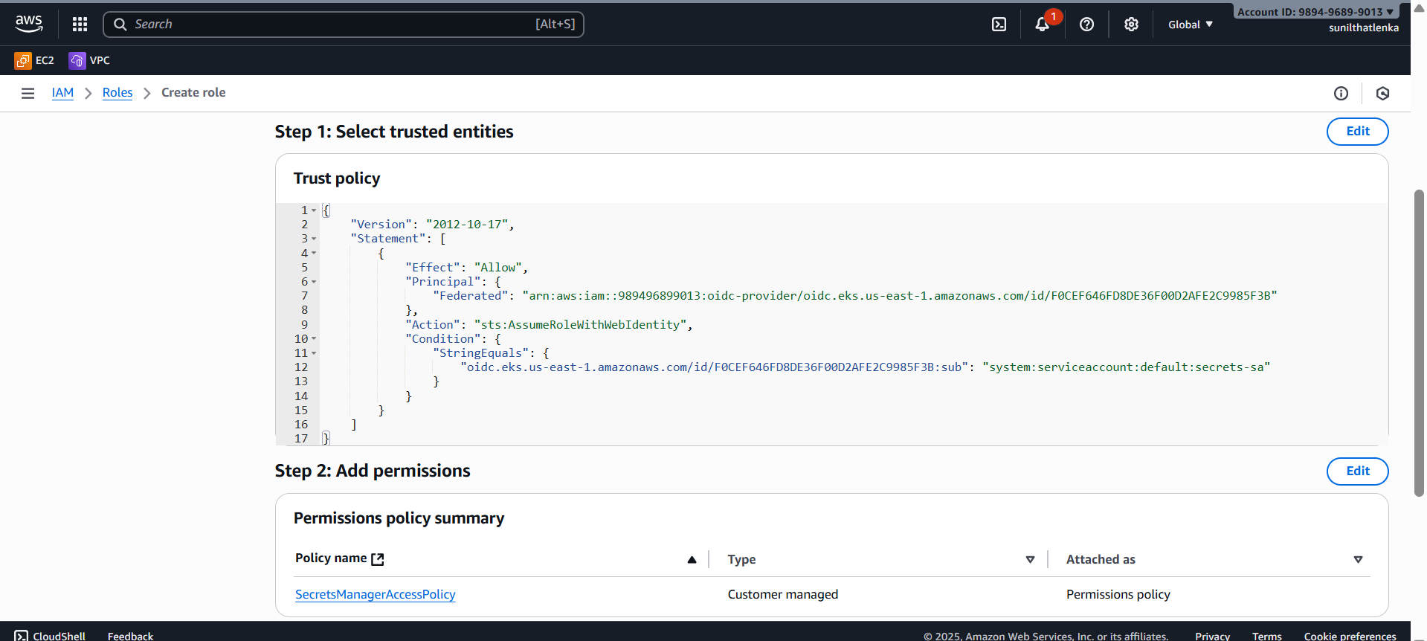
6) Create Kubernetes Service Account
Filename: serviceaccount.yaml

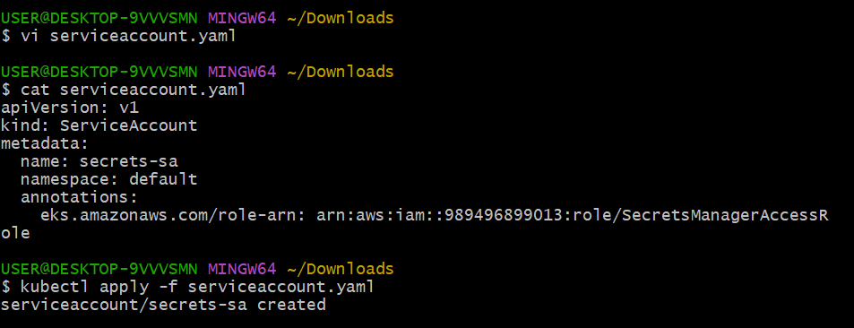
A Service Account is like an identity card for your pods, allowing them to
access the Kubernetes API and AWS services securely,
based on the permissions they are granted.
7)Deploy pod using service account.
deployment.yaml
###############
apiVersion: apps/v1
kind: Deployment
metadata:
name: secret-app
spec:
replicas: 1
selector:
matchLabels:
app: secret-app
template:
metadata:
labels:
app: secret-app
spec:
serviceAccountName: secrets-sa
containers:
- name: app
image: amazonlinux
command: [ "/bin/sh", "-c" ]
args:
- "yum install -y aws-cli jq; \
aws secretsmanager get-secret-value --secret-id db-credentials --region us-east-1 | jq .SecretString"

Create deployment: kubectl apply -f deployment.yaml
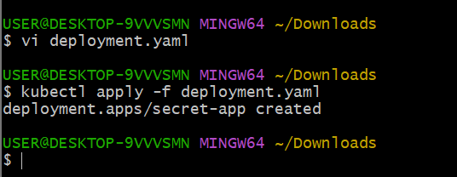
8) Test the credentials by checking logs.
kubectl logs -l app=secret-app
you can see the secret details in logs.

