Solution Design Document
Healthcare Insurance Analytics Platform

1. Solution Overview
The solution is an end-to-end Big Data analytics pipeline for a healthcare insurance company. It ingests raw data from AWS S3, cleanses it using PySpark, loads the cleaned data into Amazon Redshift (or Snowflake), and produces analytical result tables for 13 defined business use cases. The pipeline is orchestrated via AWS EMR or Databricks and deployed through GitHub.
High-level flow:
- Step 1 – Ingest: Upload raw CSV/Parquet datasets to AWS S3 (folder: input-data).
- Step 2 – Cleanse: PySpark jobs read from S3, detect nulls/duplicates, apply fixes, and write cleaned data to Redshift (schema: cleaned_data).
- Step 3 – Transform & Analyze: PySpark result-generation modules query cleaned Redshift tables and execute each use case query.
- Step 4 – Load Results: Output DataFrames are written to Redshift (schema: Project-Output), one table per use case.
- Step 5 – Visualize: Databricks notebooks display result snapshots and visualizations.
- Step 6 – Deploy: Final PySpark code is pushed to GitHub and deployed to AWS EMR or Databricks via CI/CD.

2. Use Cases
Use Case ID | Name | Logic Summary | Output Table (Project-Output schema)
UC-01 | Max Claims by Disease | JOIN claims with diagnosis table; GROUP BY disease; ORDER BY claim_count DESC LIMIT 1 | uc01_max_claims_by_disease
UC-02 | Subscribers Under 30 with Subgroup | FILTER subscribers WHERE age < 30 AND subgroup IS NOT NULL | uc02_subscribers_under30_subgroup
UC-03 | Group with Max Subgroups | GROUP BY group_id; COUNT DISTINCT subgroup_id; ORDER BY count DESC LIMIT 1 | uc03_group_max_subgroups
UC-04 | Hospital Serving Most Patients | GROUP BY hospital_id; COUNT patient_id; ORDER BY count DESC LIMIT 1 | uc04_hospital_most_patients
UC-05 | Most Subscribed Subgroup | GROUP BY subgroup_id; COUNT subscriber_id; ORDER BY count DESC LIMIT 1 | uc05_most_subscribed_subgroup
UC-06 | Total Rejected Claims | FILTER claims WHERE status = "Rejected"; COUNT(*) | uc06_total_rejected_claims
UC-07 | City with Most Claims | GROUP BY city; COUNT claim_id; ORDER BY count DESC LIMIT 1 | uc07_city_most_claims
UC-08 | Government vs Private Subscriptions | GROUP BY policy_type (Government/Private); COUNT subscriber_id | uc08_govt_vs_private
UC-09 | Average Monthly Premium | AVG(monthly_premium) FROM subscribers | uc09_avg_monthly_premium
UC-10 | Most Profitable Group | SUM(premium_collected - claims_paid) GROUP BY group_id; ORDER BY profit DESC LIMIT 1 | uc10_most_profitable_group
UC-11 | Patients Under 18 with Cancer | FILTER patients WHERE age < 18 AND diagnosis = "Cancer" | uc11_patients_under18_cancer
UC-12 | Cashless Insurance, Charges >= 50,000 | FILTER patients WHERE insurance_type = "Cashless" AND total_charges >= 50000 | uc12_cashless_high_charges
UC-13 | Female Patients Over 40 with Knee Surgery (Past Year) | FILTER patients WHERE gender = "F" AND age > 40 AND procedure = "Knee Surgery" AND admission_date >= current_date - 1 year | uc13_female_over40_knee_surgery

3. Database Design
Two schemas will be created in Amazon Redshift (or Snowflake):
- cleaned_data – stores cleansed source tables.
- Project-Output – stores one result table per use case.

3.1 Tables Metadata with PK/FK Relationships

cleaned_data.patients
Column | Data Type | Key | Notes
patient_id | VARCHAR(50) | PK
name | VARCHAR(100)
age | INTEGER
gender | CHAR(1)
city | VARCHAR(100)
diagnosis | VARCHAR(200)
admission_date | DATE
discharge_date | DATE
hospital_id | VARCHAR(50) | FK | cleaned_data.hospitals.hospital_id
insurance_type | VARCHAR(50)
total_charges | DECIMAL(12,2)
procedure | VARCHAR(200)

cleaned_data.subscribers
Column | Data Type | Key | Notes
subscriber_id | VARCHAR(50) | PK
name | VARCHAR(100)
age | INTEGER
gender | CHAR(1)
city | VARCHAR(100)
group_id | VARCHAR(50) | FK | cleaned_data.group_subgroup.group_id
subgroup_id | VARCHAR(50) | FK | cleaned_data.group_subgroup.subgroup_id
policy_type | VARCHAR(50) |  | (Government/Private)
monthly_premium | DECIMAL(10,2)
enrollment_date | DATE

cleaned_data.claims
Column | Data Type | Key | Notes
claim_id | VARCHAR(50) | PK
patient_id | VARCHAR(50) | FK | cleaned_data.patients.patient_id
subscriber_id | VARCHAR(50) | FK | cleaned_data.subscribers.subscriber_id
claim_date | DATE
disease | VARCHAR(200)
claim_amount | DECIMAL(12,2)
status | VARCHAR(50) |  | (Approved/Rejected/Pending)
city | VARCHAR(100)

cleaned_data.group_subgroup
Column | Data Type | Key | Notes
group_id | VARCHAR(50) | PK
group_name | VARCHAR(100)
subgroup_id | VARCHAR(50) | PK (composite)
subgroup_name | VARCHAR(100)
policy_type | VARCHAR(50)
premium_rate | DECIMAL(10,2)

cleaned_data.hospitals
Column | Data Type | Key | Notes
hospital_id | VARCHAR(50) | PK
hospital_name | VARCHAR(200)
city | VARCHAR(100)
state | VARCHAR(100)

3.2 ER Diagram (Conceptual)
Key relationships:
- patients.hospital_id → hospitals.hospital_id (Many-to-One)
- claims.patient_id → patients.patient_id (Many-to-One)
- claims.subscriber_id → subscribers.subscriber_id (Many-to-One)
- subscribers.group_id, subscribers.subgroup_id → group_subgroup.group_id, subgroup_id (Many-to-One)
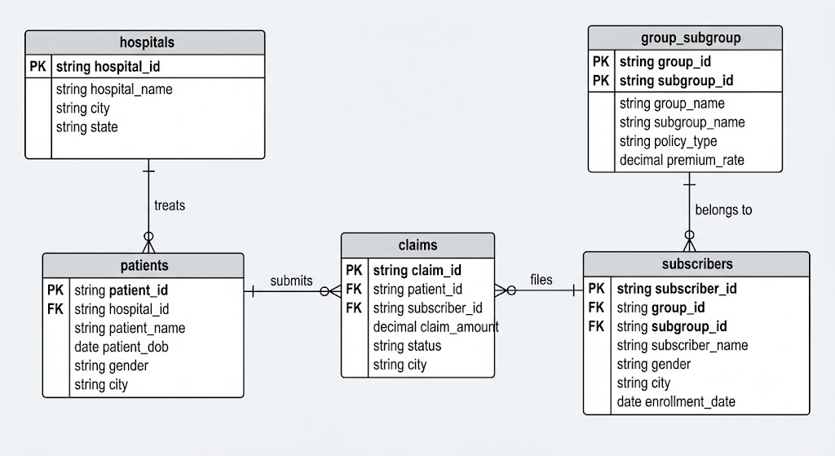

4. Technologies and Platforms
Technology / Platform | Role in Solution
AWS S3 | Raw data storage – input-data folder for source files, output folder for processed data.
AWS EMR | Managed Spark cluster for production PySpark job execution.
Databricks | Development and testing environment; also used for visualization notebooks.
Amazon Redshift | Target data warehouse for cleaned data (cleaned_data schema) and results (Project-Output schema).
Snowflake | Alternative cloud data platform; used if Redshift is not available or for specific use cases.
PySpark | Primary data processing framework for cleansing and transformation logic.
Python | Language for PySpark scripts, utility functions, and unit tests.
GitHub | Source control; repository split into Documents Repo and PySpark Source Code Repo.
PyCharm | IDE for local development and GitHub integration.
Jira | Agile project management – 2-week sprint with stories and tasks per use case.

5. GitHub Repository Structure
Documents Repository:
- docs/Requirements-Specifications-Document.docx
- docs/Solution-Design-Document.docx
- jira/Jira.csv

PySpark Source Code Repository:
- src/cleansing/ – One module per dataset (patients_cleanse.py, subscribers_cleanse.py, claims_cleanse.py, group_subgroup_cleanse.py)
- src/results/ – One module per use case (uc01_max_claims_disease.py … uc13_female_knee_surgery.py)
- src/utils/ – Shared utilities (spark_session.py, redshift_utils.py, s3_utils.py)
- tests/ – Unit tests for each cleansing and result module
- requirements.txt – Python dependencies
- README.md – Setup and deployment instructions

6. Jira Sprint Plan (2-Week)
Sprint 1 – Week 1: Documentation and Solution Design
- EPIC: Project Documentation
- Story: Write Requirements Specifications Document
- Story: Write Solution Design Document
- Story: Create DB Schema Design Document
Sprint 2 – Week 2: Implementation and Testing
- EPIC: Data Cleansing
- Story: Implement Patients cleansing module
- Story: Implement Subscribers cleansing module
- Story: Implement Claims cleansing module
- Story: Implement Group_Subgroup cleansing module
- EPIC: Use Case Implementation
- Story per use case: Implement and test result generation module
- EPIC: Testing
- Story: Write unit tests for cleansing modules
- Story: Write test cases for each use case (xls test sheet)
- Story: End-to-end pipeline integration test on Databricks

