* **OptiFlow (AI-OrchestrateX) - CNCF-Aligned Project Overview**

**🎯 Vision**

OptiFlow aims to be a domain-specific, AI-powered orchestration engine built to unify intelligent automation, cloud-native scalability, and contextual self-healing for multi-domain use cases including Healthcare, Manufacturing, Finance, and Edge Computing.

**🌐 CNCF Alignment Areas**

**☸️ Kubernetes-Native Integrations:**

* **Custom Resource Definitions (CRDs):** Workflow, DomainJob, HealthCheck, PredictivePolicy
* **Controller Manager:** Includes domain-aware LLM agent for real-time orchestration and self-healing
* **Networking:** Integrates with Calico, Cilium, Kube-OVN CNI plugins
* **Observability:** Out-of-box OpenTelemetry, Prometheus, Grafana support
* **Security & Policy:** Pluggable support for OPA/Gatekeeper-style policies

**🌩️ Cloud-Native Capabilities:**

* **Multi-Cloud Runtime:** Support for AWS, GCP, Azure, OCI, Bare Metal
* **Cloud Resource CRDs:** Kubernetes-style abstractions for cloud services
* **Cost Optimizer:** LLM-based usage + cost analysis
* **AutoScaler:** Predictive autoscaling using deep learning models
* **Infra Drift Detection:** Drift detection and reconciliation modules

**🤖 AI-Driven Orchestration:**

* **LLM Agent Core:** Embedded GPT-like model for interpreting service health, usage patterns, and offering resolutions
* **ConversationalOps (ChatOps):** Natural language CLI interface for DevOps engineers
* **Predictive Scheduler:** Learns job histories and predicts best nodes/resources
* **Context-Aware Healing:** Root cause analysis + recommended fix from LLM agent

**🚀 GitOps & DevOps Tooling:**

* **GitOps Engine:** Compatible with ArgoCD / Flux for declarative deployments
* **Helm + Kustomize Support:** Seamless app packaging and configuration management
* **DevSecOps Hooks:** CI/CD security policies using Sigstore, Kyverno, OPA

**🔧 Architecture Overview (High-Level):**

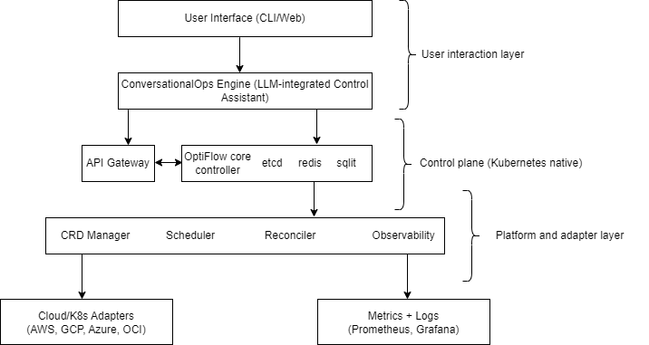

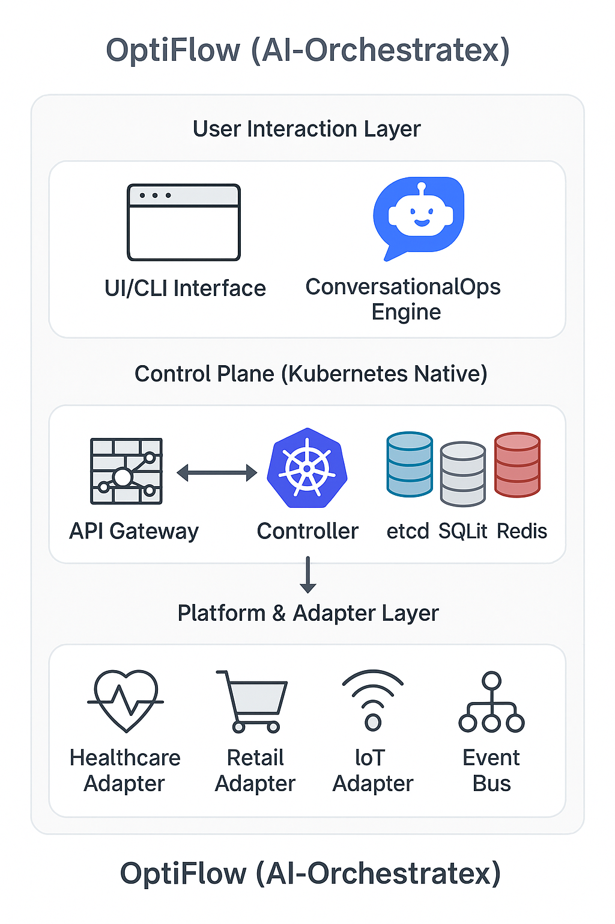

🧭 **Governance Model: *OptiFlow*** *follows a community-led governance model, encouraging open contributions and collaboration from diverse stakeholders.*

**📦 Project Status: [Alpha]:**

* Kubernetes-native prototype complete.
* SQLite and etcd backend ready.
* CRD and controller scaffolding complete.
* Cloud plugins are under development; AI-driven intelligent scheduler has been implemented and integrated into the orchestration workflow.
* GUI and LLM integration under development.

📁 **Sandbox Submission: [Planned]** Copy the GitHub link of sandbox project.

**🌍 Long-Term Goals:**

* CNCF Sandbox submission by Q1 2026
* Support for 10+ domain orchestration templates
* Integration with cloud marketplaces
* Open Governance & Maintainer Board formation

🧪 **Technical Maturity: [Prototype/POC]**

🔒 **License: [Apache 2.0]**

**🔗 Useful References:**

* [CNCF Sandbox Guidelines](https://github.com/cncf/toc/blob/main/process/project_proposals.adoc)
* [Kubernetes Controller Runtime](https://github.com/kubernetes-sigs/controller-runtime)
* [OpenTelemetry Collector](https://opentelemetry.io/docs/collector/)
* [OPA/Gatekeeper](https://www.openpolicyagent.org/)

For collaboration, partnership, or community interest, please contact the OptiFlow team at: [**sunilmkr79@gmail.com**](mailto:sunilmkr79@gmail.com)