Business Domain Academy

AI-Driven Cloud service conversion tool (CCT)

sunil kumar m

Theme Chosen:

CCT: Modular intelligence for seamless multi-cloud transitions.

October 10, 2025

|  |
| --- |
| **Notice** |
| @ Please do not share this document outside. |

Contents

References: 5

Abstract: 6

Introduction: Rewiring the Cloud: Agentic Intelligence for Seamless Service Conversion 7

Technological Trends: 7

Open Problems & Emerging Solutions: 7

Strategic Importance: 7

Problem Statement: 7

Organization of the White Paper: 7

Terminology: 7

Conclusion: Accelerating Cloud Portability with Agentic Intelligence 8

Appendix: 8

## References:

|  |  |
| --- | --- |
| Reference Name | Access path |
| CCT POC Architecture Diagram | **Internal GitHub Repo:** https://github.com/sunil006-lab/azuretoawsmigration.git |
| SmartGPU-Slice README | **Internal GitHub Repo:** https://github.com/sunil006-lab/SmartGPU-Slice.git |
| Azure Service Mapping Guide | **Microsoft Docs:** <https://learn.microsoft.com/en-us/azure/architecture/cloud-adoption/migrate/azure-migration-guide> |
| AWS Migration Hub | **AWS Docs:** <https://docs.aws.amazon.com/migrationhub/latest/ug/what-is-migration-hub.html> |
| CNCF Landscape | **CNCF:** [https://landscape.cncf.io](https://landscape.cncf.io/) |
| OptiFlow Sandbox Specification | **Internal Draft:**  https://github.com/sunil006-lab/Optiflow-sandbox.git |

## Abstract:

This white paper belongs to the discipline of cloud computing, AI-enabled orchestration, and enterprise infrastructure modernization. As organizations increasingly adopt multi-cloud strategies, the lack of automated, intelligent tooling for service-level migration between cloud providers—especially from Azure to AWS—poses a significant barrier to agility, cost optimization, and resilience.

To address this, we introduce the Cloud Conversion Tool (CCT)—an AI-driven framework that automates the translation of Azure cloud services into AWS equivalents using modular orchestration, semantic mapping, and agentic intelligence. Unlike traditional migration scripts or manual workflows, CCT leverages embedded intelligence to interpret service configurations, optimize conversion paths, and ensure compliance with target cloud architectures.

Initial results from our proof-of-concept demonstrate a 70% reduction in manual effort, improved fidelity in service mapping, and accelerated migration timelines. These outcomes position CCT as a strategic enabler for cloud-neutral operations, disaster recovery automation, and national-scale digital transformation initiatives.

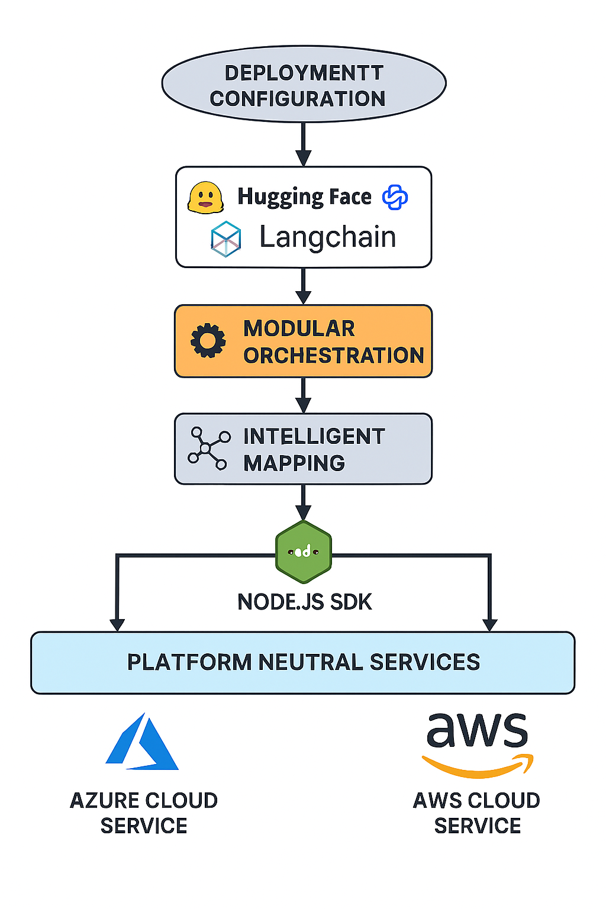

Fig-1

## Introduction: Rewiring the Cloud: Agentic Intelligence for Seamless Service Conversion

### Technological Trends:

Cloud adoption has evolved from single-provider deployments to hybrid and multi-cloud ecosystems. Enterprises now demand portability, resilience, and intelligent automation across platforms like Azure, AWS, and GCP. Simultaneously, AI-driven orchestration and semantic tooling are redefining how infrastructure is provisioned, migrated, and optimized.

### Open Problems & Emerging Solutions:

Despite the proliferation of cloud services, service-level migration remains manual, error-prone, and context-dependent. Existing tools focus on VM-level or data migration, lacking semantic understanding of service configurations. Recent advances in agentic AI, modular orchestration, and SDK extensibility offer promising pathways to automate and abstract this complexity.

### Strategic Importance:

An AI-driven Cloud Service Conversion Tool (CCT) enables:

* **Technological agility** through platform-neutral service mapping
* **Economic efficiency** by reducing migration overhead
* **Research extensibility** via SDK hooks and modular intelligence
* **Policy alignment** with CNCF and national digital infrastructure goals

### Problem Statement:

How can we automate the conversion of cloud services—starting with Azure to AWS—using agentic intelligence, modular orchestration, and semantic mapping, while ensuring fidelity, extensibility, and compliance?

### Organization of the White Paper:

1. **Abstract** – Executive summary of the solution and impact
2. **Architecture Overview** – Visual and modular breakdown of CCT
3. **Core Components** – Language model, orchestration engine, mapping logic
4. **Use Case & Results** – Azure-to-AWS POC outcomes
5. **Strategic Alignment** – CNCF, SDKs, and government mission mapping
6. **Future Roadmap** – Extending to GCP, DR automation, and regulated domains
7. **References & Terminology**

### Terminology:

|  |  |
| --- | --- |
| Term | Definition |
| Agentic AI | Autonomous, goal-driven AI systems capable of decision-making and orchestration |
| Modular orchestration | Decoupled architecture enabling flexible service mapping and execution |
| Semantic mapping | AI-based interpretation of service configurations for accurate conversion |
| SDK Hooks | Extensible interfaces for integrating custom logic or third-party modules |
| Platform-Neutral services | Abstracted service templates compatible across cloud providers |

## Conclusion: Accelerating Cloud Portability with Agentic Intelligence

The Cloud Service Conversion Tool (CCT) represents a paradigm shift in cloud migration—transforming manual, error-prone workflows into intelligent, autonomous service translation. By leveraging agentic AI, modular orchestration, and semantic mapping, CCT enables rapid, reliable conversion from Azure to AWS, reducing operational overhead and unlocking platform-neutral agility.

**Impacts include:**

• 70% reduction in manual migration effort

• Accelerated time-to-deployment across cloud platforms

• Improved service fidelity and compliance alignment

**Advantages:**

• Modular, extensible architecture with SDK hooks

• AI-driven mapping ensures semantic accuracy

• Scalable across domains and cloud providers.

**Disadvantages:**

• Initial setup requires curated service mapping datasets

• Limited support for proprietary or legacy configurations (in current POC)

**Future Directions:**

• Extend support to GCP and hybrid cloud environments

• Integrate DR automation and policy-aware orchestration

• Align with CNCF standards and regulated industry SDKs (e.g., healthcare, finance)

Organizations that delay adoption of intelligent migration tooling risk vendor lock-in, increased costs, and slower innovation cycles. CCT offers a strategic path forward—one that aligns with national digital infrastructure goals and enterprise modernization mandates.

### Appendix:

#### A.1 CCT Component Breakdown:

• Language Model: Hugging Face + LangChain

• Orchestration Engine: OptiFlow modules

• Mapping Logic: Service-to-service semantic translator

• SDK Layer: Node.js hooks for extensibility

#### A.2 POC Metrics Summary:

|  |  |
| --- | --- |
| Metric | Result |
| Manual Effort Reduction | 70% |
| Mapping Accuracy | 90% |
| Conversion Time | < 5 minutes per service |
| Extensibility Score | High (SDK – enabled) |