
Employee Name: Sunil
Employee ID No: 233
Marks: Date: 09-09-2021

ArcGIS Desktop Assessment

Note: Please show the icons where necessary in the answers.

    - What are the two important components of ArcGIS Desktop?
Ans: ArcCatalog, Arc Toolbox, Arc Scene, Arc Globe

    - Show the icons to perform some important functions in the Editor toolbar?
Ans: Edit tool, edit annotation, Stright segment, endpoint arc segment, trace, cut polygon

    - How to add different data to the ArcMap? Show the icon.
Ans: Add map- add data/add base map

    - When a new project is started, in which file type the objects’ data model is created?
Ans: .mxd

    - What is the difference between Merge and Union tools in ArcGIS Desktop?
Ans: Merge-it combined multiple features into single feature. And features belong to same type.
Union- A new feature is created on the original selected features.

    - where do we set the projection system in ArcGIS?
Ans: Table of contents /layers/ properties/ coordinate system

    - What is the icon used for measuring distance between two points?
Ans: Measure distance and Area of the Map

    - Show the Editor to place a feature using X and Y coordinates.
Ans: Advance editing toolbar- construct geodetic icon.

    - What is the first most action to draw a feature in ArcMap?
Ans: Go Arc Editor the click the start editing and enable the create feature template

    - Locate the button to draw an Arc?
Ans: Editor toolbar
    - What is this icon in ArcMap does?
Ans: To Save the Current ArcMap.

    - Write any two methods to delete any feature?
Ans: 1) Select the feature and hit the delete key in the keyboard and also Right Click the mouse and hit delete.
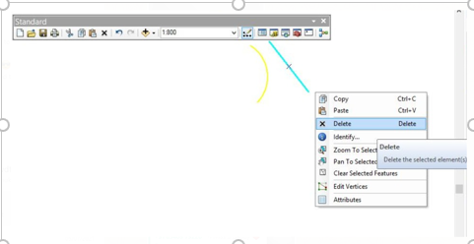

    - What is the short key F2 is used for?
Ans: F2 key is used to finish the Sketch

    - What is the name of the pane that shows the feature datasets and features?
Ans: Table of contents

    - Locate where the trim function is in ArcMap?
Ans
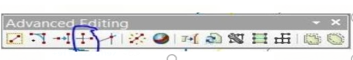

    - What are the important file types that we use for our daily tasks in ArcGIS?
Ans: Gdb & Mxd

    - Is offset function available in ArcMap? If so, locate it, if your answer is “NO”, explain how to perform offset function in ArcMAP?
Ans: Copy Parallel is used to make an Offset that we selected.

    - Show the icon to change the shape of a polygon?
Ans: Used to reshape the Polygon and Line features

    - Write any two options available in using the Split function?
Ans: Split by Distance and Split by Into Equal Parts

    - Can we create multiple point features at a time in ArcMap? If yes, how?
Ans: Open the feature to point tool found in ArcToolbox - Data Management Tools - Features - Feature To Point.
Specify the multipoint feature class as the input features and specify an output feature class name. Click OK to run Feature To Point.

    - Where do we get the Snapping toolbar from?
Ans: Under Editor we get the Snapping toolbar

    - Where do we found Trace tool what does it do? Show the icon.
Ans: Under Editor- Segment creation tools -Trace
    - Can we change the position of Vertices of a linear or polygon feature? If yes, how to do?
Ans: Select the feature and right click the mouse and hit Edit Vertices

    - Assume that a gas pipe or an electrical conductor in the existing data has stopped at wrong location. Can we continue drawing it further? If so, what tool would be useful?
Ans: continuous tool

    - What is to be done once drawing of the features is completed?
Ans: save as

