- To-be process

Generic requirements:

- All actions taken on bridge to be tracked and saved with the User ID and data/time. Action details to include specific action that has been taken and From-To values in case a value has been updated.
- Duplicity check fields should be standard fields + client specific fields as per the existing duplicity check process.
- Red X on top right of any screen cancels the current action and takes the user back to role selection screen. The item is sent to the next pull from the queue. This action is tracked on bridge as “Action cancelled” along with user id and start end time.
- Existing excel process has not been changed in Bridge 2.0. The excel cases will still follow the Bridge 2.0 batch queue process, but the remaining process will continue as is.
- When any field is in focus, the relevant documents that are already mapped will show up in the documents window on the left.

Role selection screen:
After login to bridge, user will be presented the following screen. The buttons will appear as per the user configuration / profile based on rights assigned to them.
- We will cover this configuration in Supervisor role.

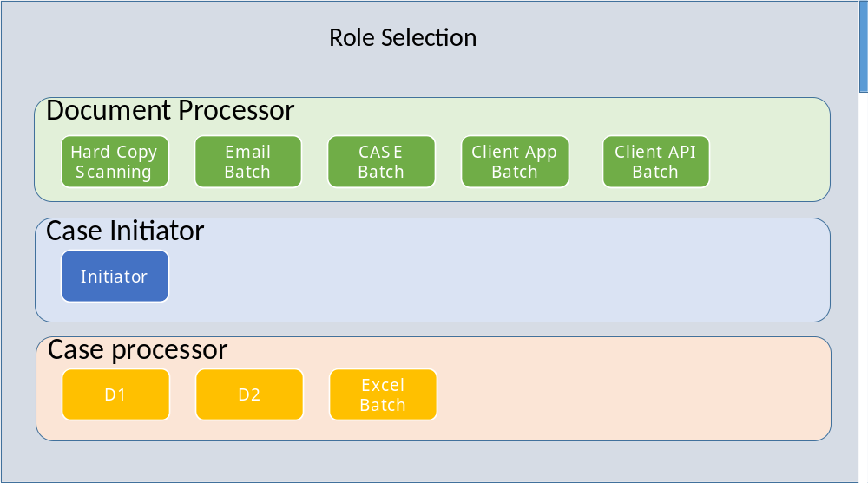

Scanner / Initiator Batch Upload Process (Hard copy / Email / Bulk CASE / Client App)
Scanner and initiator are two roles in the system. The upload process outlines the steps from the initial receipt of case till individual cases are identified separately (as in bulk upload/email/client app).
Independent process before initiation of case wise processing, depending on type of input.
Each uploaded batch to have batch reference internally. All cases emanating from this batch will maintain the batch reference information including data/time of upload, user and source.
Usage – to be able to identify other cases that came in the same batch via a search functionality to be provided separately.
Hard copy
      - Hard Copy are received though Courier by Mailroom
      - All documents are un-stapled and consolidated by the scanner/initiator and put separator documents in between to segregate cases. While scanning, the scanner will make sure that all pages are scanned properly and with good /readable resolution. If not, he will delete original images and rescan/reorder on the scanning software. A new physical stamp will also be done on the first page of each batch which will include actual courier received date and time and client name and AWB/proof of delivery numbers.
      - Scanner/initiator logs into bridge and clicks“hard copy scanning” role. The separators identified by scanner will create separate files in the destination folder, these files will all be uploaded on the same batch in bridge, segregated by separators as identified by individual files. All images will be saved/shown individually and separately.
      - System prompts for selection of client name from dropdown and post selection of client name the scanner needs to start the scan offline (manually).
      - Each scanner machine to have a default file path set in the system. The options in the dropdown will be the two scanning machines we have at present. They can be named as Scanner 1 and Scanner 2.
      - User will specify the client name and date-time the courier was received by Authbridge. This is the actual physical received time for Hard copy cases.
      - User will select the scanner number from the dropdown, system will automatically pick the un-uploaded batch from the scanner destination folder. An additional option to be provided for “Browse Folder..”. This will enable the system to pick up all the images from this folder and create a batch. Post upload of this batch, the documents will be moved to a system defined Uploaded destination folder. The main path folder will not be changed. The batch sub- folder will be deleted from the user machine / network folder.
      - User will click “batch upload” which will automatically create the next batch from the selected scanner file destination folder.
      - Time of upload will be saved as the time for Batch upload step.
      - Once uploaded, the folder will be moved to some other “Uploaded on Bridge” folder. This destination path can be created by IT as per their convenience. Some pre-defined user id’s will be given rights to view this windows folder as read only just in case they wish to cross check the actual images. These will be Supervisor 1 and Senior manager Ops. Additional users will be added to view this folder as well.
      - If the user has selected “all documents in batch are for insuff?”, all the documents will go to insuff queue rather than initiator. –
Insuff queue flow will be a provided separately.
If upload batch is clicked without “äll documents for insuff”, then use will be presented the separator screen. Post segregation, each segregated section will become a new individual case.
      - Scanner batch number/ folder name, date and time to be saved along with the batch.
      - Reordering is through drag and drop and rotation button is provided on bottom left of the screen in the wireframe.
      - Batch creation date to be saved along with batch source as the batch information. The cases generated from this batch will have a reference to this information.
      - Evaluate image optimization, cleaning and OCR options from the scanner software. By default, we propose to use resolution change, both side scanning, removing blank pages and separator options available in the scanning software. These options will not affect the final images that will be uploaded on Bridge by the batch scan. The batch upload will simply pick up the images and separators from the mapped destination folder.
Benefit:
Accuracy - Scanner does not need to scan to a system folder and then select the folder from bridge – automating this removed chance of saving incorrectly and picking up incorrectly. No missed images with this process.
Faster than saving images to a designated folder with naming convention. Saves time for the user at the time of saving documents as well as at the time of uploading the documents on Bridge as user will not need to identify the folder where it was saved.
Remove rework – This process does not need any rework as there will be no missed images or incorrectly uploaded images. Every scanned image will need to be worked.
Users are not provided the search functionality. The search functionality is a part of the supervisory module, will explain the functionality there and discuss.

Wireframe of Scanner Screen
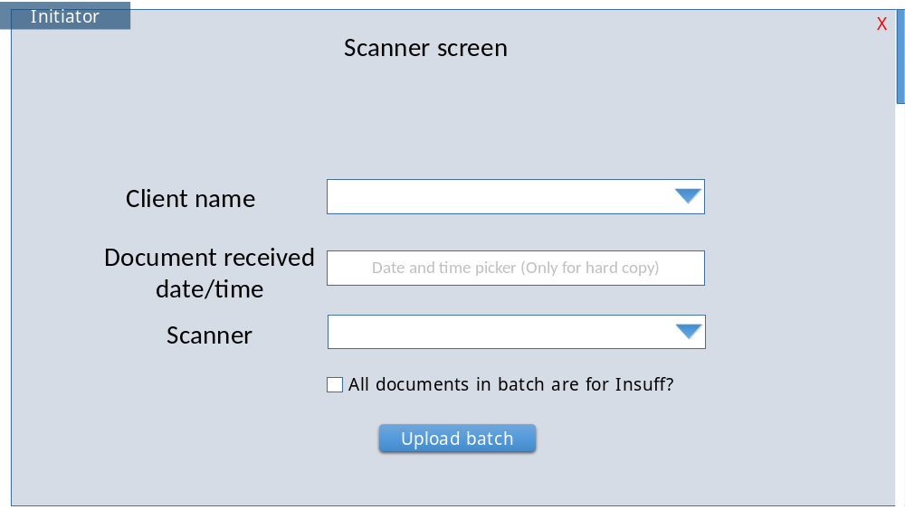
Emails
      - All emails including documents received on Newcases@authbridge.com except for pre-defined Excel clients will be visible here for bifurcation.
        - Bifurcation will be done by system depending upon mode used by client.
        - For multi-mode Clients where system bifurcation is not possible it will be done manually. E.g. Excel & Scan/Hard Copy Mode
        - Client configuration will decide the mode of receipt and excel only will go to excel queue.
      - On clicking “Email batch”, the next email in queue will be presented to the user in the segregator screen. User will continue to get next batch unless user de-selects get next batch. If user has deselected get next, then user will come back to the role selection screen. Email count
      - Each email is a new batch.
      - Separators to be added automatically after each attachment in the email. User can add/delete or move separators as per the default options on the screen.
        - In situation where non-image attachments are found then system will do automatic conversion except excel which will open with the default application.
      - E-Mail body also to be converted to image and attached to each case from the batch (Identified by separators) as the first image. E.g. if some part of email goes to insuff and remainder part for new cases, the email body image will be attached to all the cases generated from the batch. Second example – if the email only includes new cases, the email body will be attached as image to each of the cases segregated by separators. –
        - User will select first set of documents and move them to insuff. Then user will select second set of documents and send to insuff. The remaining documents will become a new case.
      - Each case to have batch reference internally. Usage – to be able to identify other cases that came in the same batch via a search functionality to be provided separately. –
      - Client Allocation would happen automatically with the help of domain name. User will have the option to change the client name if required.
      - If domain is not mapped to any client – Client field box will be shown blank. User will read the email body and select the client.
      - Screen will not allow “No Client” in client name if a new case is being created. Routing to other departments (Via the “move to” drop down) is allowed even without client name being specified.
      - Reordering and rotation similar to hard copy bifurcation window.
        - Reordering is through drag and drop and rotation button is provided on bottom left of the screen in the wireframe.

      - Once images are moved to insuff or any other queue, they will be shown shaded / half transparency.
      - Document processor would use the Scanner Role features and Windows. Processor will add separators between documents of different candidates.
      - Clicks “submit”. Move to initiator steps.
Email routing/bifurcation screen:
If the users route the case or part of case to a specific queue as outlined here. The original email will be forwarded to the mapped email address for the queue. A queue item will also be created and selected/identified documents will be moved to the identified queue.
- The insuff queue will not allow the insuff documents to be deleted till the time all the cases of the batch have crossed the PVT end point. This will be trues for all queues where delete or scrap option is available.
For each queue, there will be a set of predefined Email addresses. The user can also add additional recipients
The list of queues that the user can send to are: -
- Insuff queue - mapped to insufficiency@authbridge.com and moved to insuff queue
  - Insuff Queue Flow is missing from the document.
- PVT Supervisor - mapped to the email id of supervisor of the agent processing the email batch, moved to “PVT supervisor” queue.
  - PVT Supervisor Queue Flow is missing from the document.
- Respective CAT - mapped to email id of CAT agent for the client account. Images moved to “CAT team” queue.
  - CAT Queue flow is missing from the document.
- Excel upload - mapped to excelupload@Authbridge.com). Pre-identified excel clients email will be automatically forwarded to excelupload@Authbridge.com). Only email gets forwarded, as batch upload will happen based on the email being forwarded in the excel upload process.
  - New email address needs to be created – excelupload@authbridge.com. This will be an internal forwarded email address. Clients will still be given newcases@authbridge.com. Emails will be forwarded automatically from newcases to excel upload email address.
    - The excel files/cases wilUsers are not provided the search functionality. The search functionality is a part of the supervisory module, will explain the functionality there and discuss.l come in the excel upload batch queue. User will click on the attachment and process the excel file as per the existing process.
    - Once the excel file is manually completed, user will click “Submit” and may select the checkbox “get next batch” on Bridge 2.0. If the checkbox is not selected, then the user will go to role selection screen.
- Client app case – the batch will be created and will be moved to “Client app” batch upload queue. The Client app flow is mentioned below, this will become a new batch in the client app flow.
- Delete email – the email will be marked as deleted and will be moved to “Deleted emails” queue. Supervisors in PVT will be assigned the rights to this queue to validate that no important items have been deleted.
The supervisor action regarding what to do with the deleted items will be covered in the supervisory module, which is under documentation.

On this screen, the user can send the complete set of documents to a single queue by selecting it from the dropdown on the right.
User can also send a multi-selected set of documents individually to one queue.
Functionality is the same as Document ordering and case splitting except as outlined below.

Wireframe of Email Transfer to other queue
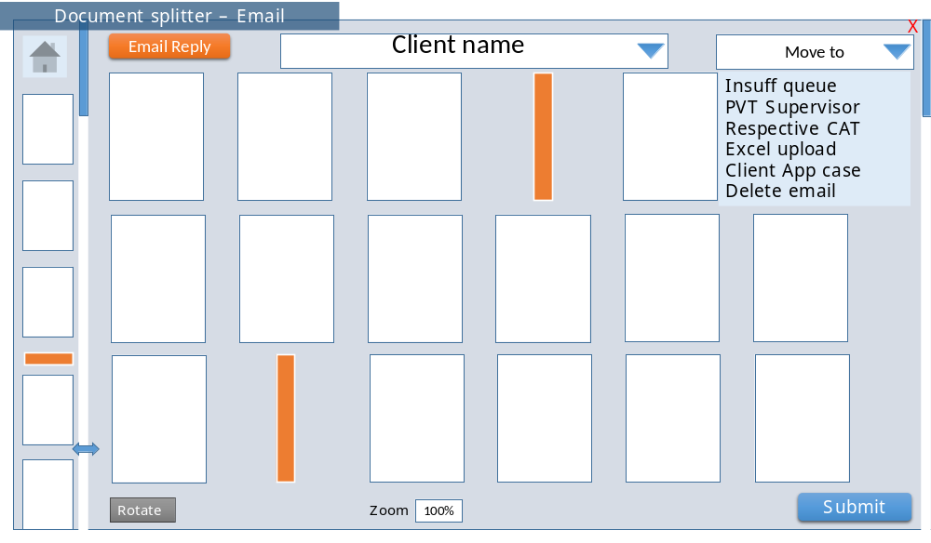
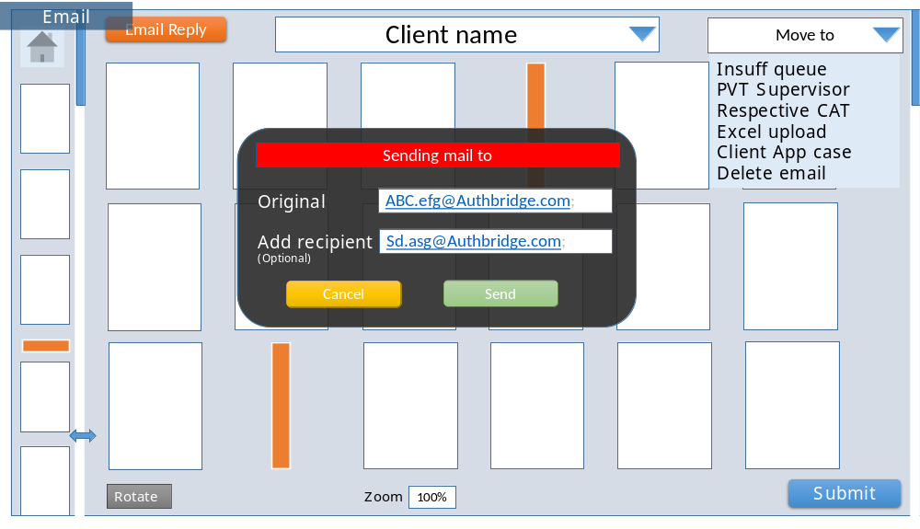
Move part of or all documents to another queue:
- Queues where no email is sent : (Insuff, signoff recd, PVT Supervisor, Client App and Delete email”)
- Queues where Email will go with attachment : To CAT and excel upload,
- There is a prompt to confirm the action “Are you sure you want to move the selected items to <selected queue>? Cancel/Send”.
- Post selecting the documents, if the user clicks on one of the items in the drop down list, the documents will be moved to that queue after the user selects “send” on the prompt. For queues that forward the email to another address, There is text box on the prompt for adding any additional email address(s)”
- On clicking “Cancel”, the action is cancelled.
Email response screen- by clicking on email reply button (top left)
- The case will follow the normal process after the email response is sent. History will capture the response action along with text and addresses used for replying to email.
Wireframe for Email reply button
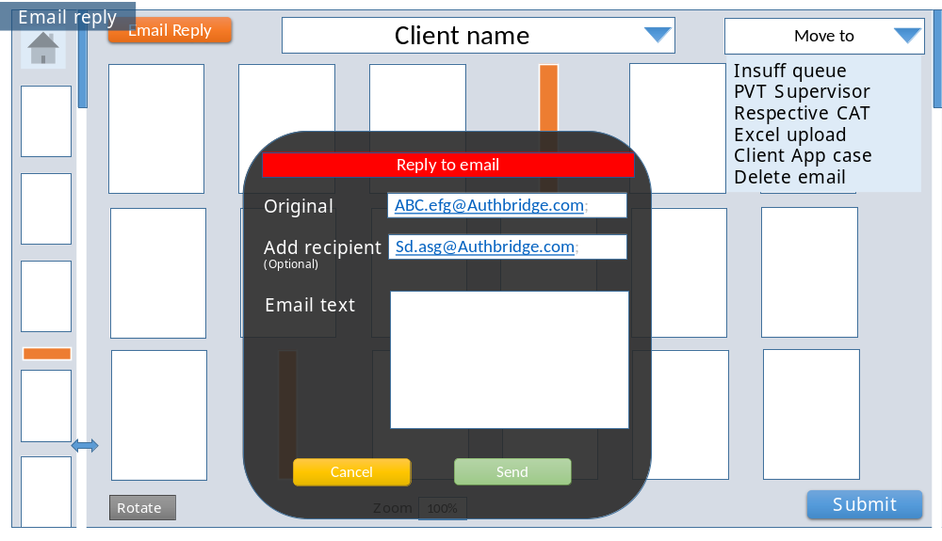
Benefits: -
- No email will be lost. Since all emails are automatically entered into bridge as batch – eliminates possibility of deleting an email in error or missing out on it because it was marked read.
- System based routing of cases to different departments brings the tracking on to Bridge rather than just on emails – reduced possibility of errors.
Case Bulk Upload
      - All documents received through CASE application will be automatically uploaded on Bridge in batches. Each bulk upload by any client is one batch.
      - Batches will be routed to the user based on priority as per Analyst module.
      - Documents of each batch will be visible in the “Document ordering and case splitting:” window similar to hard copy bifurcation window.
        - It is not clear what to do with excel file uploaded by the client? To be treated the same way as other images – excel may be given as attachment instead of an images.
      - Client Allocation would happen automatically based on client ID used to upload documents on CASE. User will not have the option to change the client name.
      - Processor will add separators between documents of different candidates. Rotate or reorder documents as required.
        - Suggestion: - In this flow, we can assume one file as a single case and system can automatically add separators after each file.
      - Clicks “submit”. Move to initiator step.

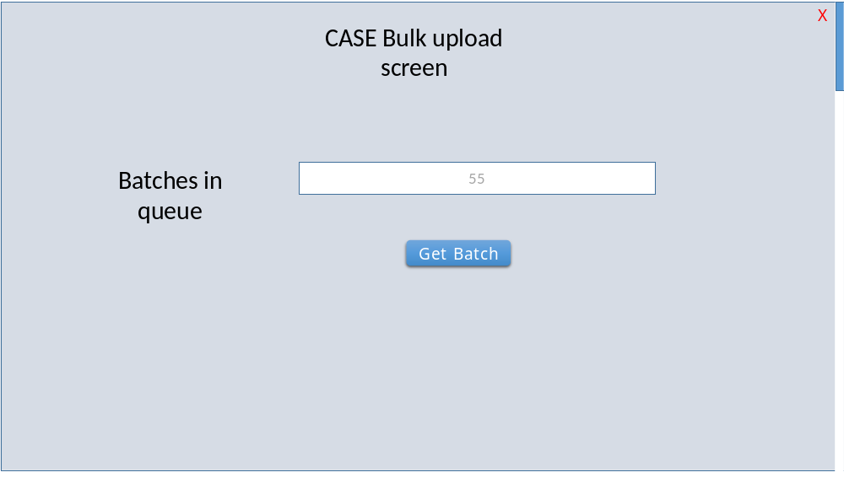
Benefits: -
- Standardization - All documents get into a standard process similar to hard copy scanning.
- Auto selection of client name removes possibility of selecting an incorrect client name.
- Ability to use logic manager / Analyst module to prioritize batches automatically.

Case Individual Upload
      - Individual cases uploaded on the case individual link will move directly to initiator step.
      - Data entered by client will be entered by the initiator and discrepant fields will be highlighted with the exclamation mark as applicable for D2 step. Document mapping will be done by initiator for case documents.
      - The case level data will not be entered by D1 as client has already entered and initiator has done second entry and validation. The fields will still be visible, however disabled for subsequent steps.
Benefits: -
- Reduced wait time and improved TAT - Case individual cases get into D1 queue immediately based on priority by Logic manager. No time wasted in waiting for case to be created manually for Individual cases.
- Client supplied fields are used for the initiator step, reducing data entry.
Client App Upload
      - Client app email addresses will be mapped to automated Macro. On receipt of a client app email, the macro will automatically download the documents and create an item in the client app queue.
        - Macros are browsers functionality and required start trigger. Some parameters are required to download cases from client portal for each macro. Macro’s to be reviewed again by IT for further automation of the process.
      - IT to conduct proof of concept to inform if macro can be run automatically including login.
        - We can do login but it depends app to app. Currently in some client’s SMS/email authentication required, login can’t be automated by Macros for those clients.
      - Login to be automated as far as possible, follow the following process in case login and download cannot be completely automated.
      - In case the automated process has downloaded the documents, all the documents along with email body will be shown on the segregation screen. The “Upload documents” button will not be visible to the user in automated upload case.
      - When documents are uploaded by the system, all document will be converted to individual images per page. Excel attachments will continue as excel file that will open outside bridge with default application.
      - A standard folder location to be created for individual to manually save the documents in that location.
      - All documents received through Client App saved at the location will be uploaded on Bridge on clicking the upload Docs button.
      - Each batch will be visible in the bifurcation window similar to hard copy bifurcation window.
      - Client Allocation would happen automatically based on Client app and / or email domain. User will have the option to change the client name.
        - Is there any specific reason to change client name? As per my understanding it should not be there because it will increase error chances. Client name change may only be allowed for manual upload. Where we have been able to identify client from email domain, client name would not need to be updatable.
      - Document processor would use the Scanner Role features and Windows. Processor will add separators between documents of different candidates.
      - Email body will be automatically added to each case post the separator. This will be done when the user submits the batch after segregation.
      - Clicks “submit”. Move to initiator step.

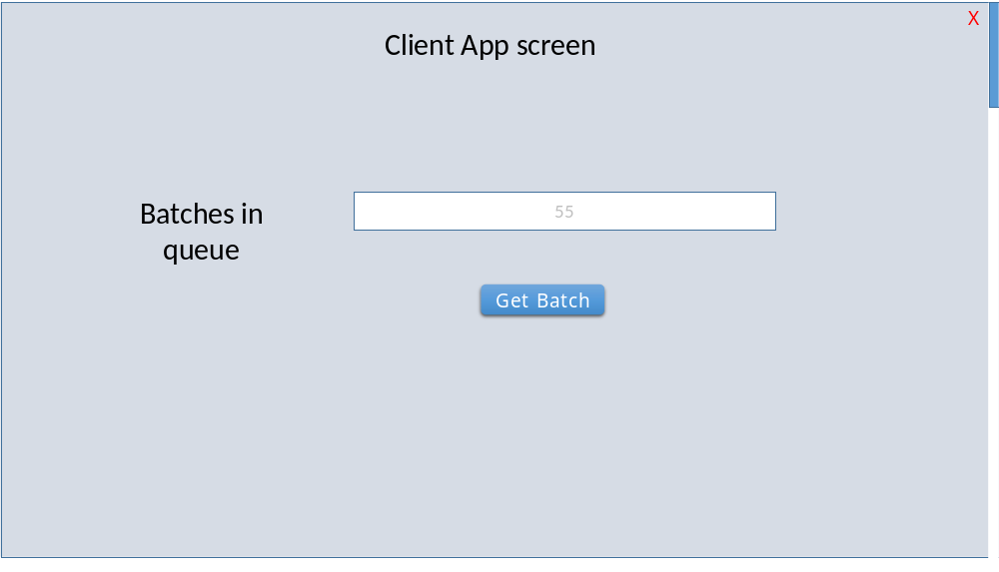

Wireframe for document upload in client APP cases
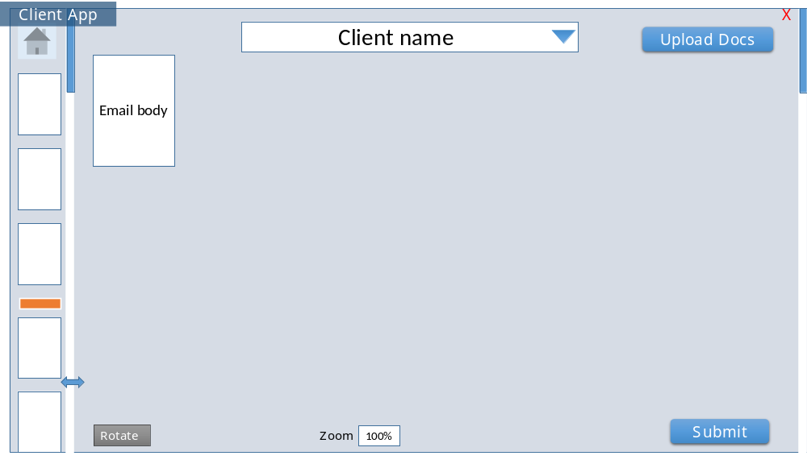
Benefits: -
- All documents get into a standard process similar to hard copy scanning.
- Auto selection of client name removes possibility of selecting an incorrect client name.
- Ability to use logic manager / Analyst module to priorities batches automatically.

Candidate App ARS Generation
      - Individual cases uploaded on the Candidate app will move directly to initiator step.
      - Data entered by candidate will not be entered by the initiator. These fields will appear pre-filled. The initiator can however change the field values.
      - Document mapping will be done automatically based on candidate uploaded documents. Initiator can change or remap the documents.
      - The case level data will not be entered by D1 as candidate has already entered and initiator has done second validation. The fields will still be visible, however disabled for subsequent steps.
      - Remaining check level fields will be shown prefilled to D1 along with ability to remap documents.
D1 can change the pre-filled values in case of an obvious error.
      - D2 step is not required for candidate app cases.
      - Ability to configure dual entry for candidate app as per single/dual entry selection.
      - This will be done based on the client /check/ field dual entry setup that will be provided separately in the supervisory module.
      - All candidate app fields to be mapped to Bridge 2.0 fields to link candidate submitted fields to Antecedents in the Bridge 2.0 format.
      - Similar interface for CASE application for individual submissions (or same interface). User interface to be covered separately in candidate app and / or case module with same functionalities.
      - Both CASE individual candidate and candidate app then get directly to D2 with documents pre-tagged and antecedents pre-filled.
      - D2 to fill antecedents and map documents if required. Submit as per standard process with the same screens but prefilled with the information that the candidate has supplied.
Auto ARS Generation (Excel)
      - Excel clients to be mapped in email input to be routed to the excel queue email address.
      - Remaining process to be followed as-is.

It is not clear, how to handle API cases? API cases are individual by client and will be reviewed separately.
Batch creation end instructions
- At the end of a batch creation, user will automatically be moved to the initiator role for the cases in the batch.
  - It is not clear what will happen if Initiator role was not mapped with user? Then the user goes back to role selection screen, however this will not be the case as users will normally be provided both batch upload and initiator roles.
- User can click “x” and go to starting another batch.
- On clicking “X” , the current transaction will be rolled back to queue and user will come back to role selection screen.
- Additional users can select the role of initiator and support in the process based on analyst module prioritization.
Document ordering and case splitting
Here the user will segregate the different cases with separators and will also reorder and rotate the images.
      - Ability to add separator on right click.
      - Delete separator with delete button. No other image can be deleted apart from separators.
      - User can move one or multi-selected documents to insuff queue by pressing “F3” and option to be provided on right click “Move selected to Insuff”.
      - Once images are moved to insuff, they will be shown shaded / half transparency. Ability to right click again and “remove from insuff”.
      - Images moved together will show up as one insuff batch in the insuff queue.
      - Drag and drop to be enabled for single or multiple selected images.
      - Images can be multi-selected by pressing shift or control buttons or mouse click with shift/control. Default windows behavior.
      - Selected images are shown with a thick border / light color background as in windows. Possibly use bigger top and bottom margin for easier identification of selected images.
      - Separator page is added between documents that automatically creates separators in the batch. This could be a page with Separator printed on it and can be read by Bridge as separator. Bridge then automatically adds a separator where it comes across this pre-identified page. (IT to recommend the separator page that is easiest to identify by the Bridge application – horizontal line/vertical line/ standard text/barcode). This page image is not saved as an image.
Wireframe for Document ordering and case splitting:

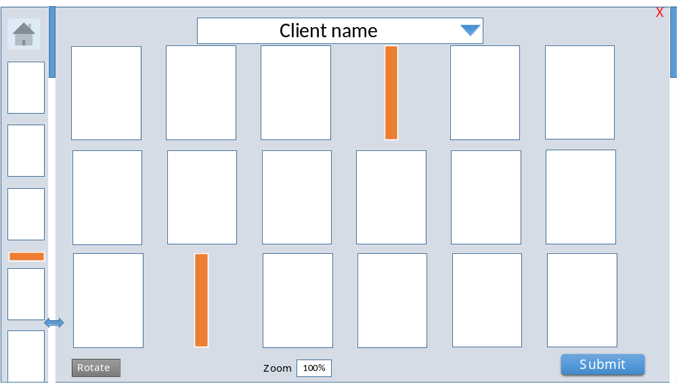

Zoomed image:
      - Scanner / initiator validates/adds separator between documents of different candidates.
      - Ability to rotate images in increments on 90%. Clicking on rotate button rotates the selected image(s) by 90 degrees clockwise on every click.
      - Ability to reorder images with drag and drop.
      - Get into zoom mode by double clicking AND by pressing enter when a single image is selected.
      - Get back into default multi-page view from zoom view by pressing ESC key.
      - Ability to split image in the zoom view – vertically and/or horizontally. This is to be achieved by using right click – two options to be provided – “Split horizontally” and “Split vertically”. The document will be split from the point of cursor location.
      - Move through images with arrow keys.
      - Active document(s) will be highlighted on the screen with a clearly visible 1.5em-2em border – red or bright blue.
      - Clicks “submit”. Move to initiator steps.

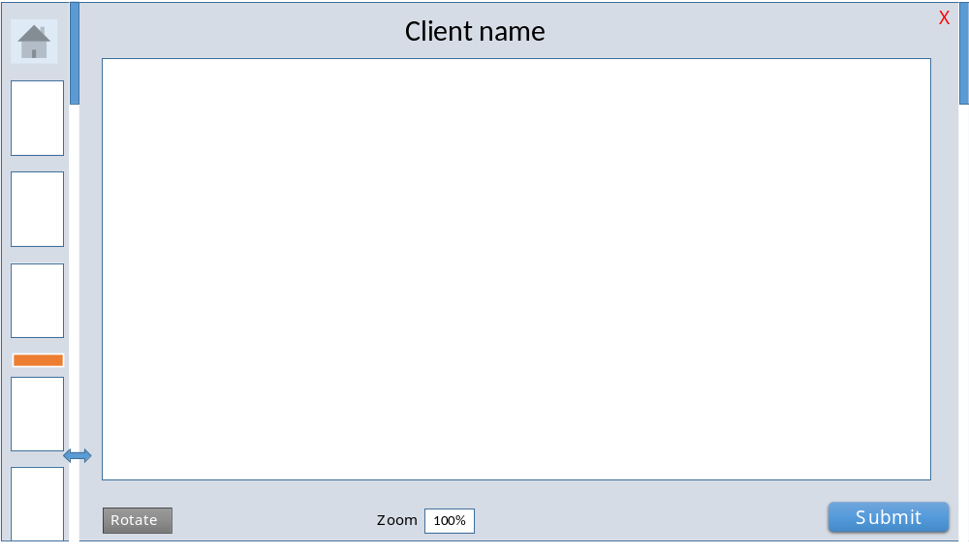

  - Initiator steps
At this stage, individual cases have been identified from all types of bulk upload.
Scanning/initiator to review the relevant documents to the case to ensure any other candidate’s documents are not attached, Ability to move a document to insuff fulfillment (so that it can be attached to the correct candidate / ARS#).
Order the documents in the following order (Guideline to scanner, but process can continue even if documents are not in this order):
      - JAF
      - Aadhar
      - PAN card
      - Passport
      - Education documents
      - Employment documents
      - Remaining documents
Enter case fields supported by rubber-banding and full image OCR where possible.
On clicking in a text field, placeholder becomes the label of field as in iciciprulife.com.
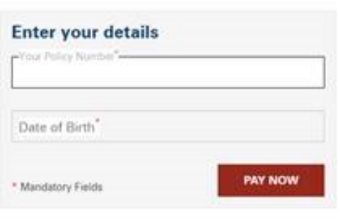

Only case signoff fields are displayed to the initiator. Case signoff fields are identified at the field level in the database as per the CSIS mapping section.
        - No flow of sign off pending cases is mentioned in document at this point. IT was supposed to be in the insuff and signoff process, however it has been created now and will be provided in this document.
All image controls to zoom in / out / rotate, etc to be provided on the left of the screen.
Ability to move all documents directly to insuff queue by pressing “Insuff document” button.
Tab order to be followed on all screens along with shortcut keys.
Documents attachment buttons and “Insuff document” button is not on tab order.
User can move one or multi-selected documents to insuff queue by pressing “F3” and option to be provided on right click “Move selected to Insuff”.
Once images are moved to insuff, they will be shown shaded / half transparency. Ability to right click again and “remove from insuff”.
To tag a document:
      - If one or more images are selected and a document button is pressed, all the selected images are tagged to that document. Reverse zoom of tag indicator to show that a document is tagged. E.g. JAF box will appear on 50% of the screen and in 300ms, will get to final small document tagging size.
      - Toggle tagging and un-tagging by clicking the document button for selected images. E.g. if user has already tagged four images to JAF, and then selects one image and clicks on JAF again, the image will be untagged. Zoom-in of tag and disappear to show that a document is un-tagged. E.g. JAF indicator box will increase size from small size to 50% of the screen in 300ms, and then disappear.
      - Images that are tagged show a semi transparent document name in both views on the top right corner.
      - By default and after tagging and un-tagging. Selection of images is removed. No image selected by default. Clicking on a blank area outside images deselects all images.
      - On clicking a document button, the tagged documents are displayed for that document.
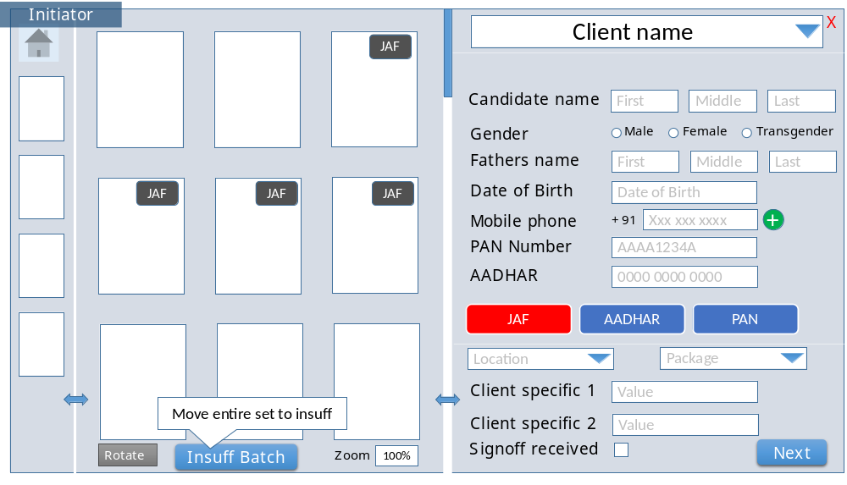
Single image zoomed in view
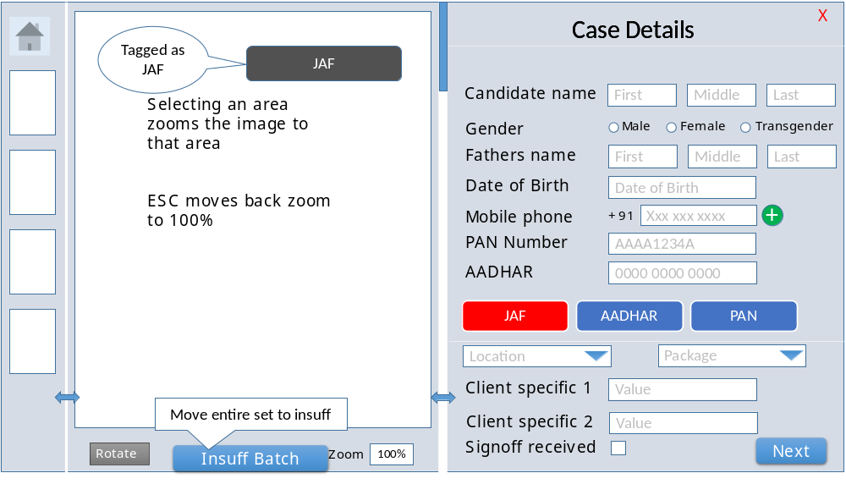

Mouse scroll on the image in zoomed view further zooms in or out from full screen view.
In this zoomed view, allow user to select an area of Wireframe for rubber-banding.
Selecting an area zooms the image to that area.
Double clicking on a text field performs the rubber-banding OCR and input into that field.
Perform system driven duplicity check while on this screen (document attachment section indicates end of duplicity check fields).
Duplicity check to be as per existing process (to be reviewed separately in the duplicity module)
Scanner / initiator to identify duplicate and choose among various duplicity outputs (No Duplicate / Mark as duplicate and continue / insuff document / mark Duplicate and Scrap).
Duplicity check screen to be shown if any duplicity is found. If no duplicity is found, next button on previous moves screen to case insuff screen.
There is no tab order or default button on this screen (to avoid mistakenly assigning case to duplicate or other status)
Duplicity check screen
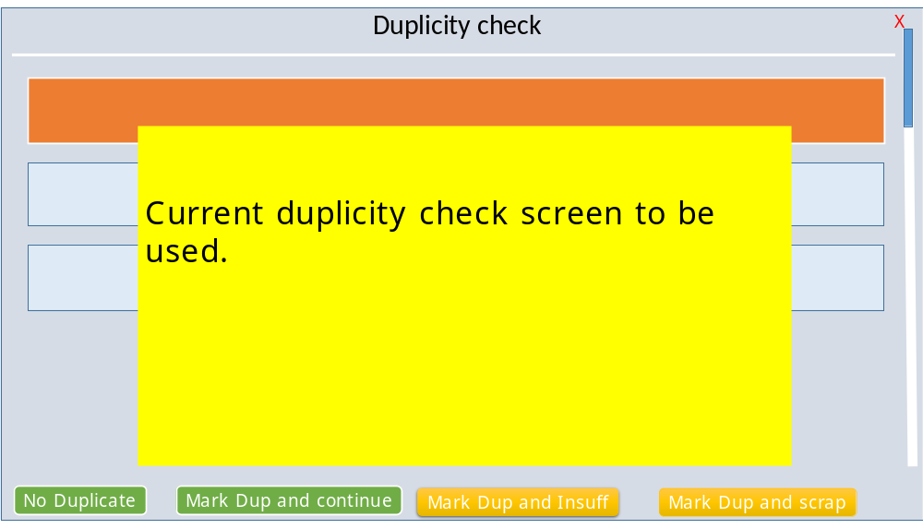

In case there is an insuff found, then the following “Case Insuff” screen is displayed. If not, the next case in the queue is presented.
User is allowed to go back to first screen and update any missing information. Duplicity check is run again in case any of duplicity check fields is changed.

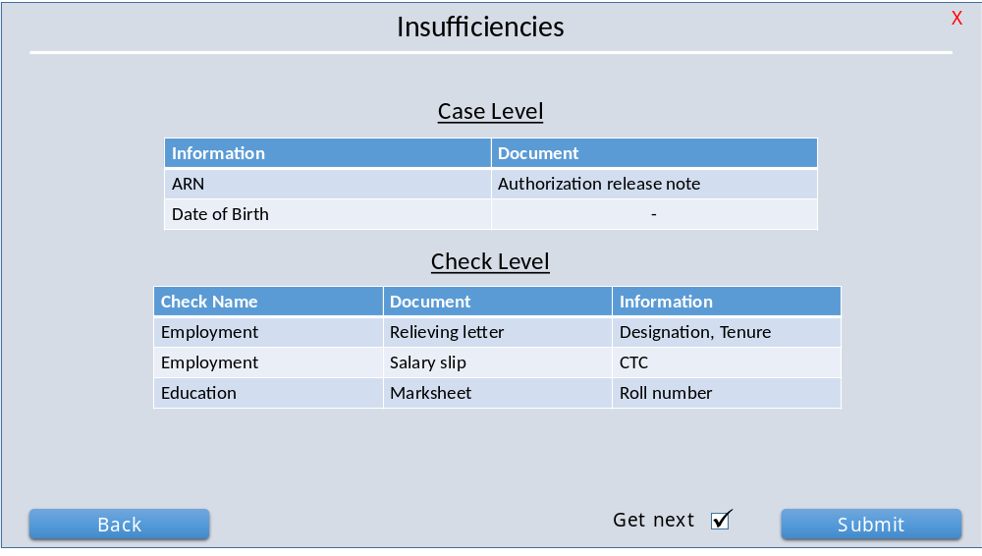
The get next checkbox is selected by default. In case the user unchecks it, the user is not presented the next case in queue and the user is transferred to the role selection screen.
If the user does not deselect the Get next check box, on submission, the next case is routed to the user.
The case is moved to case insuff/signoff queue and exception process followed as per current process. Once client signoff / insuff is fulfilled, the case is moved to D1.
System to check for field Validation
      - Check entered fields from:
        - NID check
        - Previous Duplicate tagged case
        - OCR from NID documents (Automated and not rubber-banding)
        - Items originally rubber-banded or OCR’d not to be re-validated with OCR. These will need to be manually entered for validation at D1 (next step).
  - D1 Data Entry
Data entry 1 to validate fields not automatically checked and entered by scanner.

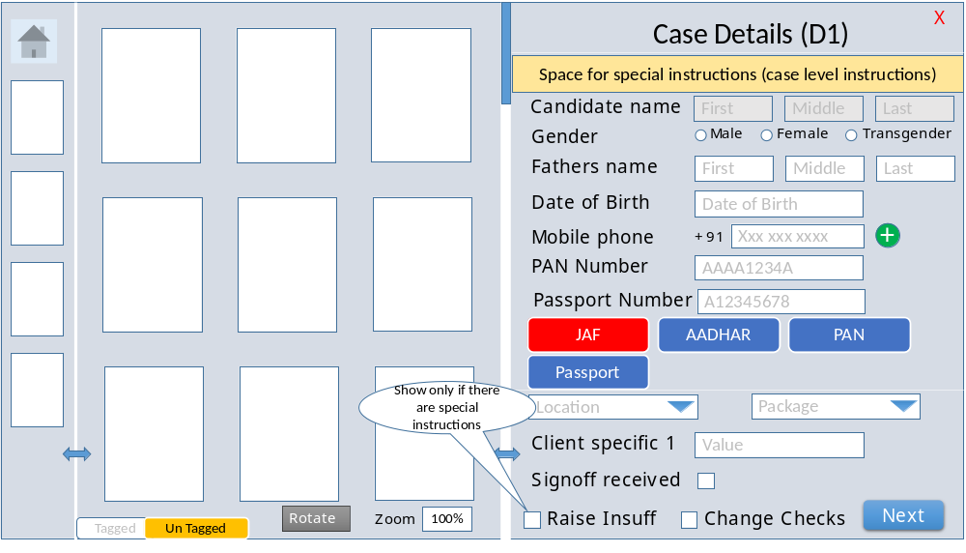

Add new fields that are required as per Antecedent Mapping – allow rubber-banding and OCR for new field entry.
Fields already OCR’d by scanner cannot be OCR’d / rubber-banded again.
Once case details are entered, check for match with original entry and highlight fields that do not match. Fields are highlighted with a red sign and different document mapping indicates document button in yellow color.
If “Change Checks” is selected for a package case: -
      - Selected checks will show on the left as per package while additional checks over and above package for the client show up on the right.
      - On selection of a check with “+” button on the right, moves the check to the left of the screen in selected checks group.
      - On selection of a check with “-” button, moves the check to the right of the screen in available checks group
      - Multiple checks can be added for Previous employment and Previous address. The “+” button will stay enabled in these checks. Other checks will disappear from available checks once selected and will show up in the selected checks list.
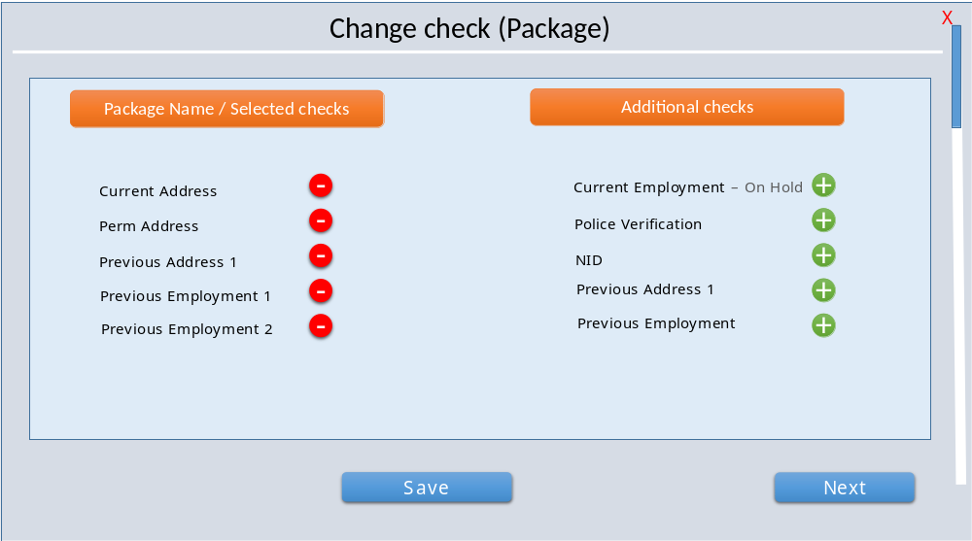

      - In case of “Check wise”, the following screen will appear. Check wise is a different package option that is selected at the client configuration during package creation.
      - The check wise process does not have specific checks mapped to it. On selection of check wise, the system will fetch all the checks mapped to the client and show them on the right hand side of the check selection screen. User will manually add the checks as required.
      - In case of check wise, the check selection screen will always appear at the D1 and D2 after the initiation screen:
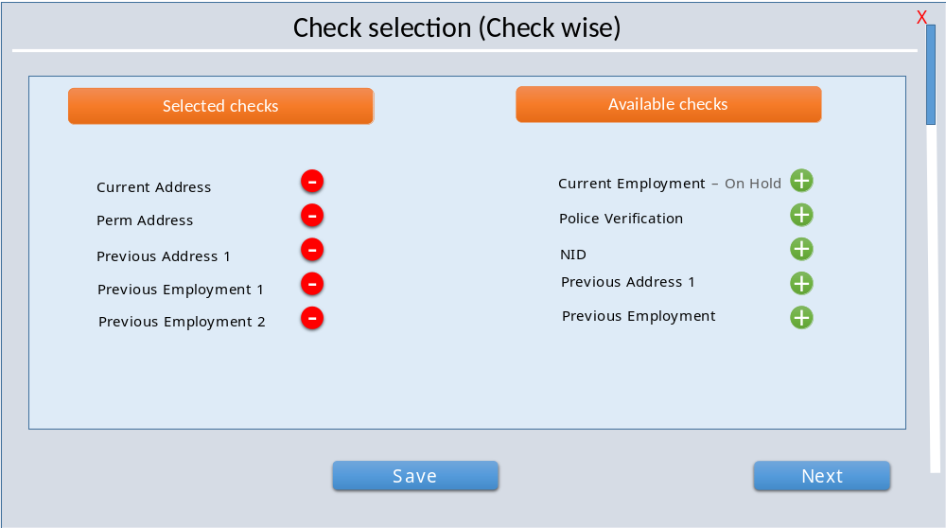
      - In case of mismatch, (additional/changed checks in package or different check wise selection), the following screen will show:
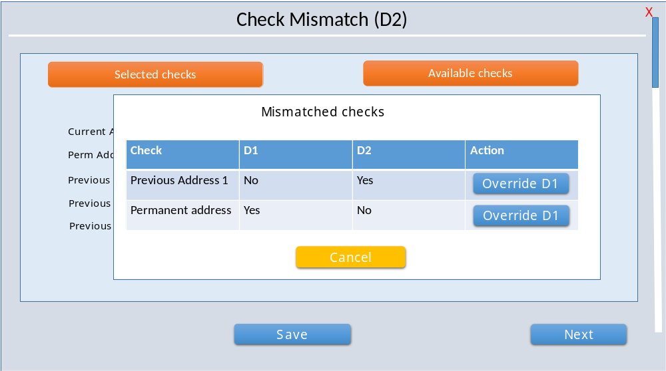

D1 First Screen
      - Fields offered for input based on priority(order) and grouping identified for various checks. (detailed in Section 4 - CSIS mapping and example attached as separate excel sheet in Annexure)
      - All case fields to be grouped and then antecedents for each check to be grouped.
      - Source to be selected at this stage for each check.
      - Education check - Source to be selected based on entry in any field – university, college/institute/address/pin code.
      - Source specific antecedes to be requested (show input field) from the D1 resource based on source requirements.
      - Provide special instructions for checks if they cannot be mapped in client logic (keep to minimum). This will also require a manual checkbox to indicate if insuff is required. Manual insuff comment also to be added (to be selected from Drop down).
      - Visual management – color coding:
        - Red – mandatory document not yet attached.
        - Blue – Non-mandatory document that could be attached.
        - Green – attached document.
        - Yellow mismatched document from previous entry (only provided to checker)
      - Send for research button to be added along with data entry fields.
        - Research Flow is Missing
      - Document buttons to be ordered in terms of priority as per the client mapping and document priority order.
      - If a mandatory document has been pre-tagged, it should open in the zoomed (full screen) view.
      - Once a document has been tagged, it moves into a separate tab for tagged documents.
      - All documents to be tagged to one of the available buttons for documents:
        - Grid view - Enable document selection on first click
        - Full screen view – Enable document selection on first click.
      - Subsequent documents:
        - Grid view – show selected documents on button click and enable selection/deselection by checking images. (indicate with solid border)
        - Full screen view – toggle tag/un-tag of image to that document. Indicate visually the tagging / un-tagging status with document name on image e.g. “Tagged as Aadhar card”.

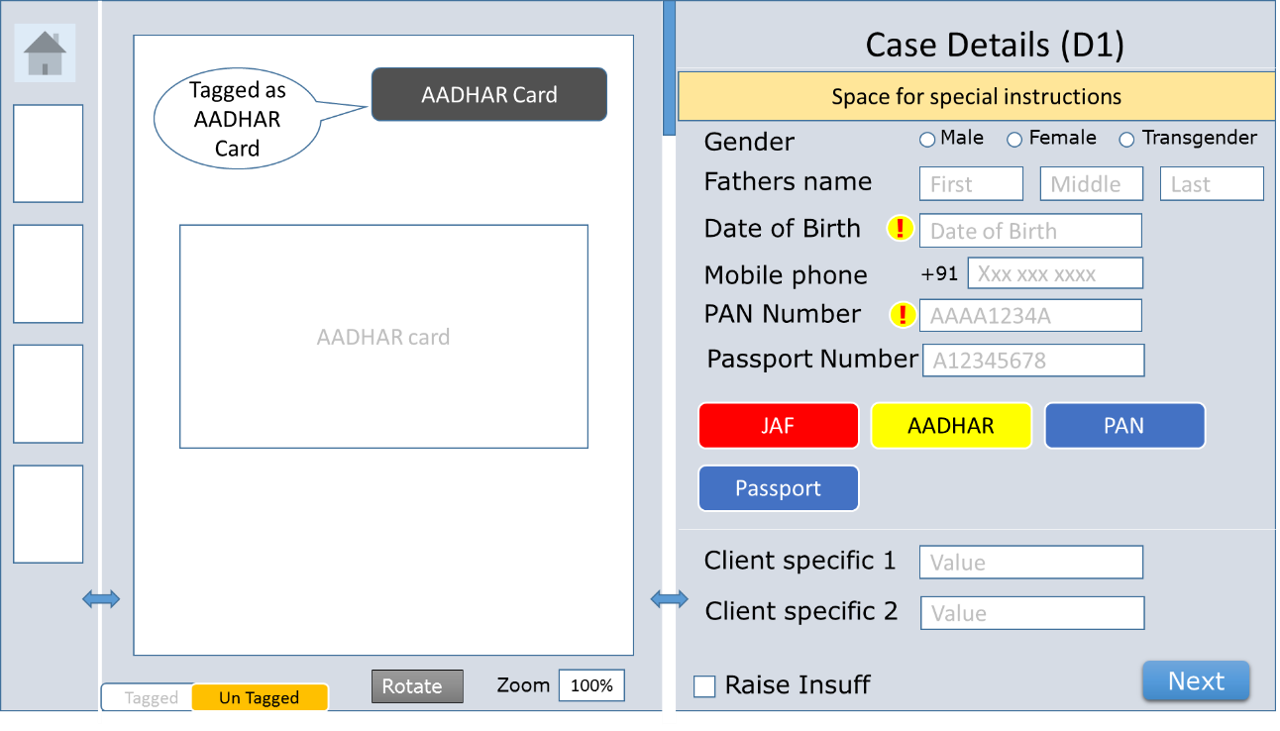
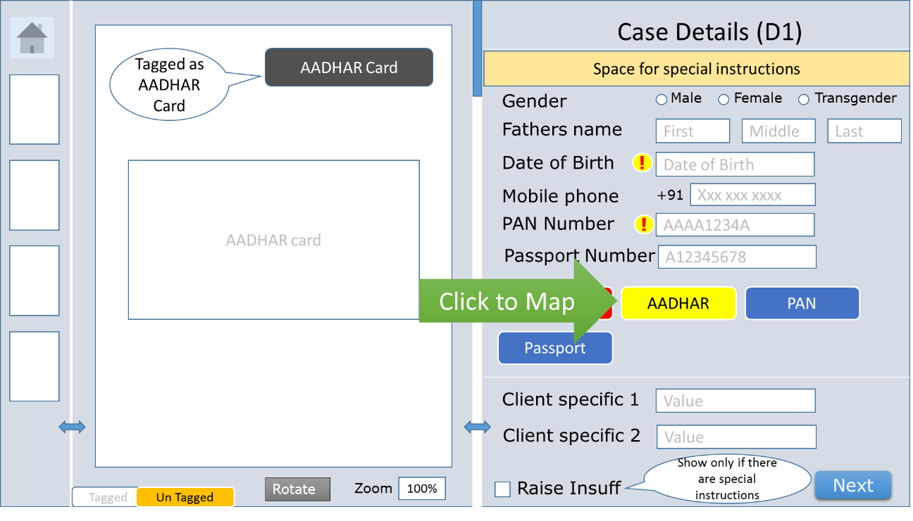

      - Field correction if different from first entry by scanner initiator: -
        - Scanner is not doing any data entry, Initiator did that.
      - First error field to pop up automatically.
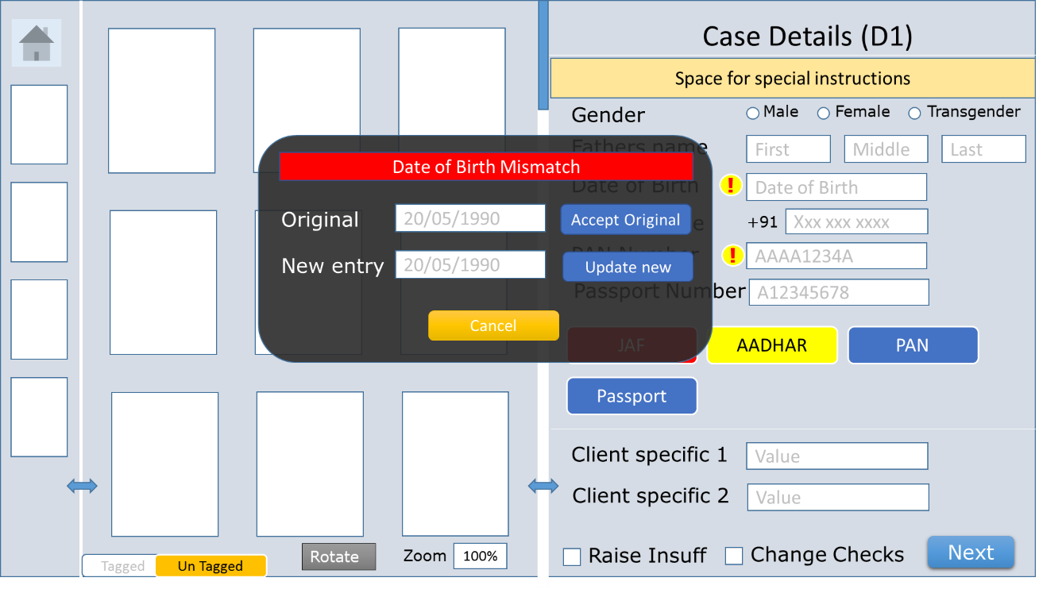
Document mismatch screen:

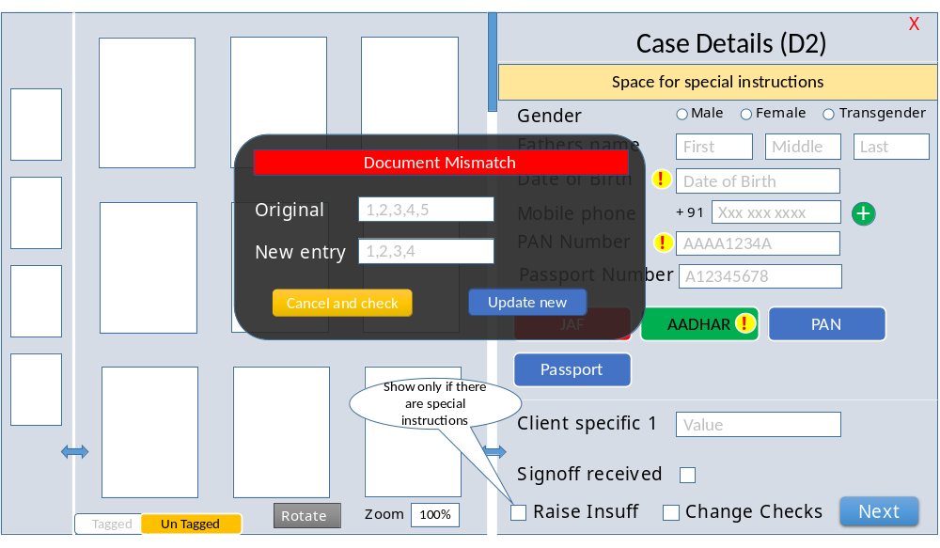
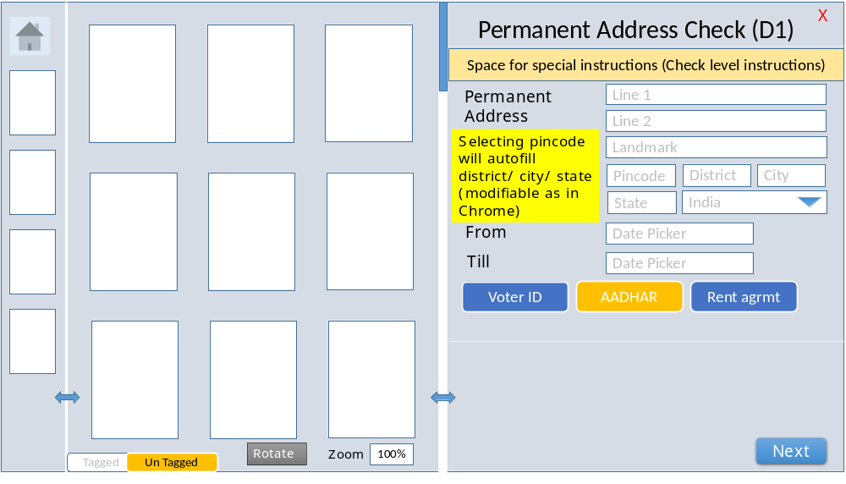
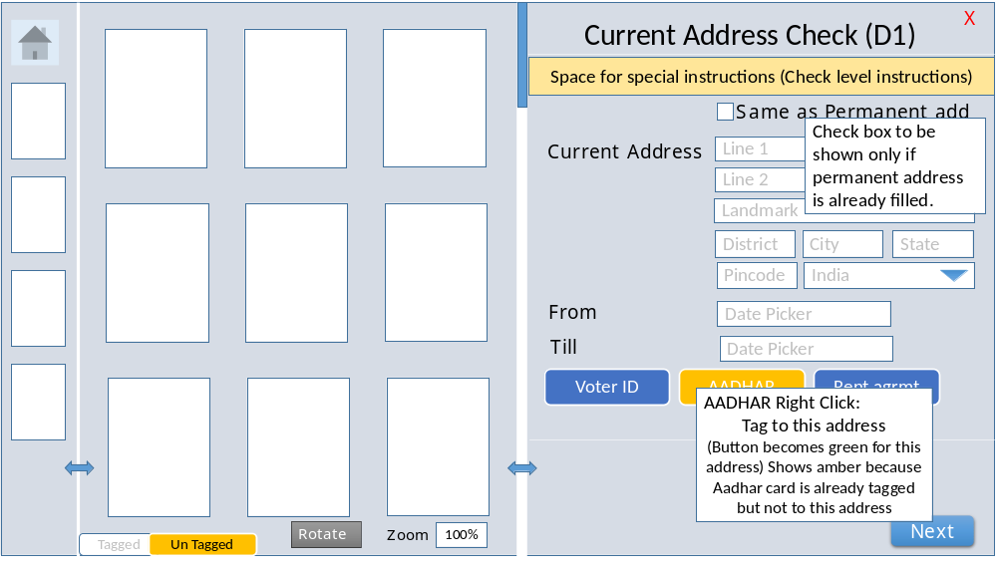
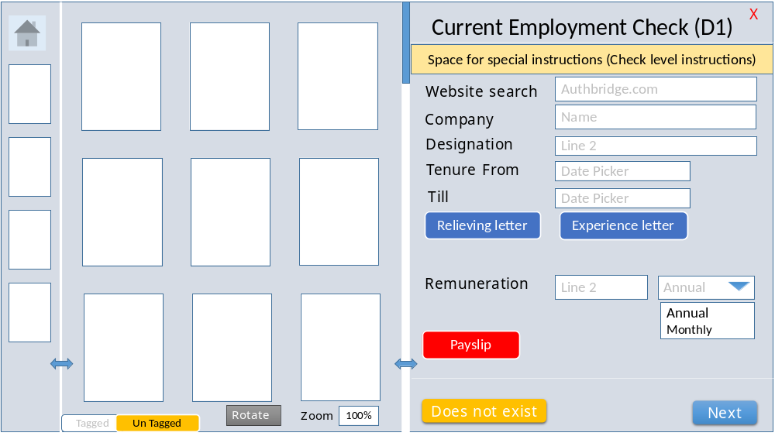
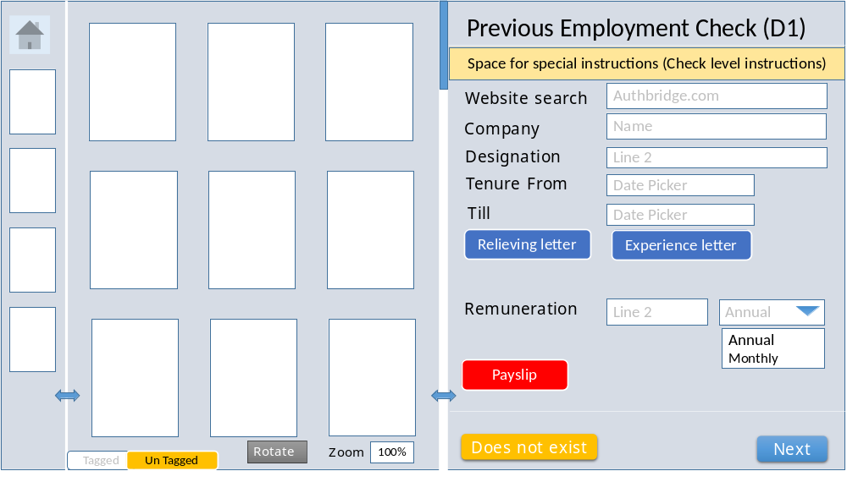
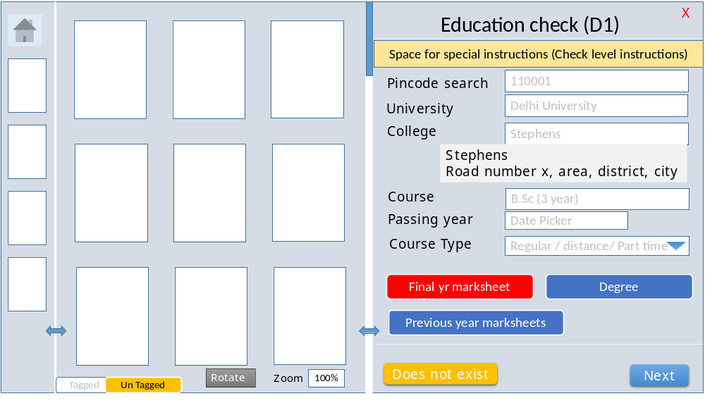

System Auto Check
System to auto-check any newly entered fields that can be checked with:
        - NID Check – Aadhar card and PAN card – all fields that can be validated from the NID will be validated.
        - Previous Duplicate tagged case
        - OCR from NID documents (Automated and not rubber-banding) Items originally rubber-banded or OCR’d not to be re-validated with OCR. These will need to be manually entered for validation at D2 (next step).
  - Data Entry D2
Data Entry 2 to enter fields which are not checked at D1 in case of variance and highlight to select correct input.
No rubber banding or OCR allowed at D2.
Variance will be highlighted on clicking “Next” button.
Option to be provided to correct field or accept original input (refer to same image as shown for D1 mismatch correction).
Similar screen for source selection.
Wireframe (same screen as D1 with Message):
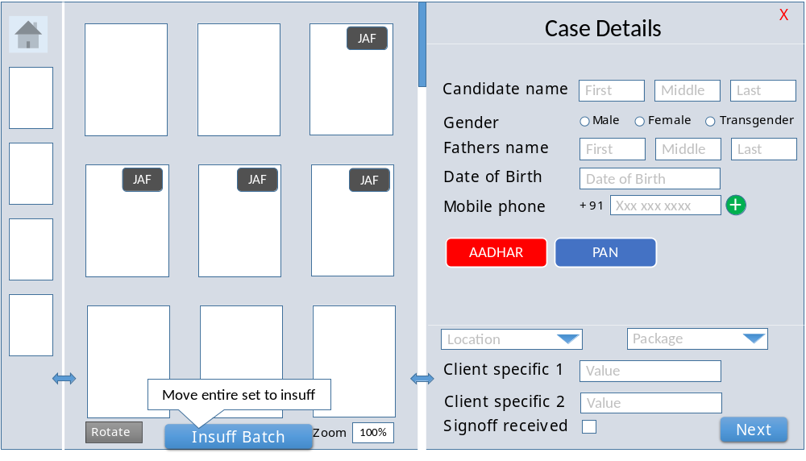
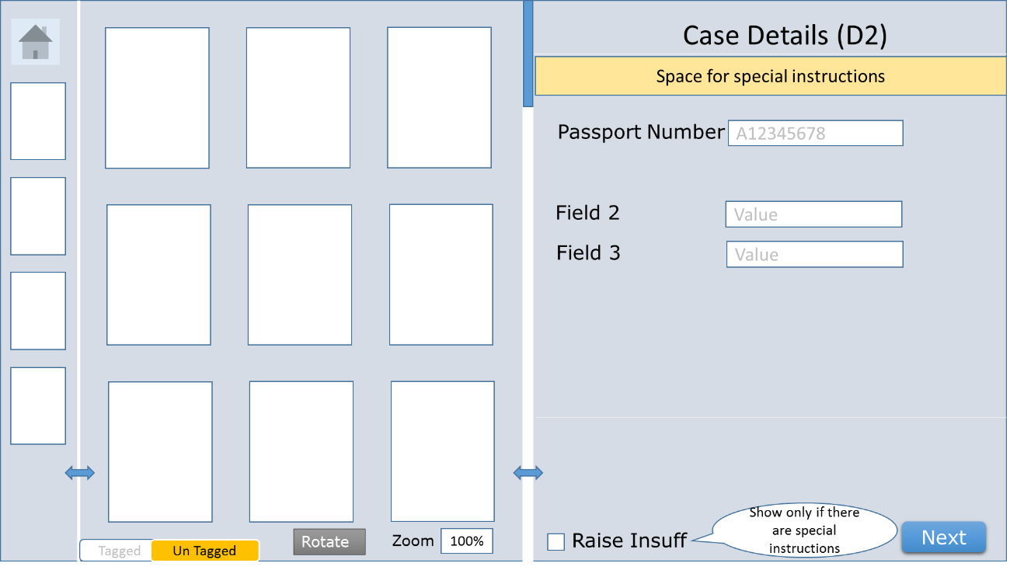
Expanded image:
The exclamation marks are to be shown after the field validation of each field (meaning the field has now been filled as per the required format) on pressing the “Next” button.
The original input of maker as well as checker should be saved for feedback.
A report to be created with start and end dates which will list all discrepancies
Maker User name | Original entry | Date-Time | Checker user name | Revised entry | Date-Time | Final accepted entry | Date-Time | Status
 |  |  |  |  |  |  |  | Accepted original/updated
Message to be provided in Red color on the screen on moving off from a field if it is different from initial input. Option to resolve on clicking the message.
History of change to be saved even if pop up is cancelled.
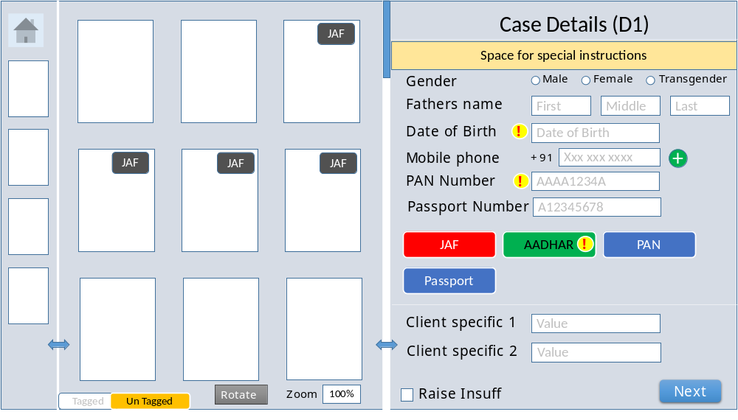
First field for correcting error is highlighted automatically.
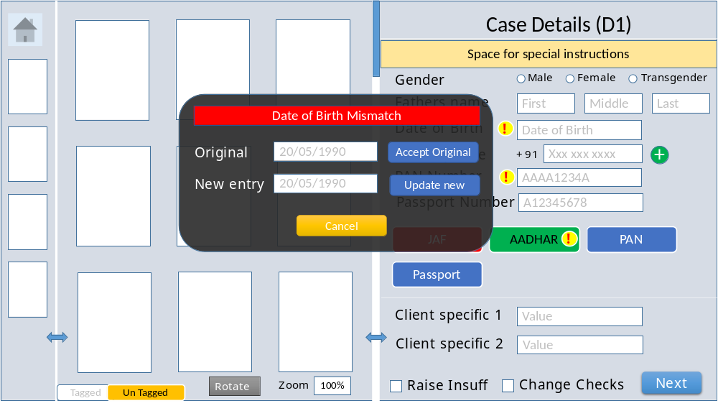
Document discrepancy to be highlighted as follows:
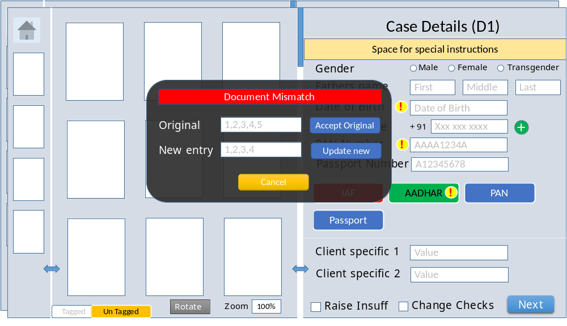
Page numbers to be added to the left bottom corner for all images.
Next button to be disabled till all the fields are resolved on the page.
Creation of Checks POST D2
For each check, system to validate if all documents and Antecedents are available. This is done based on the system antecedent-Document mapping.
Highlight all insuff at the last screen and provide the option to go back.
D2 to be validated with D1 insuff raised before submission, similar exclamation highlighted to D2 as antecedents. Case to be progressed if insuff of both D1 and D2 matches, else D2 to finalize the correct insuff. Since the checks are also validated at each screen for discrepancies, differences at this level would be rare.
Insuff decision to be made based on additional client logic – e.g. overseas employment check cost to be raised as insuff if blanket approval not there and co address is international. Client name disclosure – if source requires client name and client doesn’t give blanket approval. Example provided in annexure.
Default option (unless it is a red color code client):
        - Checks that have all required antecedents, documents and no other requirement from client exception table, are created and progressed to verification immediately.
        - Checks that do not have all required antecedents, documents or insuff due to any other requirement from client exception table, are created and progressed to insuff queue.
These check rules are subject to the client color codes as outlined below:
Verification to be initiated as per the client color code
        - Red- When Insuff is raised, all checks go on Hold.
        - Green- When Insuff is raised, other checks are processed and report is shared with Insuff status.
        - Grey- When Insuff is raised, all checks except Insuff checks are billable. This means that all completed checks are billable except the one with status as “Insuff”.
        - Yellow- When Insuff is raised, all other checks are processed but the report is not shared till the Insuff has been fulfilled.
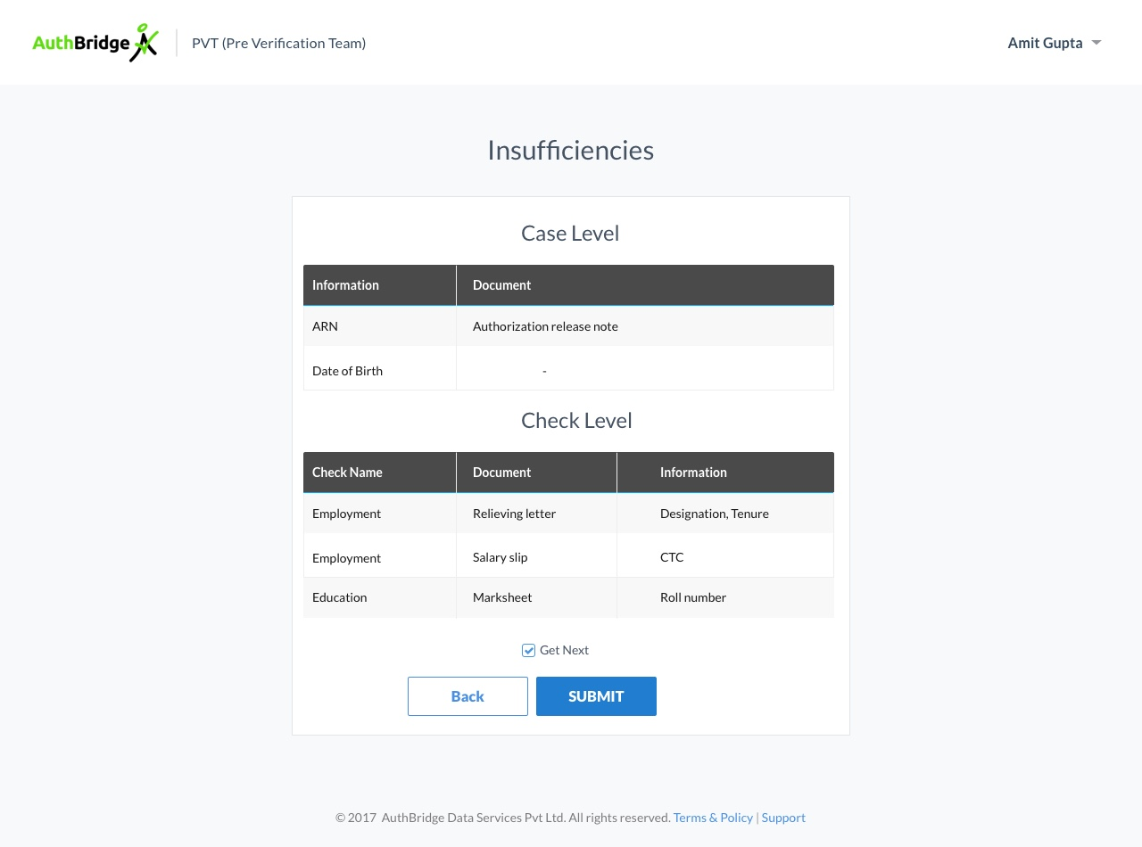
Each insuff to have a formal, verified client facing message. This message would be automatically applied to the insuff when it is sent to the insuff tracker.
  - Supervisory functions
Assign roles to agents.
Change any field or antecedent on any case regardless of the stage the case is in till end of PVT.
The case level values can be updated by supervisor. This will be included in the supervisory module.
Process/Location can not be updated and therefore autoselected checks will never change. If this is required, the case will need to be scrapped. This will be covered in Supervisor /CAT module.
Check level fields will be updated by verification supervisor. This will be covered in verification module.
Checks may be added or disabled by the supervisor / CAT team.
1)Ability to route a specific case to a specific agent for D1 or D2.
2)Ability to configure client wise D1 and D2 processing – agents will only have rights to specified clients.
- CSIS Mapping
  - There are a total of five master lists or tables:
Client and package master (Checkwise is also a package)
Check master
Source master
Antecedent master
Document master
  - Check, antecedent and document tables will have a mandatory relationship as well as a default order in the mapping of the specific client. For example, an address check may be mapped to Voter ID as the primary and mandatory document for a client. Another client may provide an order of documents in priority – first check for voter id, then aadhar, then passport.
  - Configuration of antecedent and document order needs to be provided at the client level. Mapping of documents to specific antecedents also needs to be client configurable.
  - Benefits of grouping in antecedent master:
Document linkage – antecedents of one group will have one set of dependent and mandatory documents in a specific order for a particular client.
Grouped antecedents will be shown together followed by documents for the group. Other antecedents will be shown independently with their respective documents.
Antecedent interlinkage – e.g. pincode can be used to pull up state / city.
  - These tables will be linked in the following manner:
Client and package master is linked to the specific checks applicable for the process/package. Check wise is mapped to all the agreed checks in the contract (Subsequently in bridge, use will need to select the specific checks). For all other packages, checks are pre-mapped and will be automatically selected once a package is selected.
On selection of a check, the pre-mapped antecedents for the check will be selected automatically.
Source is one of the antecedents for some of the checks.
Post selection of source for the check, additional antecedents for the source will be looked up. Sources will also be mapped to some required antecedents.
Once all the antecedents have been gathered, they will be de-duplicated in the order of checks – e.g. current address and PV both need the same antecedents, then we will only collect the antecedents once (at current check) and not show the PV check screen at all because we already have the required antecedents.
All this procedure and details are applicable for both stages of data entry.
  - Source selection may increase the antecedents or documents required. This will be at the specific check antecedent entry stage.
  - Exception rules by client to be stored separately (detailed in a table below after check-antecedent mapping image)
  - Verification Checks, antecedents and documents to be decided based on exception check.

  - Exception check to be done for each client for each check at the time of data entry. The exception list would need to be checked again at the time of insuff screen as there are some rules for insuff generation.

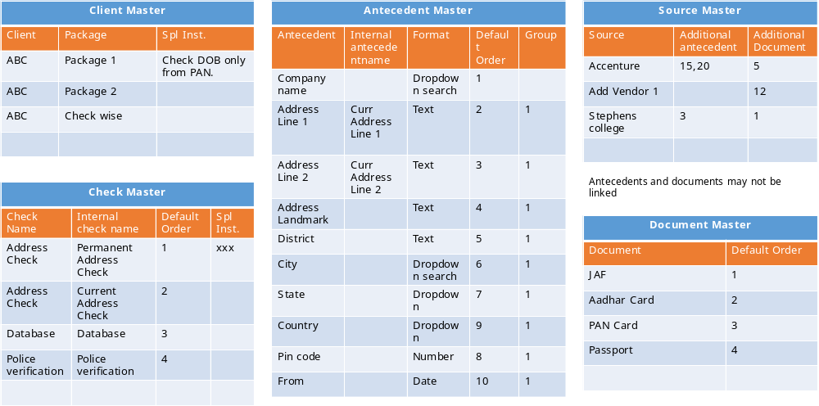

  - Exception rule master:
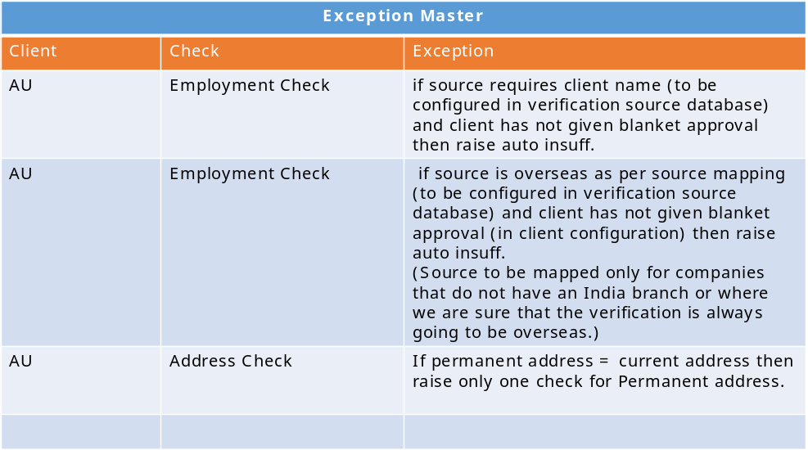
  - Client configuration table
These are all client configuration fields and indicate the requirement and type of requirement for the specific clients. These are not fields that will be shown on the form, but signoff/insuff/case routing decisions will be taken based on these fields.
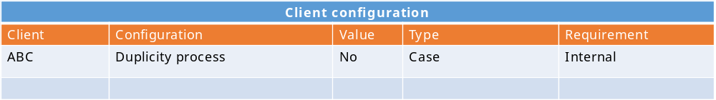
The second client configuration table indicates the client mapping to various fields, checks, antecedents and documents. It also includes some candidate and client level fields that need to be shown on the form.
The document mandatory field indicates the action to be taken in case the field is not available. E. g. in the below table, if JAF is not available for Line 1 for Address check, then a check insuff will be raised.
Second example: if recruitment manager is not available as per client signoff requirement, then it will go for Case signoff.
There are two levels of signoff/ Insuff. First is case signoff – where a case will not be progressed without the signoff being received. Second category is case insuff and check insuff - where additional information /documents are required for us to complete the case.
Maps all the relationships for the client
First level is package based check selection though all allowed checks for the client are mapped in the client configuration table – As is process that is being followed currently to identify checks for a certain package.
Lists all checks for client, antecedents for each check, and documents for each check, their priority and mandatory status are all saved in the table.
The antecedents are picked from here to show on the user screen for the check.
They are grouped as per the grouping identified in the table. Documents are aligned to groups or to individual antecedents (if not grouped).
Documents are shown below each group of antecedents.
For insuff identification – if there is a document then it is a document insuff. If there is no document, then it is a field insuff.
Mandatory and priority order is taken from the configuration table.
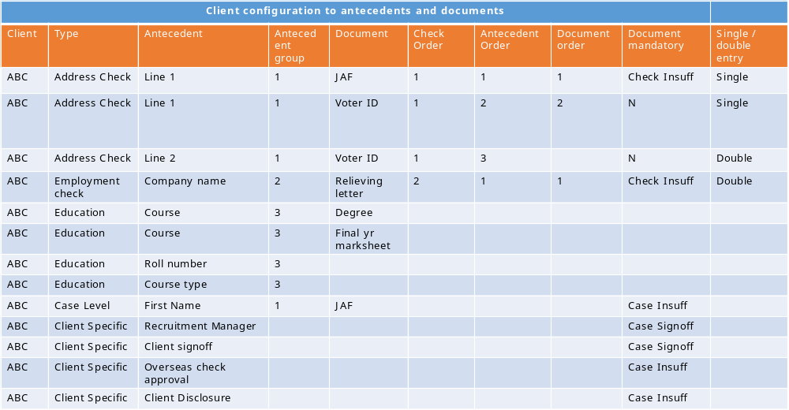
- Time Tracking
  - At this stage, individual cases have been identified from all types of bulk upload.
  - Following times are automatically captured for each case:
CASE RECEIVED DATE & TIME: When AuthBridge received the Case. The catch creation time is used for the case creation time. This is captured by System automatically, except Hard Copy Cases. Scanner to capture received date from Calendar Option with Time function
CASE INITIATION DATE & TIME (OPTIONAL): When Case is released by PVT – This is AUTO-LOCKED. While this is end of D2 step, if it is easier for queries, this date and time can be saves separately as it will be used frequently for reporting – IT’s decision.
SIGN-OFF RECEIVED DATE: When Sign-Off is received. If Sign-Off is available at the time of initiator, Sign-Off Date = Case Receive Date for reporting purposes. However original case received time is also stored and not overwritten by signoff received time. Case history show show time for each incident including start and stop times for each step.
TAT START DATE: Date when TAT would start for Client and AuthBridge. If Document is received till the Cut-Off time of the respective clients, (1500hrs or 1800hrs – Client Specific) it will be taken as same date. Else 0900hrs of the next Business Day / date (Monday to Friday) (TAT will be calculated on Sign-Off Date). Based on client configuration.
  - Automated time tracking guidelines
Time to be captured and saved for start and end of each step activity.
Time to be captured for the start and end of each user touch on each case.
Escalations to be configurable for reporting wait time at each step, items waiting at each step. Escalations Will be provided separately in reporting module, only provided as additional information here.
One summary report that will show real time items waiting at each step, average time and max time waiting at each step. Steps to be split into client type.
This report should also be color coded as per configurable limits. Format as follows
Step name | Client type | Items waiting | Max wait time (EPWT)  HH:MM | Average wait time  HH:MM
Email batch creation | Fast track | 200 | 200:30 | 120:15
Email batch creation | High Priority
Email batch creation | Normal
Email batch creation | All
CASE Batch creation | Fast track
…

- Overall validations
  - All name fields
  - Name
Name to be in three text boxes: first name, middle name, last name.
All three fields stored separately in the database to allow for searching/ de-dup in individual components (first name only / last name only) as well.
Three text boxes with placeholder text as first, middle and last.
Do not allow entry of dis-allowed characters.
Max char limit 50 for each of the three fields.
All address fields to be in the following format: line 1 (mandatory), line 2, landmark, district, City(mandatory), state(mandatory), Pin code, Country (India by default - Mandatory).
NID to be in respective standard formats –
Aadhar format: 12 digit all numeric.
Passport format: starts with character and remaining numbers
PAN card format: (5 characters + 4 numbers + 1 character) – do not allow characters in number spaces and vice versa.
Date and date-time fields: to be filled with date picker calendar control and allow direct entry as long as it is a valid date. Time also to be picked through the same control - Time format to be HH:MM AM/PM.
Mobile number:
10 digit mobile number for India (Default). Limit to 10 characters.
India mobile number does not begin with 0.
Country code to be present before mobile number and +91 selected by default. User needs to manually change country code if required. Provide a prompt “Are you sure you wish to change the country code” Yes/No. No defaults back to +91.
Country code drop down is not in tab order.
No alphabetical characters or special characters allowed.
Email address:
check standard email validation for “@” and ”.” in mid-string, @ before last ”.”, no numbers after ”.”.
Age less than 18 years to be sent for customer signoff / declined.
All phone numbers to be stored in separate fields (not comma separated). Mobile phone 1, Mobile phone 2, landline 1 (text with extn), other phone. Standard format : (+xx) xxx xxx xxxx.
- To Be Process Flow Chart
        - Below flowchart is in-complete and some sections/modules and not mentioned in this

