**Launch EC2 instance**

**step 1:Create ec2 instance in public subnet:**

1. **Sign in to AWS Console:**

In AWS Console search for EC2 and click on that service, you will redirect to the AWS EC2 page as follows and then Click on ****Launch Instance.****

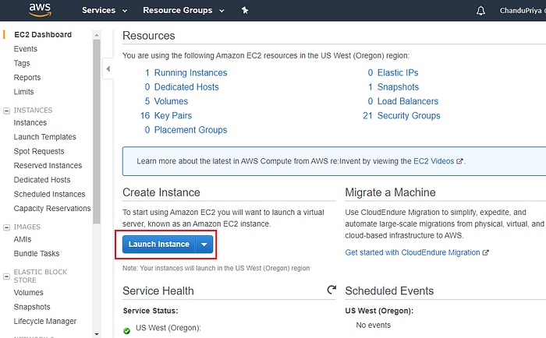

1. Choose Amazon Machine Image (AMI):

Select an Amazon Machine Image. For example, you can use the latest Amazon Linux 2 AMI.  
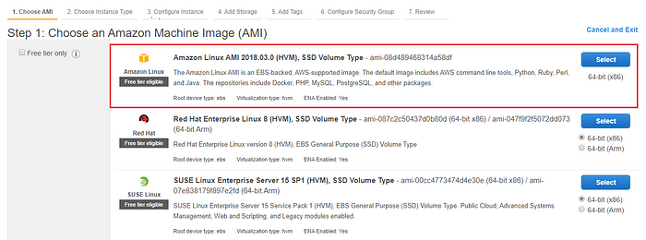

To run EC2 successfully, select an Amazon Machine Image (AMI). AMI contains all the software configurations (operating system, application server, and applications) required to launch your instance. In this case, we will pick Amazon Linux AMI.

1. Choose Instance Type:

Now, select the Instance Type that determines the type of CPU, storage, network capacity, and memory needed during the installation. Choose t2.micro, and hit the next button as shown below:

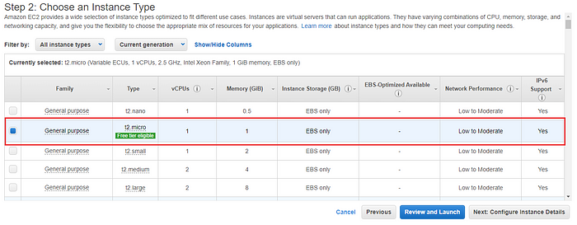

Click the next button until you reach to the Configure Security Group page to retain the default settings. A security group is a set of firewall rules that control the traffic for your instance. On this page, you can add rules to allow specific traffic to reach your instance.  
****For example,****if you want to set up a web server and allow Internet traffic to reach your instance, add rules that allow unrestricted access to the HTTP and HTTPS ports.

Enter the Security Group name and then hit the ****Review and Launch****button

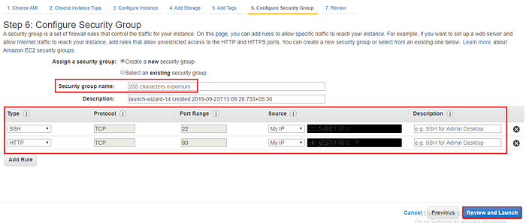

After hitting the ****Launch button**** you will see a pop-up page that requires you to select a Key Pair. This contains both a public and private key folder that is used to connect to your EC2 Instance securely via SSH. Click on the “create a new key pair” button and give name to the key pair. Go ahead and download your key pair.

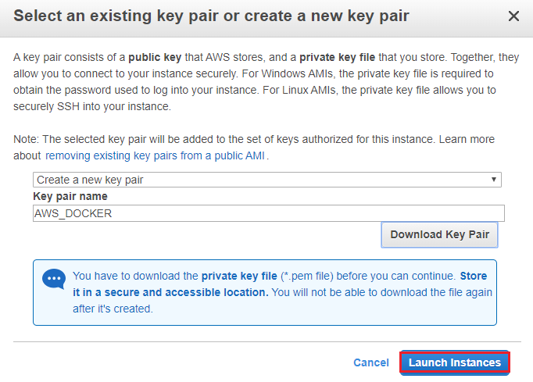

Save your key file to a safe place on your system and then click on Launch Instances, it will direct you to the launching page. Hit the “View Instances” button to access the EC2 Instances page.

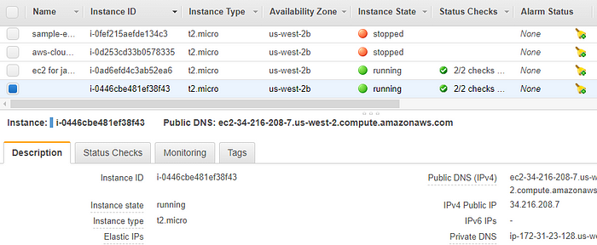

In this page, you can see the details of EC2 Instances present like public address and launch time.   
Copy the IP address, because you will use it on SSH to install Docker.  
  
**step 2: installation of Docker :**  
  
connect to ec2 machine by ssh/session connect.  
  
1. Install docker on ec2 machine:   
  
commands:  
$ sudo yum install -y docker  
$ sudo service docker start  
$ docker info  
$docker login ---->> login with username and password.