**Practical 8**

**Aim: write a c program to implement scan algorithm**

**Theory:**

**SCAN (Elevator) algorithm:**In SCAN disk scheduling algorithm, the head starts from one end of the disk and moves towards the other end, servicing requests in between one by one and reaching the other end. Then the direction of the head is reversed and the process continues as the head continuously scans back and forth to access the disk. So, this algorithm works as an elevator and hence also known as the elevator algorithm. As a result, the requests at the midrange are serviced more and those arriving behind the disk arm will have to wait.

**Advantages of SCAN (Elevator) algorithm:**

1.This algorithm is simple and easy to understand.

2.SCAN algorithm has no starvation.

3.This algorithm is better than FCFS Scheduling algorithm

**Disadvantages of SCAN (Elevator) algorithm**

1.More complex algorithm to implement.

2.This algorithm is not fair because it causes long waiting time for the cylinders just visited by the head.

3.It causes the head to move till the end of the disk in this way the requests arriving ahead of the arm position would get immediate service but some other requests that arrive behind the arm position will have to wait for the request to complete.

**Algorithm-**

1. Let Request array represents an array storing indexes of tracks that have been requested in ascending order of their time of arrival. ‘head’ is the position of disk head.

2. Let direction represents whether the head is moving towards left or right.

3. In the direction in which the head is moving, service all tracks one by one.

4. Calculate the absolute distance of the track from the head.

5. Increment the total seek count with this distance.

6. Currently serviced track position now becomes the new head position.

7. Go to step 3 until we reach at one of the ends of the disk.

8. If we reach the end of the disk, reverse the direction and go to step 2 until all tracks in the request array have not been serviced.

Code:

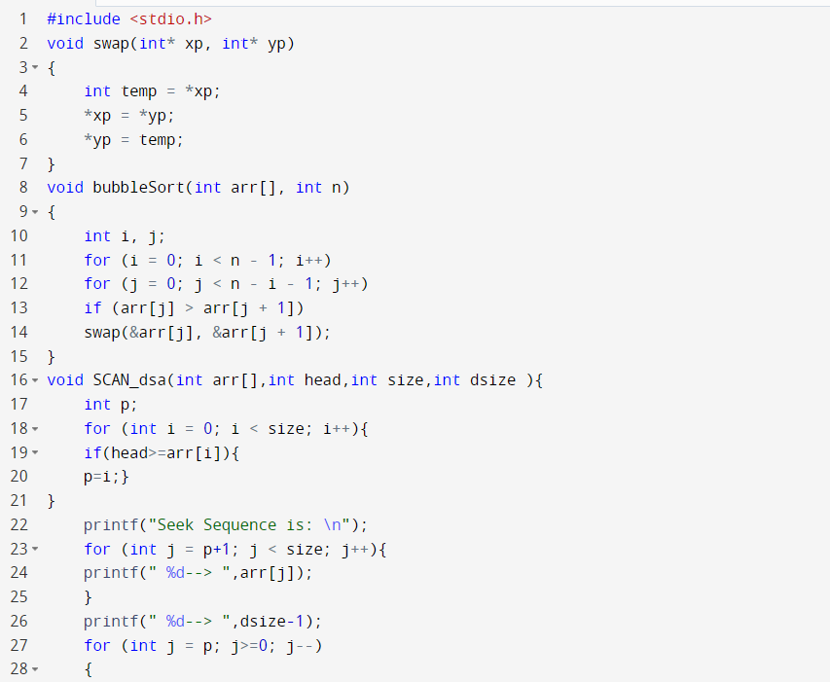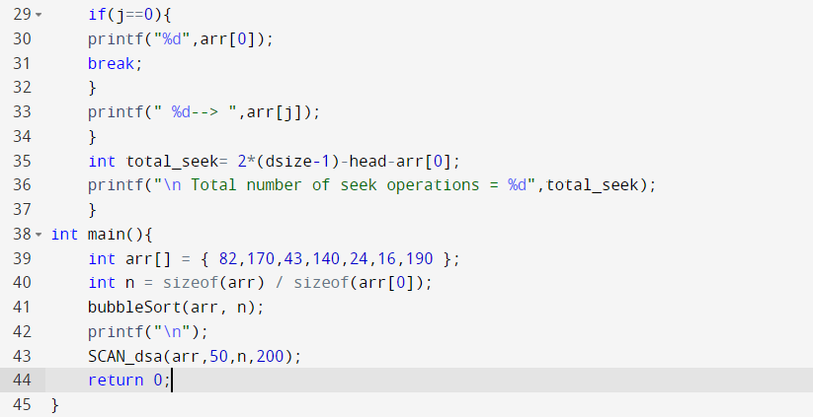

**Output:**

