CI/CD Pipe Line workflow

Step Go to action menu

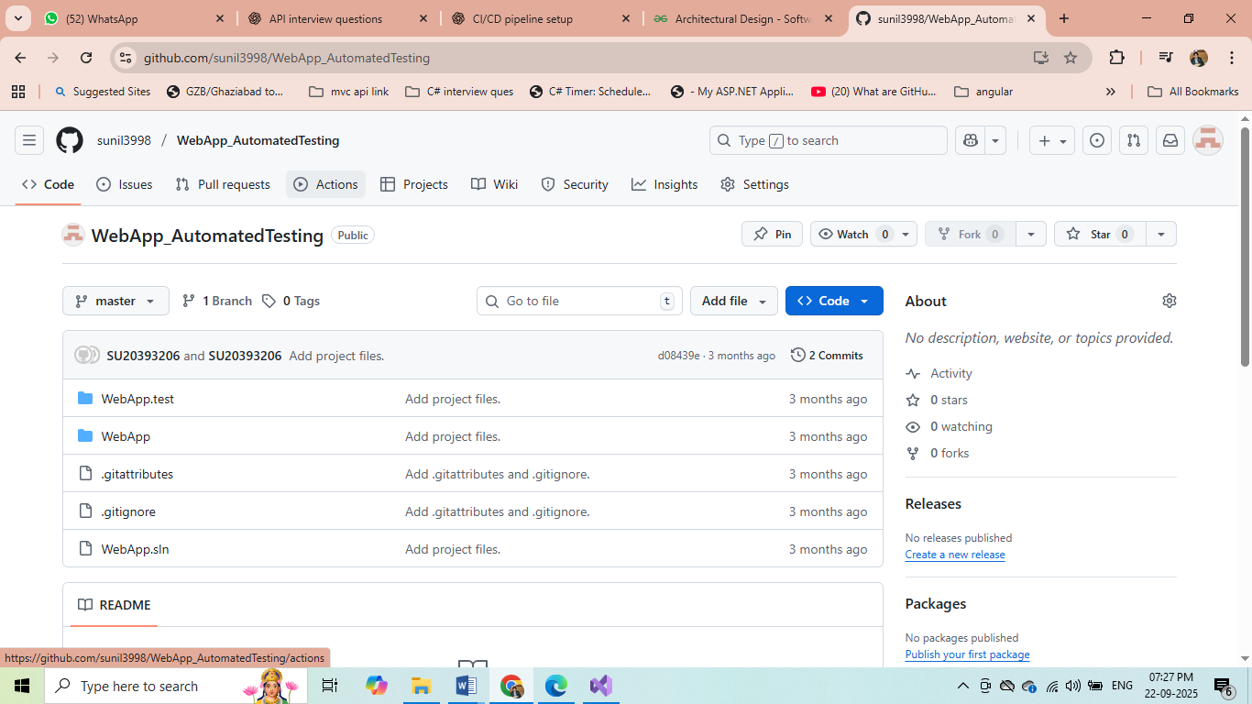

Click on set up a workflow yourself

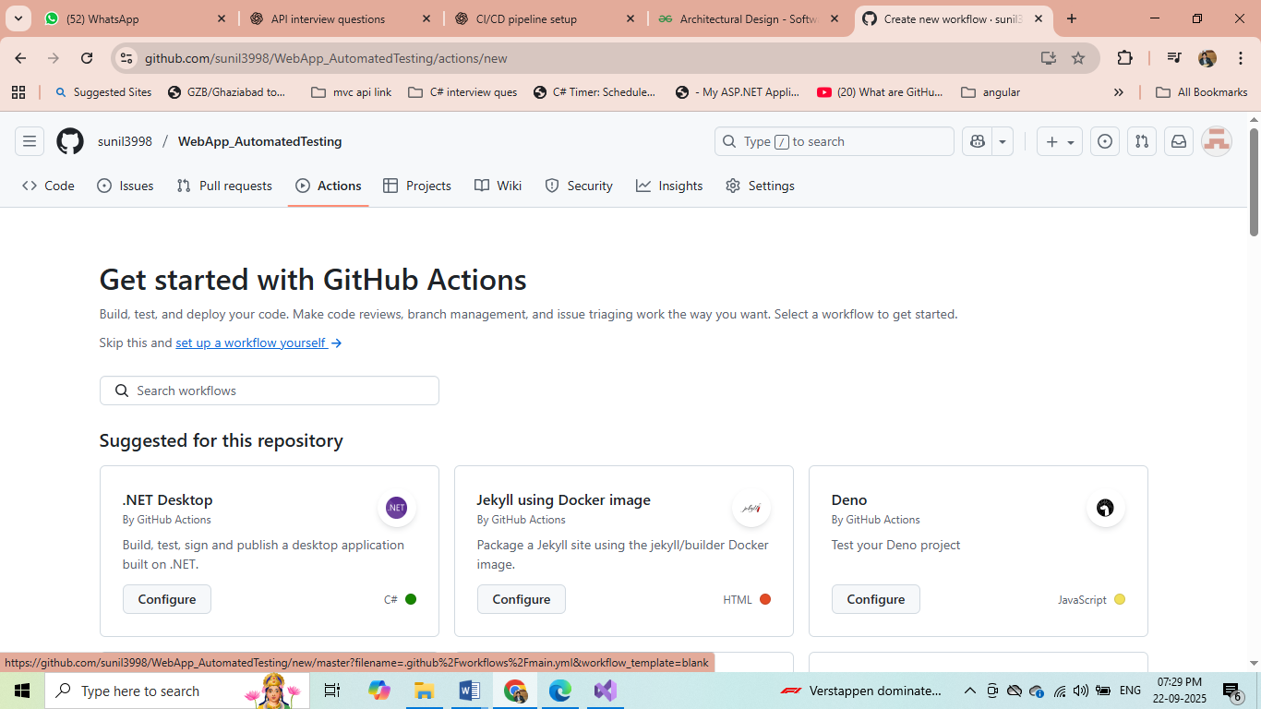

name: Web-App-Automated-Testing

on:

push:

branches: [ master ]

pull_request:

branches:

- master

workflow_dispatch:

jobs:

build:

runs-on: ubuntu-latest

steps:

- name: Checkout

uses: actions/checkout@v5.0.0

- name: Setup .NET Core SDK

uses: actions/setup-dotnet@v5.0.0

with:

dotnet-version: '9.0.x'

- name: Restore dependencies

run: dotnet restore

- name: Build

run: dotnet build --no-restore

- name: Test

run: dotnet test