Initial Screen:

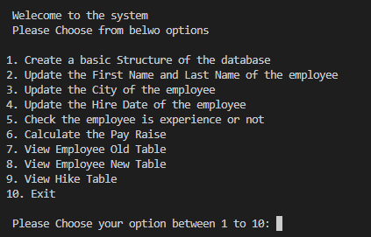

Inital Infra created:



Hike Table:

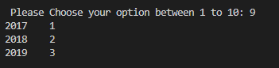

Employee New Table:

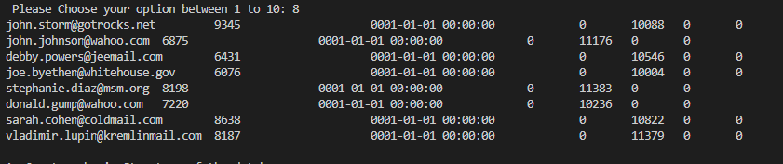

Old Employee Table

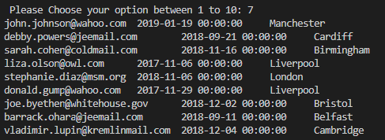

Updating the Employee 1st Name and Last Name from email id in Employee New table:

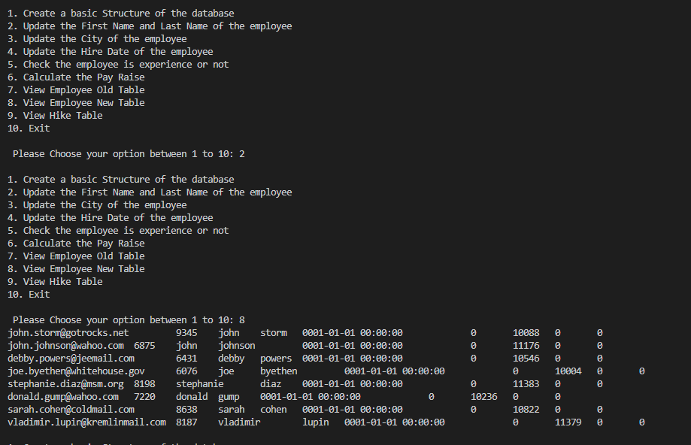

Updating the City in the Employee New Table

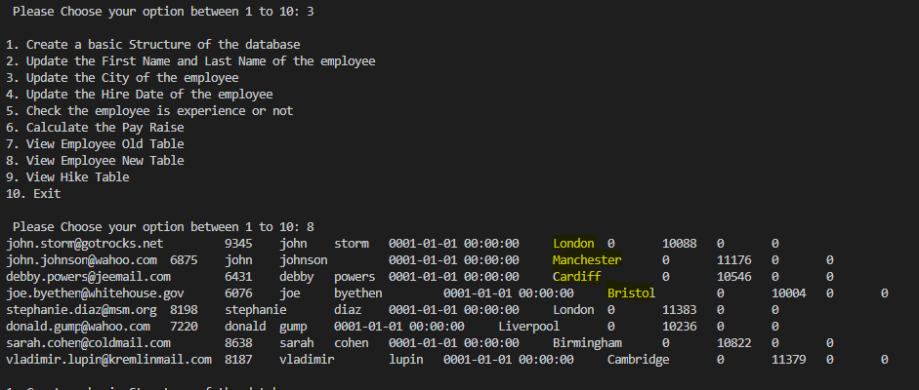

Updating the Hire Date

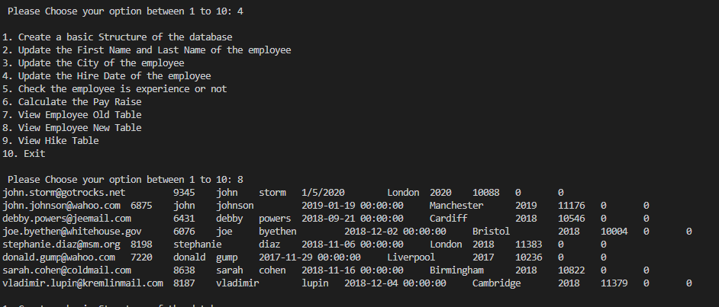

Checking the Experience and Non Experience

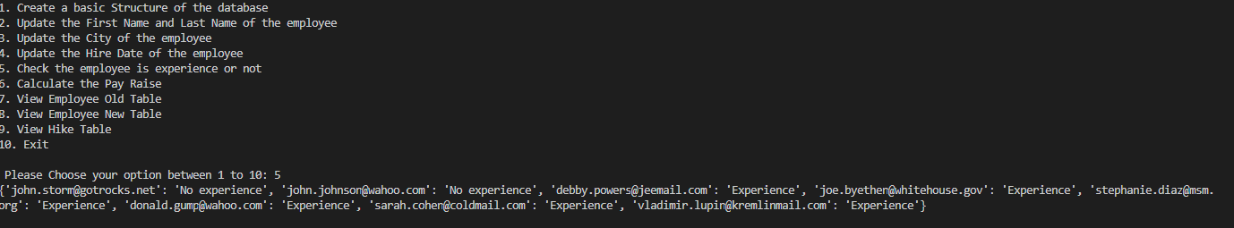

Update the Hike

