Report of week1 Exercise

Exercise 1.

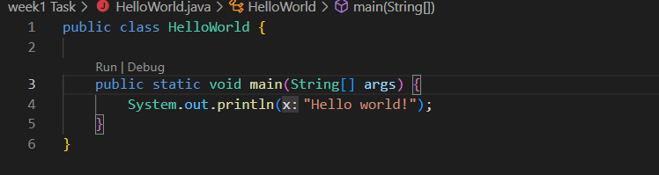

In the above program first, I created a file name called HelloWorld.java and then I defined a class HelloWorld after I defined a print statement that can print to the console and print a line 0f code that executes a task and is terminated with a;

Exercise 2.

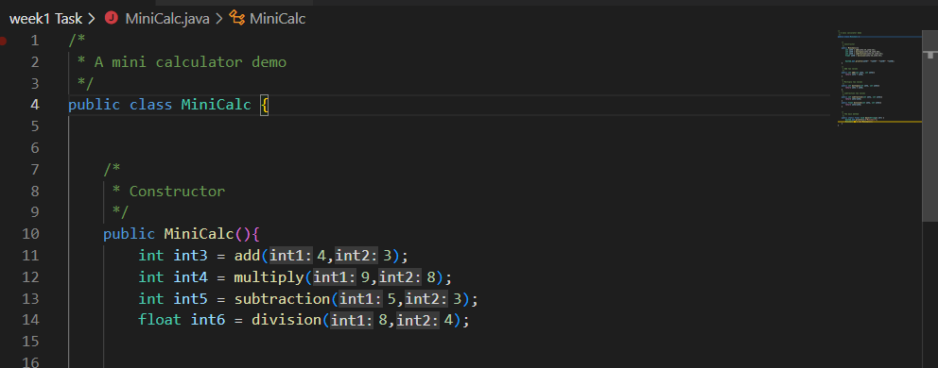

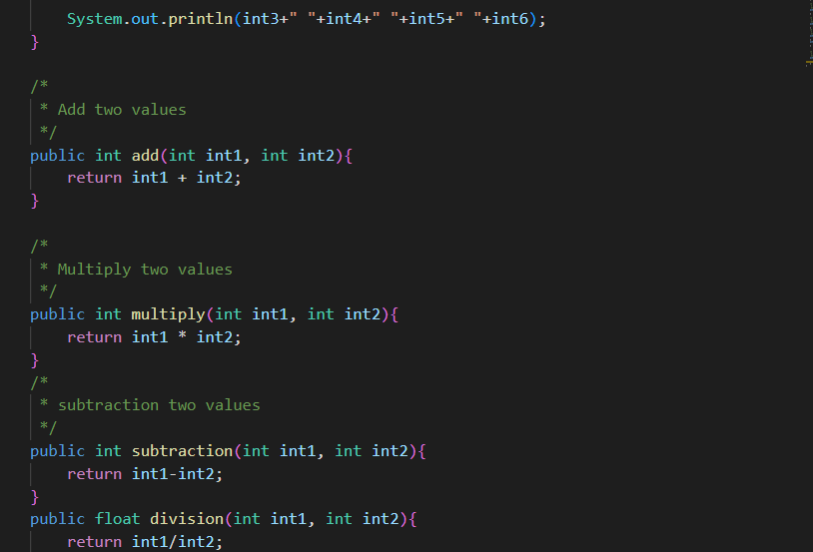

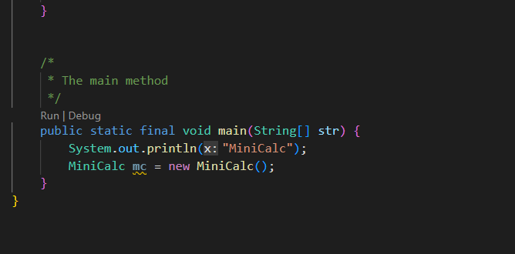

In the above program at first, I created a file name called MiniCalc.java and then I defined a class name called MiniCalc class which is same as file name and then I defined a constructor called MiniCalc. Then I declared a variable with the appropriate data type that is integer and float type. After that I declared a sum, multiply and subtraction ab division function and added two numbers and return code, multiply two number and return code, division of two numbers and then subtraction of two number and return code and then I declared a main method function and I defined a print statement to print MiniCalc and then I declared a MiniCalc mc. new MiniCalc () which helps to creating an object.

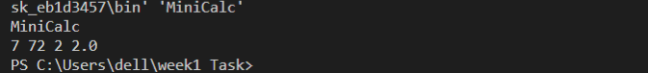

Exercise 3. Conversion of gallons to litres.

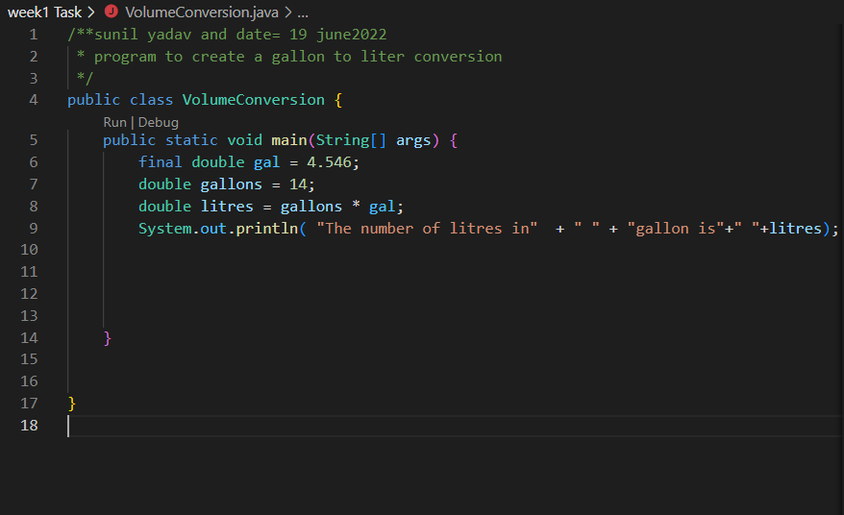

In the above program first, I created a file name called VolumeConversion.java and then after this starting my code, I defined a class name called VolumeConversion class. Then I declared a main method. In method, I initialized a variable of constant value with appropriate data type that is double then I defined a print statement to print the text what I want from them.



Exercise 4. Write a program to add together the following marks and find the average.

45,56,34,89

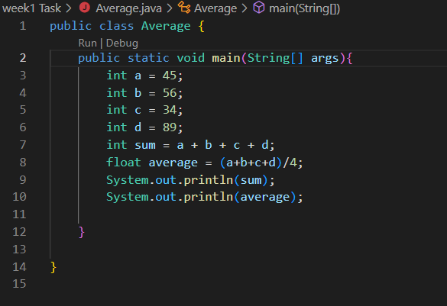

In the above program at first, I created a file name called Average.java and then starting my code, I declared a class name called Average class which is same as file name then I defined a main method. In method I declared a variable with some value and with appropriate date type that is int and then I initialized a sum with appropriate data type and then I declared an average with data type float which store decimal value. Then I defined print statement to print the value of sum and average.

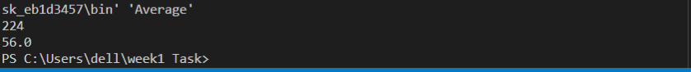

Exercise 5.

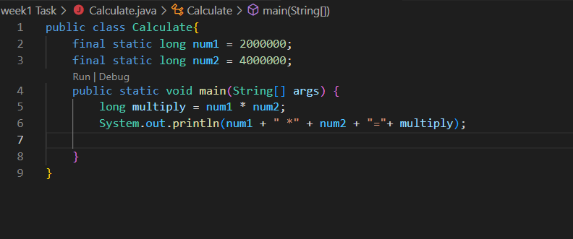

In the above program at first. I created a file name called Calculate.java and then after that starting my code, I defined a class name called Calculate class which is same as file name after that I declared a variable that is num1 and num2 for constant value with appropriate data type that is long then I defined method. In method I declare multiply variable with type long and after that I declared print statement to print the multiplication of two constant value.

