**Introduction :**

ZCG Assignment App is a Simple Demo Android application built to demonstrate the use of Modern Android development tools.

Application hits the data from the below APIs:

<https://jsonkeeper.com/b/5BEJ>

The above API provides a JSON with list of blocks where each block is of different type, Filter the section types from the json and render them accordingly.

**Application Acceptance Criteria :**

* App needs to be developed in native and completed ( project completion > great UI)

• Below designs are for reference and can be made better if felt.

• Smooth UI without any crashes.

• No app freezes.

• The assumption is that the API provides the blocks in any order, the solution should handle it accordingly.

* The number of blocks can be more hence it Is vertically scrollable.
* We highly recommend using Kotlin as programming language.
* No restriction on the library usage for common functionalities like Image loading, networking , parsers etc.
* Follow standard design practices while implementing.

**Application Problem Solution :**

Application uses MVVM architecture patterns and Jetpack Components (Compose UI, Coroutine, Material3) to solve the problem statement with the below points:

* + Pull To Refresh functionality
  + Fetch API data using Retrofit library
  + Parse data using Gaon library
  + Build UI using Compose UI Framework
  + Handling Concurrency through Coroutines framework
  + Handling edge cases ( No internet / retry)
  + Unit testing

**Application Tech Stack:**

* + MVVM Architecture Pattern
  + Jetpack Components
    - Compose UI
    - LiveData
    - Coroutines and Flows
    - ViewModels
    - Material3 Library
    - Koin Dependency Injection Library
  + Retrofits and OkHttps Library
  + Unit Testing
    - JUnit
    - Mockito
    - Roblectric

**Application ScreenShots :**

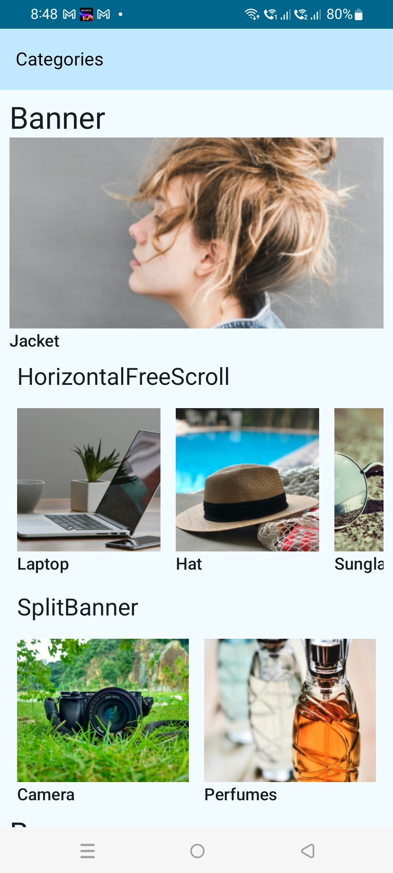

**Reference Documents :**

The below reference documents are provided for app:

* + Android APK file (***AndroidZCGAssignment.apk***)
  + App Guide
  + App Source Code