**Overview**

Flickr Photo Application is search functionality application which has following functionalities as below :

* Display Search Functionality
* Fetch Data form Flickr public API
* Display collection of photos from the search results
* Implement infinite scrolling on the search results

This Application follows the MVVM architecture along with repository as abstraction layer which interacts with network to fetch the data using Flickr public API as JSON format. It uses Android paging library to perform endless scroll.

Every response from network are wrapped in a single data type Data, with NetworkState as a field which defines the state in which the call is.

**Technical Stack**

* MVVM Architecture
* Architecture Components
* Dagger2
* Retrofit and Okhttp
* Paging (For Pagination, PagedListAdapter for recyclerview and PageKeyedDataSource for network calls)
* Unit Test
  + - JUnit
    - Mockito ((FlickrAPI Unit Testing))
    - Espresso (For activity testing with all states)

**Application Diagram**

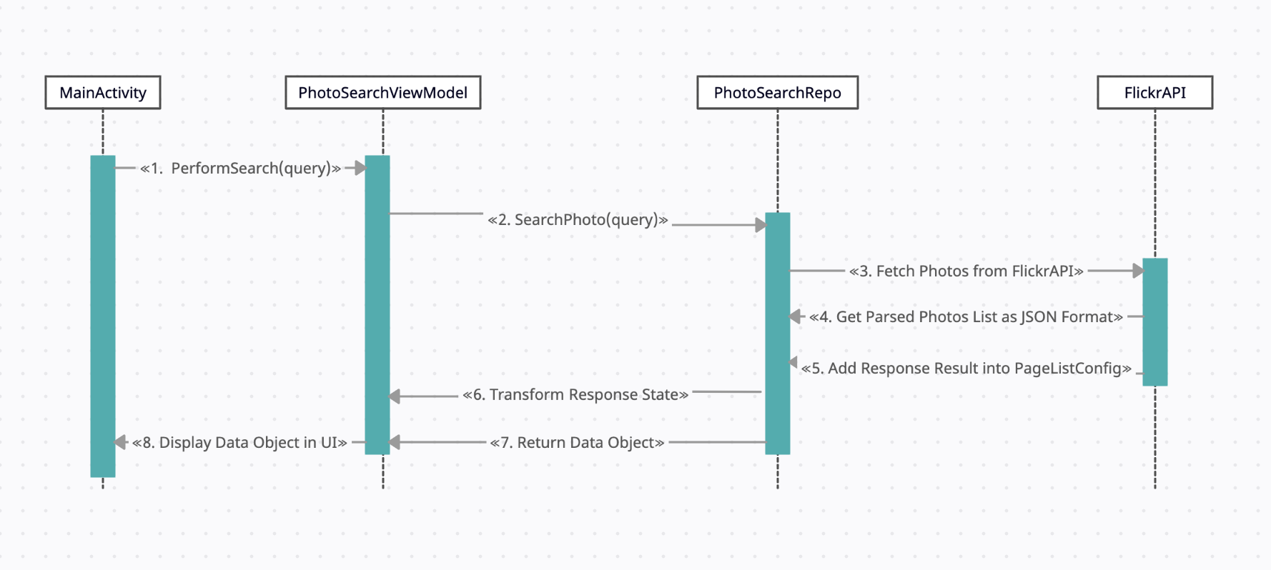

Sequence Diagram

**Application Screenshots**

