**Introduction :**

Weather Forecast Application displays the current weather forecast using the OpenWeatherMap free weather API.

This application fulfils the below objectives :

* Displays the current weather forecast for your device current location, and display location and all relevant information returned in the UI. (**Currently, Application shows only Bangalore city weather forecast related information based on hard coded city id**).
* Persist the response so that it can be retrieved again without having to make a further network request.
* Schedule a request for every 2 hours to update and persist the latest weather response.
* Send a HTTP request to the OpenWeatherMap API to retrieve the current local weather forecast and parse the response.
* Offline storage

**Application Proposed Design :**

**Application Architecture :**

This application follows android architecture guidelines that are based on MVVM.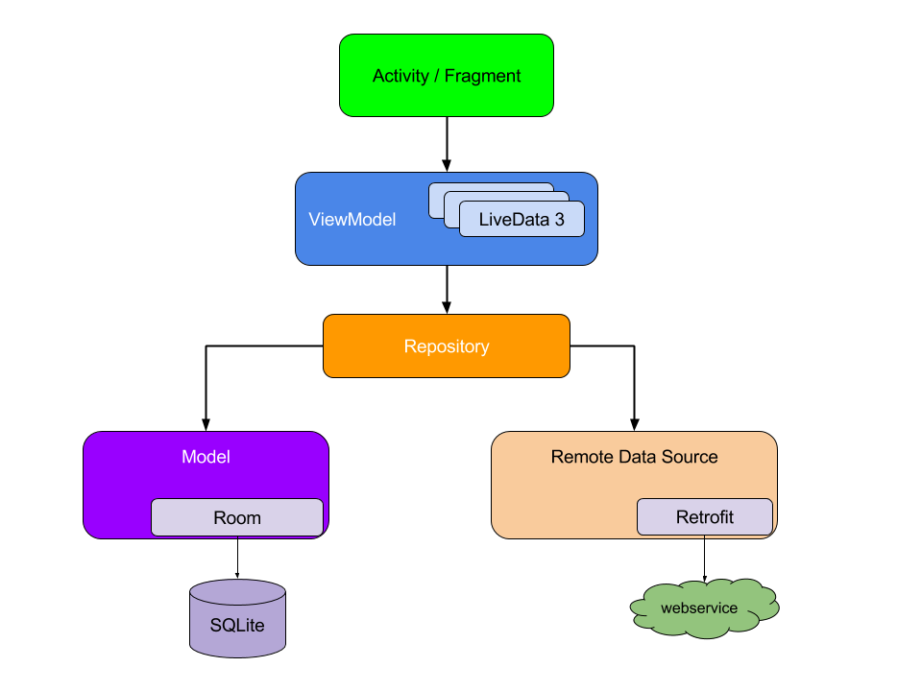

**Application Business Logic :**

* Check if there is cached data present in the internal file, if yes then load the cached data.
* Retrieve the latitude and longitude of the user.
* Request data from Weather Api
* If data received, cache it in internal file and show the updated data to user.
* If error then notify user about it.

**Application used Languages, Libraries and Tools :**

* Application Language : Kotlin
* Architectural Pattern : MVVM (Model View View Model)
* Architecture Components (Lifecycle, LiveData, ViewModel, Room Persistence library)
* RxJava and RxAndroid
* Dependency Injection with Dagger 2
* Network Communication : Retrofit 2 and Gson for constructing the REST API
* OkHttp3 for implementing interceptor, logging and mocking web server
* Timber for logging
* Unit testing : Junit, Mockito, Mockito-Kotlin, Espresso

**Application Screenshot :**

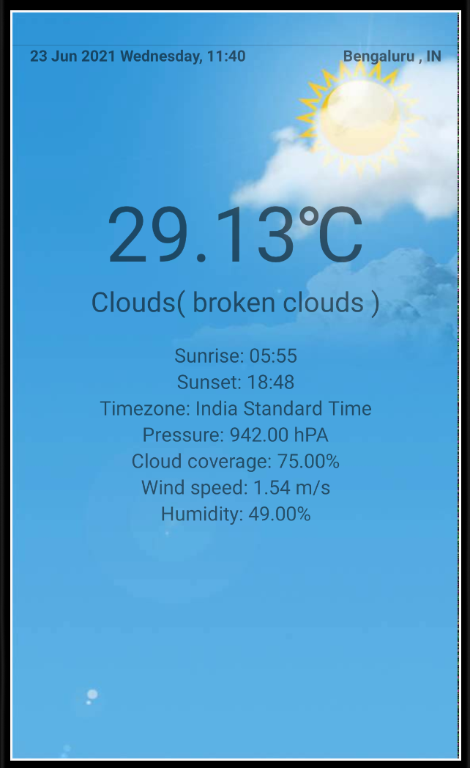

**Application Link URL :**

* Git repository URL : <https://github.com/sunilKmishra18/WeatherForecastApplication.git>

**Future Release Application Suggestions :**

* **Improvement by Application Features**
  + - * Currently, Application displays Bangalore city weather forecast information. We can extend application feature to display the weather forecast information based on geolocation latitude and longitude or device current location.(**We are using hardcoded city id to display the weather forecast information in the current application**)
      * We can implement the weather forecast information by hourly basis for a day based on one city id or other city id or geolocation info.
      * We can implement map feature to display weather forecast information when user taps on map interface to select the place (latitude and longitude).
* **Improvement by Application Development Design**
  + - * We can improve our Application UI screen based on different styles and drawables
      * We can use addition features of Android Jetpack library and Latest Android Android Architecture component to improve application performance.