**PROGRAM: EX_2**

**ACTIVITY_MAIN.XML:**

<RelativeLayout xmlns:android="http://schemas.android.com/apk/res/android"

xmlns:tools="http://schemas.android.com/tools"

android:layout_width="match_parent"

android:layout_height="match_parent"

android:paddingBottom="@dimen/activity_vertical_margin"

android:paddingLeft="@dimen/activity_horizontal_margin"

android:paddingRight="@dimen/activity_horizontal_margin"

android:paddingTop="@dimen/activity_vertical_margin"

tools:context=".MainActivity">

<!-- TextView to display the app name -->

<TextView

android:id="@+id/textView1"

android:layout_width="wrap_content"

android:layout_height="wrap_content"

android:layout_alignParentTop="true"

android:layout_centerHorizontal="true"

android:layout_marginTop="140dp"

android:text="@string/app_name" />

<!-- Button to change font size -->

<Button

android:id="@+id/button1"

android:layout_width="wrap_content"

android:layout_height="wrap_content"

android:layout_below="@+id/textView1"

android:layout_centerHorizontal="true"

android:layout_marginTop="78dp"

android:text="@string/button_font_size"

android:textSize="23sp"

android:contentDescription="@string/button_font_size_desc" /> <!-- Added contentDescription -->

<!-- Button to change font color -->

<Button

android:id="@+id/button2"

android:layout_width="wrap_content"

android:layout_height="wrap_content"

android:layout_alignStart="@+id/button1"

android:layout_below="@+id/button1"

android:layout_marginTop="40dp"

android:text="@string/button_font_color"

android:textSize="23sp"

android:contentDescription="@string/button_font_color_desc" /> <!-- Added contentDescription -->

</RelativeLayout>

**MAINACTIVITY.JAVA:**

package com.example.myapp2;

import android.app.Activity;

import android.graphics.Color;

import android.os.Bundle;

import android.view.Menu;

import android.widget.Button;

import android.widget.TextView;

public class MainActivity extends Activity {

Button b1, b2;

TextView t1;

float font = 20;

int i = 1;

@Override

protected void onCreate(Bundle savedInstanceState) {

super.onCreate(savedInstanceState);

setContentView(R.layout.activity_main);

b1 = findViewById(R.id.button1); // No need to cast

t1 = findViewById(R.id.textView1); // No need to cast

// Button 1: Change Font Size (Using lambda)

b1.setOnClickListener(v -> {

t1.setTextSize(font);

font = font + 4;

if (font == 40) {

font = 20;

}

});

// Button 2: Change Text Color (Using lambda)

b2 = findViewById(R.id.button2); // No need to cast

b2.setOnClickListener(v -> {

switch (i) {

case 1:

t1.setTextColor(Color.parseColor("#0000FF"));

break;

case 2:

t1.setTextColor(Color.parseColor("#00FF00"));

break;

case 3:

t1.setTextColor(Color.parseColor("#FF0000"));

break;

default:

t1.setTextColor(Color.parseColor("#800000"));

break;

}

i++;

if (i == 5) {

i = 1;}

});

}

@Override

public boolean onCreateOptionsMenu(Menu menu) {

// Inflate the menu; this adds items to the action bar if it is present.

getMenuInflater().inflate(R.menu.main, menu);

return true;

}

}

**Output:**

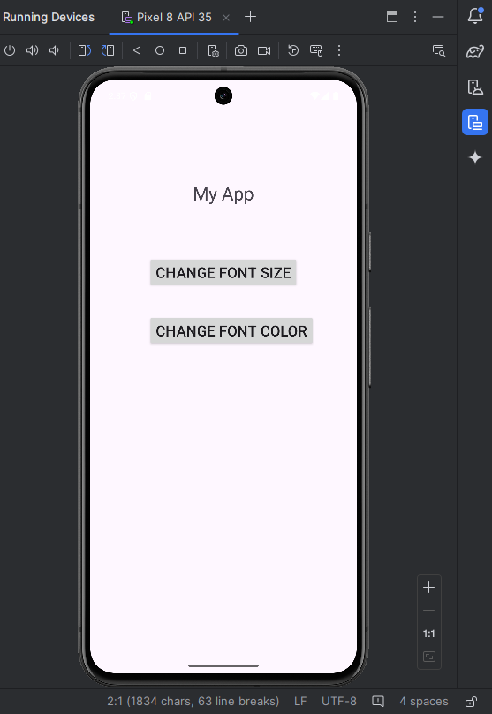

**Program: EX_3**

**ACTIVITY_MAIN.XML:**

<RelativeLayout xmlns:android="http://schemas.android.com/apk/res/android"

xmlns:tools="http://schemas.android.com/tools"

android:layout_width="match_parent"

android:layout_height="match_parent"

android:paddingTop="@dimen/activity_padding_top"

android:paddingLeft="@dimen/activity_padding_left"

android:paddingRight="@dimen/activity_padding_right"

android:paddingBottom="@dimen/activity_padding_bottom"

tools:context=".MainActivity">

<EditText

android:id="@+id/editText1"

android:layout_width="match_parent"

android:layout_height="@dimen/edit_text_height"

android:layout_alignParentLeft="true"

android:layout_alignParentTop="true"

android:layout_marginLeft="@dimen/edit_text_margin_left"

android:layout_marginTop="@dimen/edit_text_margin_top"

android:ems="10"

android:text="No 1"

android:padding="@dimen/edit_text_padding"/>

<EditText

android:id="@+id/editText2"

android:layout_width="match_parent"

android:layout_height="@dimen/edit_text_height"

android:layout_alignLeft="@+id/editText1"

android:layout_below="@+id/editText1"

android:layout_marginTop="@dimen/edit_text_margin_between"

android:ems="10"

android:text="No 2"

android:padding="@dimen/edit_text_padding"/>

<Button

android:id="@+id/button1"

android:layout_width="wrap_content"

android:layout_height="wrap_content"

android:layout_below="@+id/editText2"

android:layout_centerHorizontal="true"

android:layout_marginTop="@dimen/button_margin_top"

android:text="Add" />

</RelativeLayout>

**MAINACTIVITY.JAVA:**

package com.example.myapp_3;

import android.app.Activity;

import android.os.Bundle;

import android.view.Menu;

import android.view.View;

import android.widget.Button;

import android.widget.EditText;

import android.widget.Toast;

public class MainActivity extends Activity {

EditText t1, t2;

Button b1;

@Override

protected void onCreate(Bundle savedInstanceState) {

super.onCreate(savedInstanceState);

setContentView(R.layout.activity_main);

t1 = (EditText) findViewById(R.id.editText1);

t2 = (EditText) findViewById(R.id.editText2);

b1 = (Button) findViewById(R.id.button1);

b1.setOnClickListener(new View.OnClickListener() {

@Override

public void onClick(View arg0) {

// Get the input from EditText fields

String v1 = t1.getText().toString();

String v2 = t2.getText().toString();

// Check if inputs are valid (non-empty)

if (!v1.isEmpty() && !v2.isEmpty()) {

try {

int a = Integer.parseInt(v1);

int b = Integer.parseInt(v2);

int sum = a + b;

// Display the result as a Toast

Toast.makeText(MainActivity.this, "Sum of Two Numbers: " + sum, Toast.LENGTH_LONG).show();

} catch (NumberFormatException e) {

// Handle invalid input for parsing

Toast.makeText(MainActivity.this, "Please enter valid numbers.", Toast.LENGTH_SHORT).show();

}

} else {

Toast.makeText(MainActivity.this, "Please fill in both fields.", Toast.LENGTH_SHORT).show();

}

}

});

}

@Override

public boolean onCreateOptionsMenu(Menu menu) {

// Inflate the menu; this adds items to the action bar if it is present.

getMenuInflater().inflate(R.menu.main, menu);

return true;

}

}

**Output:**

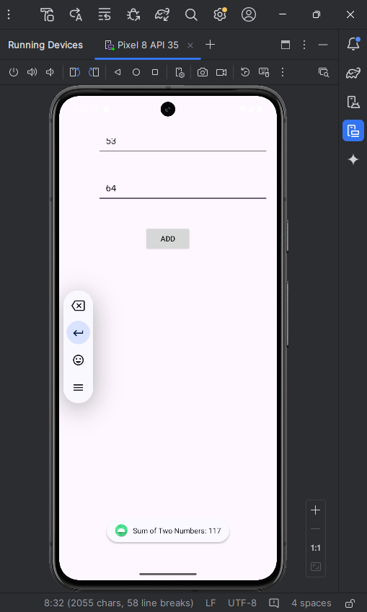

**PROGRAM: EX_4**

**ACTIVITY_MAIN.XML:**

<?xml version="1.0" encoding="utf-8"?>

<androidx.constraintlayout.widget.ConstraintLayout xmlns:android="http://schemas.android.com/apk/res/android"

xmlns:app="http://schemas.android.com/apk/res-auto"

xmlns:tools="http://schemas.android.com/tools"

android:layout_width="match_parent"

android:layout_height="match_parent"

tools:context=".MainActivity">

<!-- Display TextView -->

<TextView

android:id="@+id/display"

android:layout_width="0dp"

android:layout_height="wrap_content"

android:text=""

android:textSize="36sp"

android:gravity="end"

android:padding="16dp"

android:background="#EAEAEA"

app:layout_constraintEnd_toEndOf="parent"

app:layout_constraintStart_toStartOf="parent"

app:layout_constraintTop_toTopOf="parent"/>

<!-- Button Layout -->

<GridLayout

android:layout_width="match_parent"

android:layout_height="0dp"

android:layout_marginTop="16dp"

android:rowCount="5"

android:columnCount="4"

app:layout_constraintTop_toBottomOf="@id/display"

app:layout_constraintBottom_toBottomOf="parent">

<!-- Buttons for numbers and operations -->

<Button

android:id="@+id/button_1"

android:layout_width="wrap_content"

android:layout_height="wrap_content"

android:layout_row="0"

android:layout_column="0"

android:text="1"

android:textSize="24sp" />

<Button

android:id="@+id/button_2"

android:layout_width="wrap_content"

android:layout_height="wrap_content"

android:text="2"

android:textSize="24sp"/>

<Button

android:id="@+id/button_3"

android:layout_width="wrap_content"

android:layout_height="wrap_content"

android:text="3"

android:textSize="24sp"/>

<Button

android:id="@+id/button_add"

android:layout_width="wrap_content"

android:layout_height="wrap_content"

android:text="+"

android:textSize="24sp"/>

<Button

android:id="@+id/button_4"

android:layout_width="wrap_content"

android:layout_height="wrap_content"

android:text="4"

android:textSize="24sp"/>

<Button

android:id="@+id/button_5"

android:layout_width="wrap_content"

android:layout_height="wrap_content"

android:text="5"

android:textSize="24sp"/>

<Button

android:id="@+id/button_6"

android:layout_width="wrap_content"

android:layout_height="wrap_content"

android:text="6"

android:textSize="24sp"/>

<Button

android:id="@+id/button_subtract"

android:layout_width="wrap_content"

android:layout_height="wrap_content"

android:text="-"

android:textSize="24sp"/>

<Button

android:id="@+id/button_7"

android:layout_width="wrap_content"

android:layout_height="wrap_content"

android:text="7"

android:textSize="24sp"/>

<Button

android:id="@+id/button_8"

android:layout_width="wrap_content"

android:layout_height="wrap_content"

android:text="8"

android:textSize="24sp"/>

<Button

android:id="@+id/button_9"

android:layout_width="wrap_content"

android:layout_height="wrap_content"

android:text="9"

android:textSize="24sp"/>

<Button

android:id="@+id/button_multiply"

android:layout_width="wrap_content"

android:layout_height="wrap_content"

android:text="*"

android:textSize="24sp"/>

<Button

android:id="@+id/button_0"

android:layout_width="wrap_content"

android:layout_height="wrap_content"

android:text="0"

android:textSize="24sp" />

<Button

android:id="@+id/button_clear"

android:layout_width="wrap_content"

android:layout_height="wrap_content"

android:text="C"

android:textSize="24sp"/>

<Button

android:id="@+id/button_equal"

android:layout_width="wrap_content"

android:layout_height="wrap_content"

android:text="="

android:textSize="24sp"/>

<Button

android:id="@+id/button_divide"

android:layout_width="wrap_content"

android:layout_height="wrap_content"

android:text="/"

android:textSize="24sp"/>

</GridLayout>

</androidx.constraintlayout.widget.ConstraintLayout>

**MAINACTIVITY.JAVA:**

package com.example.my_app4;

import android.os.Bundle;

import android.view.View;

import android.widget.Button;

import android.widget.TextView;

import androidx.appcompat.app.AppCompatActivity;

public class MainActivity extends AppCompatActivity {

private TextView display;

private String currentInput = "";

private String operator = "";

private double firstOperand = 0;

@Override

protected void onCreate(Bundle savedInstanceState) {

super.onCreate(savedInstanceState);

setContentView(R.layout.activity_main);

display = findViewById(R.id.display);

// Number buttons

Button button1 = findViewById(R.id.button_1);

Button button2 = findViewById(R.id.button_2);

Button button3 = findViewById(R.id.button_3);

Button button4 = findViewById(R.id.button_4);

Button button5 = findViewById(R.id.button_5);

Button button6 = findViewById(R.id.button_6);

Button button7 = findViewById(R.id.button_7);

Button button8 = findViewById(R.id.button_8);

Button button9 = findViewById(R.id.button_9);

Button button0 = findViewById(R.id.button_0);

// Operator buttons

Button buttonAdd = findViewById(R.id.button_add);

Button buttonSubtract = findViewById(R.id.button_subtract);

Button buttonMultiply = findViewById(R.id.button_multiply);

Button buttonDivide = findViewById(R.id.button_divide);

// Other buttons

Button buttonClear = findViewById(R.id.button_clear);

Button buttonEqual = findViewById(R.id.button_equal);

// Set OnClickListener for number buttons

button1.setOnClickListener(v -> appendToInput("1"));

button2.setOnClickListener(v -> appendToInput("2"));

button3.setOnClickListener(v -> appendToInput("3"));

button4.setOnClickListener(v -> appendToInput("4"));

button5.setOnClickListener(v -> appendToInput("5"));

button6.setOnClickListener(v -> appendToInput("6"));

button7.setOnClickListener(v -> appendToInput("7"));

button8.setOnClickListener(v -> appendToInput("8"));

button9.setOnClickListener(v -> appendToInput("9"));

button0.setOnClickListener(v -> appendToInput("0"));

// Set OnClickListener for operator buttons

buttonAdd.setOnClickListener(v -> setOperator("+"));

buttonSubtract.setOnClickListener(v -> setOperator("-"));

buttonMultiply.setOnClickListener(v -> setOperator("*"));

buttonDivide.setOnClickListener(v -> setOperator("/"));

// Set OnClickListener for equal and clear buttons

buttonEqual.setOnClickListener(v -> calculateResult());

}

// Append digits to the input

private void appendToInput(String input) {

currentInput += input;

display.setText(currentInput);

}

// Set the operator when clicked

private void setOperator(String operator) {

if (!currentInput.isEmpty()) {

firstOperand = Double.parseDouble(currentInput);

currentInput = "";

this.operator = operator;

}

}

// Calculate result based on the operator

private void calculateResult() {

if (!currentInput.isEmpty() && !operator.isEmpty()) {

double secondOperand = Double.parseDouble(currentInput);

double result = 0;

switch (operator) {

case "+":

result = firstOperand + secondOperand;

break;

case "-":

result = firstOperand - secondOperand;

break;

case "*":

result = firstOperand * secondOperand;

break;

case "/":

if (secondOperand != 0) {

result = firstOperand / secondOperand;

} else {

display.setText("Error");

return;}

break; }

display.setText(String.valueOf(result));

currentInput = String.valueOf(result);

}

}

// Clear the input

private void clearInput() {

currentInput = "";

display.setText(""); }

}

**Output:**

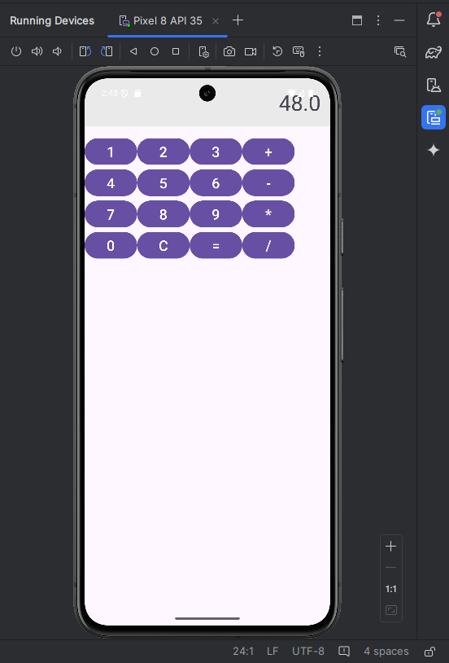

**PROGRAM: EX_5a**

**ACTIVITY_MAIN.XML:**

<?xml version="1.0" encoding="utf-8"?>

<androidx.constraintlayout.widget.ConstraintLayout xmlns:android="http://schemas.android.com/apk/res/android"

xmlns:app="http://schemas.android.com/apk/res-auto"

xmlns:tools="http://schemas.android.com/tools"

android:id="@+id/main"

android:layout_width="match_parent"

android:layout_height="match_parent"

tools:context=".MainActivity">

<TextView

android:layout_width="wrap_content"

android:layout_height="wrap_content"

android:text="Hello World!"

app:layout_constraintBottom_toBottomOf="parent"

app:layout_constraintEnd_toEndOf="parent"

app:layout_constraintStart_toStartOf="parent"

app:layout_constraintTop_toTopOf="parent" />

</androidx.constraintlayout.widget.ConstraintLayout>

**MAINACTIVITY.JAVA:**

package com.example.myapp5a;

import android.app.Activity;

import android.content.Context;

import android.graphics.Canvas;

import android.graphics.Color;

import android.graphics.Paint;

import android.os.Bundle;

import android.view.View;

public class MainActivity extends Activity {

@Override

public void onCreate(Bundle savedInstanceState) {

super.onCreate(savedInstanceState);

setContentView(new MyView(this)); // Create and set an instance of MyView

}

// Custom View class

private class MyView extends View {

public MyView(Context context) {

super(context);

}

@Override

protected void onDraw(Canvas canvas) {

super.onDraw(canvas); // Always call super.onDraw() first

// Get the center of the canvas

int centerX = canvas.getWidth() / 2;

int centerY = canvas.getHeight() / 2;

// Define the size of the rectangle

int rectWidth = 900;

int rectHeight =700;

// Calculate the left, top, right, and bottom values to center the rectangle

int left = centerX - rectWidth / 2;

int top = centerY - rectHeight / 2;

int right = centerX + rectWidth / 2;

int bottom = centerY + rectHeight / 2;

// Create a paint object to set the drawing properties

Paint myPaint = new Paint();

myPaint.setColor(Color.GREEN); // Set paint color

myPaint.setStyle(Paint.Style.STROKE); // Set stroke style (outline)

myPaint.setStrokeWidth(10); // Set the stroke width

// Draw the rectangle at the calculated position

canvas.drawRect(left, top, right, bottom, myPaint);

}

}

}

**Output:**

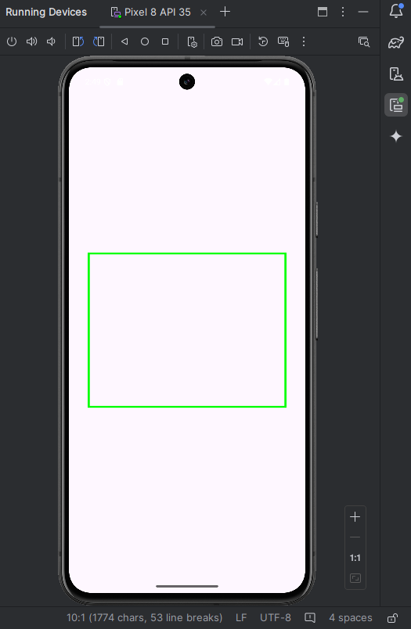

**PROGRAM: EX_5b**

**ACTIVITY_MAIN.XML:**

<?xml version="1.0" encoding="utf-8"?>

<androidx.constraintlayout.widget.ConstraintLayout xmlns:android="http://schemas.android.com/apk/res/android"

xmlns:app="http://schemas.android.com/apk/res-auto"

xmlns:tools="http://schemas.android.com/tools"

android:id="@+id/main"

android:layout_width="match_parent"

android:layout_height="match_parent"

tools:context=".MainActivity">

<TextView

android:layout_width="wrap_content"

android:layout_height="wrap_content"

android:text="Hello World!"

app:layout_constraintBottom_toBottomOf="parent"

app:layout_constraintEnd_toEndOf="parent"

app:layout_constraintStart_toStartOf="parent"

app:layout_constraintTop_toTopOf="parent" />

</androidx.constraintlayout.widget.ConstraintLayout>

**MAINACTIVITY.JAVA:**

package com.example.myapp5b;

import android.app.Activity;

import android.content.Context;

import android.graphics.Canvas;

import android.graphics.Color;

import android.graphics.Paint;

import android.os.Bundle;

import android.view.View;

public class MainActivity extends Activity {

@Override

public void onCreate(Bundle savedInstanceState) {

super.onCreate(savedInstanceState);

setContentView(new MyView(this)); // Create and set an instance of MyView

}

// Custom View class

private class MyView extends View {

public MyView(Context context) {

super(context);

}

@Override

protected void onDraw(Canvas canvas) {

super.onDraw(canvas); // Always call super.onDraw() first

// Get the center of the canvas

int centerX = canvas.getWidth() / 2;

int centerY = canvas.getHeight() / 2;

// Define the radius of the circle

int radius = 500; // You can adjust the radius as needed

// Create a paint object to set the drawing properties

Paint myPaint = new Paint();

myPaint.setColor(Color.GREEN); // Set paint color (Red for example)

myPaint.setStyle(Paint.Style.STROKE); // Set stroke style (outline)

myPaint.setStrokeWidth(10); // Set the stroke width

// Draw the circle at the center of the canvas

canvas.drawCircle(centerX, centerY, radius, myPaint);

}

}

}

**Output:**

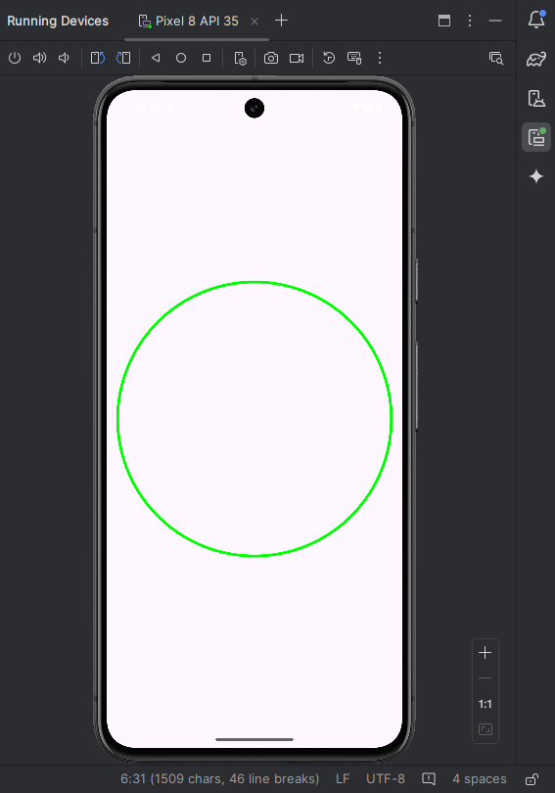

**PROGRAM: EX_6**

**ACTIVITY_MAIN.XML:**

<?xml version="1.0" encoding="utf-8"?>

<LinearLayout xmlns:android="http://schemas.android.com/apk/res/android"

android:layout_width="match_parent"

android:layout_height="match_parent"

android:orientation="vertical"

android:padding="16dp">

<!-- Title Text -->

<TextView

android:layout_width="wrap_content"

android:layout_height="wrap_content"

android:text="Student Details"

android:textSize="30sp"

android:layout_gravity="center"/>

<!-- Rollno -->

<TextView

android:layout_width="wrap_content"

android:layout_height="wrap_content"

android:text="Enter Rollno:"

android:textSize="20sp" />

<EditText

android:id="@+id/Rollno"

android:layout_width="match_parent"

android:layout_height="wrap_content"

android:inputType="number"

android:textSize="20sp"/>

<!-- Name -->

<TextView

android:layout_width="wrap_content"

android:layout_height="wrap_content"

android:text="Enter Name:"

android:textSize="20sp" />

<EditText

android:id="@+id/Name"

android:layout_width="match_parent"

android:layout_height="wrap_content"

android:inputType="text"

android:textSize="20sp"/>

<!-- Marks -->

<TextView

android:layout_width="wrap_content"

android:layout_height="wrap_content"

android:text="Enter Marks:"

android:textSize="20sp" />

<EditText

android:id="@+id/Marks"

android:layout_width="match_parent"

android:layout_height="wrap_content"

android:inputType="number"

android:textSize="20sp"/>

<!-- Buttons -->

<Button

android:id="@+id/Delete"

android:layout_width="match_parent"

android:layout_height="wrap_content"

android:text="Delete"

android:textSize="20sp" />

<Button

android:id="@+id/Update"

android:layout_width="match_parent"

android:layout_height="wrap_content"

android:text="Update"

android:textSize="20sp" />

<Button

android:id="@+id/View"

android:layout_width="match_parent"

android:layout_height="wrap_content"

android:text="View"

android:textSize="20sp" />

<Button

android:id="@+id/ViewAll"

android:layout_width="match_parent"

android:layout_height="wrap_content"

android:text="View All"

android:textSize="20sp" />

<Button

android:id="@+id/Insert"

android:layout_width="150dp"

android:layout_height="wrap_content"

android:layout_gravity="center"

android:text="Insert"

android:textSize="30sp" />

</LinearLayout>

**MAINACTIVITY.JAVA:**

package com.example.myapp6;

import android.app.Activity;

import android.app.AlertDialog;

import android.content.Context;

import android.database.Cursor;

import android.database.sqlite.SQLiteDatabase;

import android.os.Bundle;

import android.view.View;

import android.widget.Button;

import android.widget.EditText;

public class MainActivity extends Activity implements View.OnClickListener {

EditText Rollno, Name, Marks;

Button Insert, Delete, Update, View, ViewAll;

SQLiteDatabase db;

@Override

protected void onCreate(Bundle savedInstanceState) {

super.onCreate(savedInstanceState);

setContentView(R.layout.activity_main);

Rollno = findViewById(R.id.Rollno);

Name = findViewById(R.id.Name);

Marks = findViewById(R.id.Marks);

Insert = findViewById(R.id.Insert);

Delete = findViewById(R.id.Delete);

Update = findViewById(R.id.Update);

View = findViewById(R.id.View);

ViewAll = findViewById(R.id.ViewAll);

Insert.setOnClickListener(this);

Delete.setOnClickListener(this);

Update.setOnClickListener(this);

View.setOnClickListener(this);

ViewAll.setOnClickListener(this);

// Creating database and table

db = openOrCreateDatabase("StudentDB", Context.MODE_PRIVATE, null);

db.execSQL("CREATE TABLE IF NOT EXISTS student(rollno VARCHAR, name VARCHAR, marks VARCHAR);");

}

@Override

public void onClick(View view) {

if (view.getId() == R.id.Insert) {

insertRecord();

} else if (view.getId() == R.id.Delete) {

deleteRecord();

} else if (view.getId() == R.id.Update) {

updateRecord();

} else if (view.getId() == R.id.View) {

viewRecord();

} else if (view.getId() == R.id.ViewAll) {

viewAllRecords();

} else {

throw new IllegalStateException("Unexpected value: " + view.getId());

}

}

private void insertRecord() {

if (Rollno.getText().toString().trim().isEmpty() ||

Name.getText().toString().trim().isEmpty() ||

Marks.getText().toString().trim().isEmpty()) {

showMessage("Error", "Please enter all values");

return;

}

db.execSQL("INSERT INTO student (rollno, name, marks) VALUES (?, ?, ?);",

new Object[]{Rollno.getText().toString(), Name.getText().toString(), Marks.getText().toString()});

showMessage("Success", "Record added");

clearText();

}

private void deleteRecord() {

if (Rollno.getText().toString().trim().isEmpty()) {

showMessage("Error", "Please enter Rollno");

return;

}

Cursor c = db.rawQuery("SELECT * FROM student WHERE rollno = ?", new String[]{Rollno.getText().toString()});

if (c.moveToFirst()) {

db.execSQL("DELETE FROM student WHERE rollno = ?", new String[]{Rollno.getText().toString()});

showMessage("Success", "Record Deleted");

} else {

showMessage("Error", "Invalid Rollno");

}

c.close();

clearText();

}

private void updateRecord() {

if (Rollno.getText().toString().trim().isEmpty()) {

showMessage("Error", "Please enter Rollno");

return;

}

Cursor c = db.rawQuery("SELECT * FROM student WHERE rollno = ?", new String[]{Rollno.getText().toString()});

if (c.moveToFirst()) {

db.execSQL("UPDATE student SET name = ?, marks = ? WHERE rollno = ?;",

new Object[]{Name.getText().toString(), Marks.getText().toString(), Rollno.getText().toString()});

showMessage("Success", "Record Modified");

} else {

showMessage("Error", "Invalid Rollno");

}

c.close();

clearText();

}

private void viewRecord() {

if (Rollno.getText().toString().trim().isEmpty()) {

showMessage("Error", "Please enter Rollno");

return;

}

Cursor c = db.rawQuery("SELECT * FROM student WHERE rollno = ?", new String[]{Rollno.getText().toString()});

if (c.moveToFirst()) {

Name.setText(c.getString(1));

Marks.setText(c.getString(2));

} else {

showMessage("Error", "Invalid Rollno");

clearText();

}

c.close();

}

private void viewAllRecords() {

Cursor c = db.rawQuery("SELECT * FROM student", null);

if (c.getCount() == 0) {

showMessage("Error", "No records found");

return;

}

StringBuffer buffer = new StringBuffer();

while (c.moveToNext()) {

buffer.append("Rollno: ").append(c.getString(0)).append("\n");

buffer.append("Name: ").append(c.getString(1)).append("\n");

buffer.append("Marks: ").append(c.getString(2)).append("\n\n");

}

showMessage("Student Details", buffer.toString());

c.close();

}

private void showMessage(String title, String message) {

AlertDialog.Builder builder = new AlertDialog.Builder(this);

builder.setCancelable(true);

builder.setTitle(title);

builder.setMessage(message);

builder.show();

}

private void clearText() {

Rollno.setText("");

Name.setText("");

Marks.setText("");

Rollno.requestFocus();

}

}

**Output:**

1.Insert:

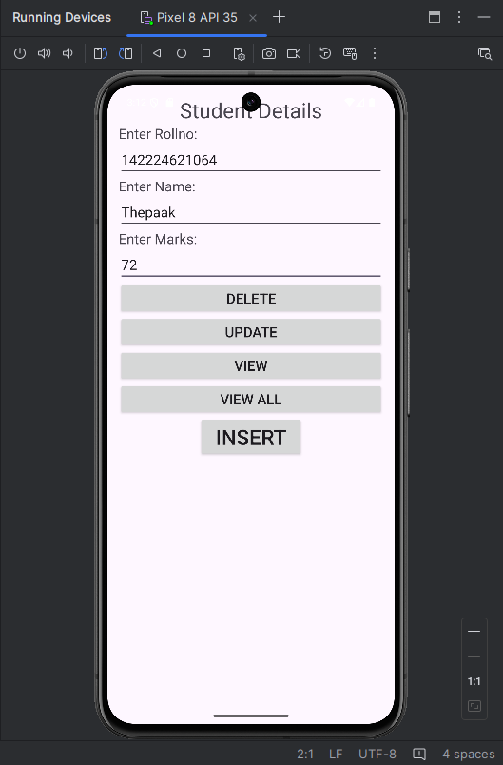

2.View:



3.Update:



4.Delete:

