HOMECHEF WEB APPLICATION
INSTANT ACCESS TO HOME COOKED MEALS
Mr.S.A.Sunil Aldo¹ and Mr.K.Maniraj²
- PG Student, Department of Computer Applications, SRM Valliammai Engineering College, Anna University, Chennai.
- Assistant professor, Department of Computer Applications, SRM Valliammai Engineering College, Anna University, Chennai.

Abstract

The increasing prevalence of unhealthy eating habits, largely driven by urbanization, busy lifestyles, and limited access to home-style meals, calls for innovative digital solutions. This paper presents HomeChef, a comprehensive web platform that connects local home chefs with consumers seeking nutritious, affordable, and personalized meals. By facilitating secure chef discovery, streamlined service booking, digital payments, and transparent feedback, HomeChef fosters local entrepreneurship, addresses dietary needs, and promotes community well-being. The paper details the platform's architecture, functional workflows, security model, related ecosystem, and adds critical evaluation and ideas for future enhancements.

INTRODUCTION

In contemporary urban settings, many individuals, including students, professionals, and elderly citizens, struggle to maintain a balanced diet due to time constraints, lack of culinary skills, or prolonged absence from home. While commercial food delivery apps provide convenience, they often neglect the need for healthy, personalized, and home-style meals. The growing awareness regarding nutrition, coupled with a surge in demand for hygienic and locally-prepared food, underscores the necessity of platforms that can bridge aspiring home chefs and potential consumers.

Objective
The primary objectives of HomeChef are to empower home chefs by providing them with a digital identity and direct access to the market. It aims to offer consumers trustworthy, healthy, and customizable meal options that cater to their specific needs and preferences. The platform ensures secure transactions, reliable scheduling, and transparent feedback mechanisms to build trust and reliability. Additionally, HomeChef seeks to contribute to economic inclusion by supporting local talent and enhancing community health through home-cooked, nutritious food.

LITERATURE STUDY
Online food delivery systems have transformed meal access, with platforms like UberEats, Zomato, and Swiggy driving rapid growth. In India, the market was projected to reach $16.1 billion by 2023 (Rahman et al., 2020), fueled by urbanization and lifestyle changes. While these platforms focus on professional kitchens, the demand for home-cooked meals rose, especially during COVID-19, highlighting the need for healthier, hygienic options. Recommendation systems—using content-based and collaborative filtering—enhance user experience by personalizing food suggestions, making online food platforms smarter and more user-centric.

SYSTEM ARCHITECTURE AND DESIGN
The HomeChef platform is structured across four main components: Client Interface, Backend Server, Database, and External Services. The Client Interface includes interactive dashboards tailored for customers, chefs, and admins. The Backend Server handles core operations such as authentication, bookings, payments, and reviews through RESTful APIs. The Database manages user profiles, service listings, transactions, and feedback, while External Services integrate essential tools like payment gateways, Google Maps for location-based chef search, and communication modules for notifications.
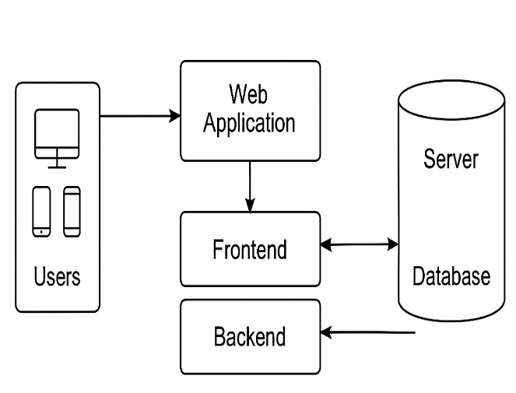
System Architecture

The system is designed with a few assumptions and constraints: users are expected to have basic digital literacy and access to internet-enabled devices; chefs are verified by the admin to meet hygiene and safety standards; and all payment methods adhere to local regulations. While the platform is built for scalability, further optimization may be required after the initial pilot deployment.

Structural Design Class Diagram

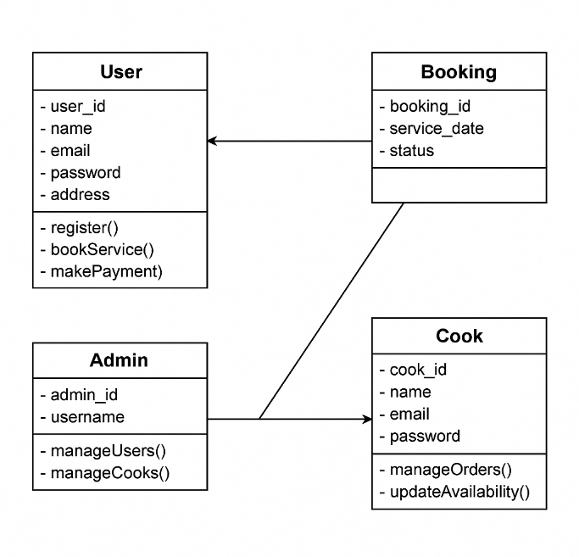
Structural Design

The class diagram illustrates the structural design of the HomeChef platform, which facilitates interactions between users, cooks, admins, and service bookings. It presents a modular approach where each class represents a key role within the system. The User class encapsulates customer-related attributes such as name, email, and address, and provides core functionalities like registration, service booking, and payment processing.

The Booking class manages the details of service requests, including booking ID, service date, and status, and is directly linked to the User, reflecting a one-to-many relationship where each user can have multiple bookings.

The Cook class represents home chefs and includes personal details along with functions for managing orders and updating availability, enabling them to control their service schedules. The Admin class functions as

a supervisory role with methods to manage both users and cooks, indicating its authority over platform operations and quality control.

The relationships among these classes reflect a clear separation of responsibilities, supporting a scalable and maintainable system.

USE-CASE MODEL
The use case illustrates how a user interacts with the Smart Academic Chart Recommender system.
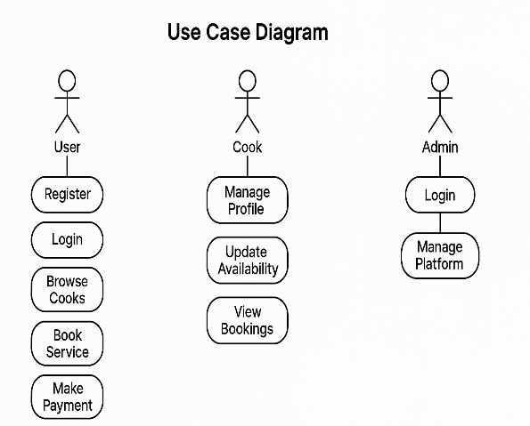
UseCase Diagram

The use case diagram illustrates the key interactions between the main actors—User, Cook, and Admin—and the HomeChef platform. Users can engage in core activities such as registering, logging in, browsing available cooks, booking services, and making payments. These actions represent the primary customer journey from account creation to order completion.
The diagram effectively captures the modular roles and use flows of each participant, reflecting a clear and organized interaction structure within the HomeChef ecosystem. This separation of concerns enhances usability, security, and operational efficiency while supporting the platform’s goal of connecting customers with verified home chefs.

Module 1: User Interface and Interaction Layer

This module is the front-end of the HomeChef web application, built with HTML5, CSS3, and JavaScript. It provides role-based dashboards for customers, chefs, and admins, enabling features like chef search, menu browsing, bookings, profile management, and system oversight. The interface supports real-time filters, responsive design, booking forms, feedback, and user registration.

Module 2: Service Matching and Booking Logic

This module handles chef discovery, service matching, and order booking by filtering based on location, service type, availability, and proximity. It validates bookings for conflicts and timing, saves confirmed details, and notifies both chefs and users, ensuring accurate and reliable real-time bookings.

Module 3: Database and Data Management

The data management module uses MySQL to store and manage user, chef, booking, and review data with normalized structures. It supports secure CRUD operations via PHP/Laravel, uses Redis for session management, and enables fast queries for search, availability, and analytics while ensuring data integrity and reliability.

Module 4: Role-Based Access Control and Authentication

This module handles secure authentication, session control, and role-based access. It ensures protected registration/login with password hashing, tokens, and email verification, directing users to role-specific dashboards. Role separation maintains privacy, restricts sensitive actions, and safeguards system data.

Module 5: Payment and Transaction Handling

This module facilitates secure payment processing and financial transaction management.The module also handles commission distribution, ensuring the chef and admin share is calculated and saved. Refund handling, dispute resolution, and invoice generation are managed through this component. Using SSL encryption and transaction logs, the platform ensures financial integrity and transparency between users and service providers.

Module 6: Admin Control and Analytics Dashboard

This module manages secure payments, commission distribution, refunds, disputes, and invoices. With SSL encryption and transaction logs, it ensures financial integrity, transparency, and trust between users and service providers.

Module 7: Review and Rating System

After a service is completed, this module allows customers to provide ratings and feedback after services, which directly impact a chef’s credibility and visibility. Feedback is stored on the chef’s profile for transparency, while admins monitor reviews to ensure appropriate content. It helps build trust, maintain quality, and guide customer choices.

Module 8: Feedback & Dispute Management

This module enables users and chefs to report issues, raise disputes, or share suggestions. Complaints about service, hygiene, or cancellations are submitted to admins, who review and resolve them through a dedicated dashboard. It ensures accountability, smooth conflict resolution, and better user support.

Module 9: Admin and Sub-Admin Management Panel

This module enables administrators and sub-admins to manage core platform functions such as chef approvals, user management, bookings, and disputes. It supports CRUD operations, role-based access, and analytics dashboards for performance monitoring. The panel ensures smooth backend operations and effective enforcement of platform policies.

Module 10: Booking and Calendar Integration

This module manages the complete booking process, from chef selection to confirmation. It validates availability in real-time, prevents double bookings, and updates dashboards for both users and chefs. Calendar management helps chefs organize schedules effectively for smooth service delivery..

Related Work
Popular food delivery platforms such as Swiggy, Zomato, and Uber Eats currently dominate the urban food delivery ecosystem. These services primarily focus on aggregating restaurants and commercial kitchens, aiming to offer customers a wide range of meal options with fast delivery times.

While they have revolutionized the way people access food, their model revolves around commercial vendors, leaving out a significant segment of talented home-based chefs who operate outside the formal restaurant industry.
These platforms have inspired several key features now considered standard in food tech, including real-time order tracking, digital payments integration, location-based filtering, user ratings and reviews, and discount campaigns to drive customer engagement. However, they generally offer limited personalization, and the opportunity for direct customer-chef interaction is almost nonexistent.
More importantly, the emphasis on speed often leads to compromises in meal quality and freshness, especially for health-conscious users seeking nutritious, home-style food. The needs of students, working professionals, and families who prefer customized meals, dietary accommodations, or event-based catering are frequently unmet. These gaps highlight the need for an alternative platform like HomeChef that prioritizes local cooks, personalized service, and meaningful chef-customer connections.

RESULTS AND DISCUSSION

The HomeChef platform successfully bridges the gap between home chefs and customers by Offeringstructured,user-friendly environment for meal booking and delivery.

Through its dedicated interfaces, users can seamlessly interact based on their roles customers can easily browse and book meals, chefs can manage menus and availability, and admins can oversee quality and operations.

The platform’s backend effectively handles core services like authentication, booking, payment, and feedback, ensuring smooth and secure transactions across all interactions.

Unlike traditional food delivery apps that primarily feature restaurant kitchens, HomeChef emphasizes personalized, healthy, home-cooked meals—an approach that gained strong traction post-COVID.

By automating critical workflows and offering scalable infrastructure, the platform empowers independent chefs, improves consumer choice, and promotes safe and customized food options.

This makes HomeChef not just a technical solution, but a socially impactful one that enhances community well-being through local economic participation.
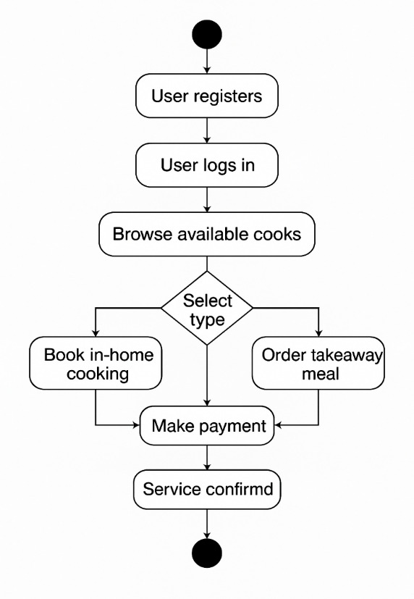

(Activity diagram)

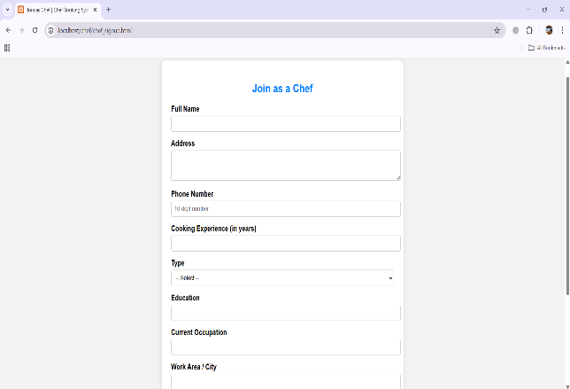

(Screen displays the registration page where new chefs can register.)

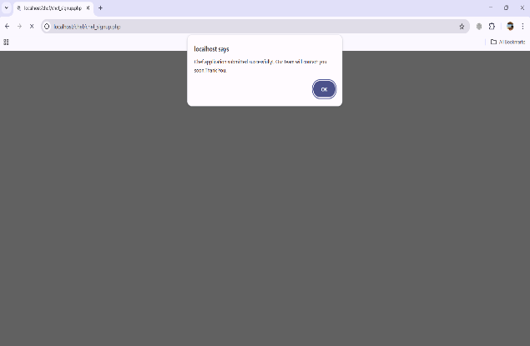

(Screen displays the message that registration submitted successfully.)

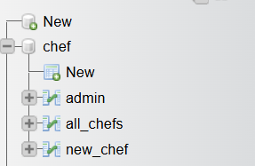

(Screen shows the Table design in database)

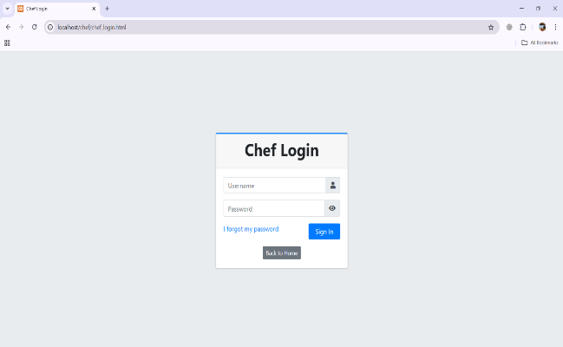
(Screen shows the Chef panel, where the chef can see their orders and Manage it.)

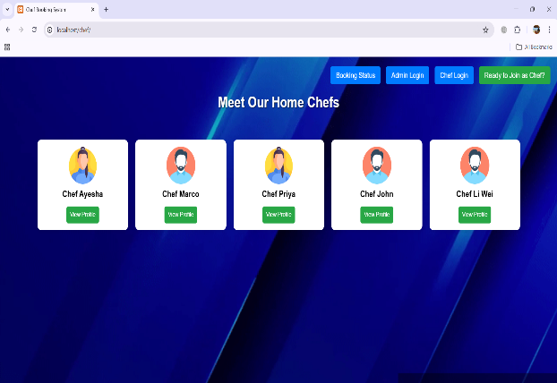
(Screen shows the main menu, where the user can see the chef profiles and choose.)

FUTURE WORK
In future versions of the HomeChef platform, integrating with smart kitchen devices can significantly improve efficiency and user experience. By connecting the application with smart ovens, timers, and kitchen sensors, home chefs can automate parts of the cooking process, receive real-time alerts, and better manage their kitchen operations.
For example, the system can send reminders for order preparation time, adjust cooking settings based on the dish selected, or notify the chef when ingredients are running low. This smart integration will help chefs maintain consistent quality, reduce cooking errors, and save time—leading to quicker deliveries and increased customer satisfaction.
Beyond operational benefits, this advancement could open new features like predictive cooking assistance, where the system offers recipe suggestions based on real-time kitchen data or previous order trends. Furthermore, customers could receive updates not only on booking and delivery status but also on live cooking stages, enhancing transparency and trust.
From a business standpoint, this level of integration positions HomeChef as a technologically advanced and user-centric platform in the competitive food-tech industry.
It also supports future collaborations with kitchen appliance manufacturers and IoT service providers. Overall, smart device integration will empower home chefs, improve food quality, enhance delivery precision, and set a new standard for personalized food service in the digital age.

CONCLUSION
The HomeChef web application is a user-friendly platform that connects home-based chefs with local customers seeking fresh, homemade meals. It simplifies the process of discovering chefs, viewing menus, and placing orders through an intuitive interface. The platform not only enhances convenience for customers but also empowers home chefs—especially women and small-scale cooks—by offering them a digital space to showcase their culinary skills and earn income.Through features like location-based chef discovery, real-time booking, chef registration, and order management, HomeChef ensures a seamless and personalized food delivery experience.
The inclusion of admin and sub-admin panels strengthens quality control, improves service monitoring, and ensures platform reliability.
In addition to supporting local entrepreneurship, the paper promotes healthier eating by offering hygienic, home-cooked meals as an alternative to fast food. It encourages community interaction, reduces food delivery monopolies, and contributes to social and economic inclusion.
By bridging the gap between home kitchens and customers, HomeChef supports Sustainable Development Goal 3 by promoting good health, and aligns with SDG 8 by fostering decent work and economic growth.

References
- Swiggy. (2024). How Swiggy works.
- Zomato. (2024). Zomato for home chefs.
- Sharma, P., & Rani, M. (2023). Connecting local food talent with digital platforms: A case study on home-based food delivery. International Journal of Modern Computing, 11(4), 213- 220.
- Kumar, A., & Singh, R. (2022). Role of location-based services in food delivery apps. Journal of Mobile Applications and Services, 9(1), 56-68.
- Bhatia, K., & Kaur, G. (2021). Impact of food tech startups on the gig economy. Indian Journal of E-Commerce and Digital Innovation, 6(3), 99-108.

- Google. (2023). Firebase for web apps: Realtime database and authentication.
- Sharma, N. (2022). User-centric design for food ordering interfaces. UX Review Journal, 5(2), 45-53.
- Kapoor, S., & Jain, V. (2020). Secure and scalable PHP & MySQL based web applications. International Conference on Web Engineering, 223-231.
- Figma. (2024). Collaborative UI/UX design.
- World Economic Forum. (2023). Digital inclusion and the future of food delivery platforms.
- Khan, A., & Patel, S. (2021). Enhancing user trust in food delivery platforms through transparency and hygiene ratings.
- Journal of Digital Consumer Behavior, 8(1), 89-97. 12. W3C. (2023). Web accessibility guidelines for inclusive interfaces.
- Bootstrap. (2024). Responsive web design made easy.
- Mozilla Developer Network. (2024). HTML, CSS, and JavaScript documentation.
- OWASP Foundation. (2023). Web Application Security Testing Guide.
- Stack Overflow. (2024). PHP: Best Practices for Secure Web Development.
- W3Schools. (2024). Introduction to MySQL and PHP Integration.
- Nielsen, J. (2021). Usability Engineering Principles for Web Applications.
- Microsoft Azure. (2023). Cloud deployment strategies for scalable web services.
- GitHub. (2024). Version control and collaborative development for web projects.

