Lustre
Components of a Lustre File System
Lustre’s scalable architecture has three main components; the Metadata Server, Object Storage Server and clients. The Metadata Servers (MDS) provide metadata services for a file system and manages a Metadata Target (MDT) that stores the file metadata. The Object Storage Servers (OSS) manage the Object Storage Targets (OST) that store the file data objects.

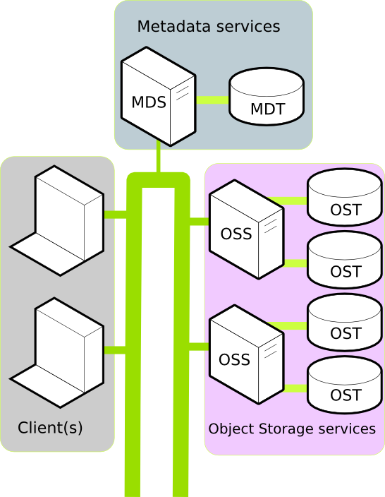
Metadata Server (MDS)
Service nodes that manage all metadata operations, such as assigning and tracking the names and storage locations of directories and files on the OSTs. There is 1 MDS per filesystem.
Object Storage Target (OST)
Storage devices where users' file data is stored. The size of each OST varies from approximately 7 terabytes (TB) to approximately 22 TB, depending on the Lustre filesystem. The capacity of a Lustre filesystem is the sum of the sizes of all OSTs. There are multiple OSTs per filesystem.
Metadata Target (MDT)
A storage device where the metadata (name, ownership, permissions and file type) are stored. There is 1 MDT per filesystem.
Object Storage Server (OSS)
Service nodes that run the Lustre software stack, provide the actual I/O service and network request handling for the OSTs, and coordinate file locking with the MDS. Each OSS can serve multiple OSTs. The aggregate bandwidth of a Lustre filesystem can approach the sum of bandwidths provided by the OSSes. There can be 1 or multiple OSSes per filesystem.
Lustre Clients
Compute nodes that mount the Lustre filesystem, and access/use data in the filesystem. There are commonly thousands of Lustre clients per filesystem.
How Does Lustre I/O Work?
When a client (a compute node from your job) needs to create or access a file, the client queries the metadata server (MDS) and the metadata target (MDT) for the layout and location of the file's stripes. Once the file is opened and the client obtains the striping information, the MDS is no longer involved in the file I/O process. The client interacts directly with the object storage servers (OSSes) and object storage targets (OSTs) to perform I/O operations such as locking, disk allocation, storage, and retrieval.
If multiple clients try to read and write the same part of a file at the same time, the Lustre distributed lock manager enforces coherency so that all clients see consistent results.
Lustre Best Practice usage
- Avoid Using ls -l
- Avoid Having a Large Number of Files in a Single Directory
- Avoid Accessing Small Files on Lustre Filesystems
- Use a Stripe Count of 1 for Directories with Many Small Files
- Keep Copies of Your Source Code on the Pleiades Home Filesystem
- Avoid Accessing Executables on Lustre Filesystems
- Increase the Stripe Count for Parallel Access to the Same File
- Restripe Large Files
- Limit the Number of Processes Performing Parallel I/O
- Use the Soft Link to Refer to Your Lustre Directory

which version?
The current version of Lustre that is in use on the client can be found using the command lctl get_param version, for example:
$ lctl get_param version
version=
lustre: 2.7.59
kernel: patchless_client
build: v2_7_59_0-g703195a-CHANGED-3.10.0.lustreopa

POSIX
POSIX defines the API along with command line shells and utility interfaces for s/w compatibility with variants of Unix and other OS.
Lustre FS performs better with single server than other file system due to it’s strong locking and data coherency.
A Lustre filesystem is a high-performance shared filesystem for Linux clusters that is managed with Lustre software. It is highly scalable and can support many thousands of client nodes, petabytes of storage, and hundreds of gigabytes per second of I/O throughput
Lustre is written in C. file size limits[32 MB -1 EB]
Each Lustre filesystem is actually a set of many small filesystems, which are referred to as object storage targets (OSTs). The Lustre software presents the OSTs as a single unified filesystem.
File Striping
Files on the Lustre filesystems can be striped, which means they can be transparently divided into chunks that are written or read simultaneously across a set of OSTs within the filesystem. The chunks are distributed among the OSTs using a method that ensures load balancing.
Files larger than 100 gigabytes (GB) must be striped in order to avoid taking up too much space on any single OST, which might adversely affect the filesystem.
Benefits include:
- Striping allows one or more clients to read/write different parts of the same file at the same time, providing higher I/O bandwidth to the file because the bandwidth is aggregated over the multiple OSTs.
- Striping allows file sizes larger than the size of a single OST.
The default stripe count is 4.
To check the existing stripe settings on your directory, use the lfs getstripe
To change the number of OSTs, use the lfs setstripe command
Note: The stripe settings of an existing file cannot be changed. If you want to change the settings of a file, create a new file with the desired settings and copy the existing file to the newly created file.

