1. 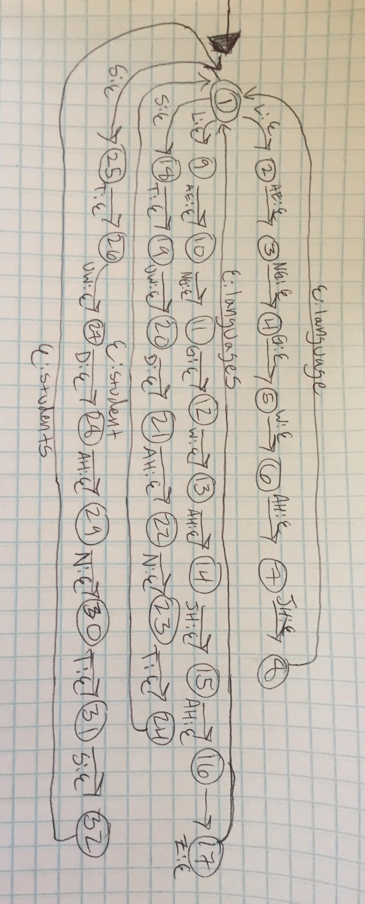Drawn FST:
2. Code needed to run the scenario of both being epsilon:

run(State, In, Out) :-

transition(State, eps, NextState, eps),

run(NextState, In, Out).

1. Values of W I received:  
   W = [“ai”, “scream”]

W = [“aye”, “scream”]

W = [“eye”, “scream”]

W = [“i”, “scream”]

W = [“ice”, “cream”]

W = [“ice”, “creme”]

Code for confuse predicate:

confuse(X, Y) :-

run(State, Z, X),

run(State, Z, Y),

X \= Y.

My observations for running my confuse code with [“computational”, “linguistics”] was that there was a large amount of arguments that had the same pronunciation. In fact, there were so many that I could not reach the end of the data. Some examples of the pronunciations I viewed were:

* A = ["com", "pew", "tay", "shun", "uhl", "lingg", "wyss", "ticks"]
* A = ["com", "peugh", "tae", "shun", "ul", "lingg", "wiss", "ticks"]
* A = ["calm", "pute", "ay", "shun", "uhl", "lingg", "wyss", "ticks"]
* A = ["computational", "lingg", "wiss", "ticks"]