**Definition**: Create a CRUD module for event using php and MySQL as database.

**Project Setup**

1. Take pull of code from <https://github.com/sunilchauhan940/event_tatvasoft.git>
2. Run “php artisan migrate” command to insert database tables.

**Description**: There are 3 pages for this module:

1. Event add/edit page

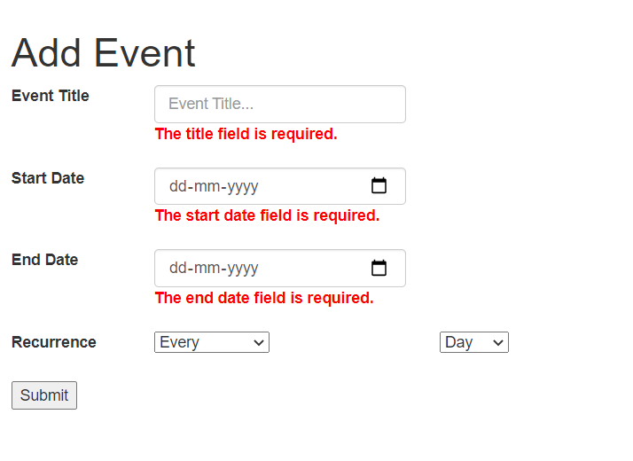

2. Event list page – Listing of events with “View” button

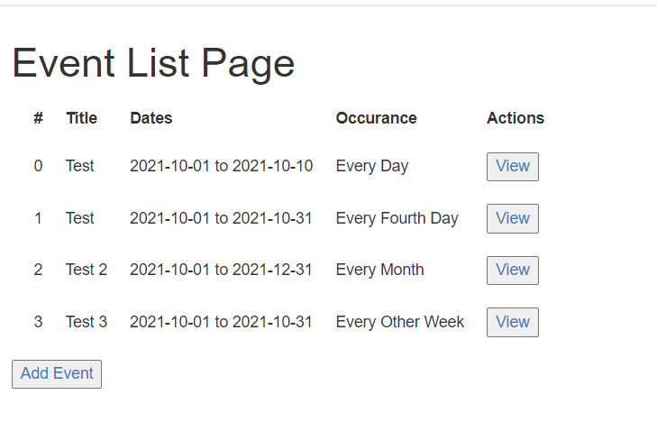

3. View Event page

