**create a HBase table names ‘clicks’ with column family ‘hits’ such that it should be able to store last 5 values of qualifiers inside ‘hits’ column family.**

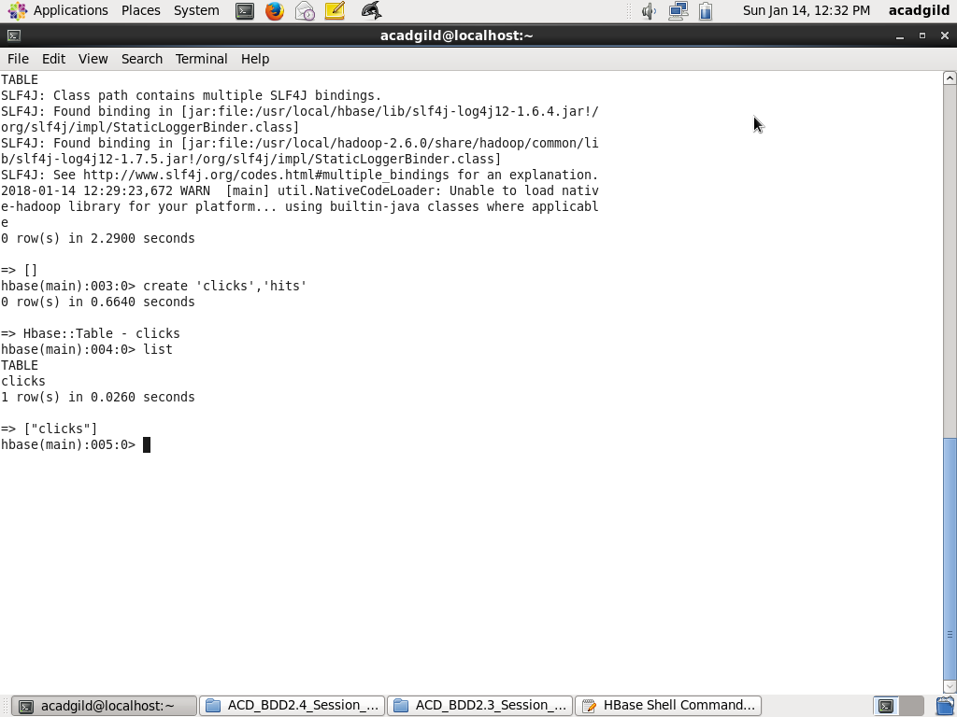

**Add few records in the table and update some of them. Use IP Address as row-key.**

**Scan the table to view if all the previous versions are getting displayed.**

**Added records in the table using put command**

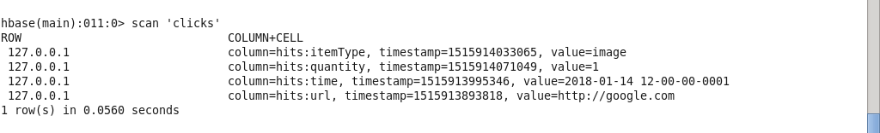

* **updated clicks table quantity value to 2**
* **put ‘clicks’,’127.0.0.1’,’hits:quantity’,’2’**
* **scanned again to check the updated value of the quantity to 2.**

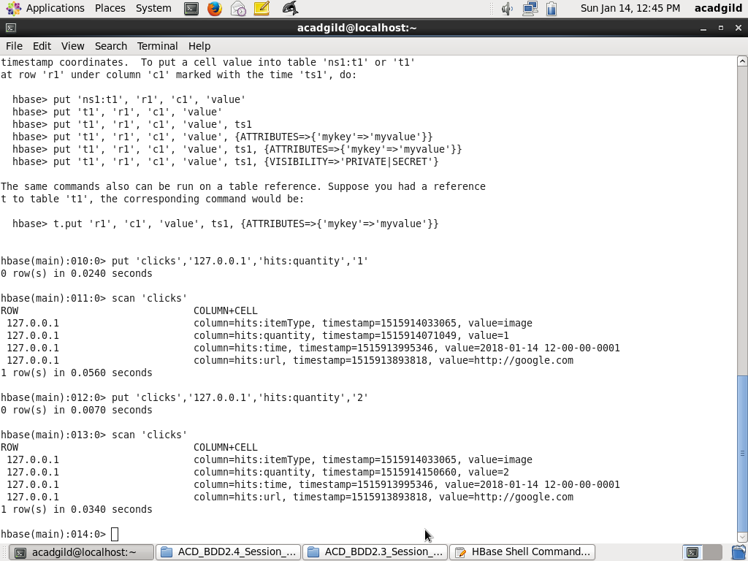

**versions of the table can be displayed using scan command**

