Register jar in hive prompt and call the temporary function:

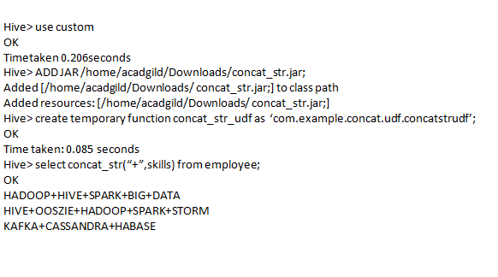

concat_str_udf custom udf function to concat string using delimiter ‘+’ .