**Data set**

001 Amit105 Data Minning

002 Pankaj 85 Data Engineer

003 Kiran 110 Data Scientist

004 Arpitha 95 Data Engineer

005 Viraj 105 Data Mining

006 Smitha 80 Data Analyst

007 Supriya 90 Data Engineer

008 Vihan 120 Data Scientist

009 Emma100 Data Engineer

010 Siddharath 100 Data Engineer

**create table and load data to employee_salary table:**

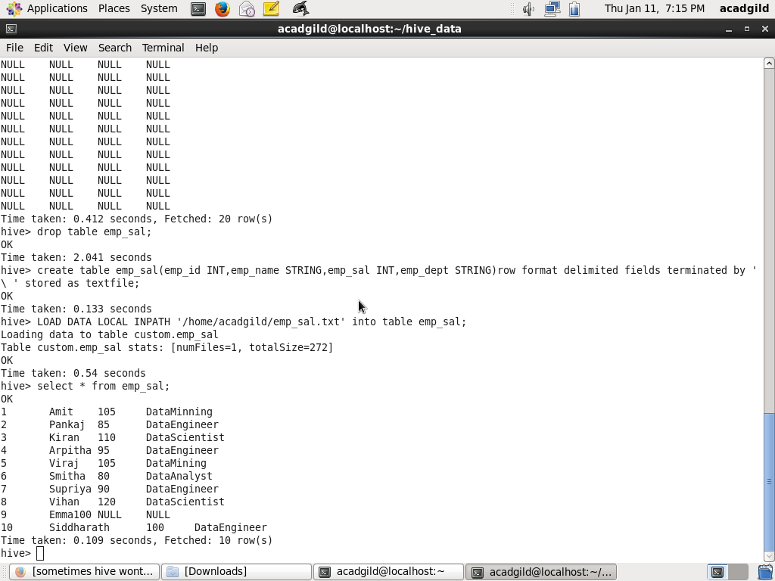

**Get a list of employees who receive a salary less than 100,**

**compared to their immediate employee with higher salary in the**

**same unit**

**Query**

select * from emp_sal x join(select max(emp_sal) as max_sal, emp_dept from emp_sal group by emp_dept) y

where x.emp_sal<100 and x.emp_sal < y.max_sal and x.emp_dept = y.emp_dept;

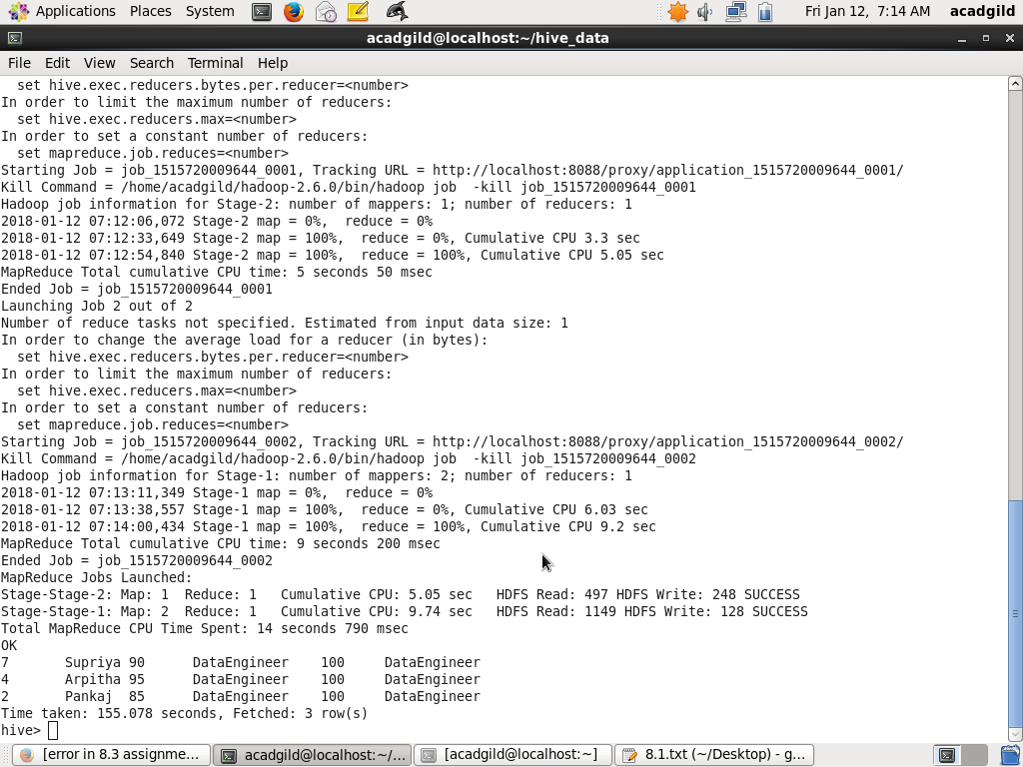

**List of all employees who draw higher salary than the average**

**salary of that department**

select * from emp_sal x join ( select avg(emp_sal) as average, emp_dept from emp_sal group by emp_dept ) y

where x.emp_sal > y.average and x.emp_dept = y.emp_dept;

