**Transactions in Hive:**

The different row-level transactions available in Hive 0.14 are as

follows:

1 Insert

2 Delete

3 Update

The below properties needs to be set appropriately in ***hive shell*** ,

order-wise to work with transactions in Hive, By default they are

turned off in hive:

**Creating a Table That Supports Hive Transactions:**

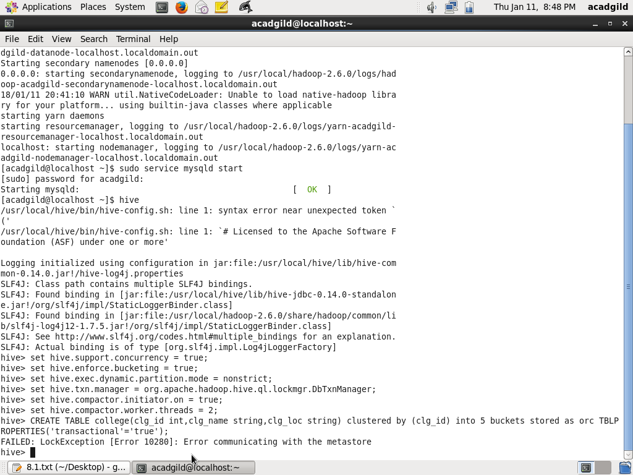

Not executing properly showing error

**FAILED: LOCKEXCEPTION [Error 10280]: Error communicating with the metastore**  
  
Thus, to resolve the above issue open a new terminal and start the hive metastore service parallely using below command.

**hive --service metastore**

**I tried the above still dint get the output**

**I update the hive and try, as today is last date am uploading the same**