Importing acadgild sparkvm and installing

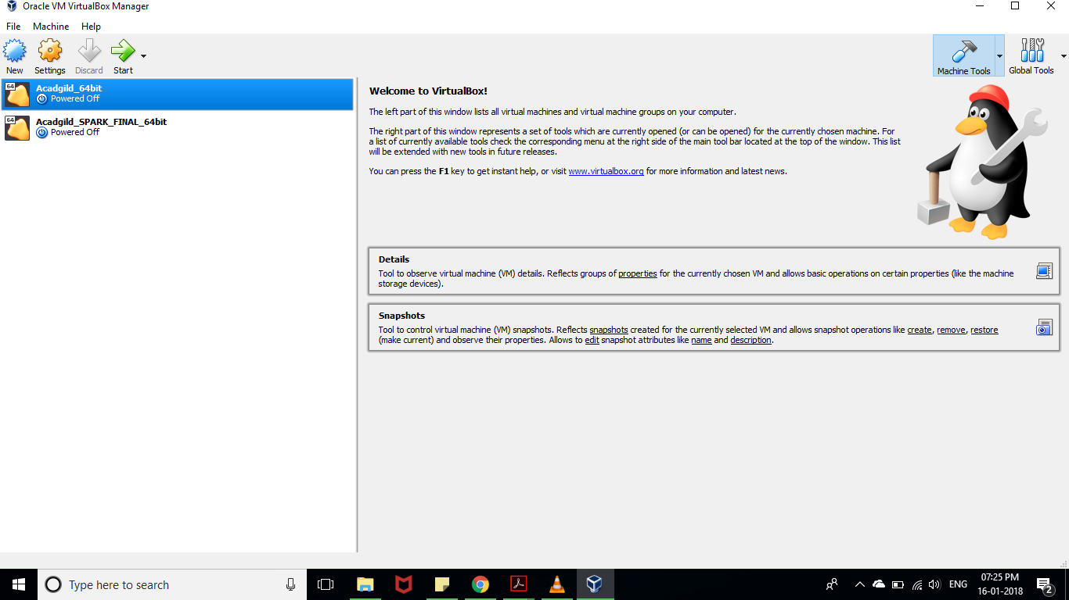



**Open the terminal and type the command jps to check the list of daemons, we need to start all the daemons for the first time.**

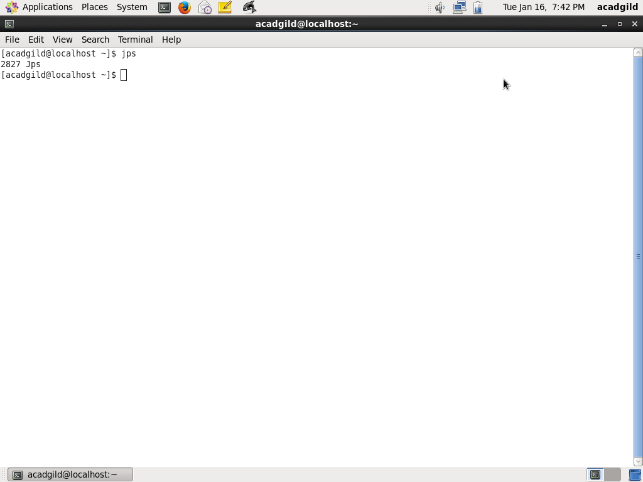

**Starting Hadoop daemons**

# Starting NameNode, DataNode, ResourceManager, NodeManager and Jobhistoryserver

**Starting namenode:**

**Command: ./hadoop-daemon.sh start namenode**

**Starting datanode:**

**Command: ./hadoop-daemon.sh start datanode**

**Starting resourcemanager:**

**Command: ./yarn-daemon.sh start resourcemanager**

**Starting nodemanager:**

**Command: ./yarn-daemon.sh start resourcemanager**

**Type the command jps to check the health of the daemons, if all the daemons will be running then cluster is ready.**

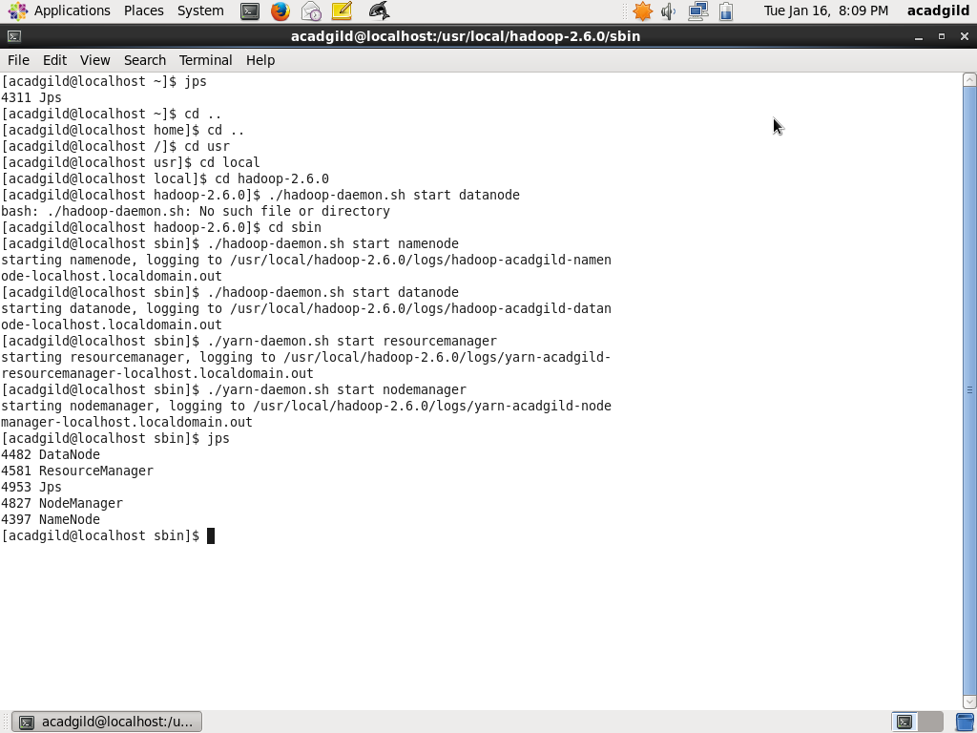

**Starting Spark daemons Master,Workers**

Move into the sbin folder of spark installed directory(Here spark is installed in /usr/local/spark/ directory.)

**Starting Master:**

**Command: ./ start-master.sh**

**Starting Slaves:**

**Command: ./start-slaves.sh**

