Given a list of strings - List[String] (“alpha”, “gamma”, “omega”, “zeta”, “beta”)

- find count of all strings with length 4

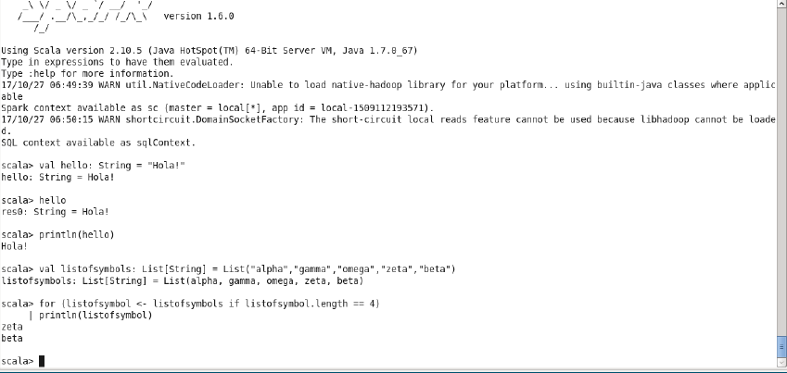

- convert the list of string to a list of integers, where each string is mapped to its

corresponding length

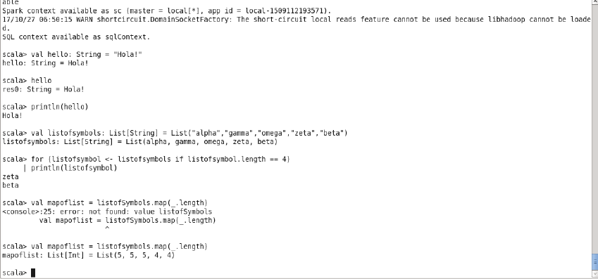

- find count of all strings which contain alphabet ‘m’

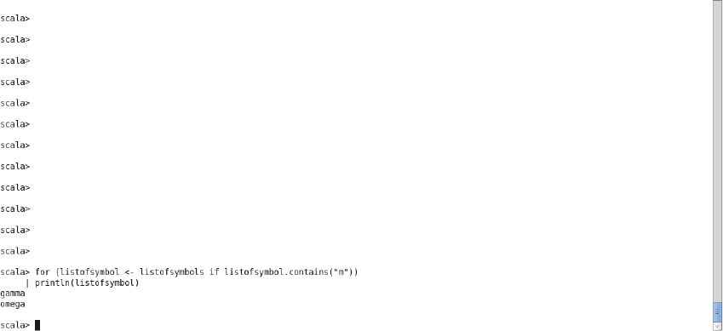

find the count of all strings which start with the alphabet ‘a’

