Given list of numbers - List[Int] (1,2,3,4,5,6,7,8,9,10)

- find the sum of all numbers

- find the total elements in the list

- calculate the average of the numbers in the list

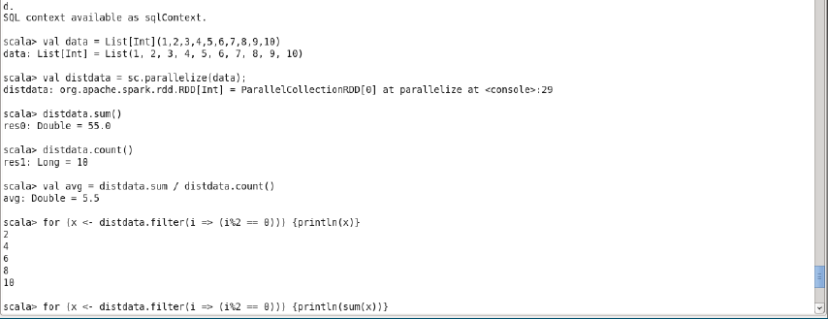

- find the sum of all the even numbers in the list

- find the total number of elements in the list divisible by both 5 and 3

