**1. Write a program to read a text file and print the number of rows of data in the document.**

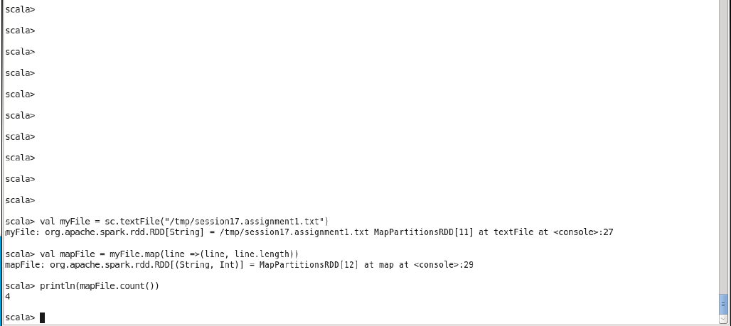

**2. Write a program to read a text file and print the number of words in the document.**

**Or**

**We have a document where the word separator is ‘-‘, instead of space. Write a spark code, to obtain the count of the total number of words present in the document**

