**Problem Statement 1:**

1. **Read the text file, and create a tupled rdd**

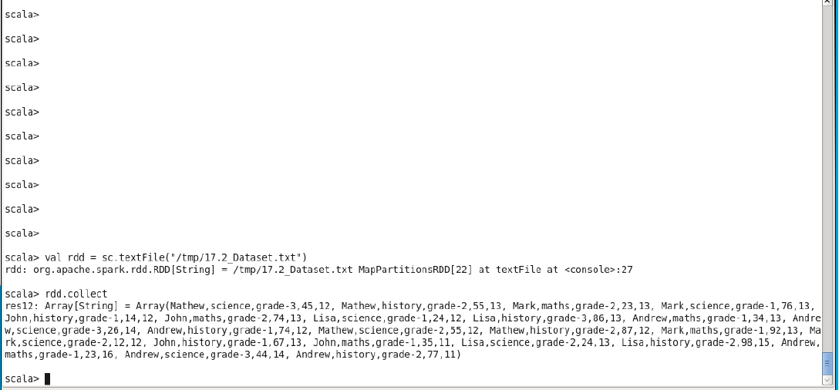

1. **Find the count of total number of rows present.**

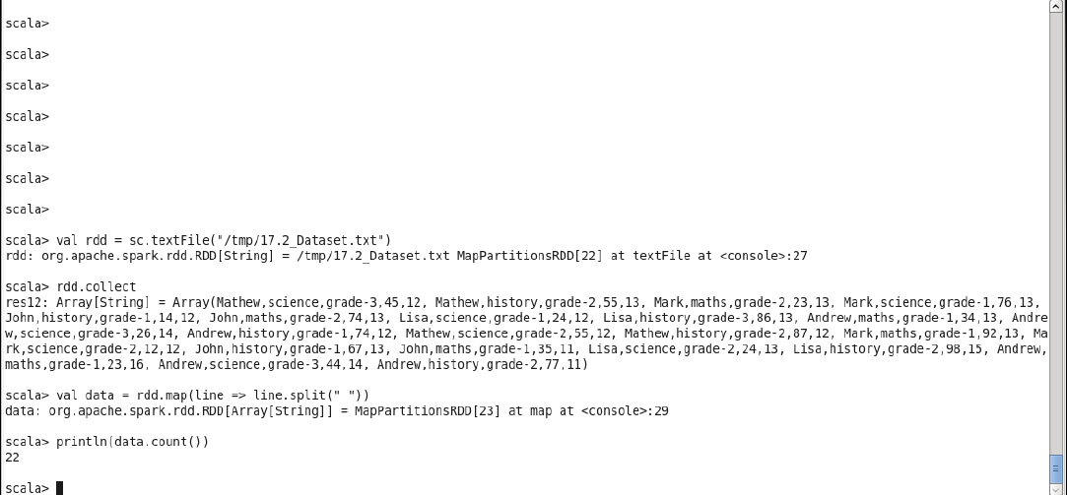

1. **What is the distinct number of subjects present in the entire school**

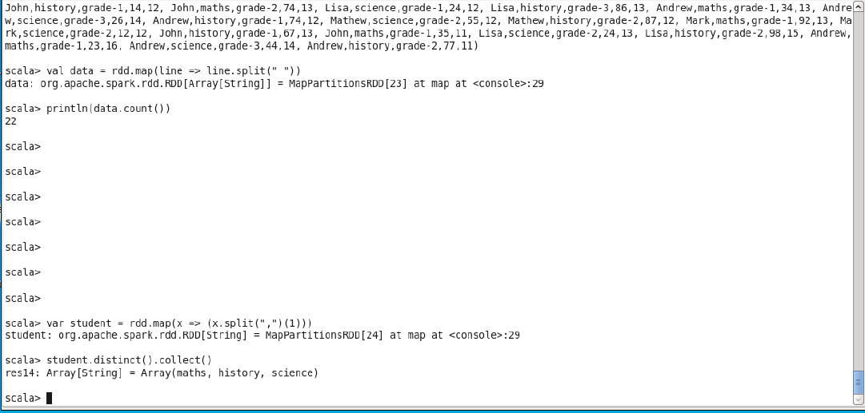

**4. What is the count of the number of students in the school, whose name is Mathew and marks is 55**

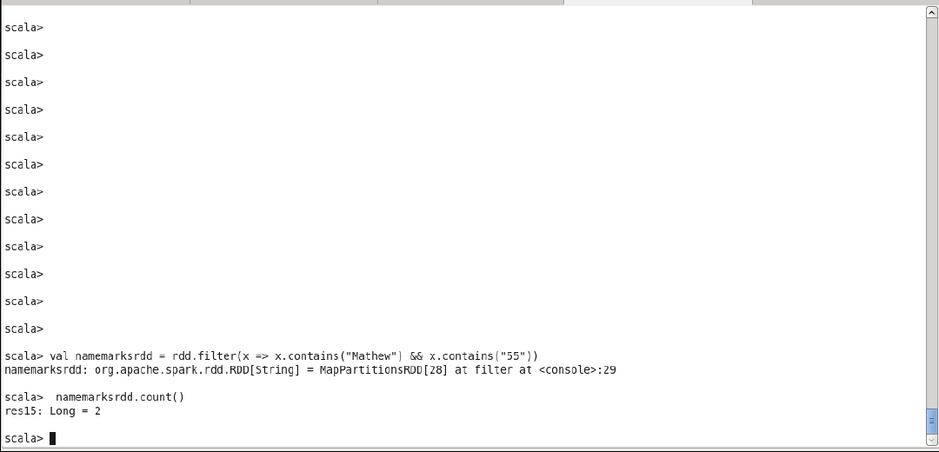

**Problem Statement 2:**

1. **What is the count of students per grade in the school?**

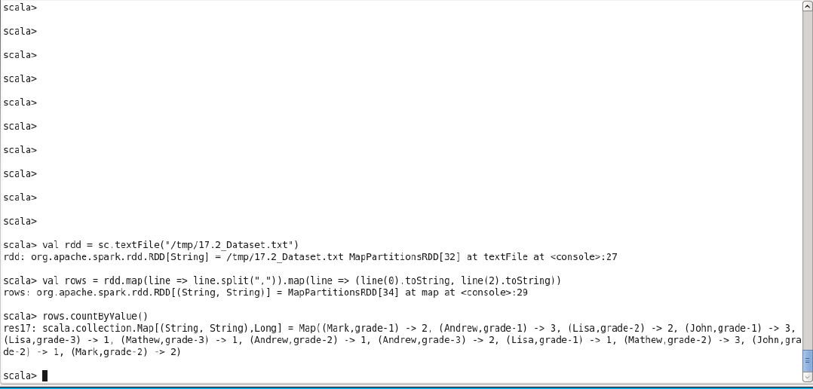

**2. Find the average of each student (Note - Mathew is grade-1, is different from Mathew in some other grade!)**

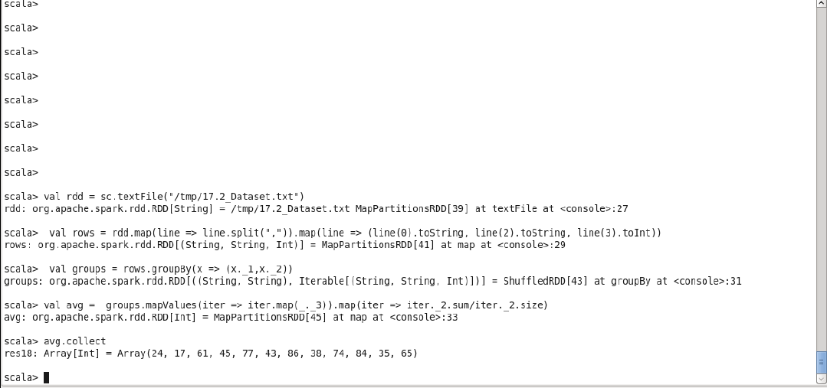

1. **What is the average score of students in each subject across all grades?**

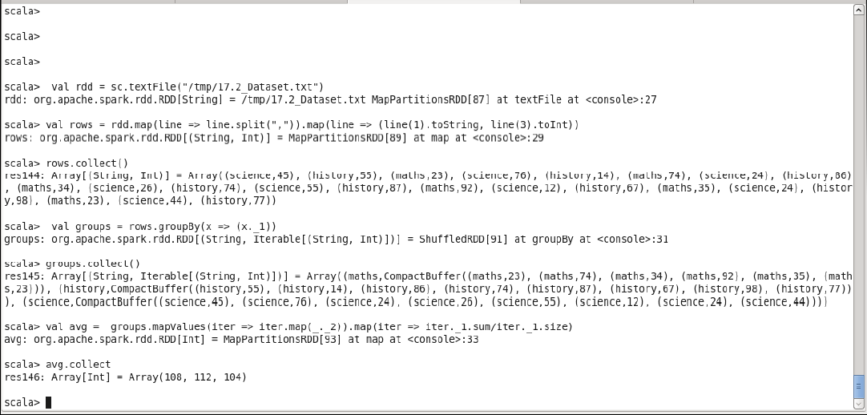

1. **What is the average score of students in each subject per grade?**

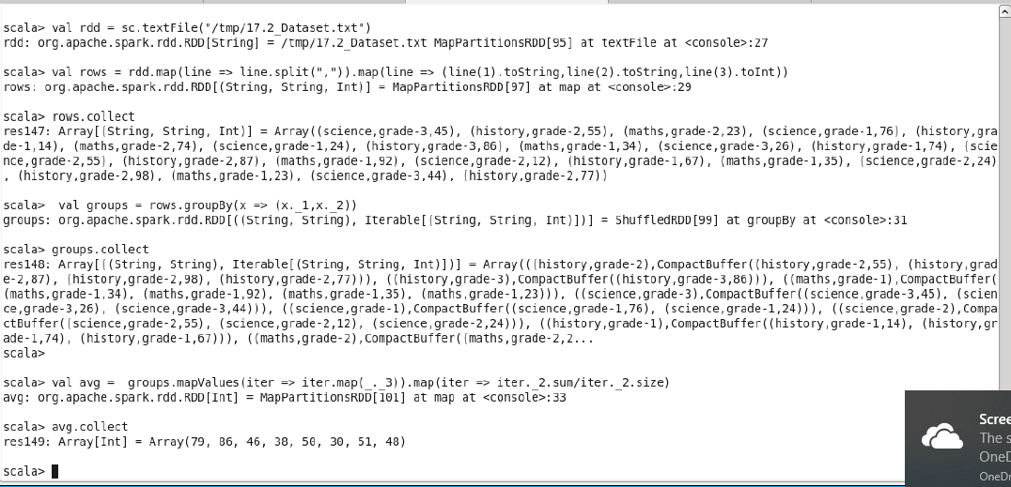

1. **For all students in grade-2, how many have average score greater than 50?**

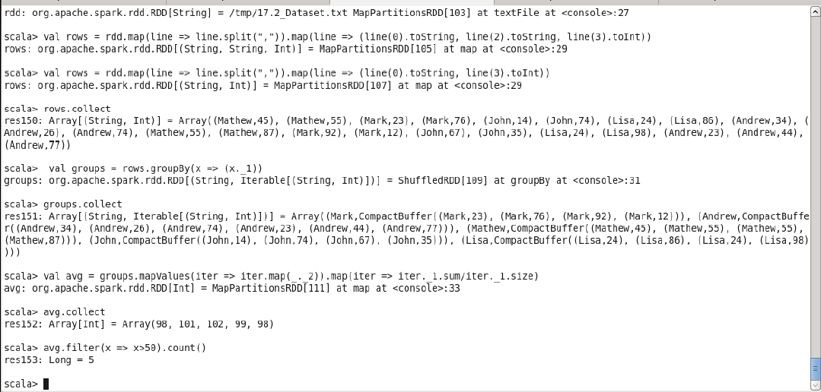

**Problem Statement 3:**

**Are there any students in the college that satisfy the below criteria :**

1. **Average score per student_name across all grades is same as average score per student_name per grade**

**Hint - Use Intersection Property**

