**Convert text file to data frame to run queries:**

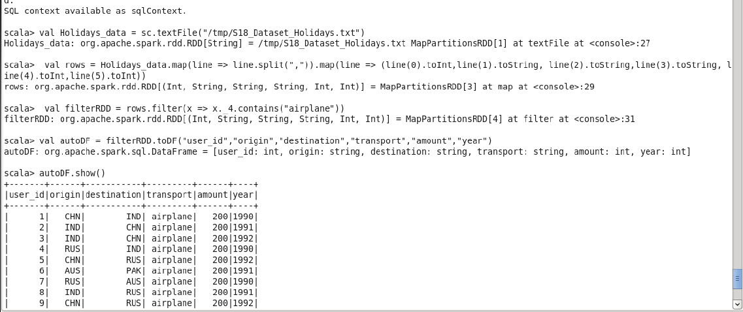

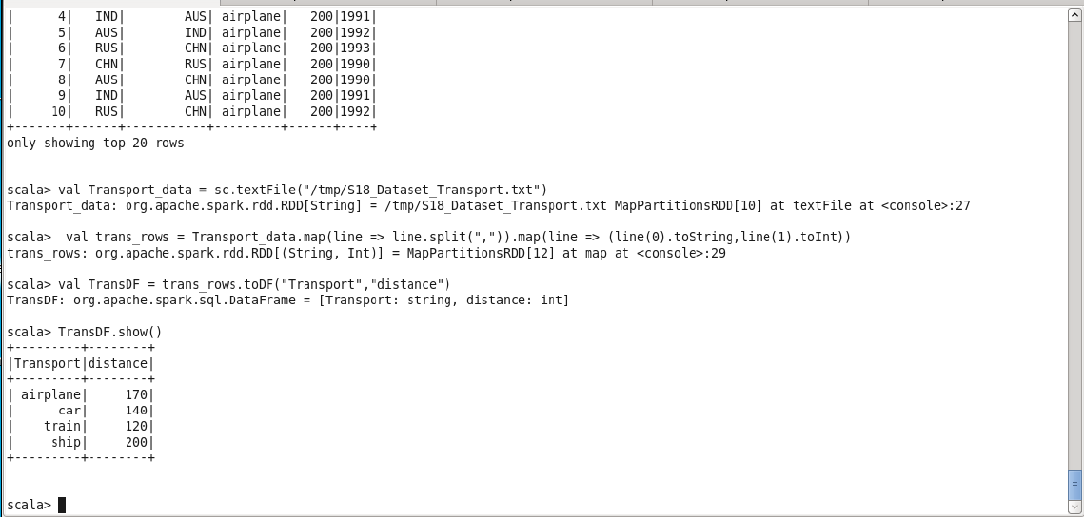

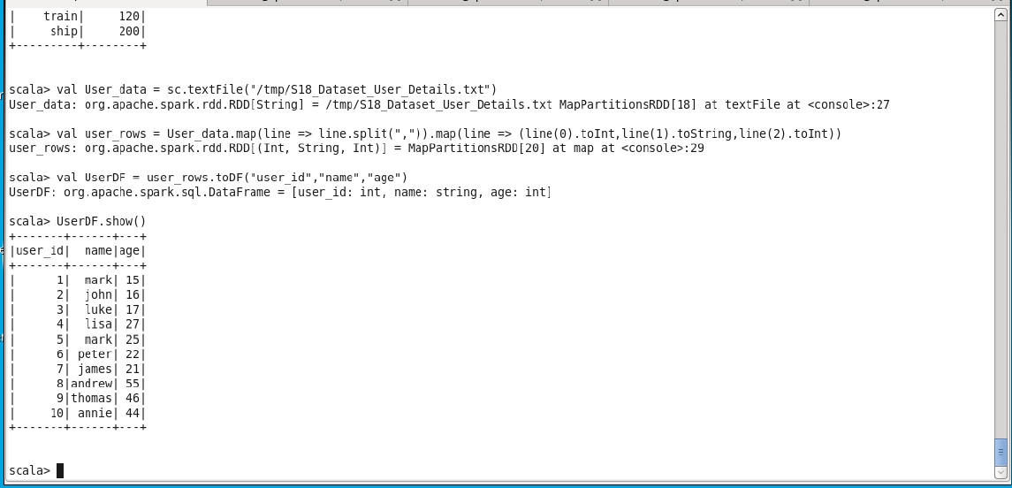

1. **What is the distribution of the total number of air-travelers per year**

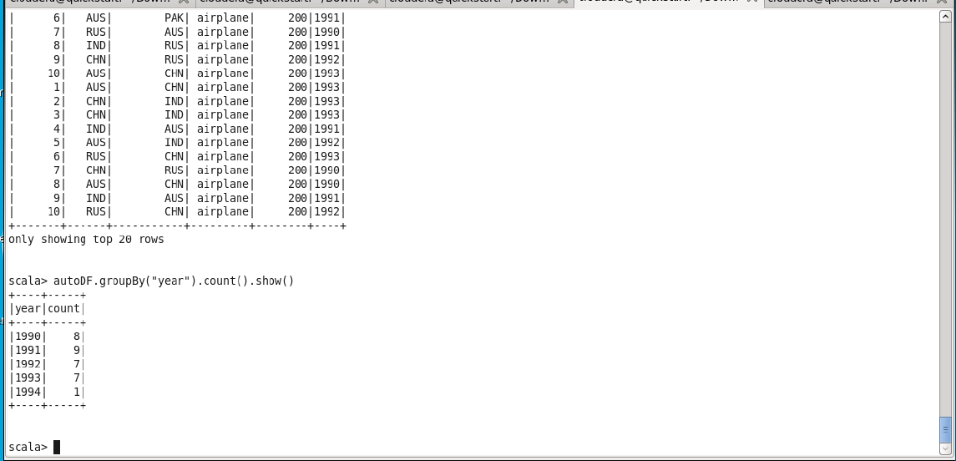

1. **What is the total air distance covered by each user per year**

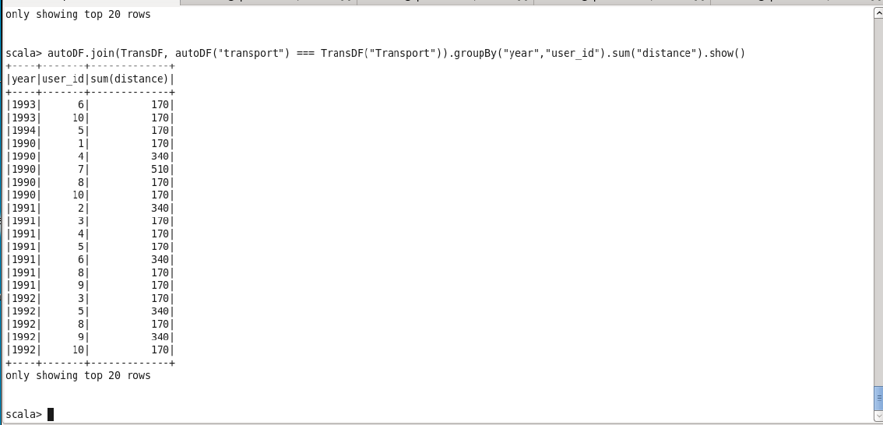

1. **Which user has travelled the largest distance till date**

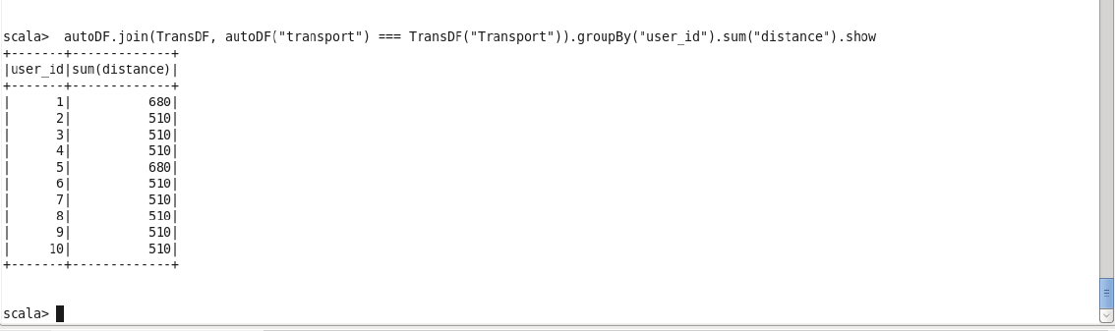

1. **What is the most preferred destination for all users.**

