**Using spark-sql, Find:**

1. **What are the total number of gold medal winners every year**

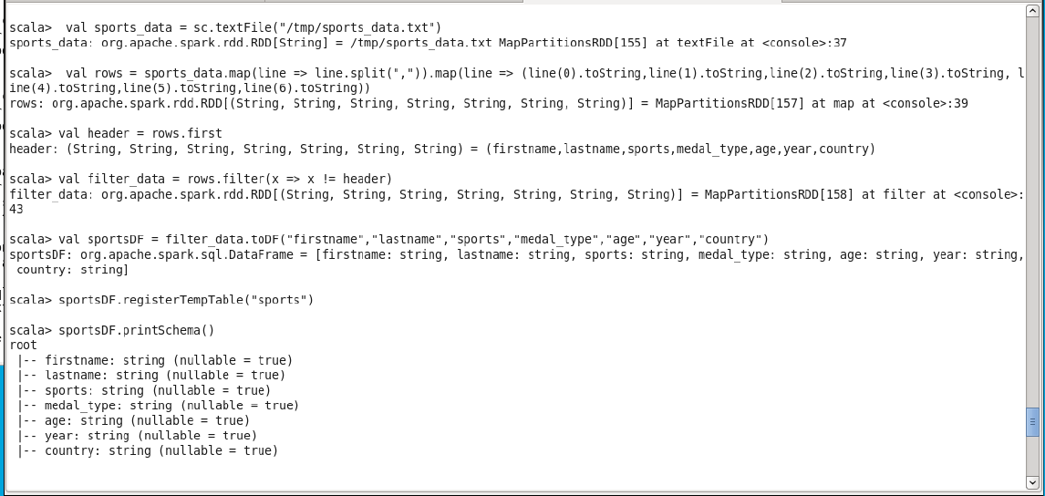

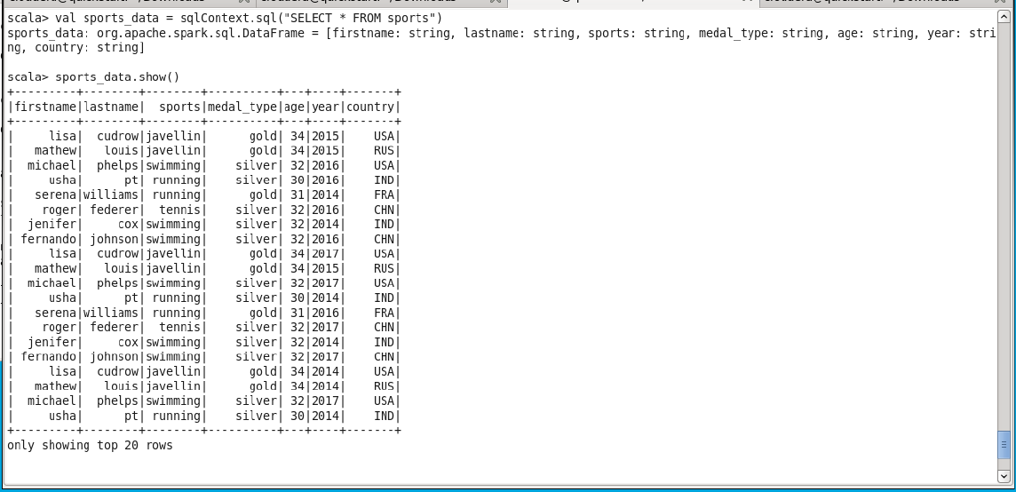

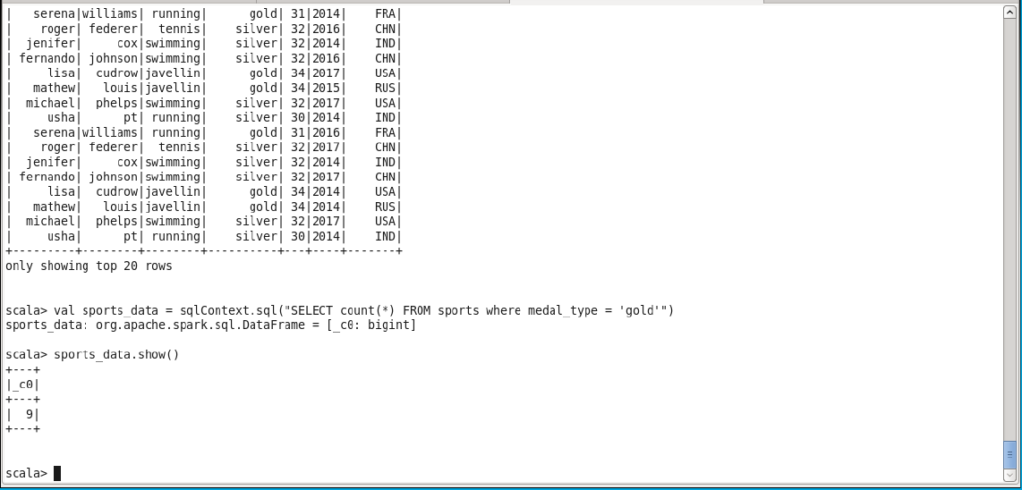

1. **How many silver medals have been won by USA in each sport**

