**Using udfs on dataframe**

1. **Change firstname, lastname columns into Mr.first_two_letters_of_firstname<space>lastname for example - michael, phelps becomes Mr.mi phelps**

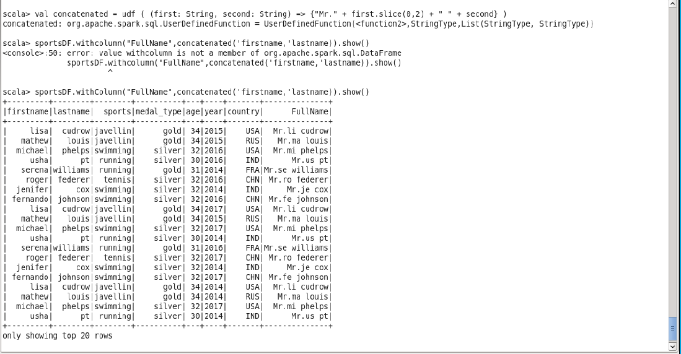

**2. Add a new column called ranking using udfs on dataframe, where :**

**gold medalist, with age >= 32 are ranked as pro**

**gold medalists, with age <= 31 are ranked amateur**

**silver medalist, with age >= 32 are ranked as expert**

**silver medalists, with age <= 31 are ranked rookie**

