**Counting popular hashtags using spark sql**

1. **Copy the JSON file to HDFS using**

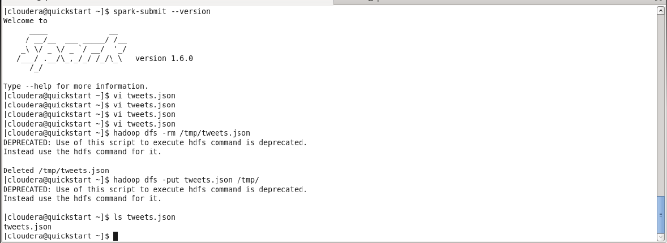

**2. Source code to**

**1.To read json file**

**2. Extract hashtags from file.**

**3. Split the words and count the number of occurrence hashtags.**

