1. **Copy delayed_flights.csv to HDFS using**

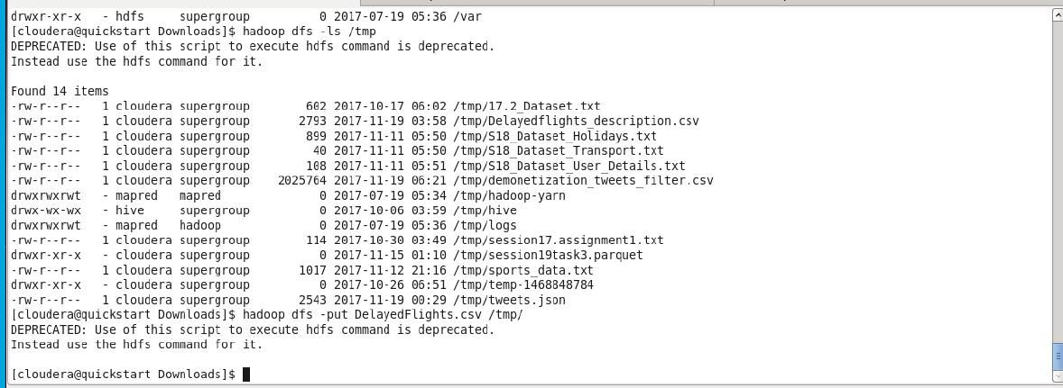

**Problem statement 1:**

1. **Find out the top 5 most visited destinations.**

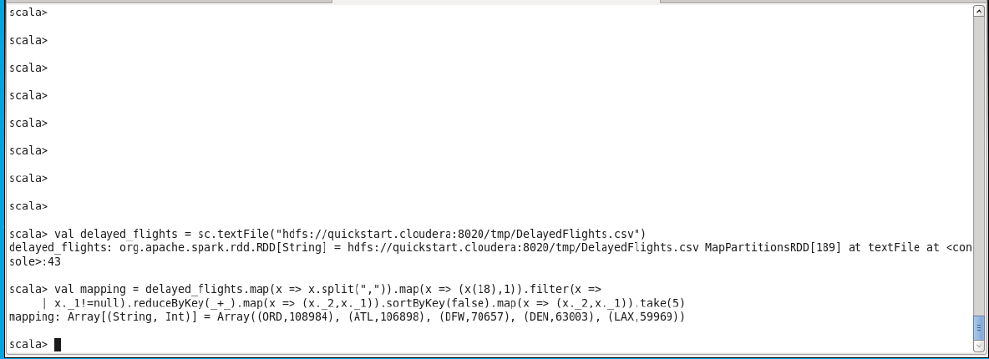

**Problem statement 2**

**Which month has seen the most number of cancellations due to bad weather?**

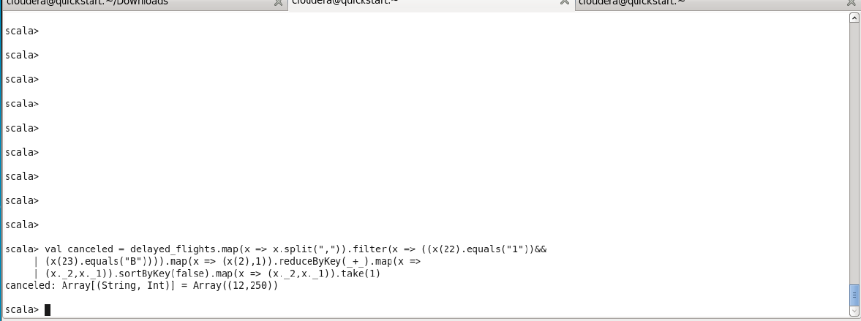

**Problem statement 3:**

**Top ten origins with the highest AVG departure delay**

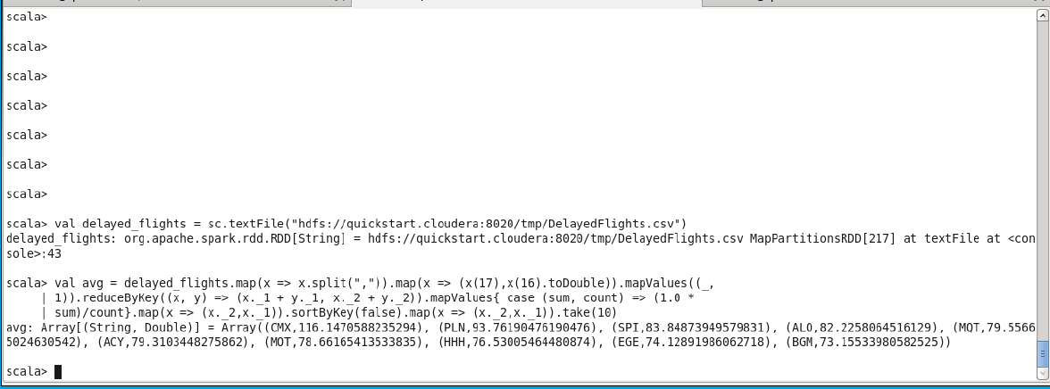

**Problem statement 4**

**Which route (origin & destination) has seen the maximum diversion?**

