**Census data analysis**

**1. Copy data to HDFS directory using Hadoop dfs -put command**

**2. Read csv file and create data from using csv data**

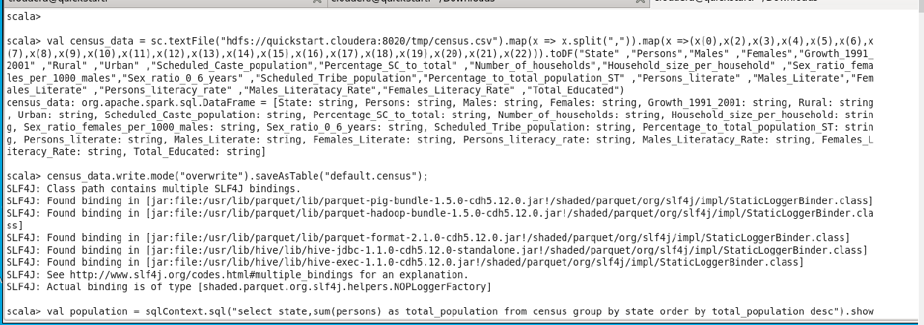

**3. Find out the state wise population and order by state**

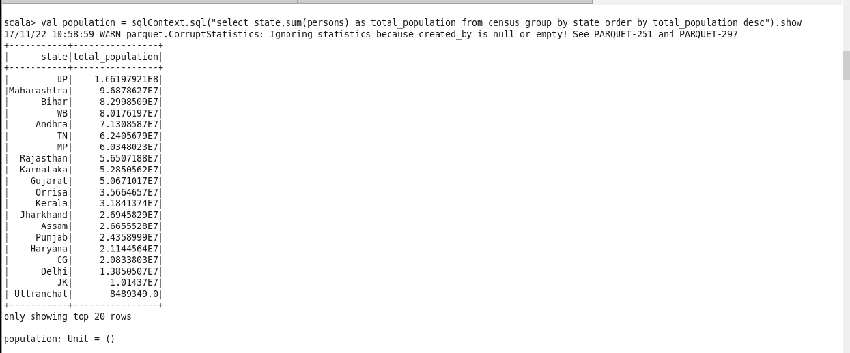

**Find out the Growth Rate of Each State Between 1991-2001**

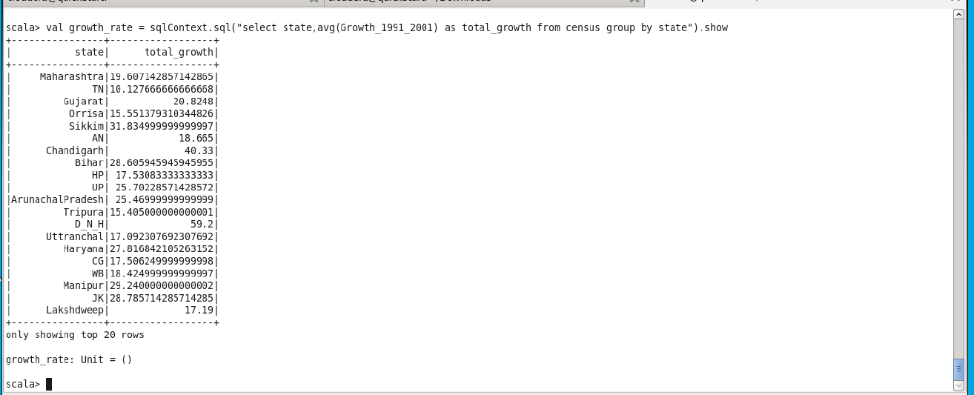

**Find the literacy rate of each state**

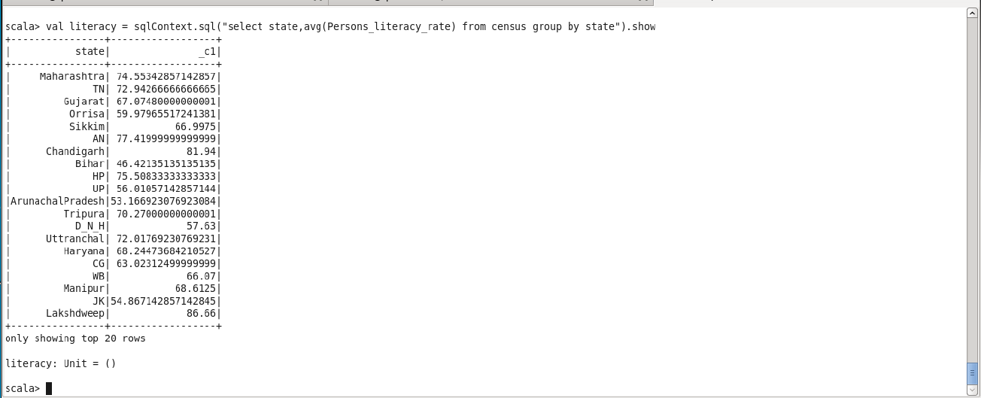

**Find out the States with More Female Population**

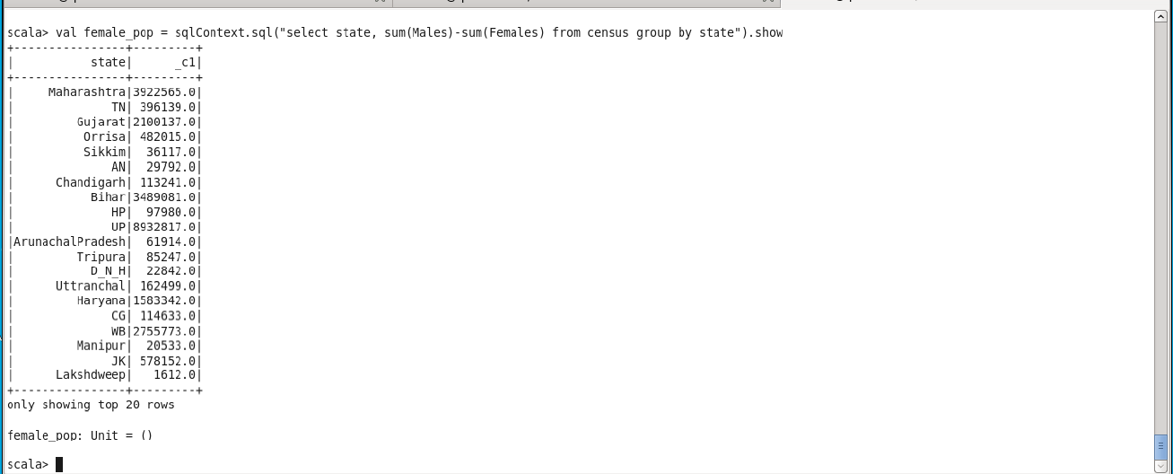

**Find out the Percentage of Population in Every State**

