**Sentiment_analysis_on_demonetization**

1. **Copy datasets to HDFS tmp directory**

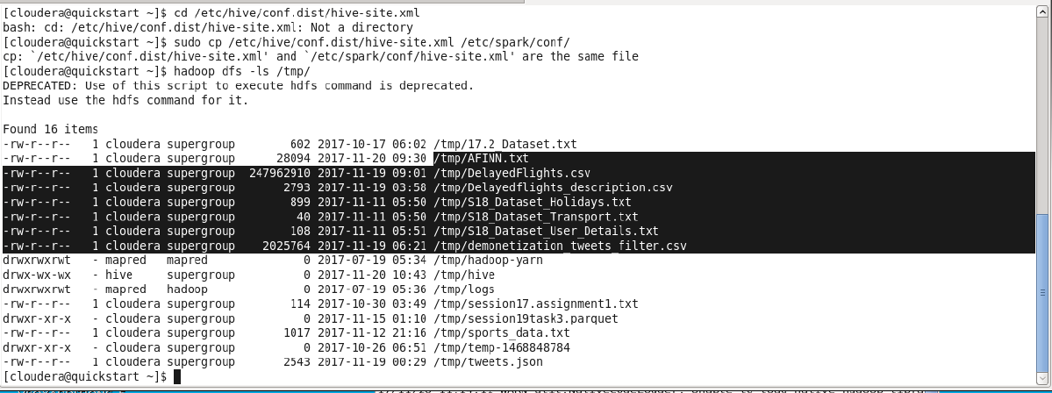

1. **Read text file and filter the unwanted lines from the file.**

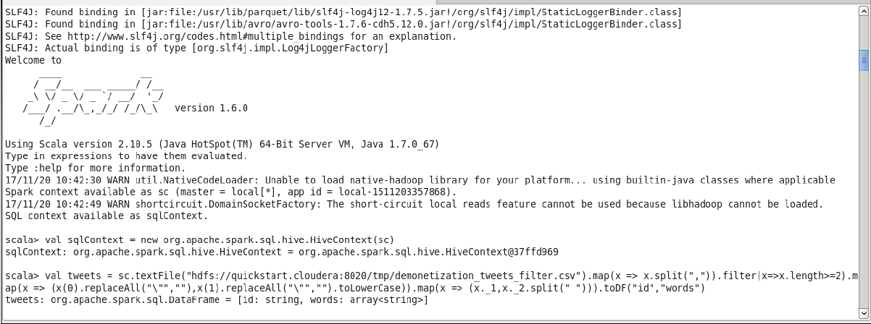

1. **Create table from data frame created from step 2**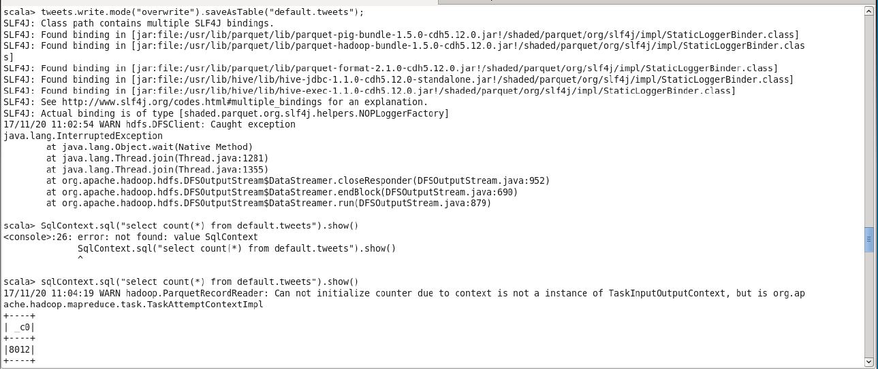
2. **explode words from the step 3 and create another table**

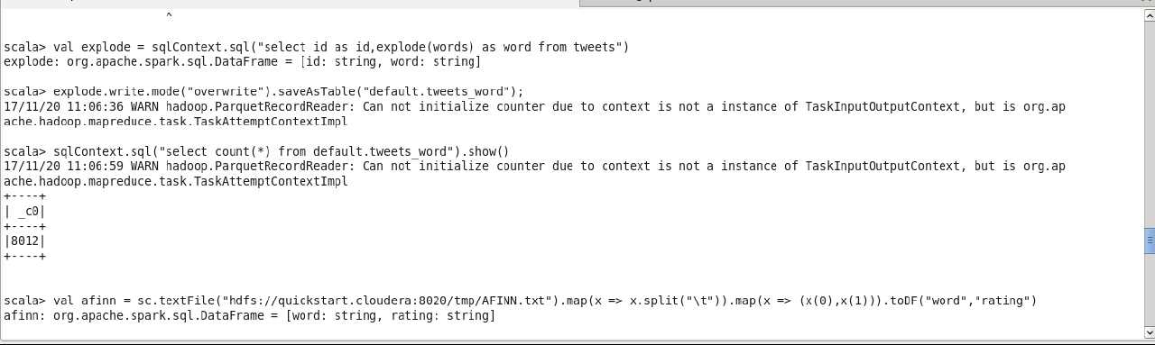

1. **Read another text file in to Dataframe and create a table from the data frame**

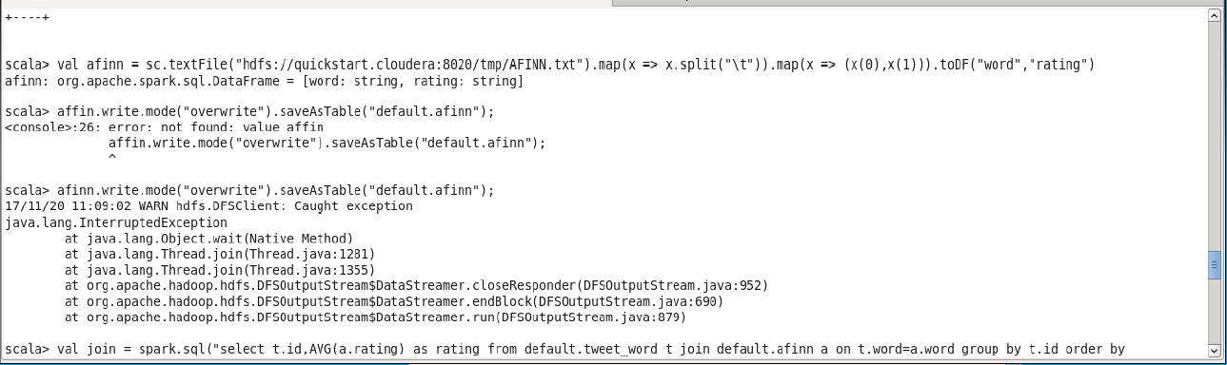

1. **Select average rating by going the tweet words and affin words**

