step 1:

create database named custom using hive command prompt:

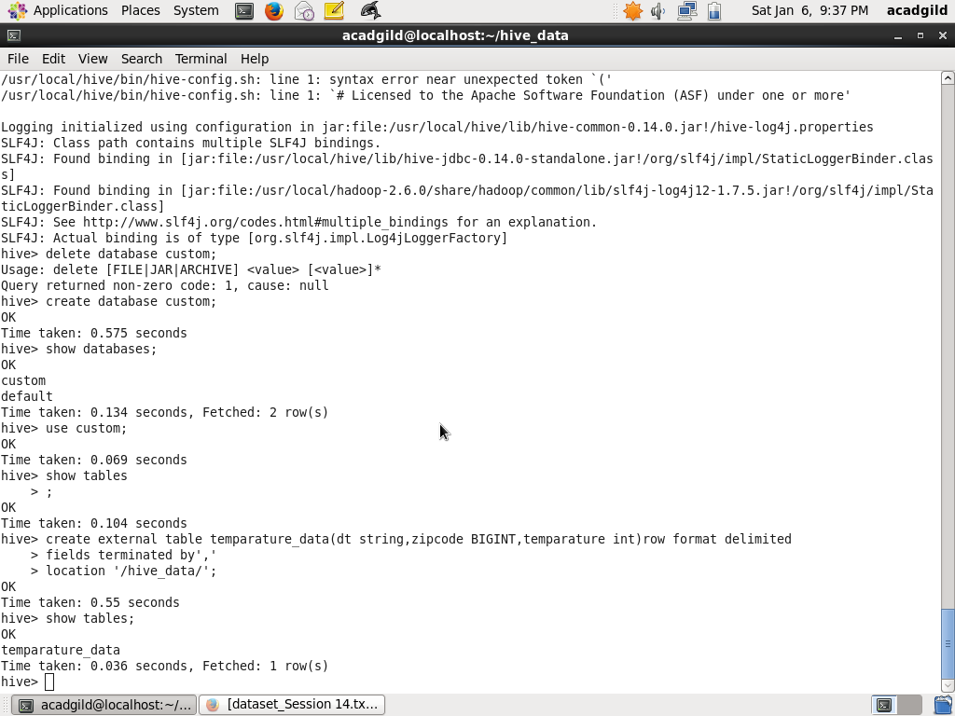

2. copy dataset.txt to hadoop using put command and then check the data in the

hadoop path using cat command:

Create a table named temperature_data inside custom having below fields:

1. date (mm-dd-yyyy) format

2. zip code

3. temperature

The table will be loaded from comma-delimited file.

commad for table creation:

create external table temperature_data

(

dt string,

zipcode BIGINT,

temperature int

)

row format delimited

fields terminated by ','

location '/hive_data/';

