1.Fetch date and temperature from temperature_data where zip code is greater

than

300000 and less than 399999.

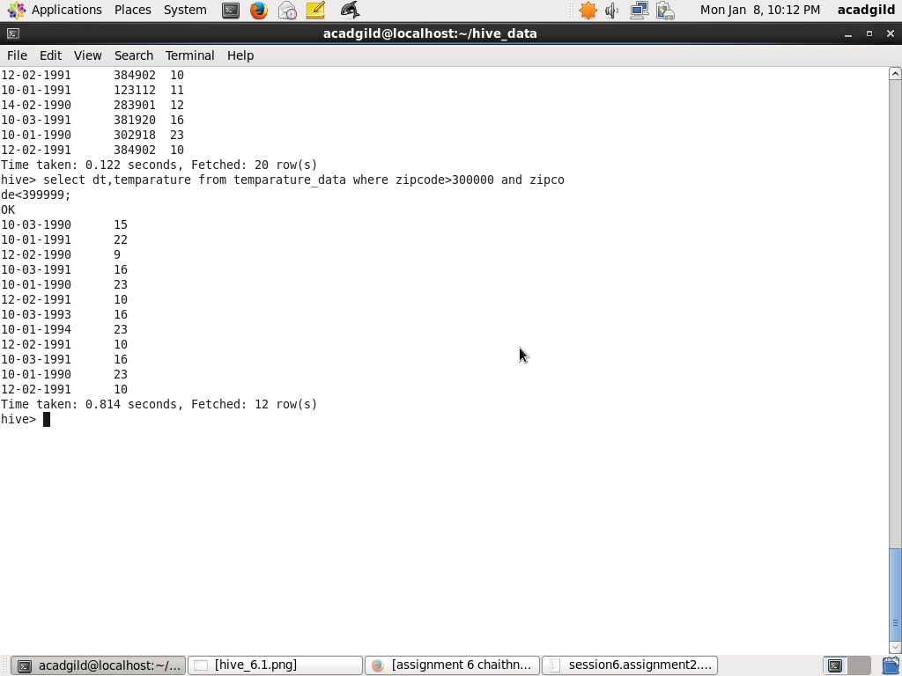

2. Calculate maximum temperature corresponding to every year from

temperature_data

table.

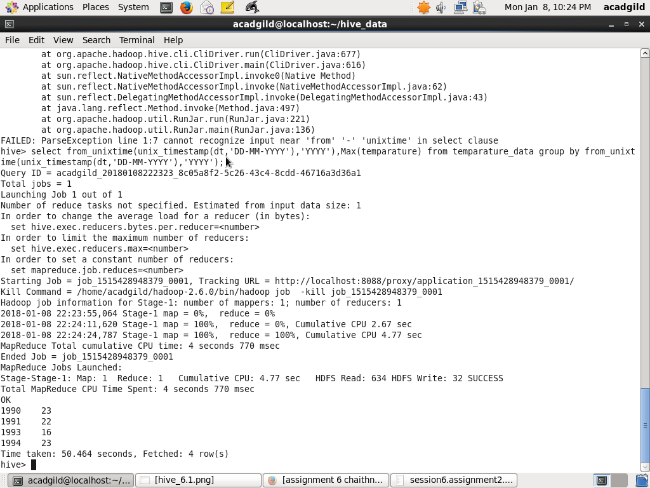

3. Calculate maximum temperature from temperature_data table corresponding to

those

years which have at least 2 entries in the table.

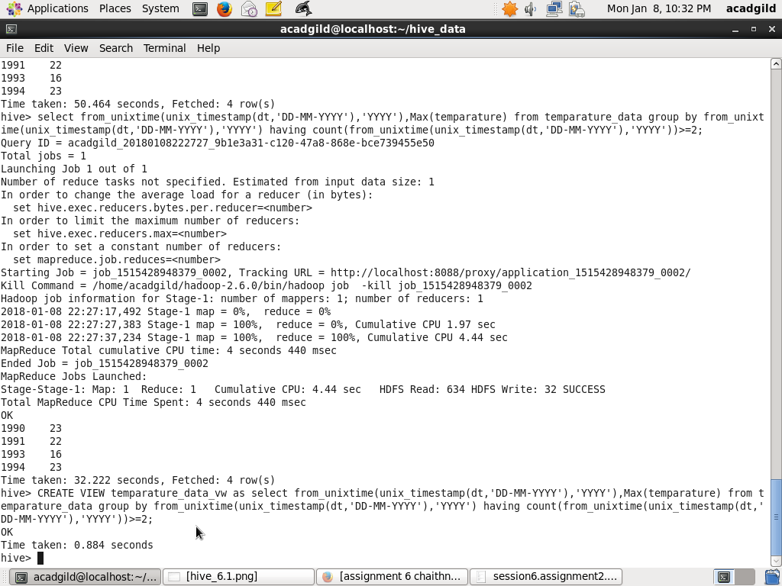

4. Create a view on the top of last query, name it temperature_data_vw.

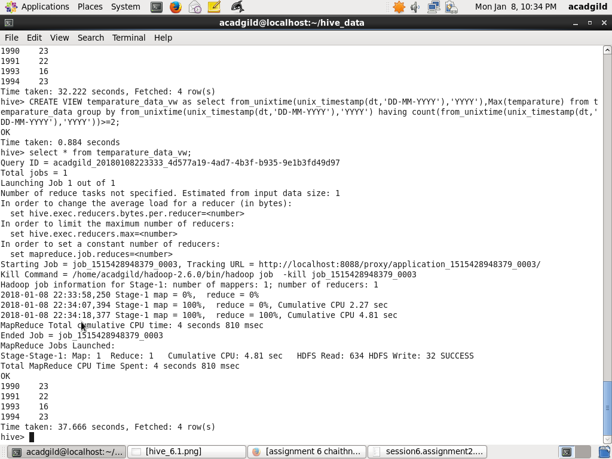

5. Export contents from temperature_data_vw to a file in local file system, such that

each

file is '|' delimited.

