Transfer data between Mysql and HDFS using
sqoop:
Importing data from mysql to HDFS:
- Create database ‘testDb’ and create table student and add records to the table:

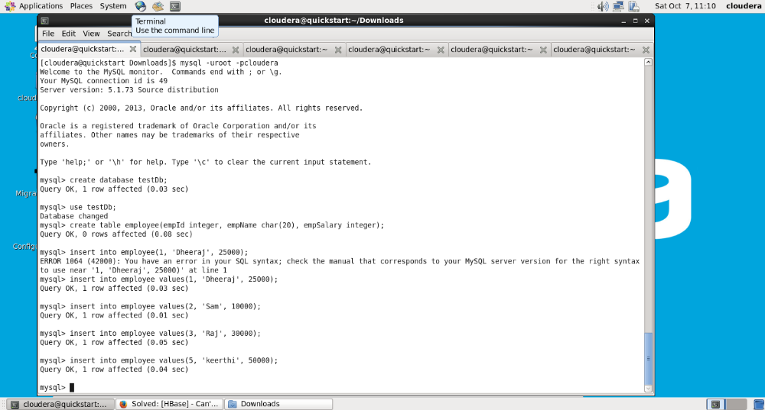

- Import a table into HDFS using sqoop import command:
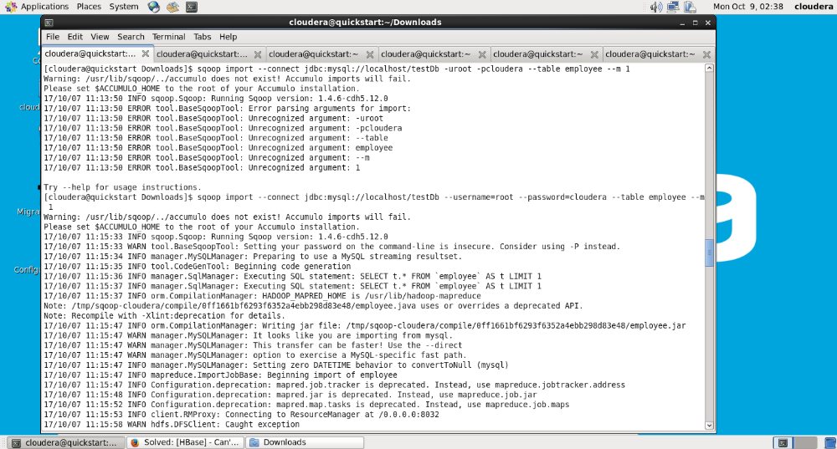

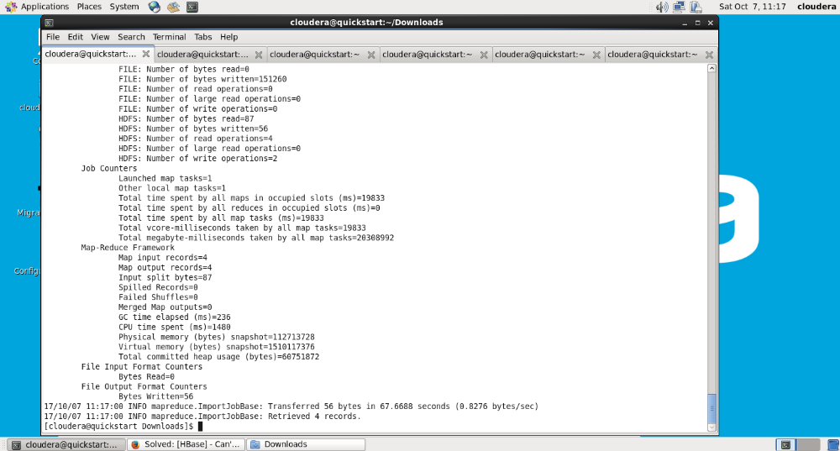

3. Once import is done, data from the student table should be present in the HDFS
at /user/cloudera/employee/part-m-00000 location:
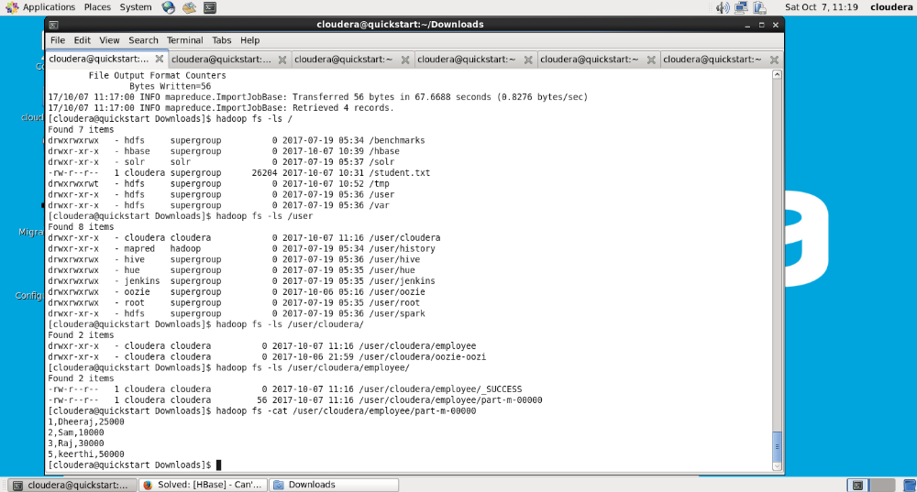

Task: Export Data from HDFS to mysql using swoop:
- Create a new tables in the mysql in existing database testDb

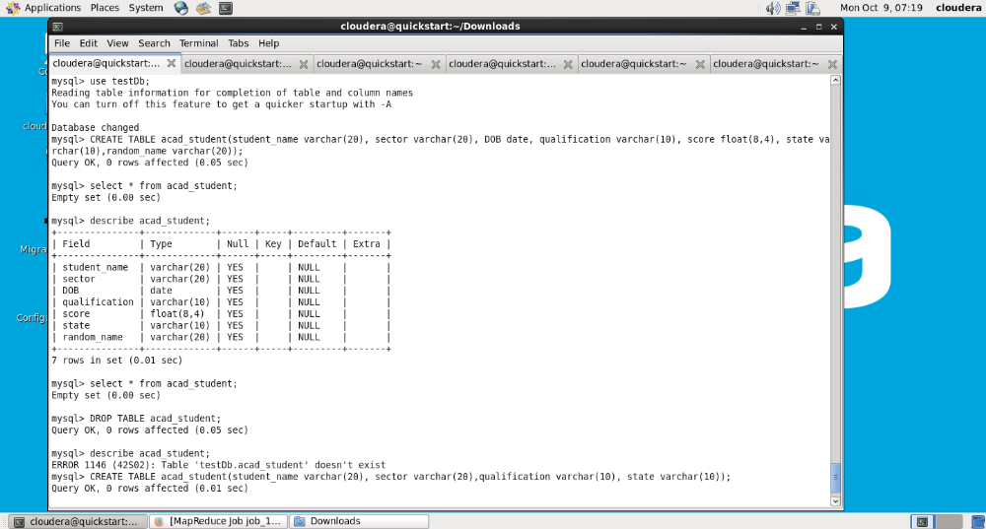

2. Copy the file that needs to be exported from HDFS using command
Hadoop fs -put <file_name> <path_in_hdfs_file_system>

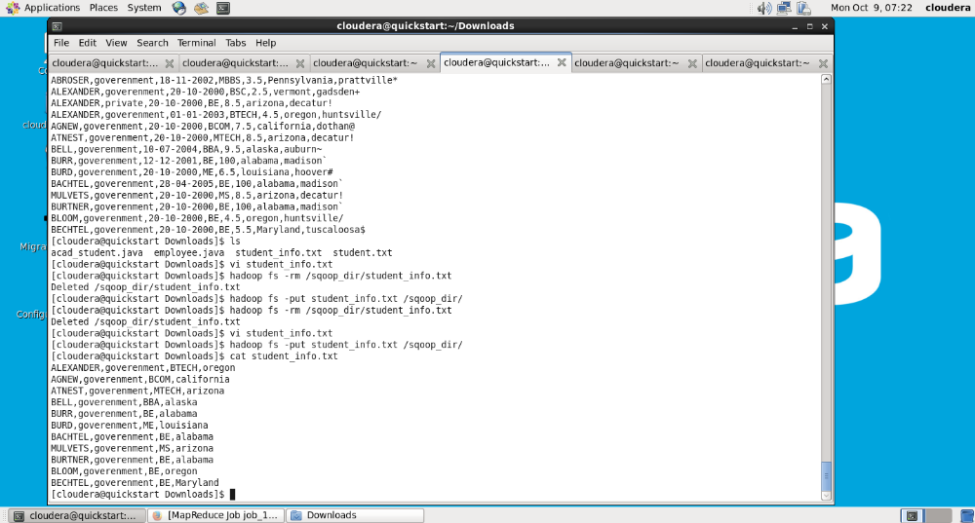

- Export file from HDFS to mysql using sqoop export command:
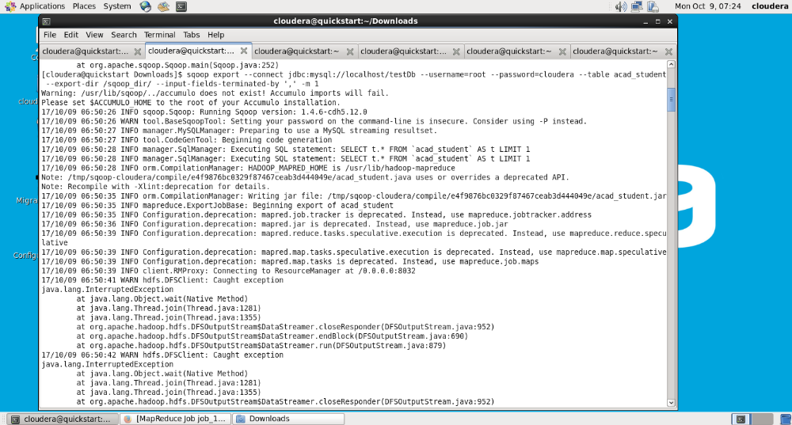

- Job completion statement will be displayed as
