Transfer data between mysql and Hive using sqoop:
Import data from mysql to Hive:
1. Create table in mysql and load some data:
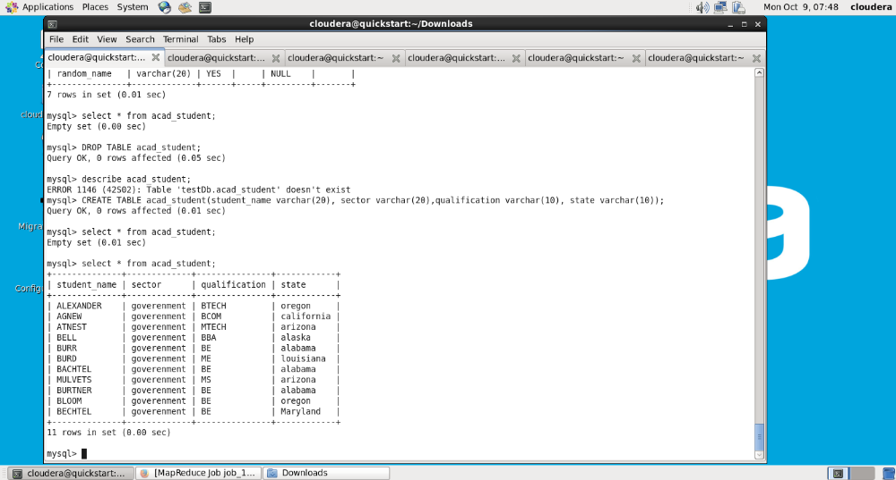
acad_student table have total 11 rows.
2. Create database in hive table and copy the acad_student table to hive:
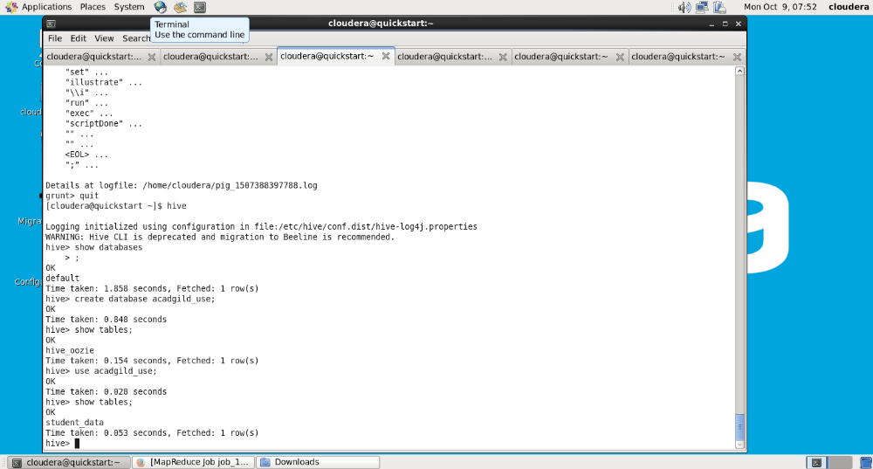
3. Scoop import command to import data directly to hive table:
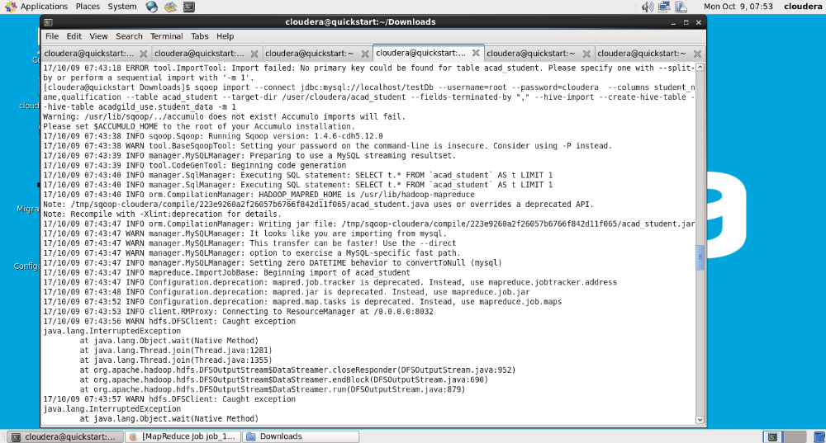
4. Once the import is complete, data is copied to hive table using acadgild_use
database:
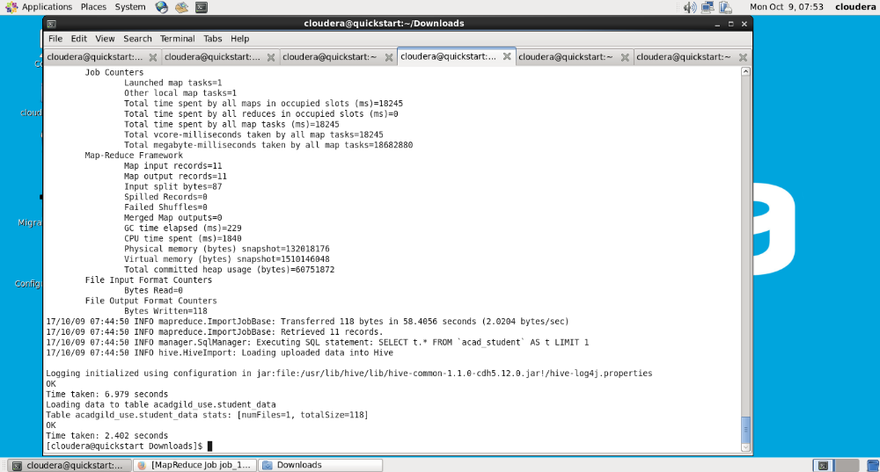
5. Check the data in hive table to make sure the data is copied properly:
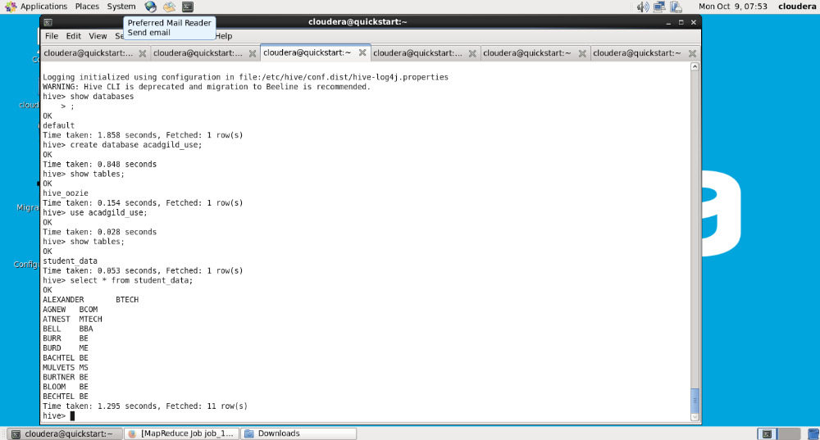
Export data from hive to mysql using sqoop:
1.create table in hive with some data in table or use the existing table
with data for export. Here I am using the existing table student_data with
columns student_name and qualification:
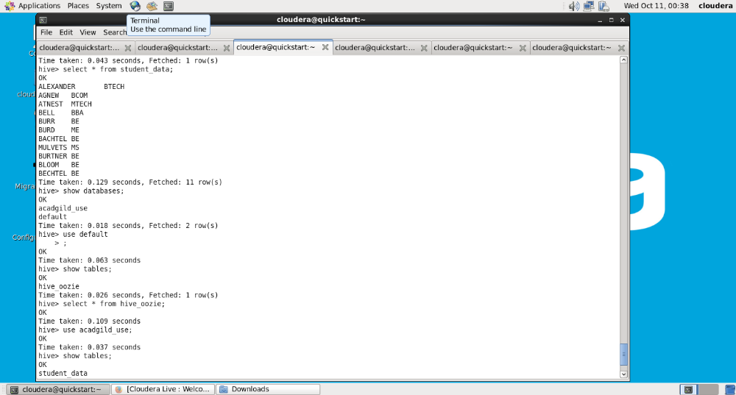
2. Create table in mysql with the same number of columns as hive:
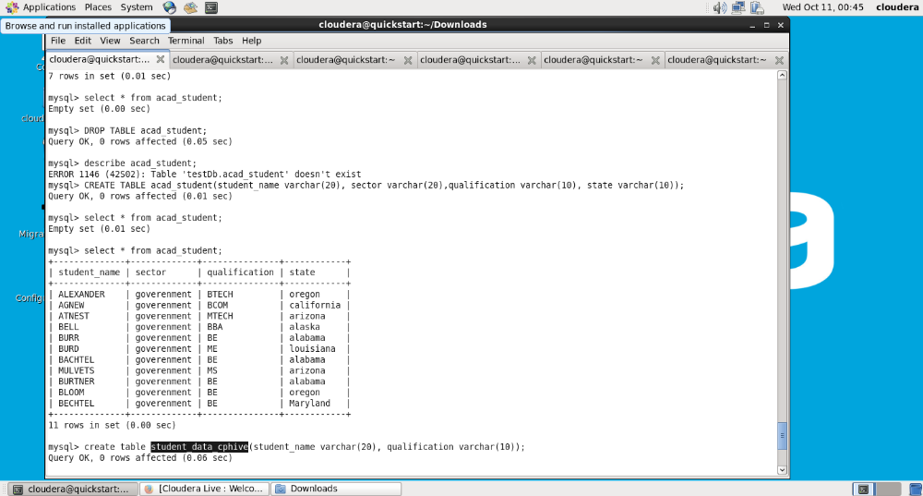
3. Transfer data from hive to mysql using sqoop export command:
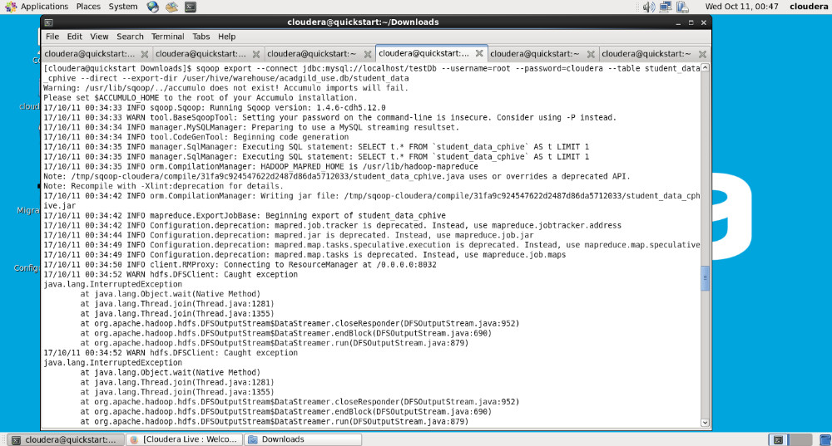
4. Once it is completed, check for the exported success command:
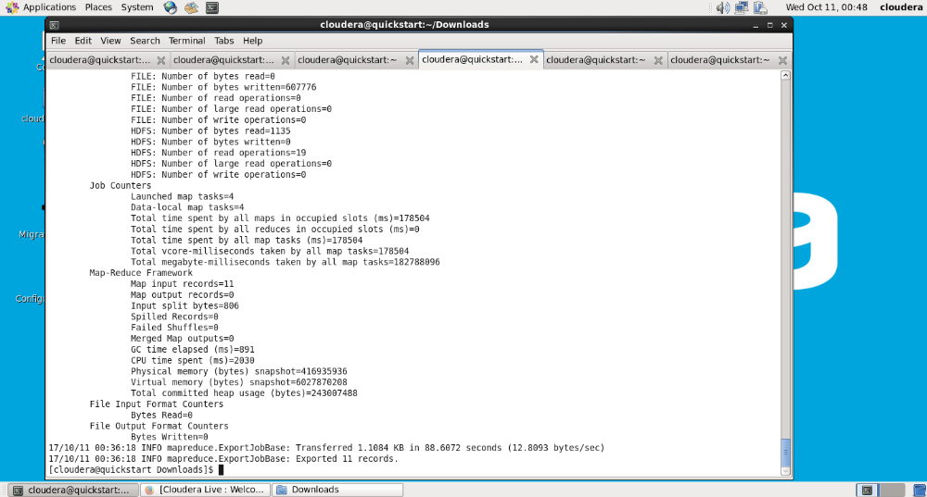
5. Check the data in mysql table for the successful transfer of data:
