Incremental load in hive:
1. Create table in mysql and insert some data.

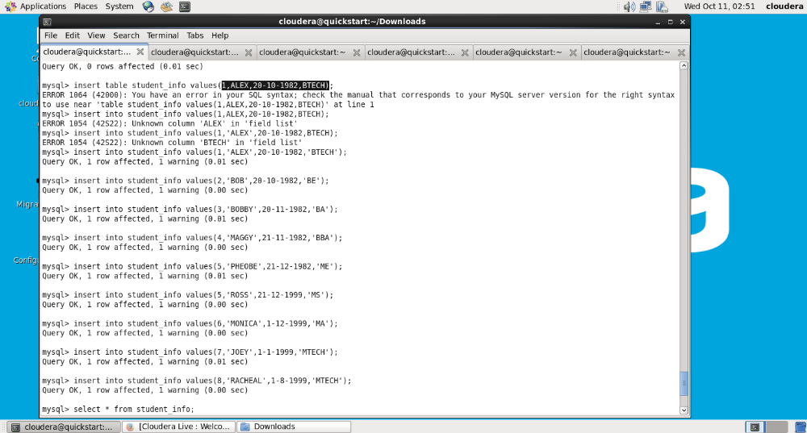
2. Import data from mysql to hive using sqoop incremental command:
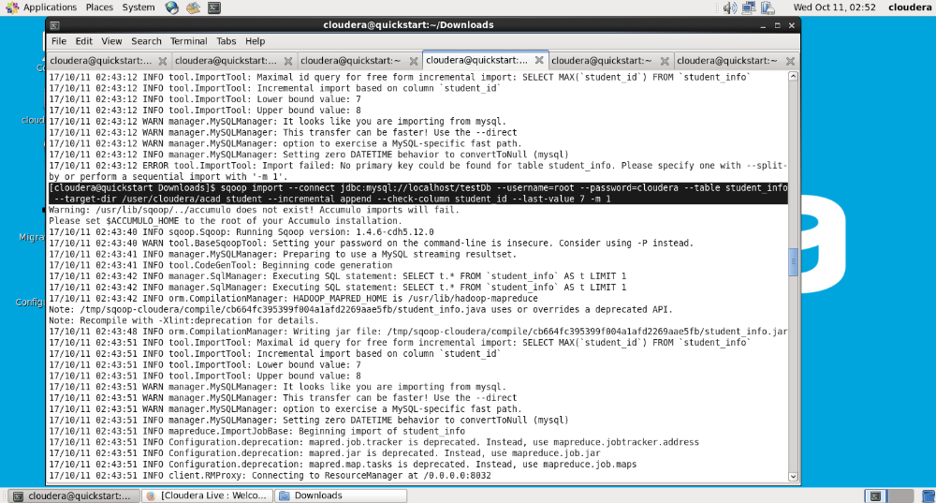
3. Once its complete, it should print incremental load complete
