1. Login to the twitter account and go to the apps link and create a new app
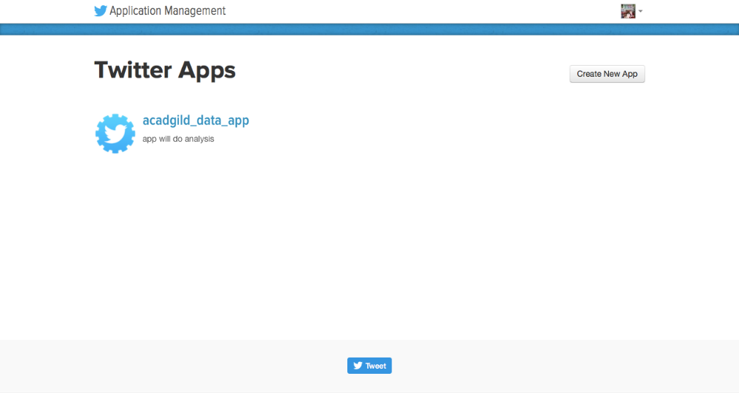
2. Copy the twitter 4j jar file to Cloudera flume directory
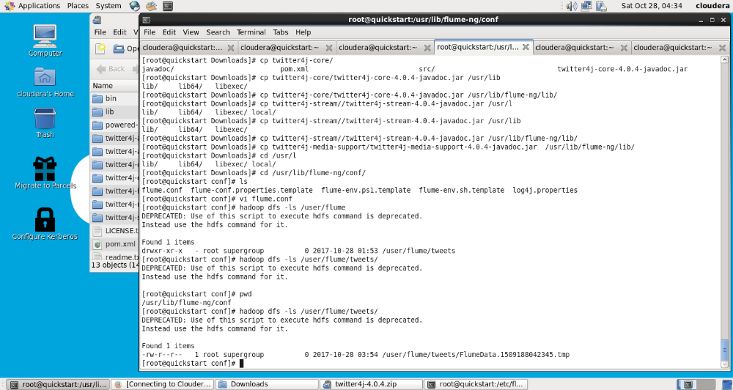
3. Change the twitter api keys with the keys generated :
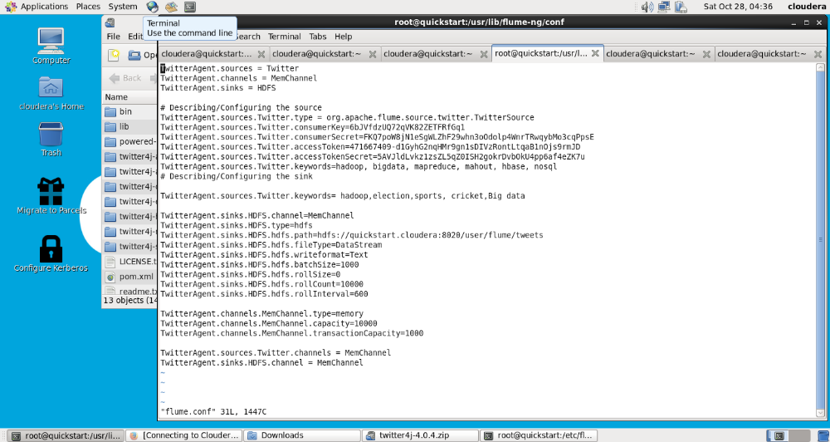
4. Create a new directory inside HDFS path, where the twitter tweet data should be
stored using command :
hdfs -mkdir /user/flume/tweets/
5. For fetching data from twitter, use the below command to fetch the twitter tweet
data in to HDFS cluster path
flume-ng agent -n TwitterAgent -f <location of created/edited conf
file>
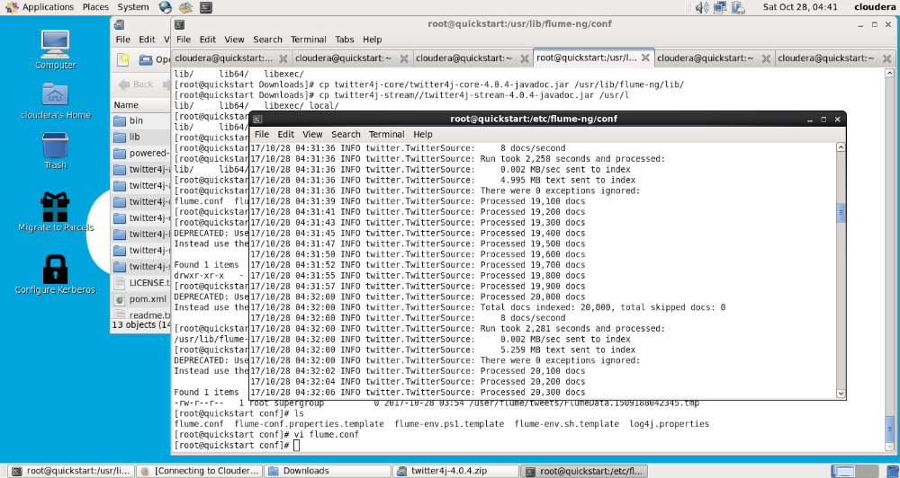
6. Check the contents of the tweet data using command:
Hdfs -ls /user/flume/tweets
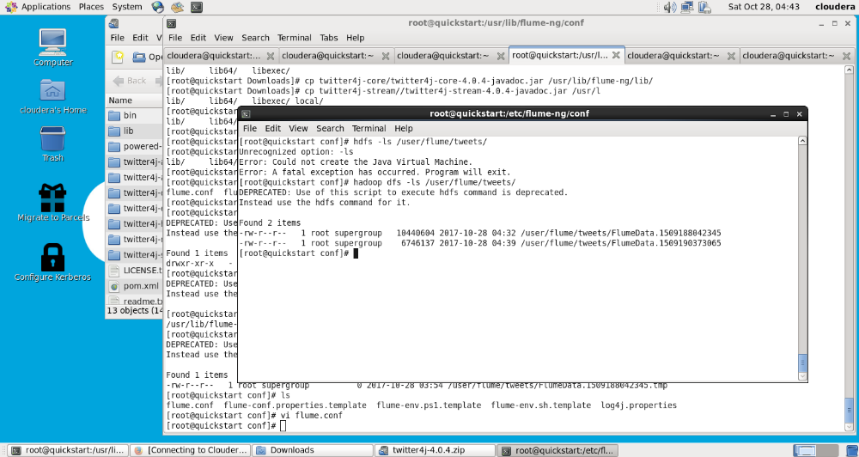
7. We can use cat command to display the tweet data inside the path:
