**Calculate the number of employees corresponding to each skill from the table**

**'employee' which is loaded in the Demo.**

**Data set**

**Employee_details.txt**

**creating table using txt data:**

Loading **Employee_details.txt** data to table:

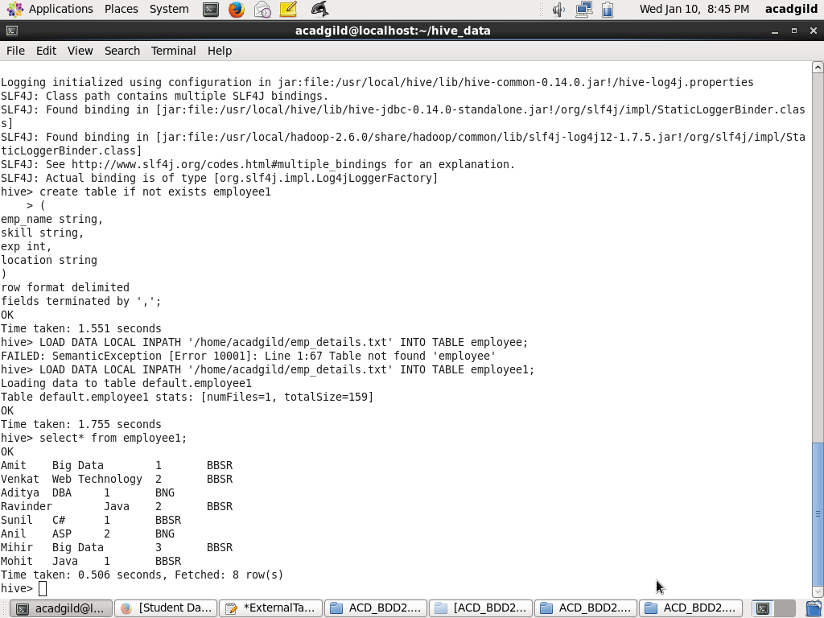

Query to retrieve the number of employees corresponding to each skill from the table

'employee' **:**

