**Create olympics table and load data from csv file olympix_data.csv**

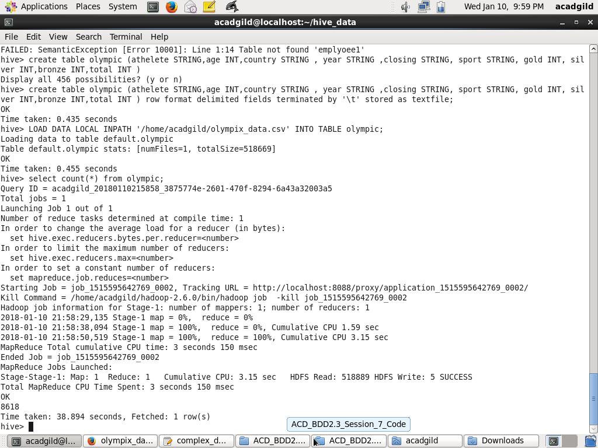

**1. Write a Hive program to find the number of medals won by each country in**

**swimming.**

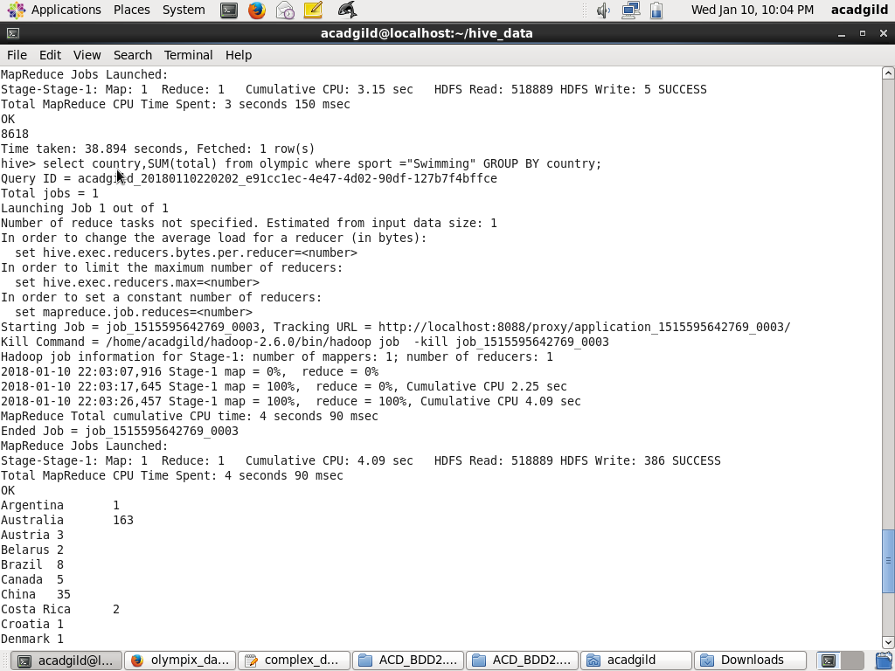

**2. Write a Hive program to find the number of medals that India won year wise**

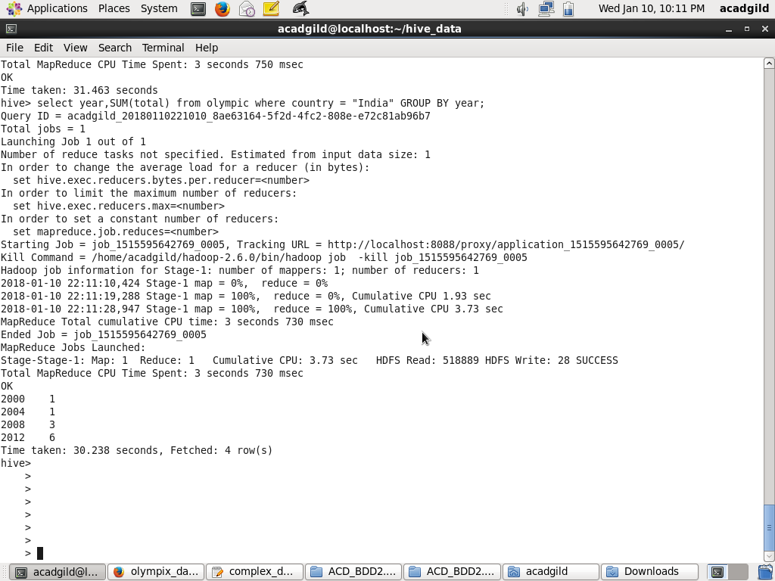

**3. Write a Hive Program to find the total number of medals each country won.**

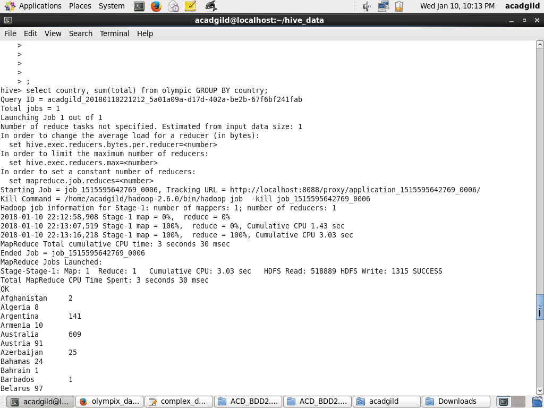

**4. Write a Hive program to find the number of gold medals each country won.**

